Whole genome analysis of rare deleterious variants adds further evidence to BRSK2 and other risk genes in Autism Spectrum Disorder

Running title: Genome sequencing in Autism Spectrum Disorder

Marta Viggiano^{1,#}, Fabiola Ceroni^{1,2#}, Paola Visconti³, Annio Posar^{3,4}, Maria Cristina Scaduto³, Laura Sandoni¹, Irene Baravelli¹, Cinzia Cameli¹, Magali J. Rochat⁵, Alessandra Maresca⁶, Alessandro Vaisfeld⁷, Davide Gentilini^{8,9}, Luciano Calzari⁹, Valerio Carelli^{6,4}, Michael C Zody¹⁰, Elena Maestrini^{1,}, Elena Bacchelli^{1,}

1 Department of Pharmacy and Biotechnology, University of Bologna, Bologna, Italy
2 Faculty of Health and Life Sciences, Oxford Brookes University, Oxford, UK.
3 IRCCS Istituto delle Scienze Neurologiche di Bologna, UOSI Disturbi dello Spettro Autistico, Bologna, Italy.
4 Department of Biomedical and Neuromotor Sciences, University of Bologna, Bologna, Italy.
5 IRCCS Istituto delle Scienze Neurologiche di Bologna, Functional and Molecular Neuroimaging Unit, Bologna, Italy.
6 IRCCS Istituto delle Scienze Neurologiche di Bologna, Programma di Neurogenetica, Bologna, Italy.
7 Department of Medical and Surgical Sciences, University of Bologna, Bologna, Italy
8 Department of Brain and Behavioral Sciences, University of Pavia, Pavia, Italy.
9 Bioinformatics and Statistical Genomic Unit, IRCCS Istituto Auxologico Italiano, Milan, Italy.
10 New York Genome Center (NYGC), New York, NY, USA.

# These authors contributed equally to this work

* Correspondence:
- Elena Maestrini: elena.maestrini@unibo.it
- Elena Bacchelli: elena.bacchelli@unibo.it

The contents of supplementary materials

Supplementary Data: Clinical description of probands with BRSK2, SCN3A and NFIX de novo variants
Supplementary References
Supplementary Figures:
- Figure S1. Clinical data of ASD individuals
- Figure S2. Score distribution of the Broad Autism Phenotype Questionnaire (BAPQ) in parents and the Social and Communication Disorders Checklist (SCDC) in the entire cohort
- Figure S3. Analysis workflow
- Figure S4. Genotype-computed ancestry of individuals included in this study
- Figure S5. Rate of rare coding de novo and inherited pdSNVs in ASD individuals and unaffected siblings
- Figure S6. De novo large duplication in Family 9
- Figure S7. Multiple hits in families with CNVs in genomic disorders loci
- Figure S8. PRS analysis. Polygenic transmission disequilibrium test (pTDT) showed that PRS was significantly over-transmitted in individuals with ASD, but not in non-ASD siblings
- Figure S9. SCN3A de novo stop-gain variant in Family 40
- Figure S10. HOMER1 deletion in Family 82
- Figure S11. Facial photographs of probands with BRSK2, SCN3A and NFIX de novo variants
Supplementary Tables:
- Table S1. Summary of phenotype information for individuals with ASD
- Table S2. Distribution of rare de novo variants
- Table S3. Gene ontology from 18 genes carrying the 19 most severe de novo pdSNVs identified in 144 cases
- Table S4. List of de novo and inherited pdSNVs in cases
- Table S5. SynGO Gene Set Enrichment Analysis (GSEA) of genes carrying de novo and inherited pdSNVs in 144 cases
- Table S6. List of high-confidence ASD/NDD genes
- Table S7: Comorbidities of probands with pdSNVs in the list of 684 high-confidence ASD/NDD genes
- Table S8: Rare genic CNVs in affected individuals and SLD siblings
- Table S9: Rare homozygous and compound heterozygous pdSNVs
- Table S10: Rare hemizygous pdSNVs

Supplementary Data: Clinical description of probands with BRSK2, SCN3A and NFIX de novo variants
Proband 14.4
The patient is an 11-year-old twin boy with ASD, diagnosed at 3 years of age. Dichorionic diamniotic pregnancy was complicated by threatened miscarriage since the end of the first trimester. Caesarean section was performed at 38 weeks. Birth weight was 2900 g.
After birth, the baby showed mild hypotonia and hypoglicemia, which gradually resolved in the first days of life. Motor milestones were only slightly delayed, and he walked unsupported at 18-20 months. Verbal skills were severely impaired: first words were reported at 2 years of age without any further improvement in the subsequent months. Due to poor eye contact, he was first referred to a child neurologist at the age of 2 years and got ASD diagnosis at the age of 3 years. Despite medical intervention, language improvements have not been reported until the age of 8-9 years, however in the last few years he acquired the ability to speak in short but clear sentences. Other remarkable findings included motor stereotipies, inability to cope with frustration, delayed fine motor skills and mild myopia (-2 D). No anomalies were detected at EEG, ECG and brain MRI.
He was born from healthy, non-consanguineous parents. His dizygotic twin brother (14.3) also has an ASD diagnosis, with poorer performances in speech fluency and autonomy in daily life activities. The remaining family history is unremarkable. Both brothers underwent CMA and FMR1 genetic analyses, with no abnormalities detected. WGS identified a de novo BRSK2 heterozygous variant (NP_001243556.1:p.(Ala158Thr)) in patient 14.4, not shared with his twin brother.
On the last evaluation, at the age of 11 years and 2/12, height was 152 cm (85thpercentile) and OFC 52 cm (20th percentile). His speech abilities were improved from the previous evaluation, although inadequate for his age, likewise for fine motor control. No major dysmorphisms were noted, however trigonocephaly, wide mouth with thick lips, bilateral broad hallux and a supernumerary right nipple, just below the normal one, were reported (Figure S11a). At the time of our last examination, puberal development had just begun.

Proband 32.3
The patient is a 10 years old boy with ASD, diagnosed at 3 years of age. He was born from healthy non consanguineous parents at 38 weeks after an uneventful pregnancy. Birth weight was 3850 g and neonatal parameters were normal.
Motor development was regular, he walked at age 13 months. At 18 months his parents noted a delay in verbal skills, poor eye contact and stereotyped behaviors, but only at 3 years he was diagnosed with ASD. His nonverbal IQ, evaluated at 4 years by Leiter-R test, was normal. Despite rehabilitation interventions he has important language problems (few single words). Maternal and paternal family history is positive for language disorders. Other remarkable findings included motor stereotypies, frustration intolerance and agitation. No major dysmorphisms were noted. ABR, EEG and brain MRI were all normal.
CMA and FMR1 analyses were performed, with no abnormalities detected. WGS revealed a de novo BRSK2 frameshift variant (NP_001243556.1:p.(Asp540GlufsTer9)).

Proband 40.3
The patient is a 12-year-old twin boy with ASD, diagnosed at 4 years of age. Dichorionic diamniotic pregnancy was uneventful, caesarean section was performed at 39 weeks. Birth weight was 2900 g and neonatal parameters were normal.
Motor development was regular, he walked unsupported at age 10 months. At 18 months, his parents noted a mild delay in verbal skills, but only at 3 years he was referred to child neurologist and he was diagnosed with ASD at the age of 4 years. His IQ, evaluated at 4 years through Leiter-R test, was 111. After 5 years of age, he started composing complex sentences. No anomalies were detected at EEG and brain MRI.
He was born from healthy, non-consanguineous parents. His dizygotic twin brother (40.4) also has an ASD diagnosis, with no ID, but a less structured language. EEG and MRI analyses did not reveal any anomalies. The remaining family history is unremarkable.
CMA and FMR1 analyses were performed on both twins, with no abnormalities detected. WGS revealed a de novo SCN3A variant (NP_008853.3:p.(Arg1630Ter)), not shared with his twin.
At the last evaluation, at the age of 11 years and 8 months, his height was 150 cm (64th percentile) and OFC 53 cm (35th percentile). No major dysmorphisms were noticeable (Figure S11b). We only noted mild kyphosis, bilateral clinodactyly of the 5th finger, bilateral syndactyly of 2nd-3rd toes.

Proband 81.3
The patient is a 7 years old boy, with a clinical history of global developmental delay and ASD. He was born at 41 weeks after an uneventful pregnancy. Birth weight was 3300 g, length 52 cm and OFC 35 cm.
At 8 days of life, he started showing episodes of generalized pallor with perioral cyanosis, hypotonia and apneas. EEG and ECG were performed with normal results. Cerebral US detected ventricular asymmetry (left>right). The episodes were attributed to gastroesophageal reflux disease (GERD) and became milder and less frequent with anti-reflux therapy. At 15 months of age, a cluster of 3 seizures occurred, characterized by eye deviation, hypertonia and myoclonus, during an episode of gastroenteritis. Since the age of 6 years, the child has presented focal epileptic motor seizures with or without secondary generalization. Currently he is taking Valproic Acid. EEG shows epileptic abnormalities in right central-parietal regions. Brain MRI (3 Tesla) was normal.
Motor milestones were regularly acquired, while verbal skills were delayed. Due to absent language, poor eye contact and stereotyped behaviors, he was referred to child neurologist at the age of 2 years, where developmental delay and ASD diagnosis was diagnosed at the age of 2 years and 10 months. Macrocephaly (OFC> +2 SD) was reported since then. Despite speech therapy, language is still absent with the emission of only mono-syllabic sounds. Severe ID is present.
He was born from non-consanguineous parents. He has an older healthy brother. Family history is positive for nonfebrile seizures (mother and maternal grandmother), eventually resolved without sequelae.
He first underwent FXS analysis, with detection of a normal FMR1 allele. CMA was then performed, with the detection of a large duplication 15q13.2-13.3, also confirmed by SNP array and WGS data. The duplication is inherited from the mother, who has a personal and family history of uncomplicated seizures. In addition to this recurrent CNV, WGS detected a de novo NFIX heterozygous variant (NP_001352831.1:p.(Leu75Pro)) in the proband, providing a clinical diagnosis of Malan syndrome. This result also confirmed that the duplication was not the main cause of the patient’s condition, even if we couldn’t exclude a partial contribution to his complex phenotype.
At the last evaluation, at the age of 7 years and 9 months, height was 129 cm (65th percentile) and OFC 56,9 (+3.5 SD), indicating the presence of macrocephaly. In addition, he had dolicocephaly with a wide forehead, low set eyes, high-arched and narrow palate (Figure S11c). As collateral findings, we also reported a supernumerary left nipple and two cafè-au-lait spots, one in the back between scapulae and one in the right forearm.

Supplementary References
1. Sasson NJ, Lam KS, Childress D, Parlier M, Daniels JL, Piven J. The broad autism phenotype questionnaire: prevalence and diagnostic classification. Autism Res. Apr 2013;6(2):134-43. doi:10.1002/aur.1272
2. Skuse DH, Mandy WP, Scourfield J. Measuring autistic traits: heritability, reliability and validity of the Social and Communication Disorders Checklist. Br J Psychiatry. Dec 2005;187:568-72. doi:10.1192/bjp.187.6.568

Figure S1. Clinical data of ASD individuals. a) Age of onset of first symptoms and age of ASD diagnosis. b) Autism severity according to ADOS-2 comparison score. c) Autism severity according to CARS2-ST score. CARS total scores below 30 indicate that an individual is “non-autistic,” while scores of 30 or above indicate that an individual is “autistic.” Individuals with scores above 30 are further subdivided into having “mild to moderate autism” (30 to 36.5) or “severe autism” (37 to 60).

Figure S2. Score distribution of the Broad Autism Phenotype Questionnaire (BAPQ) in parents and the Social and Communication Disorders Checklist (SCDC) in the entire cohort. a) BAPQ total score in parents. Red points indicate individuals with BAPQ score over the cutoffs (male threshold= 3.55; female threshold=3.17)¹. b) Boxplots of SCDC scores in parents, affected individuals and unaffected siblings. The dotted line indicates the suggested cut-off score (a score of 9 or above reflects difficulties in social interaction and communication)².

Figure S3. Analysis workflow. This workflow shows the cohort composition and the primary analyses performed in this study. 18 families were analysed by both WES and WGS. Filtering steps employed to prioritize rare coding variants that could be associated with ASD susceptibility are described in detail in the Methods.

Figure S4. Genotype-computed ancestry of individuals included in this study. Multidimensional scaling (MDS) analysis was performed merging our cohort data with the 1000 Genomes Project reference panel (20100804 release). We assigned ancestry labels to all individuals of our cohort through visual inspection of the first two MDS coordinates and confirmed that 19 families are of non-European origin, consistent with self-reported ancestry. Green, red, pink and blue circles indicate European (EUR), Asian (ASN), Admixed American (AMR) and African (AFR) individuals of the 1000G, respectively. Black crosses indicate all individuals included in this study (n=435).
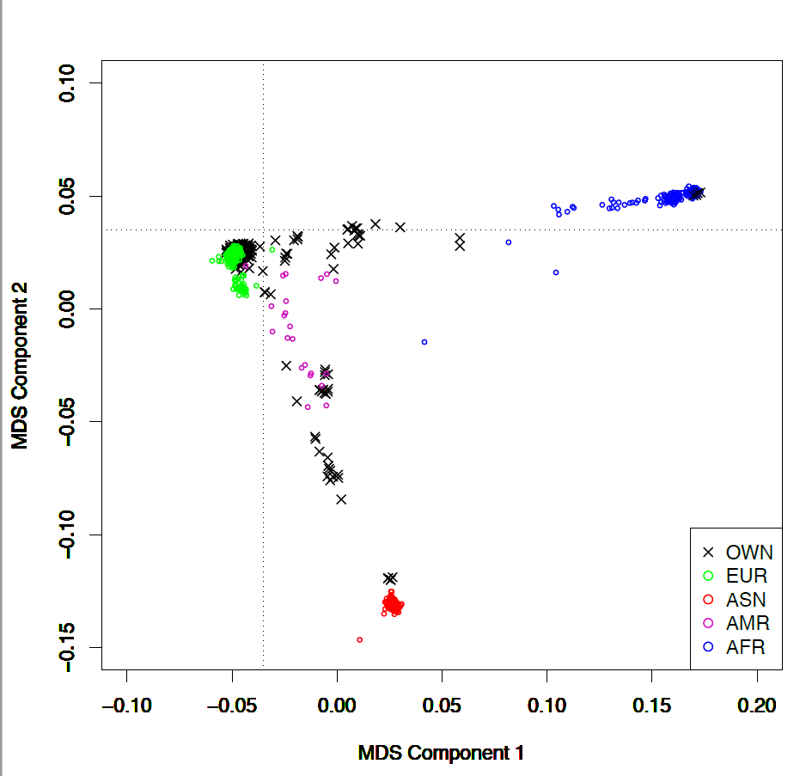

Figure S5. Rate of rare coding de novo and inherited pdSNVs in ASD individuals and unaffected siblings. Comparison of individual rate of de novo and inherited pdSNVs in cases and unaffected siblings (ASD cases=144, unaffected siblings=55). pdSNVs include PTVs in genes with pLI score ≥0.5 (PTV_0.5), missense variants with MPC score ≥2 (DmisB) and missense variants with MPC score 1-2 (DmisA).

Figure S6. De novo large duplication in Family 9. a) UCSC schematic (hg38) showing the 18p11.22-p11.21 region. The 3.2 Mb de novo duplication identified in individual 9.4 is indicated by a black bar. The transcripts from the MANE track are shown for each gene. b) IGV visualisation of the breakpoints. Read alignments are shown for the father (9.1), mother (9.2) and SLD child (9.4). The positions of the two clusters of green reads in 9.4 indicate the boundaries of the tandem duplicated fragment. c) Schematic indicating the location of the primers used to validate the position of the breakpoints. Tandem duplicated sequence indicated in green, forward and reverse primers are indicated with blue and purple arrows, respectively. The primers are designed such that in the reference sequence they are divergent (top), whereas in the tandem duplicated allele they are convergent and can generate a PCR product across the junction. d) Chromatogram of the junction between the duplicated segments demonstrating their tandem orientation. The sequence highlighted in red is common to both ends of the duplicated fragment and therefore cannot be definitively ascribed to either.
Figure S7. Multiple hits in families with CNVs in genomic disorders loci. Pedigrees of families carrying a CNV associated with recurrent genomic disorders (RGD) and additional hits consisting of i) de novo pdSNVs, ii) PTVs_{0.5} in NDD genes inherited from the parent not transmitting the recurrent CNV, iii) pdCNVs inherited from the parent not transmitting the recurrent CNV (listed in Table 2). De novo variants are reported in red. ASD, autism spectrum disorder; SLD, specific learning disabilities; del, deletion; dup, duplication. All HGVS nomenclatures are based on the MANE select transcripts.

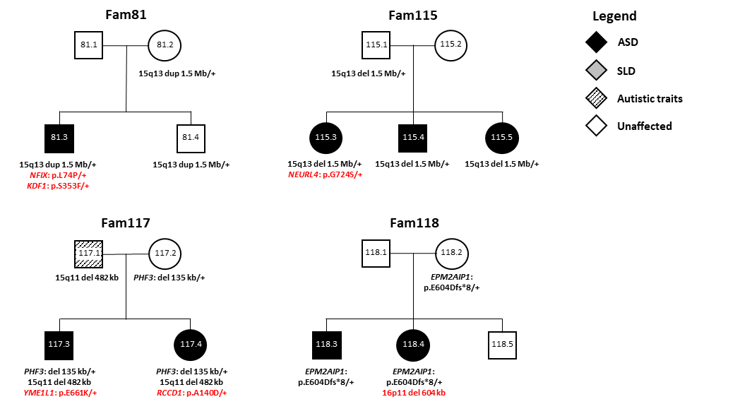

Figure S8. PRS analysis. a) PRS distributions in cases (n=121) and unaffected siblings (n=54). b) Polygenic transmission disequilibrium test (pTDT) showed that PRS was significantly over-transmitted in individuals with ASD (pTDT mean=0.222, p-value=0.019), but not in non-ASD siblings (pTDT mean=0.107, p-value=0.45).

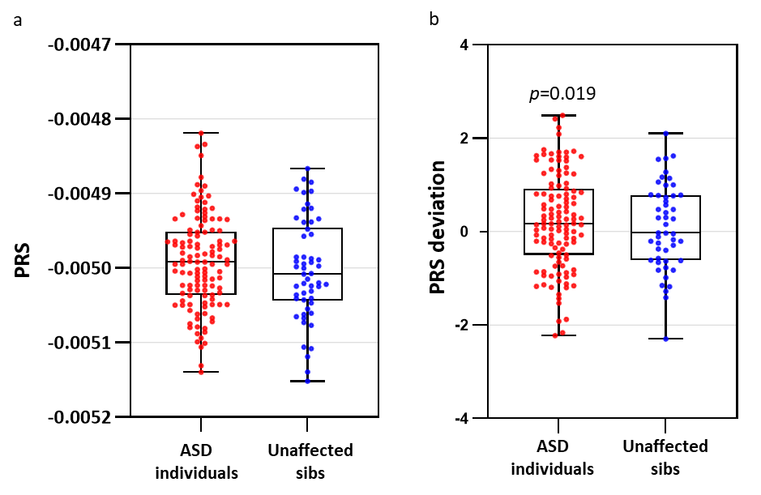
Figure S9. SCN3A de novo stop-gain variant in Family 40. a) UCSC schematic (hg38) showing the genomic structure of SCN3A. The position of the de novo stop-gain variant, mapping within the last exon of all Refseq isoforms, is indicated by the red arrow. b) Schematic of the SCN3A protein. SCN3A encodes the type III voltage-gated sodium (Na+) α subunit Nav1.3, a transmembrane protein with four domains (D1-D4), each formed by six subunits (S1-6). Subunits 4 (S4) act as "voltage sensor" and transduce the transmembrane voltage into mechanical changes that alter channel gating. Subunits S5-6 form the channel pore. The premature stop-gain identified in our study is predicted to determine the loss of half of S4D4, critical for voltage sensing, the two pore-building segments S5D4 and S6D4, and the entire cytoplasmic C-terminal tail, needed for the protein-protein interaction with one of the β subunits.
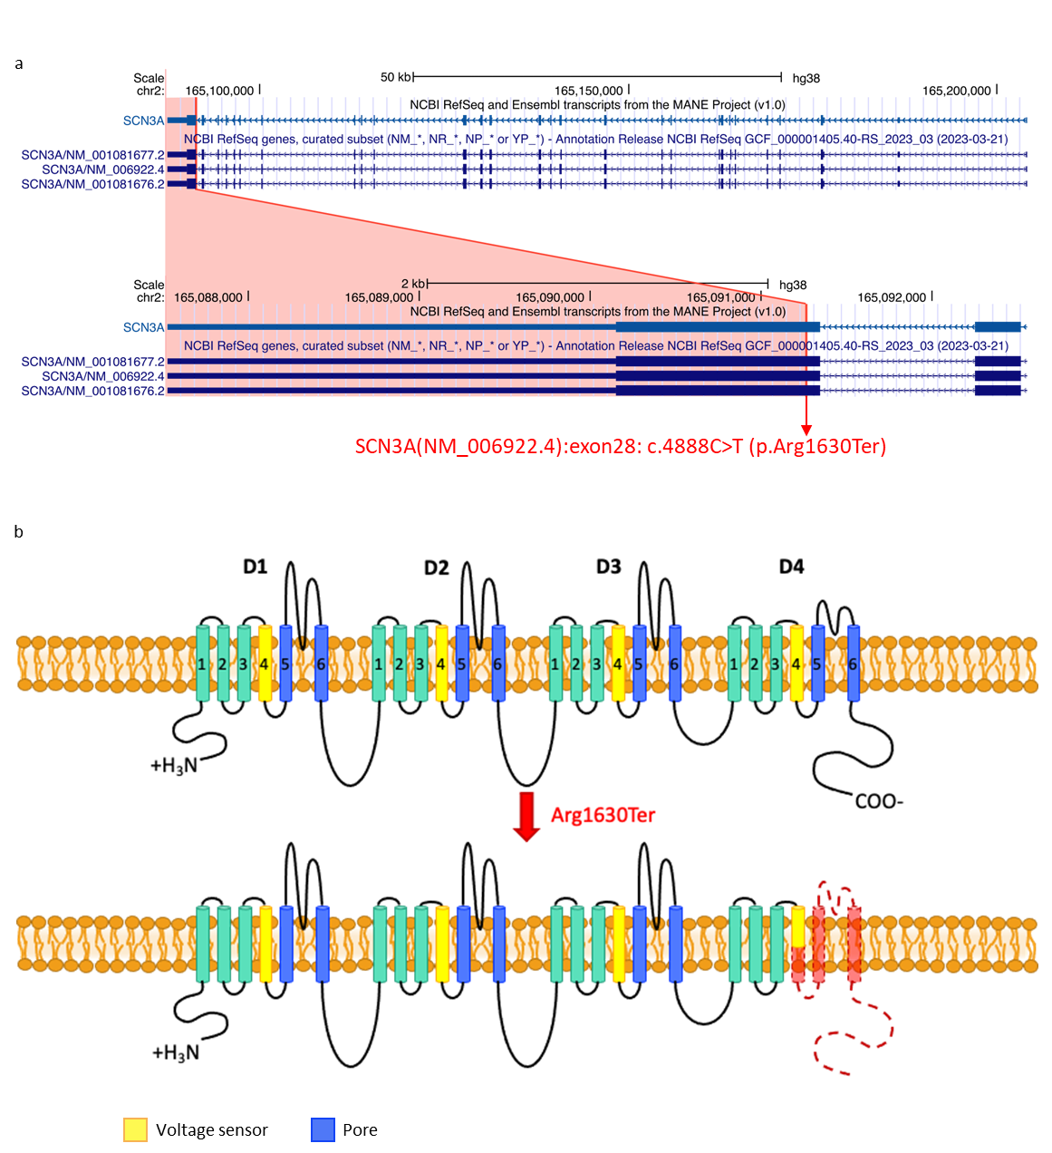
Figure S10. HOMER1 deletion in Family 82. a) UCSC schematic (hg38) showing the genomic structure of HOMER1. The 19 kb deletion identified in family 82 is indicated by a black bar and encompasses exon 6 of the isoform NM_004272 (MANE transcript). b) IGV visualisation of the deleted region. Coverage tracks and read alignments are shown for the father (82.1), mother (82.2), ASD child (82.3) and unaffected sister (82.4). The deleted region shows a decreased read depth in 82.2, 82.3 and 82.4, with clusters of red reads at both sides indicating the positions of the breakpoints. c) Sanger sequencing confirming the location of the breakpoints. The chromatograms indicate that an insertion of 13 nucleotides (highlighted in red) has occurred between the breakpoints.
Figure S11. Facial photographs of probands with BRSK2, SCN3A and NFIX de novo variants. For detailed descriptions please see Supplementary Data.
