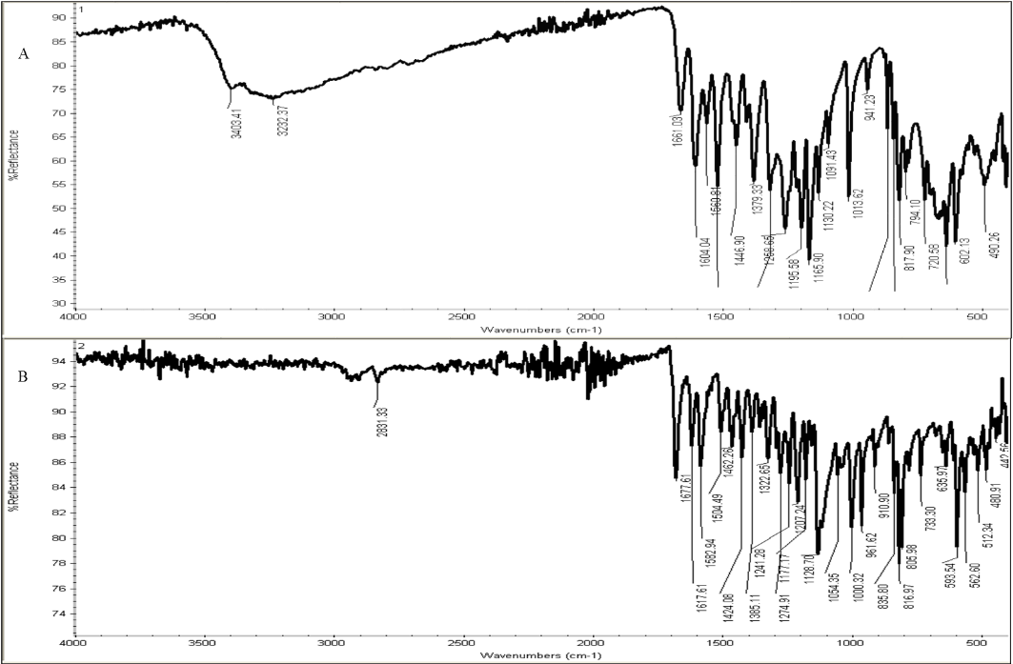
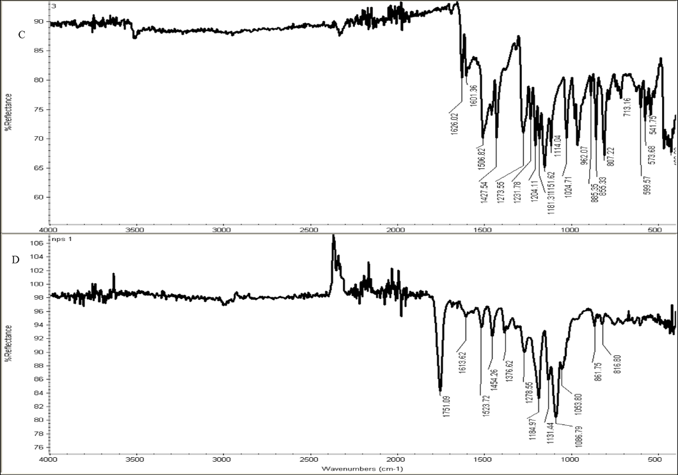
Supplementary Fig. 1 FT-IR spectra of (A) quercetin, (B) piperlongumine, (C) curcumin and (D) three molecules quercetin, piperlongumine, curcumin Loaded NPs

