Graphical Abstract
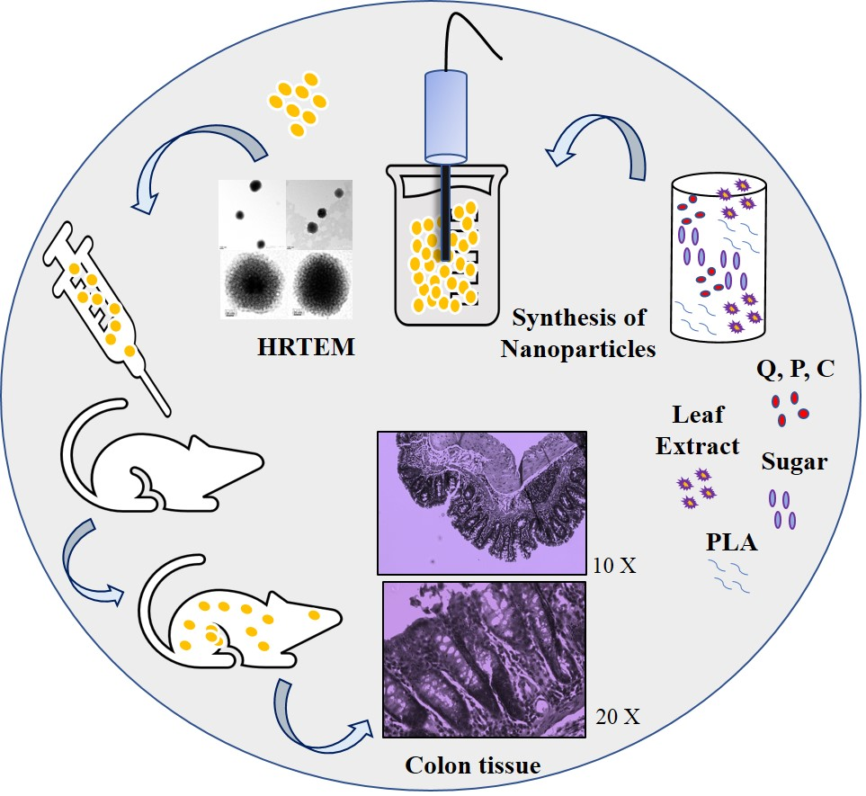
In this study, for the first time, three natural molecules- quercetin, piperlongumine and curcumin were encapsulated in Ficus benghalensis (Banyan) coated biodegradable poly-D,L-lactide nanoparticles to check their anticancer potential against the colon cancer (DMH-DSS) in colon cancer model (BALB/c mice). The coated nanoparticles maintained the detectable concentration of quercetin, piperlongumine and curcumin in colon even in liver, kidney and serum after 8 h of administration. The surface coating of leaf extract and dextrose sugar enhanced the potential of the formulation of nanoparticles.

