Supplementary information

Fig. S1. HadCM3 (Krapp et al. 2021) hindcasts of anomalies of net primary production (NPP; green), temperature (red), and precipitation (blue) for Cyprus, with the CRIWM-estimated human arrival window shown in vertical grey, the Bølling-Allerød interstadial (B-O; light pink shading), the Younger Dryas (light blue shading), and the early Holocene (brown shading).Type or paste legend here.

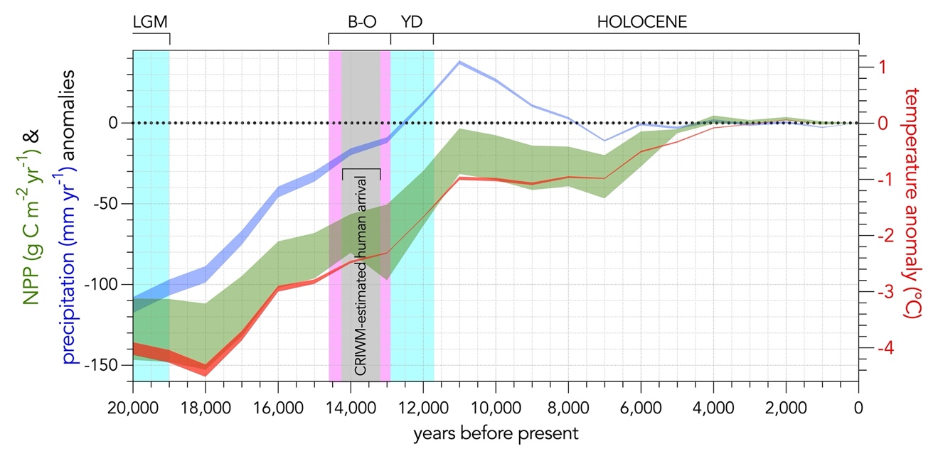

Fig. S2. Hindcasted net primary production (green scale) from the HadCM3 global circulation model (Krapp et al. 2021) at 14 ka for the Eastern Mediterranean-Middle East (resolution 0.5º × 0.5º latitude/longitude). The model predicts a net primary production of the cells covering Cyprus ranging from 181–223 g C m⁻² year⁻¹, whereas other sites with dated archaeological material around 14 ka on the mainland (e.g., Karain and Öküzini Caves, Türkiye; Moghr El Ahwal Cave 3, Lebanon; Hayonim Terrace and Kebara Cave, Israel — Palmisano et al. 2022) have hindcasted net primary production ranging from 140 to 216 g C m⁻² year⁻¹. Background blue indicates relative bathymetry in the Mediterranean Sea.

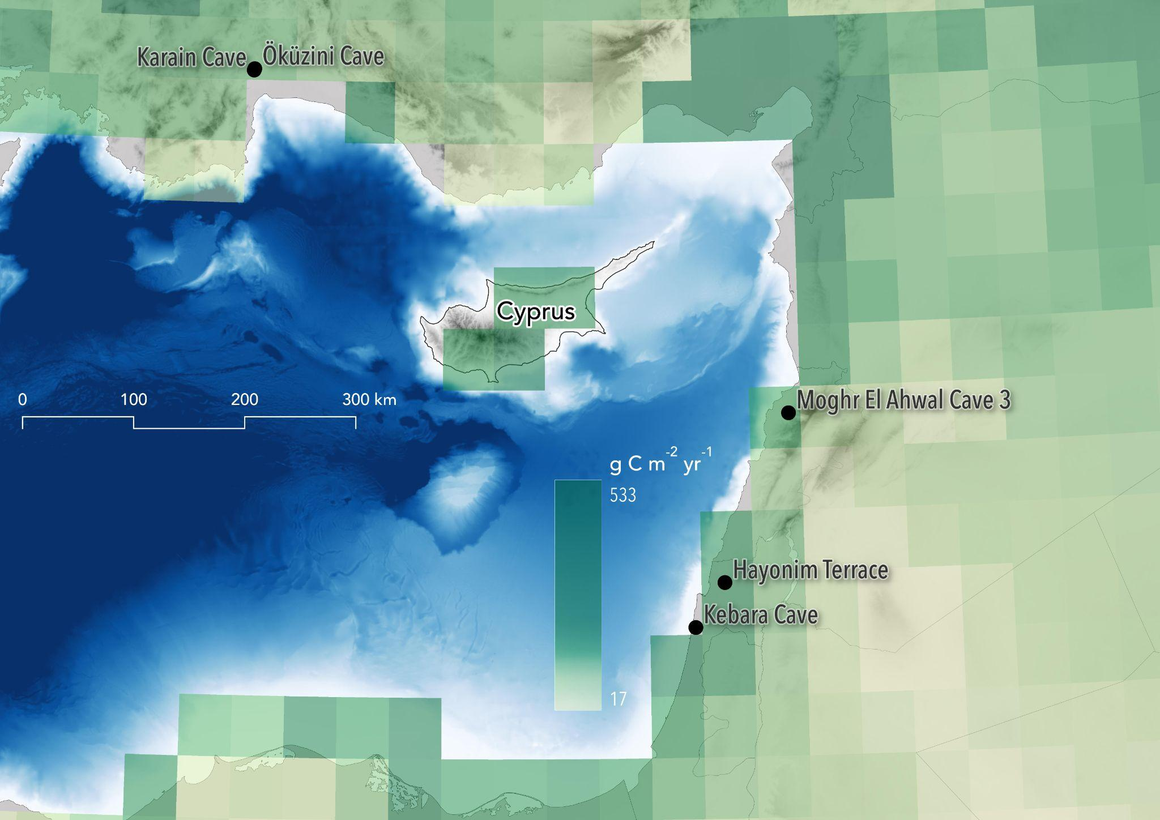
Fig. S3. Comparison of hindcasted temperature anomalies (ºC) derived from the HadCM3 (Krapp et al. 2021) and TraCE21ka (Liu et al. 2009; Liu et al. 2014) global circulation models. The temporally finer-resolution TraCE21 (seamless, but shown here in 100-year increments) compared to HadCM3 (1000 years) captures the dynamics of the Bølling-Allerød interstadial (B-O; light pink shading) and the Younger Dryas (light blue shading) compared to other climate hindcasts (Fordham et al. 2017). Also shown is the Last Glacial Maximum (LGM).

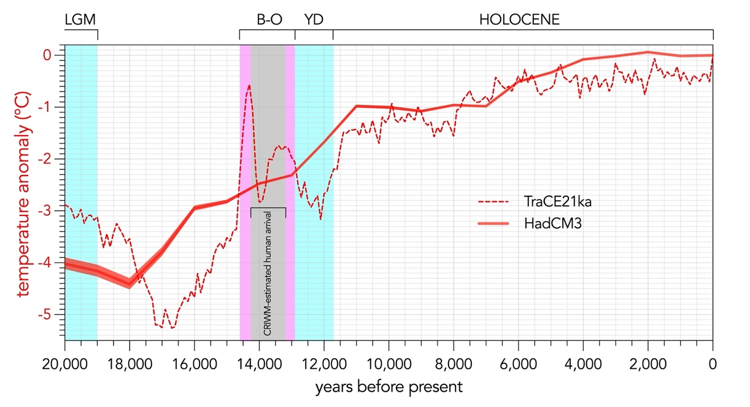
Fig. S4. Average annual rainfall (mm; orange-purple scale) pattern in Cyprus derived from the Climate Hazards Center InfraRed Precipitation with Station Data (CHIRPS) dataset from 1981–2022 (chc.ucsb.edu/data/chirps). Background blue indicates relative bathymetry.

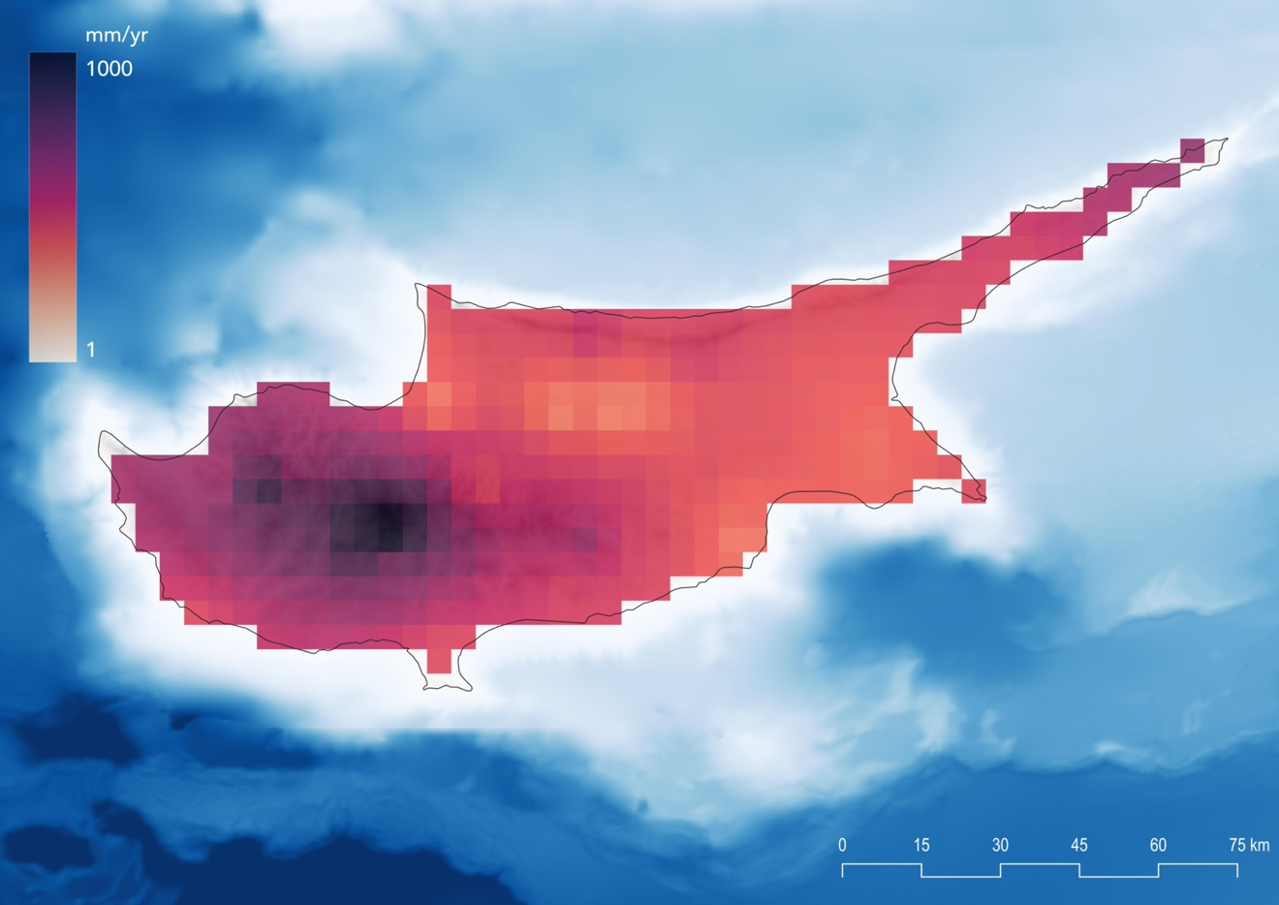

Fig. S5. Global sea-level variation (from Lambeck et al. 2014) and reconstructed time series of Cyprus land area derived from the General Bathymetric Chart of the Oceans (gebco.net). Also shown are the calibrated re-sampled inverse-weighted McInerney (CRIWM) estimate of initial entry window (grey shading), the end of the Last Glacial Maximum (LGM; light blue shading), the Bølling-Allerød interstadial (B-O; light pink shading), the Younger Dryas (YD; light blue shading), and the early Holocene (brown shading).

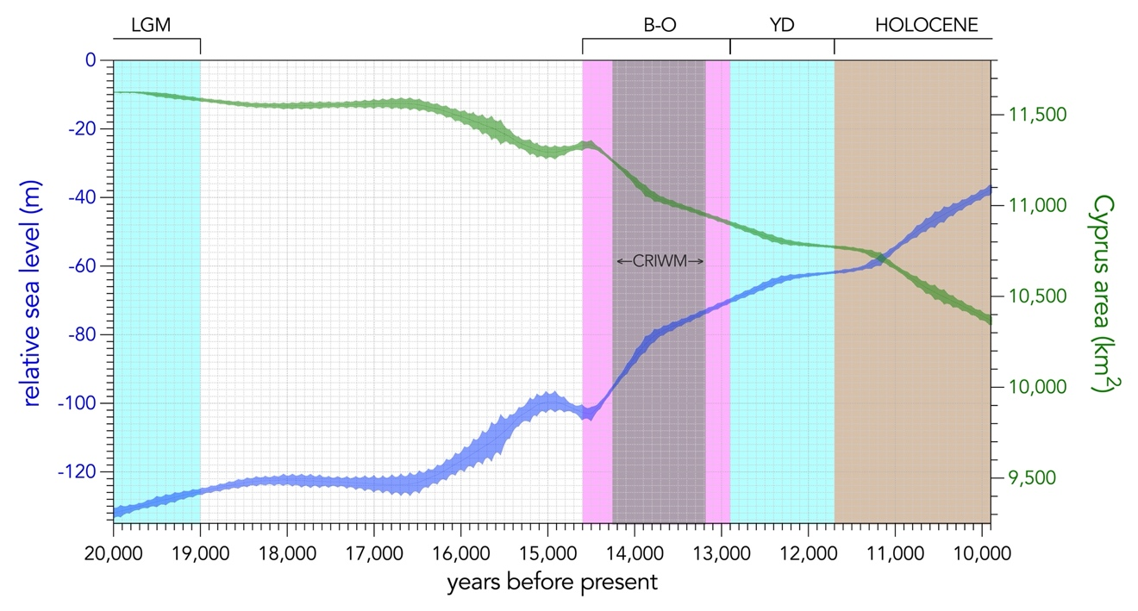

Fig. S6. An example projection of carrying capacity (K) based on the changing net primary production from the HadCM3 model (Krapp et al. 2021) and size of Cyprus (changing with seal level; Fig. S5). Also shown are the calibrated re-sampled inverse-weighted McInerney (CRIWM) estimate of initial entry window (grey shading), the duration of the Younger Dryas (YD; light blue shading) and the early Holocene (brown shading).

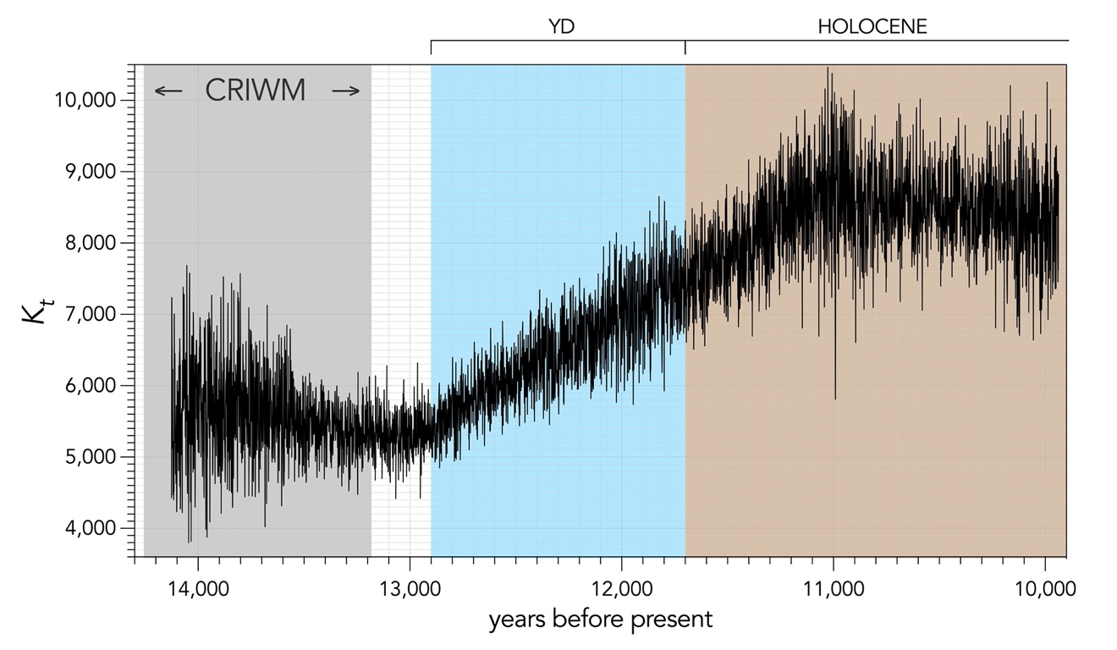

SI References
Fordham, D.A., Saltré, F., Haythorne, S., Wigley, T.M.L., Otto-Bliesner, B.L., Chan, K.C. et al. (2017). PaleoView: a tool for generating continuous climate projections spanning the last 21 000 years at regional and global scales. Ecography, 40, 1348-1358. doi:10.1111/ecog.03031
Krapp, M., Beyer, R.M., Edmundson, S.L., Valdes, P.J. & Manica, A. (2021). A statistics-based reconstruction of high-resolution global terrestrial climate for the last 800,000 years. Scientific Data, 8, 228. doi:10.1038/s41597-021-01009-3
Lambeck, K., Rouby, H., Purcell, A., Sun, Y. & Sambridge, M. (2014). Sea level and global ice volumes from the Last Glacial Maximum to the Holocene. Proceedings of the National Academy of Sciences, 111, 15296-15303. doi:10.1073/pnas.1411762111
Liu, Z., Lu, Z., Wen, X., Otto-Bliesner, B.L., Timmermann, A. & Cobb, K.M. (2014). Evolution and forcing mechanisms of El Niño over the past 21,000 years. Nature, 515, 550-553. doi:10.1038/nature13963
Liu, Z., Otto-Bliesner, B.L., He, F., Brady, E.C., Tomas, R., Clark, P.U. et al. (2009). Transient simulation of Last Deglaciation with a new mechanism for Bølling-Allerød warming. Science, 325, 310-314. doi:10.1126/science.1171041

