Supplement fig. 1
The curse of PSM
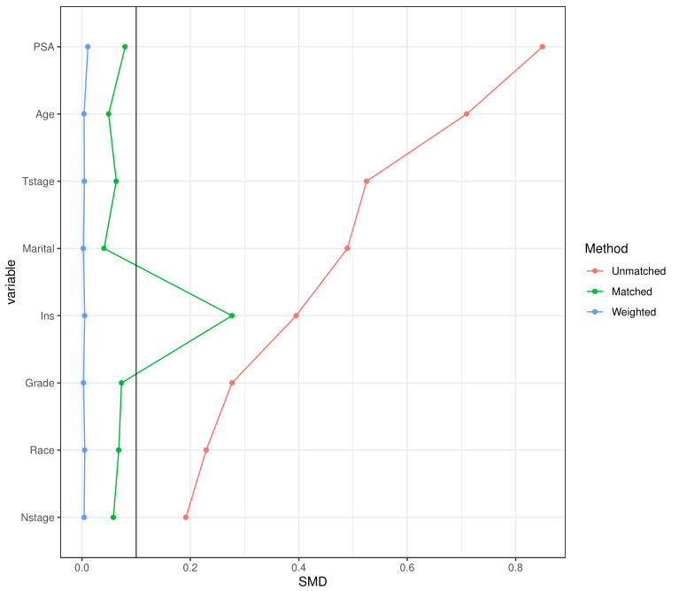

Fig.2 The OS of subgroups

