Supporting information

Tracking health threat from gaseous organic mixture in industry
Di Wang,^{a,*}, Xinmin Zhangª, Wenjuan Zhaoª, Weiqi Zhangª ,Lei Nie^{b}, Xia Shao^{b}
ª Innovation Base of Regional & Urban Atmospheric Environmental Research, Chinese Research Academy of Environmental Sciences, Beijing 100012, China
^{b} Beijing Key Laboratory of Urban Atmospheric Volatile Organic Compounds Pollution Control and Application, Beijing Municipal Research Institute of Environment Protection, Beijing 100037, China

*Corresponding authors:
wangdi@craes.org.cn

Instrumental analysis. Samples in Summa Canisters were connected to an automatic sampler firstly (Entech instruments, 7032), guided into a preconcentrator (Entech instruments, 7100), and then analyzed with a gas chromatograph connected to a mass spectrometer detector and flame ionization detector (GC-MSD/FID) (Agilent 7890A-5975C). The gas chromatograph was equipped with DB-5ms capillary column with length, inner diameter and film thickness being 60 m, 350 μm, 1.0 μm respectively. The operating program of GC was as follows: injection volume and flow rate of sample were 400 ml and 1.2 ml/min; temperature of inlet port and transmission line were 250 and 280 ℃; initial temperature was set at 40 ℃ (8 min hold), ramp to 160 ℃ at 5 ℃/min, and then ramp to 220 ℃ at 10 ℃/min (5 min hold). MSD with full SCAN model was operated with temperature of EI and Quadrupole being 230 and 150 ℃, voltage of electron multiplier was 1329 V, and scanned area was 35 to 300 amu with a scanning speed of 5.36 scans/s. External and internal standard methods were employed simultaneously to identify and quantify individual VOCs with comparing with NIST mass spectral library. TO-15 (64 components) and PAMS (56 components) multi-components standard gases were selected as external standard gases, and 1ppmv bromochloromethane, 1,4-difluorobenzene, chlorobenzene, 4-bromofluorobenzene served as internal standard gas (Scotty Gases).
Samples in Tedlar bags were detected by GC-FID (Beifen, 3420A) in advance to obtain the total VOCs concentration, and then guided into Summa Canister by six-way valve and injector with diluting the sample below 10 ppmv. GC-FID was equipped with a double-capillary column to quantify methane and total hydrocarbon respectively, and the difference was total VOCs concentration. The specific performance was conducted to protect capillary column from being contaminated by injected samples with high level VOCs concentration that would likely invalidate capillary column.
Prior to implementation of sample, all materials and equipment employed were calibrated and pretreated. Tedlar bags were rinsed three times by high purity nitrogen with duration of 20 min individually in laboratory, and the Teflon lines were rinsed 10 min by sample gas to reach saturation adsorption before sampling. Soap-film flowmeter was used to calibrate low-rate pumps for confirming the error ranges were less than 1%. Additionally, 100 ppm isobutene (Scotty Gases) was serving as standard gas to calibrate MiniPID.
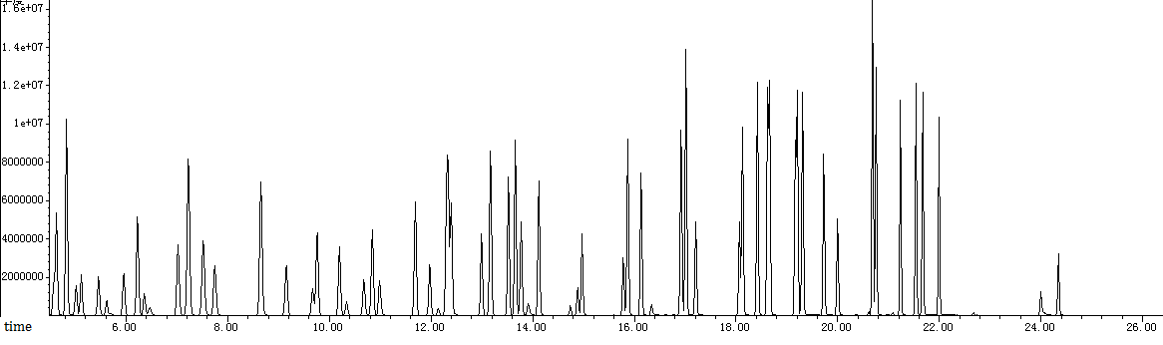
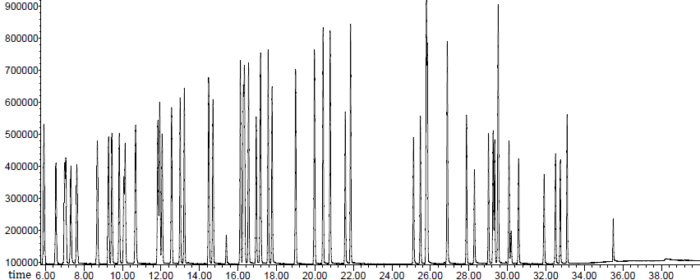
Figure S1. Spectrogram of TO-15 (upper) and PAMS (below) standard gas

Table 1. List of studied industries.
Aircraft Maintenance
Auto Parts manufacturing
Automobile Maintenance
Automobile manufacturing
Ceramic manufacturing
Coal Chemical
Coking
Electrical machinery manufacturing
Equipment manufacturing
Food Manufacturing
Furniture manufacturing
Household appliance manufacturing
Liquor making
Metal Products Manufacturing
Oil and gas storage
Organic chemical
Packaging and Printing
Paint and ink manufacturing
Paper product manufacturing
Petrochemical
Petroleum refining
Pharmaceutical manufacturing
Plastic product manufacturing

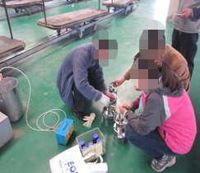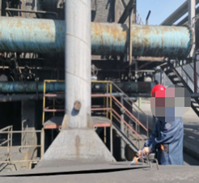
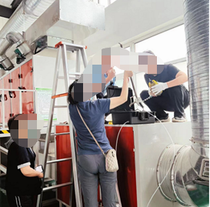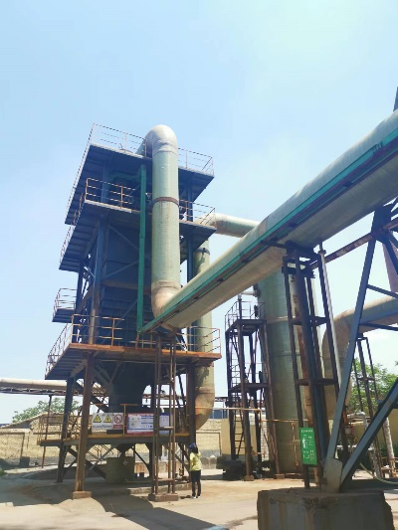
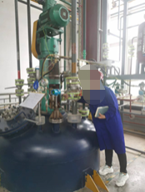
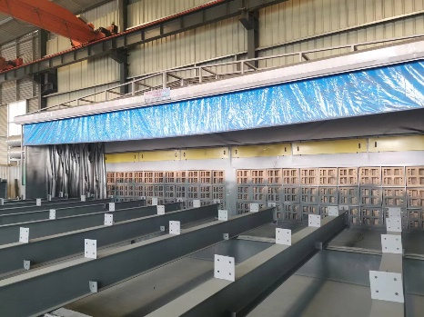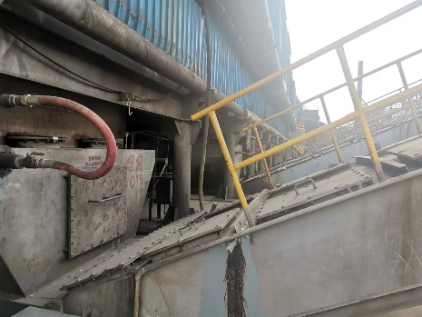
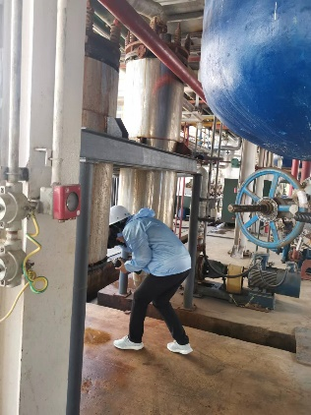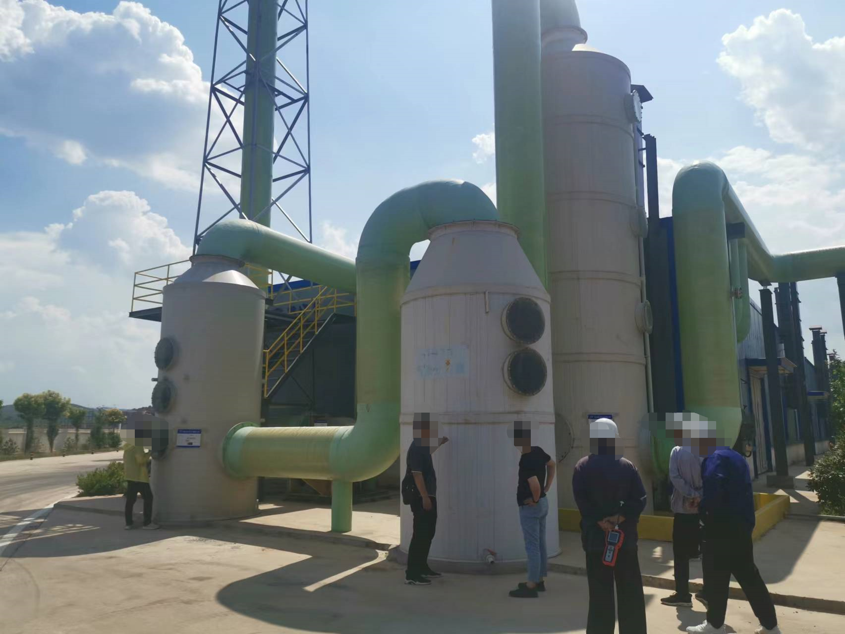
Figure S2. Photos of the field investigation (locate sampling site and conduct sampling).

