Supplementary figure 1: zone of inhibition (in mm) of the fungus comb extract SOT40 (59 mg/mL) for gram-negative and gram-positive bacteria as well as mycobacteria tested. Up, HPLC water was tested as a negative control. Down, 50 μL (2.9 mg) of crude extract was placed in the agar wells of each strain.
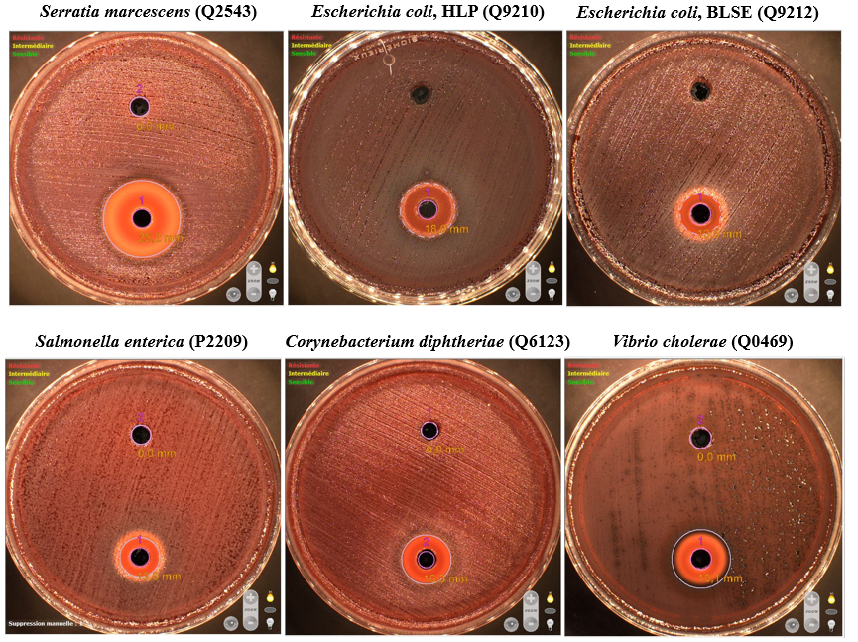

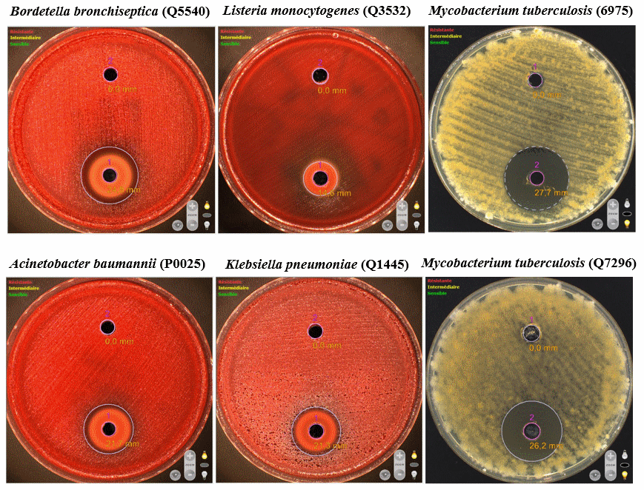

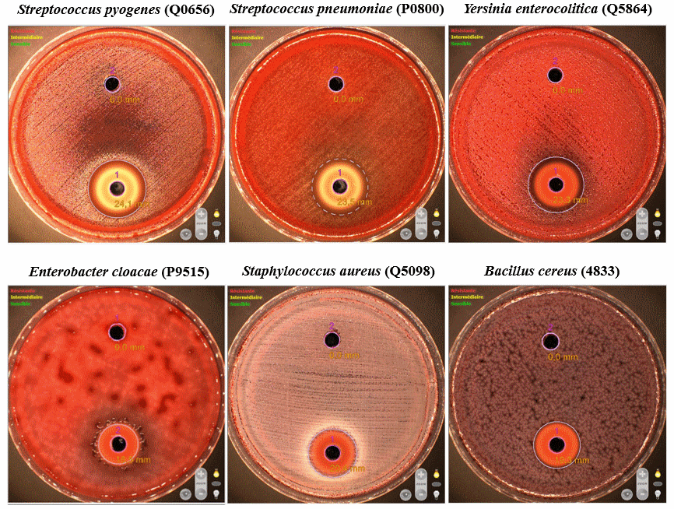

Supplementary figure 2: the main correlation spots ^{2,3}JHC HMBC (blue) observed.

Supplementary figure 3: high resolution mass spectrum in positive electrospray and negative electrospray mode of the SOT40 sample calibrated for the exact mass measurement. The target ion is detected at m/z 185.0424 in positive electrospray (3A) and m/z 161.045 negative electrospray mode (3B).
3A:
3B:

Supplementary table 1: exact mass measurements of the m/z 185.0 ion obtained after electrospray ionization in positive mode of the SOT40 sample.
 |  | m/z | error (mDa) | error (ppm)
Theoretical value |  | 185.0420 | - | -
 | 1 | 185.0424 | + 0.4 | + 2.2
Experimental values | 2 | 185.0424 | + 0.4 | + 2.2
 | 3 | 185.0424 | + 0.4 | + 2.2
These experimental measurements are associated with an ion of elemental composition C₆H₁₀O₅Na⁺ which has 2 unsaturations.

Supplementary table 2: exact mass measurements of the m/z 161.0 ion obtained after electrospray ionization in negative mode of the SOT40 sample.
 |  | m/z | error (mDa) | error (ppm)
Theoretical value |  | 161.0455 | - | -
 | 1 | 161.0457 | + 0.2 | + 1.2
Experimental values | 2 | 161.0462 | + 0.7 | + 4.3
 | 3 | 161.0460 | + 0.5 | + 3.1
These experimental measurements are associated with an ion of elemental composition C₆H₉O₅-which has 2 unsaturations.

