C-Score, a predictive signaure for Oxaliplatin and 5-fluorouracil based chemotherapy in locally advanced gastric cancer

Qinchuan Wang ^{1,2,3}, Xiyong Liu², Chen Chen³, Jida Chen¹, Beisi Xu⁴, Lini Chen¹, Jichun Zhou¹, Yasheng Huang^{2,5}, Wenjun Chen¹, Rongyue Teng¹, Wenhe Zhao¹, Lidan Jin¹, Jun Shen¹, Jianguo Shen¹, Yun Yen^{2,6}*, Linbo Wang¹*

Supplemental Tables

Table S1: Chemo-sensitivity of gastric cancer cell lines
Cell lines | GI50 | Sources | *Drug sensitivity
AGS | 5.04 | ATCC | 1
AZ521 | 5.1 | JCRB | 1
CLS145 | 4.04 | RIKEN | 0
Fu97 | 4.57 | JCRB | 0
HGC27 | 4.47 | RIKEN | 0
Hs746T | 4.86 | ATCC | 0
IM95 | 5.33 | JCRB | 1
Ist1 | 4.61 | JCRB | 0
KatoIII | 4.97 | ATCC | 1
MKN1 | 5.24 | JCRB | 1
MKN45 | 4.95 | JCRB | 1
MKN7 | 5.44 | JCRB | 1
NCI-N87 | 7.31 | ATCC | 1
NUGC3 | 4.43 | JCRB | 0
SCH | 6.45 | Ito | 1
SNU719 | 5.07 | ATCC | 1
TMK1 | 4.03 | JCRB | 0
YCC1 | 5.22 | Rha | 1
YCC10 | 5.87 | Rha | 1
YCC11 | 5.29 | Rha | 1
YCC16 | 4.66 | Rha | 0
YCC18 | 3.87 | Rha | 0
YCC19 | 3.42 | Rha | 0
YCC2 | 4.04 | Rha | 0
YCC3 | 5.6 | Rha | 1
YCC6 | 4.27 | Rha | 0
YCC7 | 4.64 | Rha | 0
YCC9 | 4.12 | Rha | 0
* 1 indicates GI50 of this cell line is higher than median value, 0 inidcates below median value.

Table S2: Distribution of Selected Host Characteristics and expression of biomarkers (SRRSH cohort)
Variables/Biomarkers |  | RRM1+(%) | RRM2+(%) | RRM2B+(%) | POLH+(%) | DUT+(%) | KI67+(%) | TS+(%) | TP+(%)
†All cases | 291 | 110(45.4) | 135(55.6) | 137(55.1) | 154(63.6) | 140(57.4) | 155(63.8) | 141(57.5) | 59(23.4)
Age
mean(SD) | 59.7(11.6)
Range | 29-80
<=60 | 133 | 45(39.5) | 64(55.7) | 60(52.6) | 61(53.5) | 58(50.0) | 64(55.7) | 64(55.7) | 32(26.5)
>60 | 158 | 65(50.8) | 73(56.2) | 75(58.1) | 93(72.7) | 82(64.1) | 91(71.1) | 77(59.2) | 37(28.2)
Sex
Male | 207 | 88(50.6) | 100(56.8) | 108(61.7) | 115(60.1) | 110(62.5) | 117(66.9) | 104(59.4) | 49(27.2)
Female | 84 | 22(32.4) | 37(53.6) | 27(39.7) | 39(57.4) | 30(44.1) | 38(55.9) | 37(52.9) | 20(27.8)
TNM Stage
II | 111 | 35(40.2) | 50(56.2) | 49(55.7) | 55(63.2) | 44(50.0) | 56(63.6) | 47(53.4) | 26(28.3)
III | 180 | 75(48.4) | 87(55.8) | 86(55.5) | 99(63.9) | 96(61.5) | 99(63.9) | 94(59.9) | 43(26.9)
Tumor Grade
low | 35 | 17(58.6) | 19(65.5) | 16(55.2) | 22(75.9) | 18(62.1) | 24(80.0) | 10(35.7) | 9(29.0)
medium | 71 | 28(46.7) | 35(56.5) | 34(56.7) | 39(65.0) | 35(57.4) | 33(55.0) | 41(67.2) | 19(30.2)
high | 185 | 65(42.5) | 83(53.9) | 85(55.2) | 93(60.8) | 87(56.5) | 98(64.1) | 90(57.7) | 41(26.0)
Histology
Papillary | 4 | 3(75.0) | 1(25.0) | 3(75.0) | 3(75.0) | 2(50.0) | 4(100.0) | 2(50.0) | 1(25.0)
Mucinous | 24 | 5(23.8) | 10(47.6) | 9(42.9) | 14(66.7) | 9(40.9) | 16(67.2) | 9(40.9) | 6(26.1)
Signet ring cell | 30 | 2(8.0) | 12(48.0) | 10(40.0) | 10(40.0) | 8(32.0) | 12(48.0) | 12(40.0) | 3(11.5)
Poor Differentiation | 231 | 100(52.6) | 112(58.0) | 111(58.1) | 125(65.8) | 120(62.8) | 122(63.9) | 116(60.4) | 58(29.4)
Tumor location
Proximal | 61 | 28(56.0) | 27(52.9) | 31(60.8) | 34(68.0) | 32(62.8) | 35(68.6) | 33(67.4) | 18(33.3)
Body | 63 | 22(43.1) | 28(54.9) | 25(49.0) | 35(68.6) | 33(64.7) | 33(64.7) | 26(49.1) | 11(21.6)
Distal | 156 | 57(43.5) | 77(57.9) | 71(54.2) | 78(59.5) | 71(53.8) | 83(63.7) | 75(56.4) | 37(27.0)
Linitis Plastica | 11 | 3(30.0) | 5(50) | 8(80.0) | 7(70.0) | 4(40.0) | 4(40.0) | 7(70.0) | 3(30.0)
aTumor Size
Yes | 108 | 31(37.4) | 47(53.3) | 47(56.0) | 55(66.3) | 43(51.2) | 53(63.1) | 40(47.6) | 20(22.5)
No | 174 | 76(50.00 | 87(56.9) | 83(54.6) | 94(61.8) | 94(61.4) | 99(65.1) | 95(61.7) | 46(29.5)
Chemotherapy (5-Fu and Platinum based)
Yes | 173 | 84(44.4) | 83(57.2) | 80(55.2) | 91(63.2) | 80(54.8) | 88(60.7) | 77(53.1) | 41(27.2)
No | 118 | 46(46.9) | 54(54.0) | 55(56.1) | 63(64.3) | 60(60.1) | 67(68.4) | 64(64.0) | 28(27.7)
†:Among all biomarkers, there are part of patients' expression information missing: 49 patients in RRM1,48 patients in RRM2, 46 patients in RRM2B, 49 patients in POLH, 47 patients in DUTPASE, 48 patients in KI-67, 46 patients in TYMS and 39 patients in TYMP.

Table S3 Distribution of Selected Host Characteristics and expression of biomarkers (TCGA cohort)
Variables/Biomarkers |  | RRM1+(%) | RRM2+(%) | RRM2B+(%) | POLH+(%) | DUT+(%) | KI67+(%) | TYMS+(%) | TYMP+(%)
†All cases | 279 | 136(49.0) | 140(50.0) | 126(45.0) | 150(54.0) | 146(52.0) | 135(48.0) | 136(49.0) | 155(56.0)
Age
mean(SD) | 65.8(10.6)
Range | 29-80
<=60 | 81 | 41(50.6) | 36(44.4) | 39(48.2) | 47(58.0) | 45(55.6) | 35(43.2) | 35(43.2) | 44(54.3)
>60 | 193 | 93(48.2) | 101(52.3) | 86(44.6) | 101(52.3) | 99(51.3) | 98(50.8) | 100(51.8) | 108(56.0)
Sex
Male | 179 | 88(49.2) | 71(50.8) | 80(44.7) | 92(51.4) | 92(51.4) | 84(46.9) | 88(49.2) | 96(53.6)
Female | 100 | 48(48.0) | 49(49.0) | 46(46.0) | 58(58.0) | 54(54.0) | 51(51.0) | 48(48.0) | 59(59.0)
TNM Stage
II | 117 | 57(48.7) | 60(51.3) | 47(40.2) | 60(51.3) | 65(55.6) | 58(49.6) | 56(47.9) | 70(59.8)
III | 162 | 79(48.8) | 80(49.4) | 79(48.8) | 90(55.6) | 81(50.0) | 77(47.5) | 80(49.4) | 85(52.5)
*Tumor Grade
low | 6 | 1(16.7) | 3(50.0) | 3(50) | 1(16.7) | 2(33.3) | 2(33.3) | 3(50.0) | 3(50.0)
medium | 81 | 41(50.6) | 44(54.3) | 26(32.1) | 34(42.0) | 38(46.9) | 46(56.8) | 39(48.2) | 42(51.9)
high | 188 | 92(48.9) | 93(49.5) | 96(51.1) | 113(60.1) | 104(55.3) | 85(45.2) | 93(49.5) | 108(57.5)
Chemotherapy (5-Fu and Platinum based)
Yes | 146 | 70(48.0) | 76(52.1) | 63(43.2) | 76(52.1) | 82(56.2) | 71(48.6) | 76(52.1) | 79(54.1)
No | 133 | 66(49.6) | 64(48.1) | 63(47.4) | 74(55.6) | 64(48.1) | 64(48.1) | 60(45.1) | 76(57.1)
†:In TCGA dataset, age information in 5 cases were missing. * 4 cases are undifferentiated, which were not included.

Table S4: Univariable and Multi-Variable COX proportional hazard analysis of Chemo-signatures in TCGA dataset
 |  | Univariable Model |  | Multi-Variable Model
Gene signatures | Treatment | HR (95%CI) | *P | †HR (95%CI) | *P
RRM1
low | Surgery alone | Reference |  | Reference
 | Surgery +AC | 0.41(0.3-0.73) | 0.002 | 0.40(0.27-0.73) | 0.002
high | Surgery alone | Reference |  | Reference
 | Surgery +AC | 0.47(0.24-0.90) | 0.02 | 0.49(0.24-0.94) | 0.03
RRM2B
low | Surgery alone | Reference |  | Reference
 | Surgery +AC | 0.38(0.20-0.69) | 0.001 | 0.45(0.23-0.81) | 0.007
high | Surgery alone | Reference |  | Reference
 | Surgery +AC | 0.50(0.26-0.95) | 0.03 | 0.51(0.27-0.99) | 0.045
RRM2
low | Surgery alone | Reference |  | Reference
 | Surgery +AC | 0.42(0.23-0.76) | 0.004 | 0.44(0.24-0.79) | 0.006
high | Surgery alone | Reference |  | Reference
 | Surgery +AC | 0.42(0.21-0.79) | 0.007 | 0.48(0.24-0.93) | 0.03
POLH
low | Surgery alone | Reference |  | Reference
 | Surgery +AC | 0.48(0.25-0.91) | 0.025 | 0.51(0.26-0.97) | 0.04
high | Surgery alone | Reference |  | Reference
 | Surgery +AC | 0.40(0.22-0.71) | 0.002 | 0.43(0.24-0.78) | 0.005
dUTPase
low | Surgery alone | Reference |  | Reference
 | Surgery +AC | 0.32(0.17-0.58) | 2.00E-04 | 0.34(0.17-0.62) | 4.00E-04
high | Surgery alone | Reference |  | Reference
 | Surgery +AC | 0.55(0.29-1.01) | 0.05 | 0.63(0.33-1.16) | 0.14
Ki67
low | Surgery alone | Reference |  | Reference
 | Surgery +AC | 0.40(0.21-0.72) | 0.002 | 0.42(0.22-0.76) | 0.004
high | Surgery alone | Reference |  | Reference
 | Surgery +AC | 0.48(0.25-0.89) | 0.02 | 0.52(0.27-0.98) | 0.04
TS
low | Surgery alone | Reference |  | Reference
 | Surgery +AC | 0.36(0.19-0.66) | 7.00E-04 | 0.39(0.21-0.71) | 0.002
high | Surgery alone | Reference |  | Reference
 | Surgery +AC | 0.52(0.27-0.97) | 0.04 | 0.56(0.29-1.04) | 0.07
TP
low | Surgery alone | Reference |  | Reference
 | Surgery +AC | 0.35(0.16-0.69) | 0.002 | 0.47(0.22-0.96) | 0.04
high | Surgery alone | Reference |  | Reference
 | Surgery +AC | 0.49(0.28-0.86) | 0.01 | 0.50(0.28-0.88) | 0.015
Chemo-signature
low | Surgery alone | Reference |  | Reference
 | Surgery +AC | 0.35(0.07-1.25) | 0.11 | 0.38(0.08-1.43) | 0.15
medium | Surgery alone | Reference |  | Reference
 | Surgery +AC | 0.47(0.25-0.84) | 0.01 | 0.48(0.26-0.86) | 0.01
high | Surgery alone | Reference |  | Reference
 | Surgery +AC | 0.36(0.15-0.75) | 0.006 | 0.43(0.19-0.93) | 0.03
* Indicate p value <0.05, AC: Adjuvant Chemotherapy †: Adjusted by age and sex.

Supplemental Figures

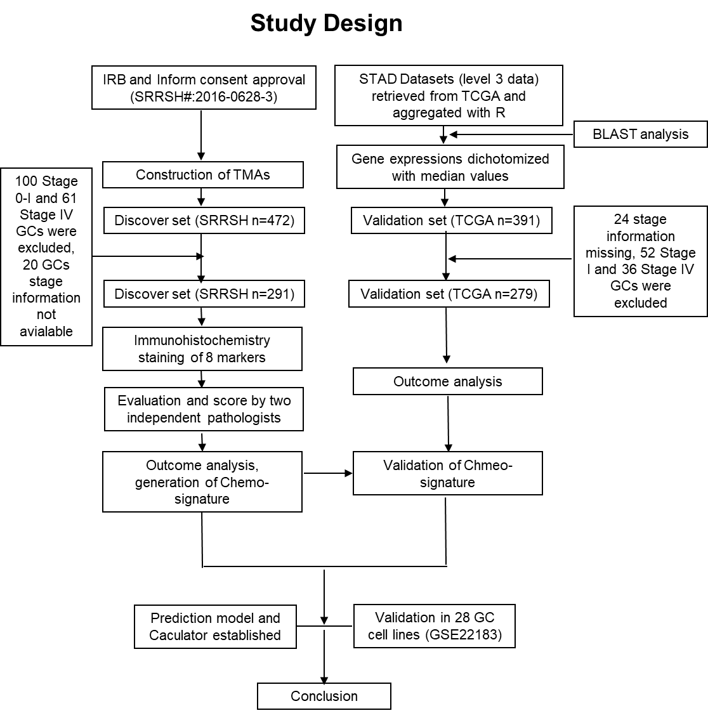

Figure S1: the schematic design of this study.

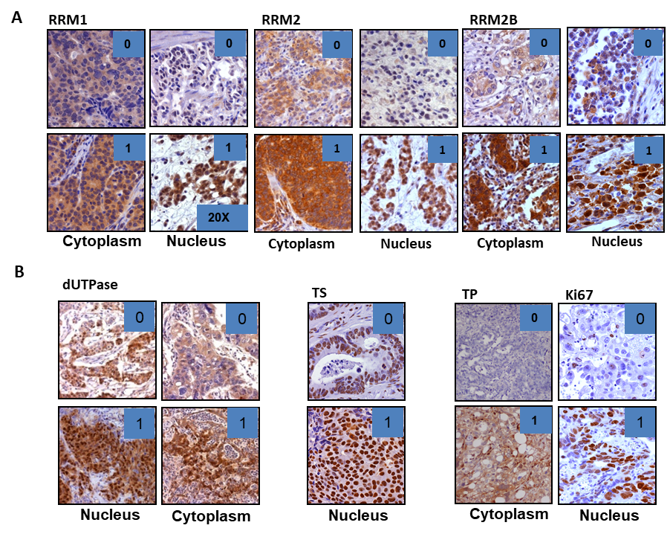

Figure S2: the scoring criteria of biomarkers in IHC.

