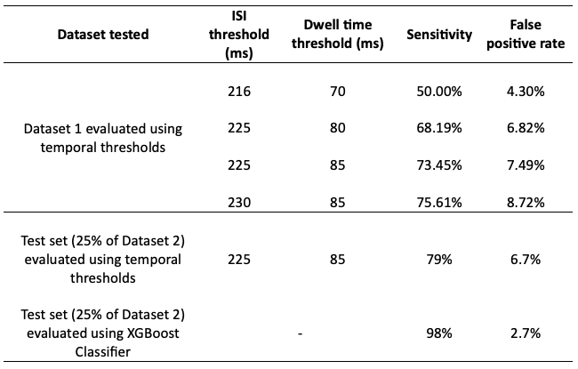
Table 1: Sensitivity and false positive rates of different temporal threshold combinations and XGBoost

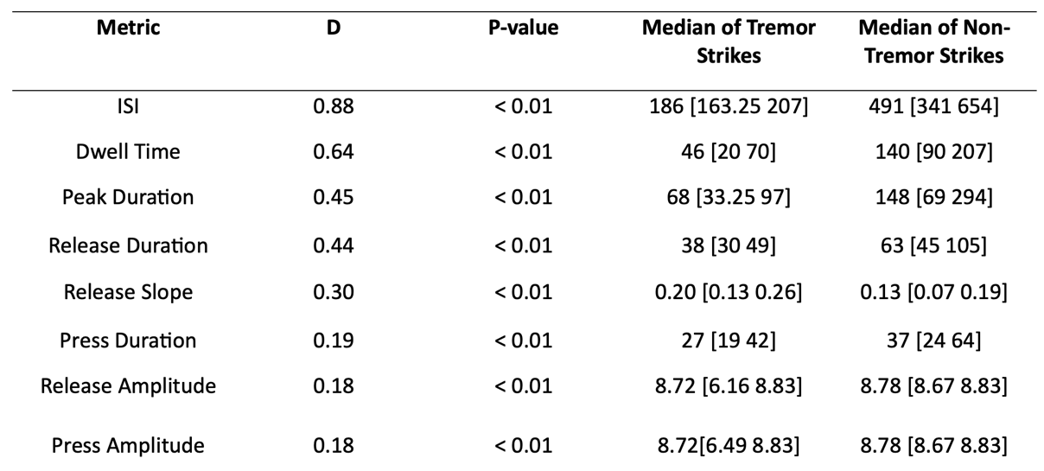
Table 2: Digital differences between tremor and voluntary strikes

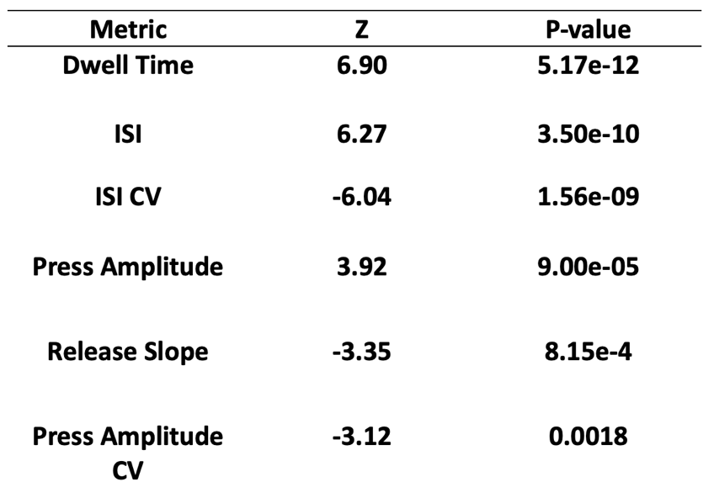
Table 3: Change in QDG Metrics of bradykinesia, rigidity and arrhythmicity after exclusion of tremor strikes in trials performed by TD individuals (85 trials)

