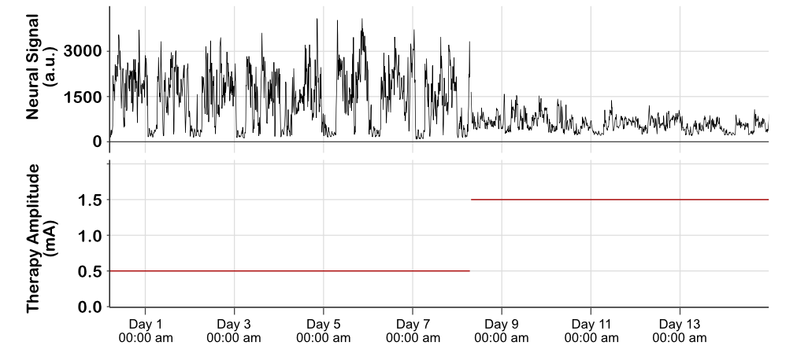 Supplementary Figure 1. Stimulation settings can alter circadian rhythm. In this patient, beta power was initially recorded with stimulation at 0.5mA. A large reduction in power can be observed at night. This large circadian beta rhythm, decreasing at night, was strongly diminished when stimulation amplitude was increased from 0.5mA to 1.5mA without changing any other stimulation or sensing parameters (sensing frequency, stimulation contact, or other stimulation parameters),

