Freiburg Mindfulness Inventory (FMI) Short Form and Revised Form (FMI-13R) — Norm Scores and Psychometrics in a Representative German Sample

Supplement Material
Part 1 Supplementary Figures and Tables

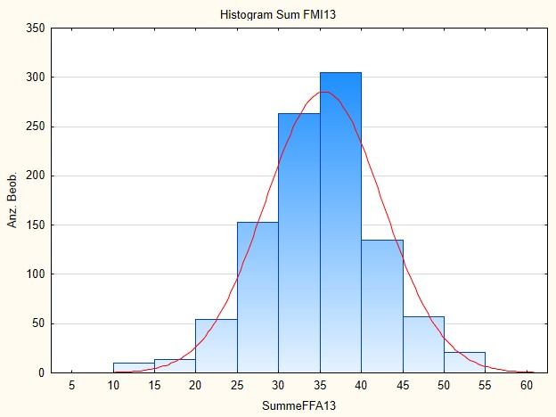
Figure S1 – Histogram of the Sum of FMI-13R
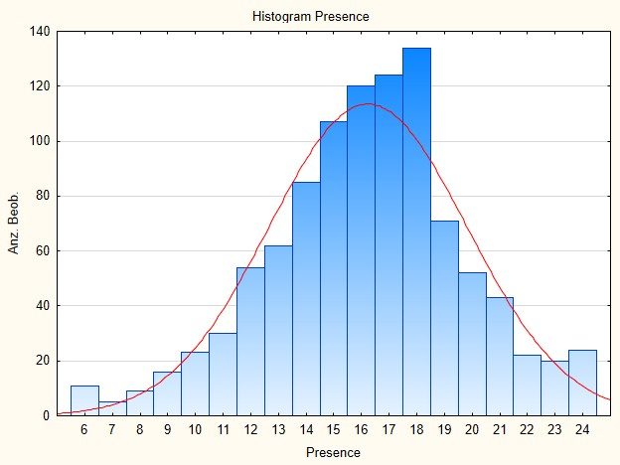
Figure S2 – Histogram of Subscale Presence of FMI_13R

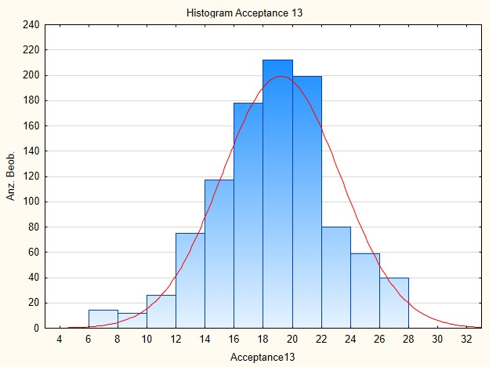
Figure S3 – Histogram of Subscale Acceptance of FMI-13R

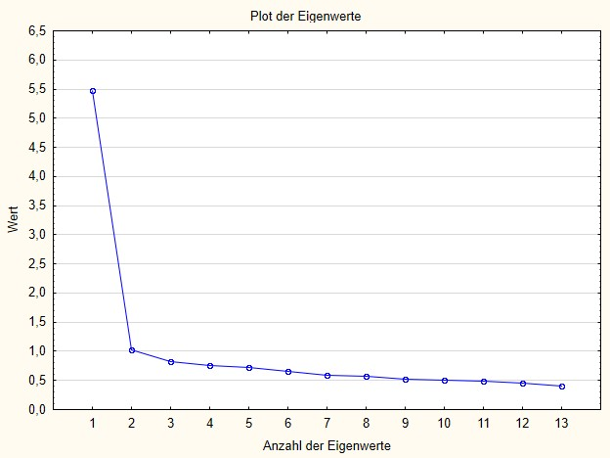
Figure S4 – Screeplot of the exploratory factor analysis

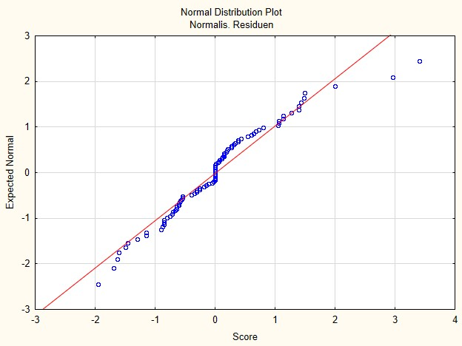
Figure S5 – Normal probability Plot of the residuals of the confirmatory factor analysis model

Table S1 – Single indications of „regular practice“

Indication | n | Prozent
none | 1 | 0.1
contemplating | 1 | 0.1
meditation | 1 | 0.1%
Cranio Sacral | 1 | 0.1
Archery | 1 | 0.1%
Biking or hiking in nature | 1 | 0.1%
Guided meditation | 1 | 0.1%
Body Scan | 1 | 0.1%
Stress breathing techniques | 1 | 0.1%
Nothing | 1 | 0.1%
Concentration exercises | 1 | 0.1%
Dancing | 1 | 0.1%
Autogenic Training, Relaxation | 1 | 0.1%
Boxing | 2 | 0.2%
Quiet thinking about various topics | 3 | 0.3%
Own relaxation exercises | 1 | 0.1%
fitness training | 1 | 0.1%
Relaxation techniques | 1 | 0.1%
Progressive muscle relaxation according to Jacobson | 1 | 0.1%
Relaxation | 1 | 0.1%
Nothing | 1 | 0.1%
Quiet music | 1 | 0.1%
Consuming 5-MeO-Mipt | 1 | 0.1%
Relaxation according to Jacobson | 1 | 0.1%
Autogenic Training | 1 | 0.1%
Pilates | 1 | 0.1%
Autogenicttraining | 1 | 0.1%
5 prayers per day | 1 | 0.1%
Conversation in texts | 1 | 0.1%

Table S2 – Results of the exploratory factor analysis on a randomly split data set of n = 481 data; * Items loading primarily on the respective scale; ** marker items
Item | Acceptance | Presence
1. I am open to the experience of the present moment. | 0.26 | *0.60
2. I sense my body, whether eating, cooking, cleaning, or talking. | 0.12 | **0.77
3. When I notice an absence of mind, I gently return to the experience of the here and now. | 0.15 | *0.72
4. I am able to appreciate myself. | *0.71 | 0.11
5. I pay attention to what’s behind my actions. | *0.56 | 0.39
6. I see my mistakes and difficulties, without judging them. | *0.69 | 0.24
7. I feel connected to my experience in the here and now. | 0.49 | *0.54
8. I accept unpleasant experiences. | 0.29 | *0.50
9. I am friendly to myself, when things go wrong. | **0.76 | 0.11
10. I watch my feelings without getting lost in them. | *0.56 | 0.34
11. In difficult situations, I can pause without immediately reacting. | *0.66 | 0.24
12. I experience moments of inner peace and ease, even when things get hectic and stressful. | *0.64 | 0.31
14. I am able to smile when I notice how I sometimes make life difficult. | *0.54 | 0.30

Table S3 - Lasso Regression: Number of iterations (24), Lambda parameters, variables and their weight after each iteration step
  Lambda
  FG
  constant
  Age
  Education
  Size of household
  employed
  income
  course
  Daily practice
  Mindf. Reg.
 | 1.3 | 0 | 35.32
  1
 | 1.18 | 2 | 34.97 |  | 0.09
  2
 | 1.08 | 2 | 34.65 |  | 0.17
  3
 | 0.98 | 2 | 34.36 |  | 0.24
  4
 | 0.9 | 2 | 34.1 |  | 0.3
  5
 | 0.82 | 3 | 33.77 | 0.00 | 0.36
  6
 | 0.74 | 4 | 33.27 | 0.01 | 0.41
  7
 | 0.68 | 6 | 32.78 | 0.01 | 0.45
  8
 | 0.62 | 8 | 32.33 | 0.02 | 0.48 |  |  | 0.01 |  |  | 0.03
  9
 | 0.56 | 8 | 31.9 | 0.02 | 0.5 |  |  | 0.03 |  |  | 0.12
  10
 | 0.51 | 9 | 31.51 | 0.03 | 0.52 |  |  | 0.05 |  |  | 0.2
  11
 | 0.47 | 9 | 31.17 | 0.03 | 0.53 |  |  | 0.06 |  |  | 0.27
  12
 | 0.43 | 11 | 30.85 | 0.03 | 0.55 |  |  | 0.08 |  |  | 0.34
  13
 | 0.39 | 12 | 30.54 | 0.03 | 0.56 |  |  | 0.1 |  |  | 0.41
  14
 | 0.35 | 12 | 30.26 | 0.04 | 0.57 |  |  | 0.11 |  |  | 0.46
  15
 | 0.32 | 12 | 30.00 | 0.04 | 0.58 |  |  | 0.12 |  |  | 0.52
  16
 | 0.29 | 12 | 29.77 | 0.041 | 0.58 |  |  | 0.13 |  |  | 0.56
  17
 | 0.27 | 14 | 29.56 | 0.04 | 0.60 |  |  | 0.14 |  |  | 0.61
  18
 | 0.24 | 15 | 29.37 | 0.05 | 0.6 |  |  | 0.15 |  |  | 0.64
  19
 | 0.22 | 16 | 29.21 | 0.05 | 0.61 |  |  | 0.15 |  | -0.00 | 0.68
  20
 | 0.2 | 17 | 29.1 | 0.05 | 0.62 |  |  | 0.16 |  | -0.05 | 0.76
  21
 | 0.18 | 18 | 29.02 | 0.05 | 0.62 |  |  | 0.16 | -0.06 | -0.09 | 0.85
  22
 | 0.17 | 19 | 28.92 | 0.05 | 0.63 |  |  | 0.17 | -0.16 | -0.13 | 0.93
  23
 | 0.15 | 21 | 28.83 | 0.05 | 0.64 |  |  | 0.18 | -0.24 | -0.17 | 1
  24
Continued to the right on the next page

 | SummeFFA13 - Koeffizientenmatrix (Achtsamkeit_Daten_FFAEichung_rekodiert) Lineare Regression
  Vip_regl
  Zen_reg.
  TM_regl
  Contemp regl
  Yoga_regl
  TaiChi_regl
  ChiGong_regl
  Tantra_regl
  Other_regl
  Years of practice
  Retreats
1

 |  |  |  |  | 0.21
  2
 |  |  |  |  | 0.44
  3
 |  |  |  |  | 0.65
  4
 |  |  |  |  | 0.84
  5
 |  |  |  |  | 1.02
  6
 |  |  |  |  | 1.21
  7
 |  |  |  |  | 1.35 |  | 0.24 |  |  | 0
  8
 |  |  |  |  | 1.47 |  | 0.46 |  |  | 0.01
  9
 |  |  |  |  | 1.57 |  | 0.66 |  |  | 0.01
  10
 |  |  |  |  | 1.66 |  | 0.84 |  |  | 0.01
  11
 |  |  |  |  | 1.74 |  | 0.1 |  |  | 0.01
  12
 |  |  |  |  | 1.81 | 0.1 | 1.13 | 0.06 |  | 0.02
  13
 |  |  |  |  | 1.88 | 0.26 | 1.24 | 0.36 |  | 0.02
  14
 |  |  |  |  | 1.94 | 0.41 | 1.34 | 0.64 |  | 0.02
  15
 |  |  |  |  | 1.99 | 0.55 | 1.43 | 0.89 |  | 0.02
  16
 |  |  |  |  | 2.04 | 0.67 | 1.52 | 1.12 |  | 0.03
  17
 |  |  |  | 0.03 | 2.09 | 0.78 | 1.59 | 1.330418 |  | 0.03
  18
 |  | -0.06 |  | 0.12 | 2.14 | 0.89 | 1.64 | 1.54 |  | 0.03
  19
 |  | -0.19 |  | 0.2 | 2.19 | 0.99 | 1.69 | 1.73 |  | 0.03
  20
 |  | -0.33 |  | 0.29 | 2.28 | 1.11 | 1.75 | 1.90 |  | 0.03 | 0.01
  21
 |  | -0.44 |  | 0.38 | 2.38 | 1.23 | 1.81 | 2.05 |  | 0.03 | 0.03
  22
 |  | -0.53 |  | 0.46 | 2.48 | 1.35 | 1.88 | 2.18 |  | 0.04 | 0.05
  23
 |  | -0.62 |  | 0.54 | 2.57 | 1.47 | 1.94 | 2.31 |  | 0.04 | 0.07
  24
Continued to the right on the next page
 | SummeFFA13 - Koeffizientenmatrix (Achtsamkeit_Daten_FFAEichung_rekodiert) Lineare Regression
  Theory
  male
  female
  diverse
  catholic
  protestant
  Other Christian
1

2

3

4

5

6

 | 0.05
  7
 | 0.17
  8
 | 0.25
  9
 | 0.32
  10
 | 0.38
  11
 | 0.44
  12
 | 0.48
  13
 | 0.52 |  |  |  |  | 0.06
  14
 | 0.55 |  |  |  |  | 0.13
  15
 | 0.58 |  |  |  |  | 0.2
  16
 | 0.61 |  |  |  |  | 0.26
  17
 | 0.64 |  |  |  |  | 0.3
  18
 | 0.66 |  |  |  |  | 0.33
  19
 | 0.68 |  |  |  |  | 0.35
  20
 | 0.7 |  |  |  |  | 0.38
  21
 | 0.73 |  |  |  |  | 0.39
  22
 | 0.77 |  |  |  |  | 0.42
  23
 | 0.81 | -0.04 | 0 |  |  | 0.45
  24
Continued to the right on the next page

 | SummeFFA13 - Koeffizientenmatrix (Achtsamkeit_Daten_FFAEichung_rekodiert) Lineare Regression
  Islam
  Buddhism
  Judais
  Hinduismus
  Other religion
  No religion
1

2

3

4

5

6

7

8

9

10

 |  |  | -0.38
  11
 |  |  | -0.97
  12
 |  |  | -1.52
  13
 |  |  | -2.01
  14
 |  |  | -2.46
  15
 |  |  | -2.87
  16
 |  |  | -3.24
  17
 |  |  | -3.58 |  |  | -0.01
  18
 |  |  | -3.89 |  |  | -0.05
  19
 |  |  | -4.15 |  |  | -0.08
  20
 |  |  | -4.38 |  |  | -0.11
  21
 |  |  | -4.59 |  |  | -0.14
  22
 | 0.09 |  | -4.76 |  |  | -0.16
  23
 | 0.21 |  | -4.88 |  |  | -0.17
  24

Table S3 – Linear Regression on FFA13 sum score of all variables that a LASSO regression (Table S2) had identified as potential predictors. R²_{adj} = 0.11, F (18.993) = 8.4; p < .001
 | Beta (std.error beta) | t-score | p
Age | 0.14 (0.03) | 4.2 | p<.001
Education | 0.12 (0.03) | 3.4 | p<.001
Lutheran religion | 0.04 (0.03) | 1.3 | .20
Islam | 0.05 (0.03) | 1.4 | .16
Judaism | -0.06 (0.03) | -2.1 | .03
No religion | -0.02 (0.04) | -0.6 | .55
Income | 0.05 (0.03) | 1.6 | .11
Course participation | -0.06 (0.04) | -1.7 | .087
Daily practice | -0.11 (0.04) | -2.8 | .005
Mindfulness regularly | 0.10 (0.03) | 3.0 | .002
Zen regularly | -0.04 (0.03) | -1.4 | .16
Contemplation regularly | 0.04 (0.03) | 1.4 | .16
Yoga regularly | 0.21 (0.03) | 5.8 | 0
TaiChi regularly | 0.08 (0.03) | 2.5 | .012
ChiGong regularly | 0.07 (0.03) | 2.2 | .024
Tantra regularly | 0.06 (0.03) | 1.9 | .05
Years of practice | 0.06 (0.03) | 1.8 | .06
Theory | 0.09 (0.03) | 2.4 | .01

