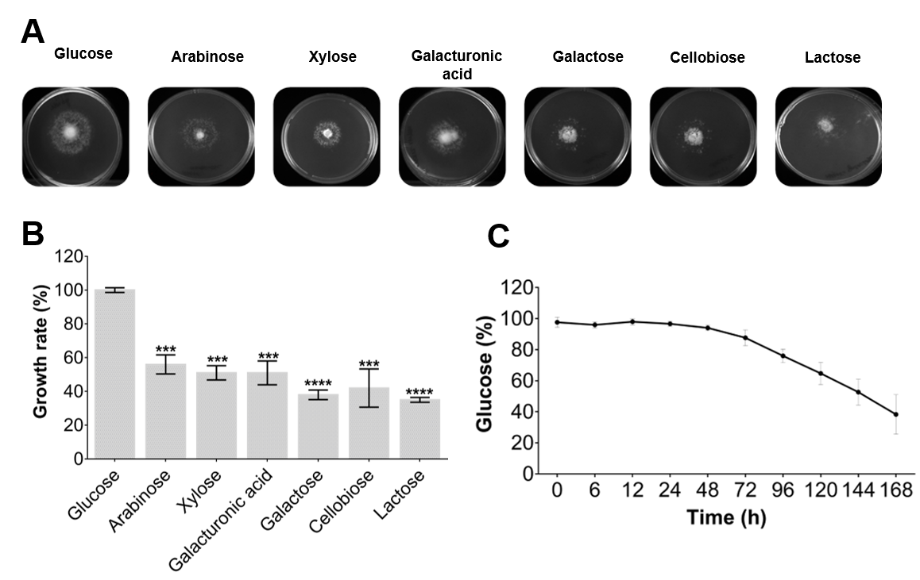

Figure S1. Analysis of L. sulphureus ATCC 52600 growth on different carbohydrates. (A) Growth for 7 days on agar plates supplemented with different carbohydrates. (B) Growth rate estimated by colony diameter measurement. Values expressed relative to glucose. (C) Relative glucose consumption measured using HPLC during growth in liquid medium. Growth rates were analyzed using two‑way ANOVA with Tukey’s test and is indicated as follows: *p<0.05, **p<0.01, ***p<0.001.

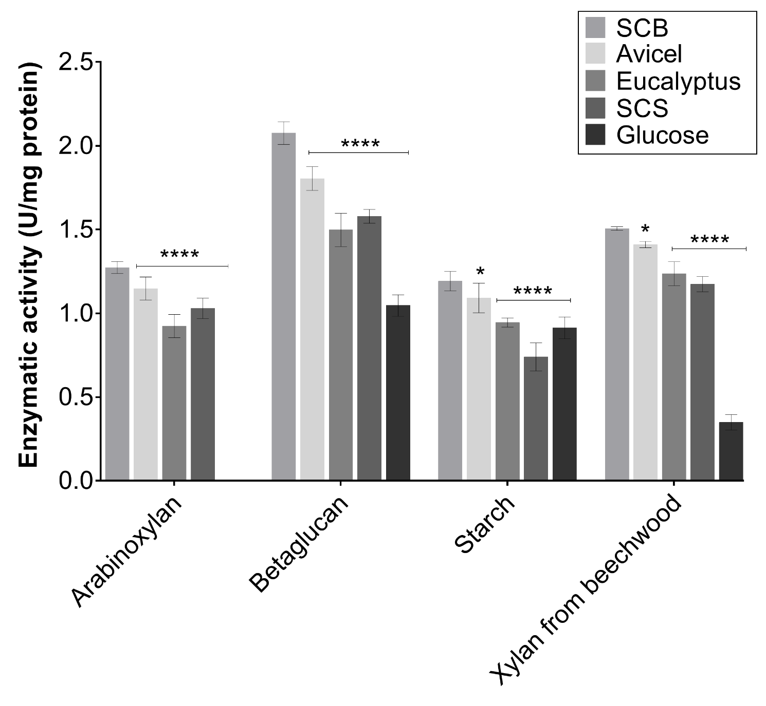
Figure S2. Enzymatic activity profile of L. sulphureus ATCC 52600 secretomes. Enzymatic assays containing the different secretomes (Avicel; SCB: sugarcane bagasse; Eucalyptus: Eucalyptus grandis residue, SCS: sugarcane straw and glucose) were carried out in 50 mM sodium acetate buffer pH 5.5 for 240 min at 50 °C. Activities were analyzed assuming the secretome produced on SCB as control by two‑way ANOVA with Tukey’s test (95% confidence interval) and is indicated as follows: *p<0.05, **p<0.01, ***p<0.001. Reducing sugars were measured using the DNS method.

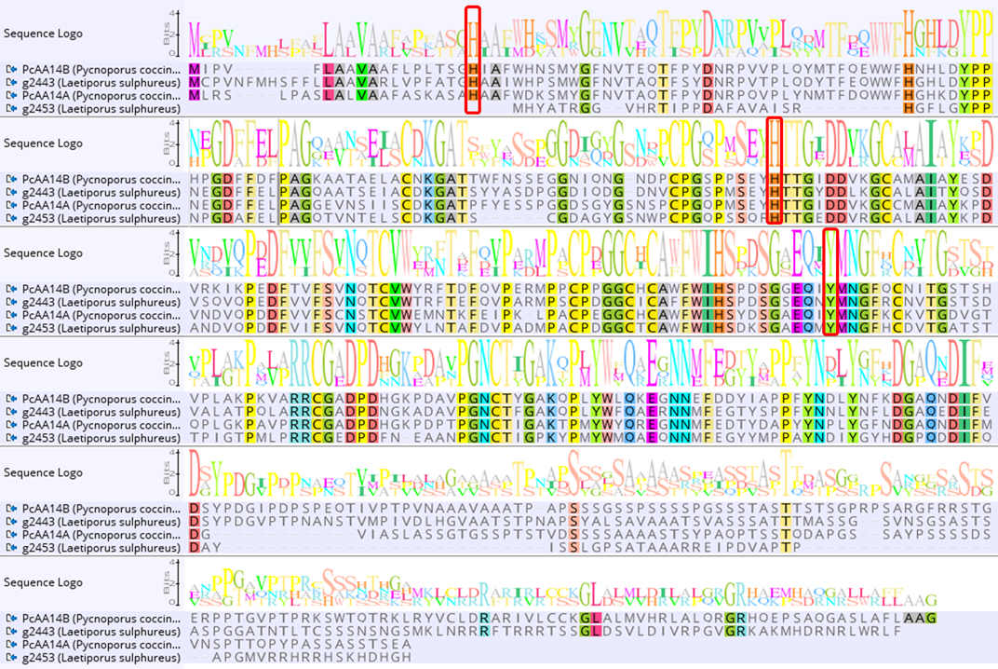
Figure S3. Multiple AA14 sequences alignment. Alignment was generated by Clustal using two characterized lytic polysaccharide monooxygenases (LPMOs) from Pycnoporus coccineus CIRM-BRFM 310 (PcAA14A and PcAA14B) and two putative AA14 found in the L. sulphureus ATCC 52600 genome. The red boxes highlight the conserved amino acid residues in the histidine brace.

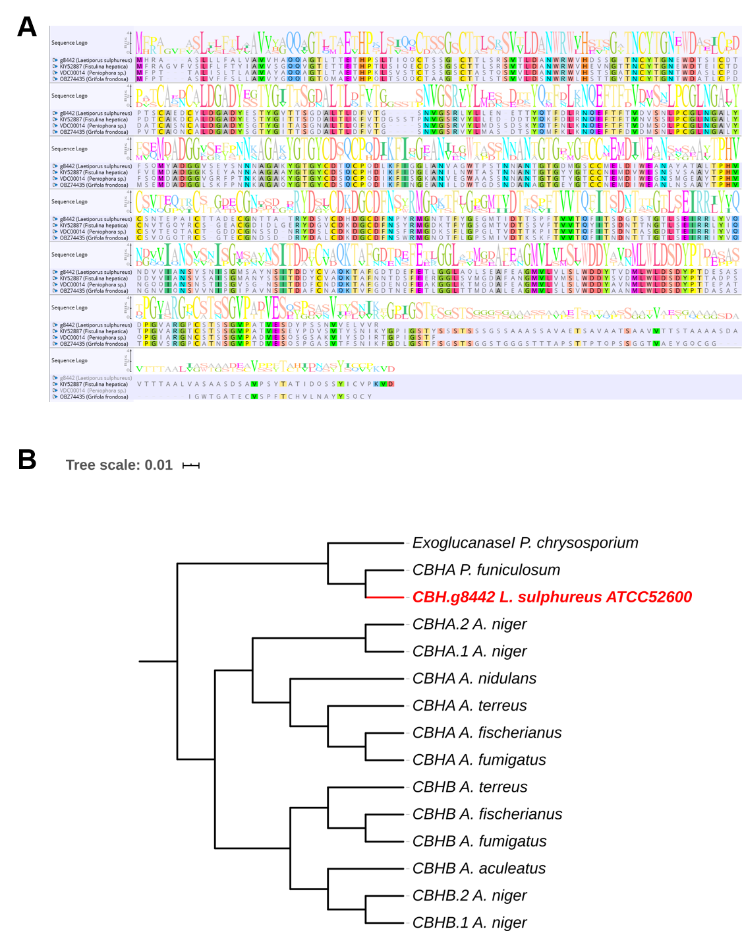
Figure S4. Multiple alignment of GH7 amino acid sequences. (A) Alignment was performed by Clustal using basidiomycete cellobiohydrolases with identity higher than 65% (GenBank: KIY52887, VDC00014, and OBZ74435). (B) Phylogenetic tree of GH7 amino acid sequences, which includes 14 characterized cellobiohydrolases according to UniProt, which are from Aspergillus aculeatus, Aspergillus niger, Aspergillus terreus, Aspergillus fischerianus, Aspergillus fumigatus, Aspergillus nidulans, Penicillium funiculosum, and Phanerochaete chrysosporium.

