Appendix

Game Rules
Adapted from Halfbrick Studio’s Prototype ‘Tank Turn Tactics'
Survive to the end and win the cash.
1st $50 | 2nd $25 | First Blood: $5
RULES
- All players start at a random location on the grid, and have 3 hearts and 1 Action Points.
- Every 24 hours on a work day, everyone will receive 1 Action Point (AP). The time the point is given may vary day to day. When Quick Rules are applied, everyone will receive 1 AP every hour.
- At any time you like, you can do one of the four following actions:

- Move to an adjacent, unoccupied square (1 AP)
- Shoot someone who is within your range (1 AP). Shooting someone removes 1 heart from their health.
- Add a heart (3 AP)
- Upgrade your range (3 AP)

- At the start of the game, everyone has a range of 2. That is, they can shoot or trade with somehow within 2 squares of them. Upgrading your shooting range increases this by 1 square each time.
- If a player is reduced to 0 hearts, then they are dead. Any action points the dead player had are transferred to the player who killed them. Dead players remain on the board and not removed.
- Players are able to send gifts of hearts or actions points to any player currently within their range.
- Dead players can have a heart sent to them. This will revive that player who will have 1 heart and 0 AP.

ADDITIONAL NOTES
- Dead players form a jury. Each day they vote, and whoever received most votes will be 'haunted', and not revive any AP for that day.
- Once a day, at a random time, a heart will spawn on the field. The first player to move into the square containing the heart will revive an additional heart.
- The game ends when a clear 1st and 2nd place can be determined.
- Action points are secret! Probably a good idea to try and hide how many you have.
- You can't win this game without making some friends and stabbing some backs. Probably.

SOEP-Trust
In general, you can trust people.
- disagree strongly
- disagree somewhat
- agree somewhat
- agree strongly
Nowadays, you can’t rely on anybody.
- disagree strongly
- disagree somewhat
- agree somewhat
- agree strongly
How much do you trust strangers you meet for the first time?
- no trust at all
- little trust
- quite a bit of trust
- a lot of trust
When dealing with strangers, it’s better to be cautious before trusting them.
- disagree strongly
- disagree somewhat
- agree somewhat
- agree strongly

Degree Distributions and Main Networks
Season 1, degree distribution
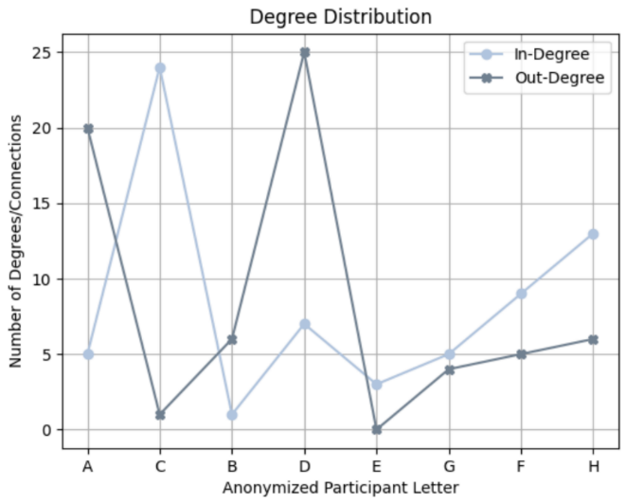
Season 1, main network
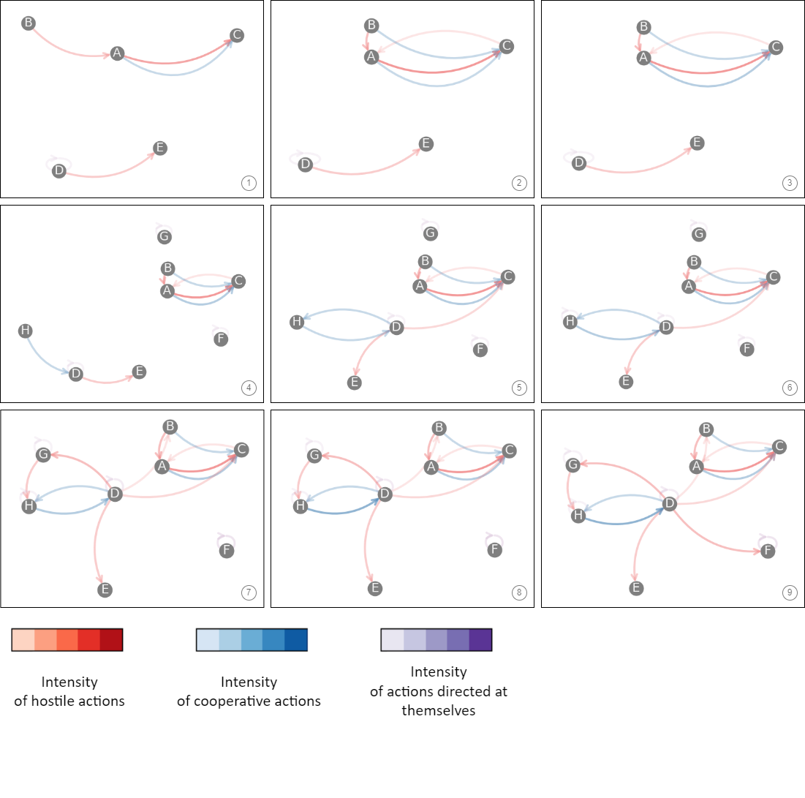
Season 2, degree distribution
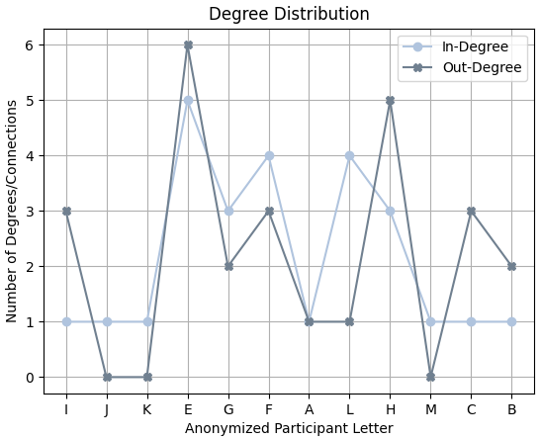
Season 2, main network

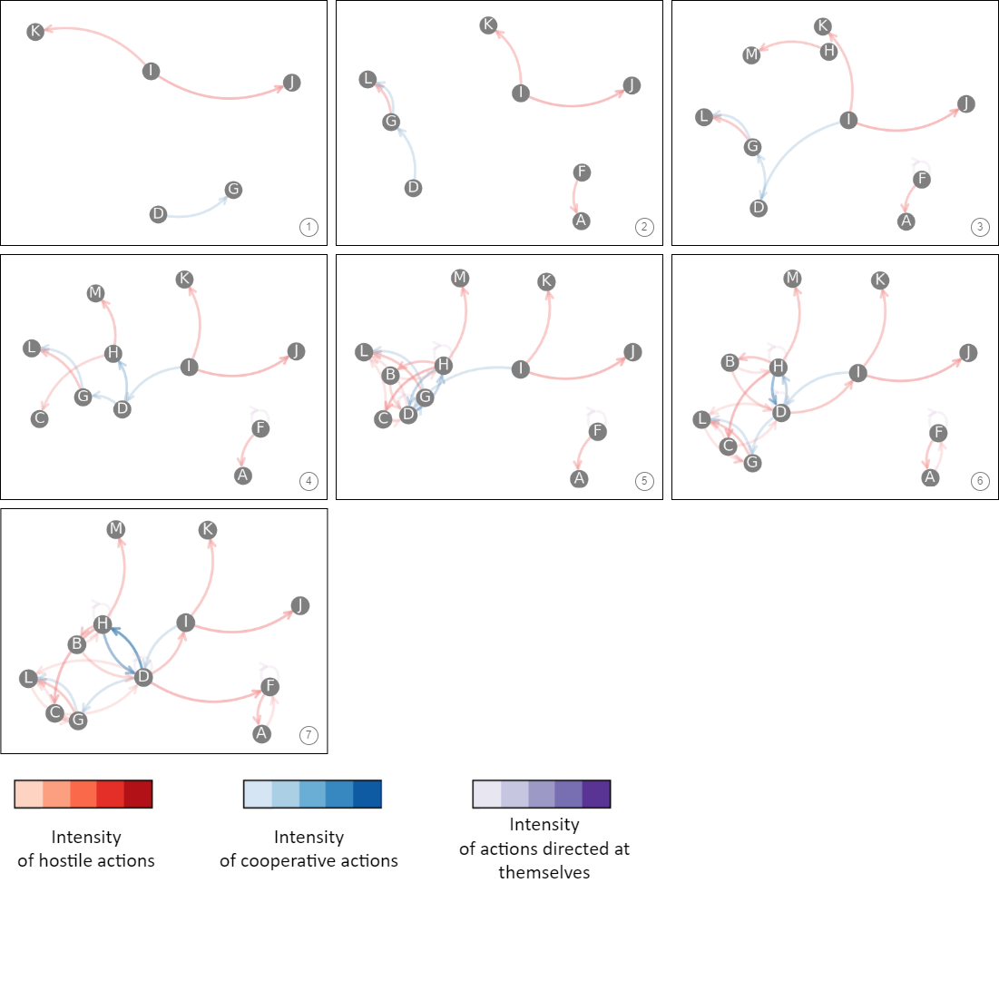

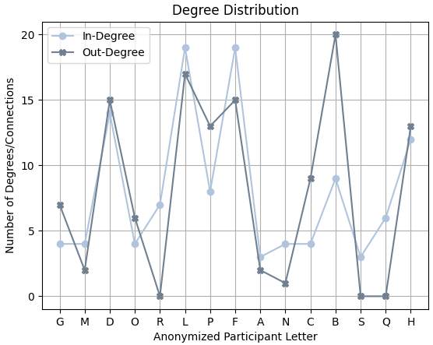
Fig. 27 Season 3, degree distribution

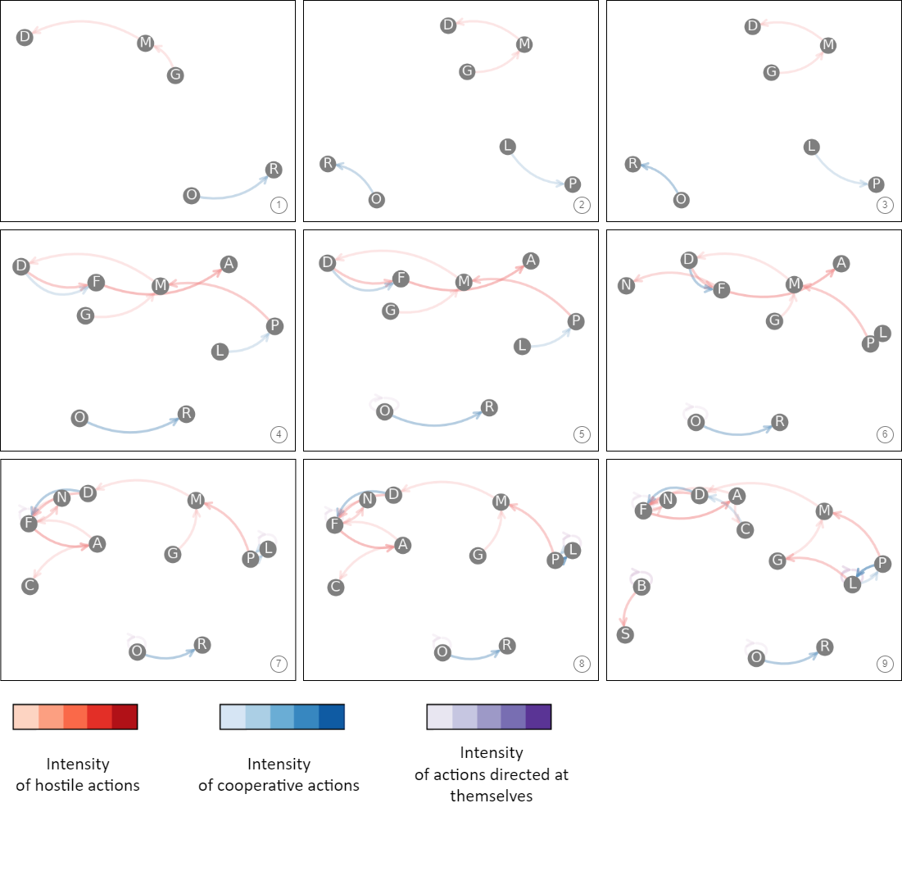
Fig. 28 Season 3, main network 1

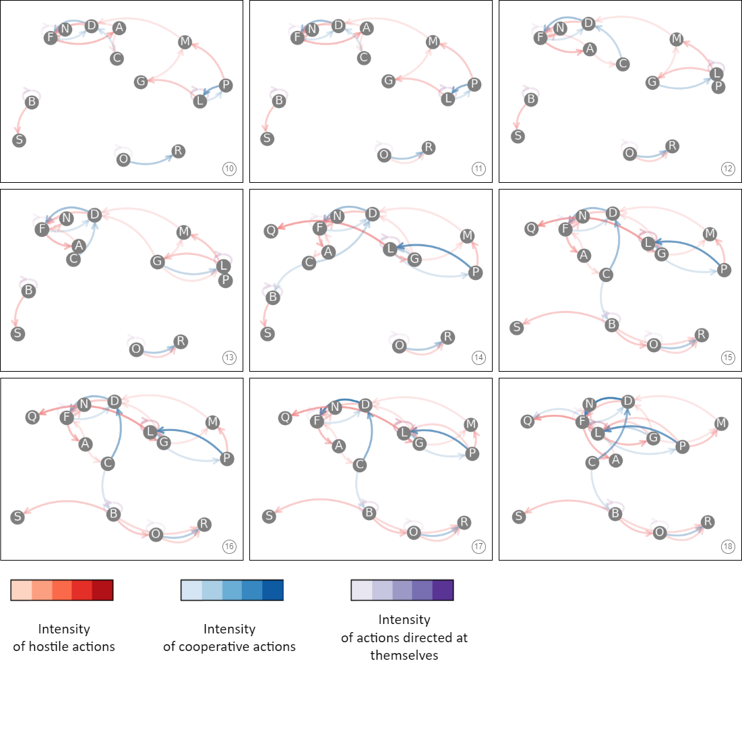
Fig. 29 Season 3, main network 2
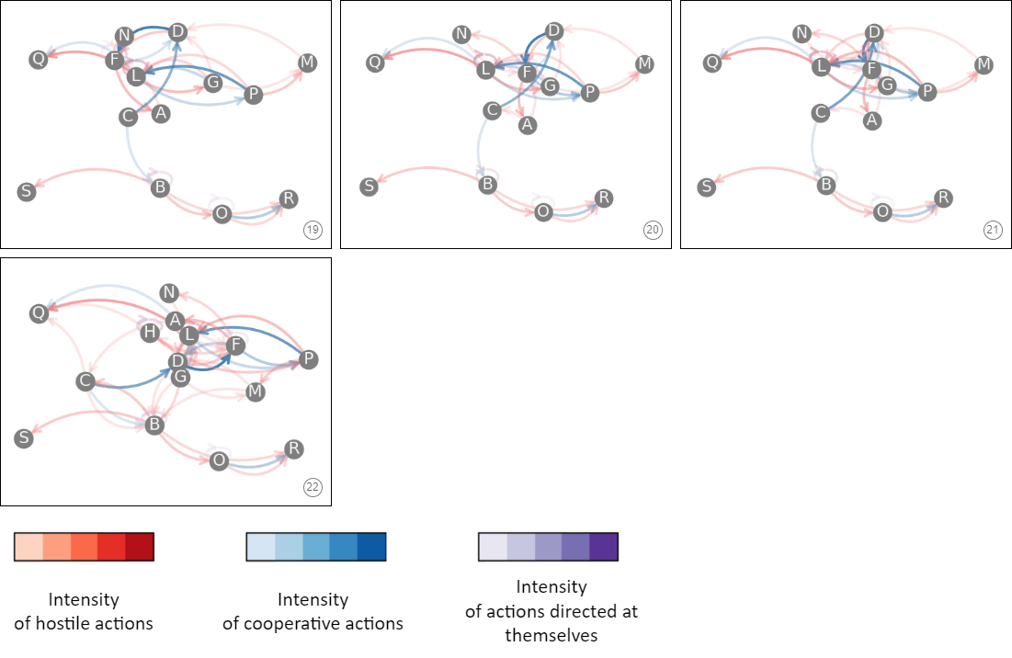
Fig. 30 Season 3, main network 3

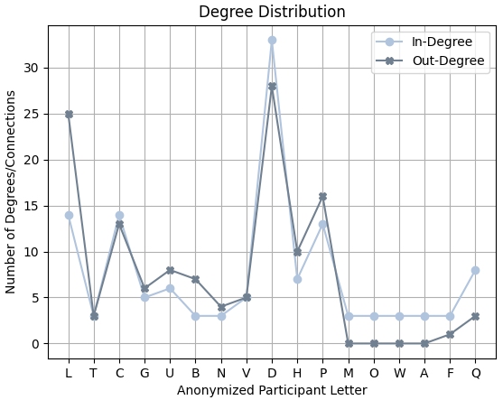
Fig. 31 Season 4, degree distribution

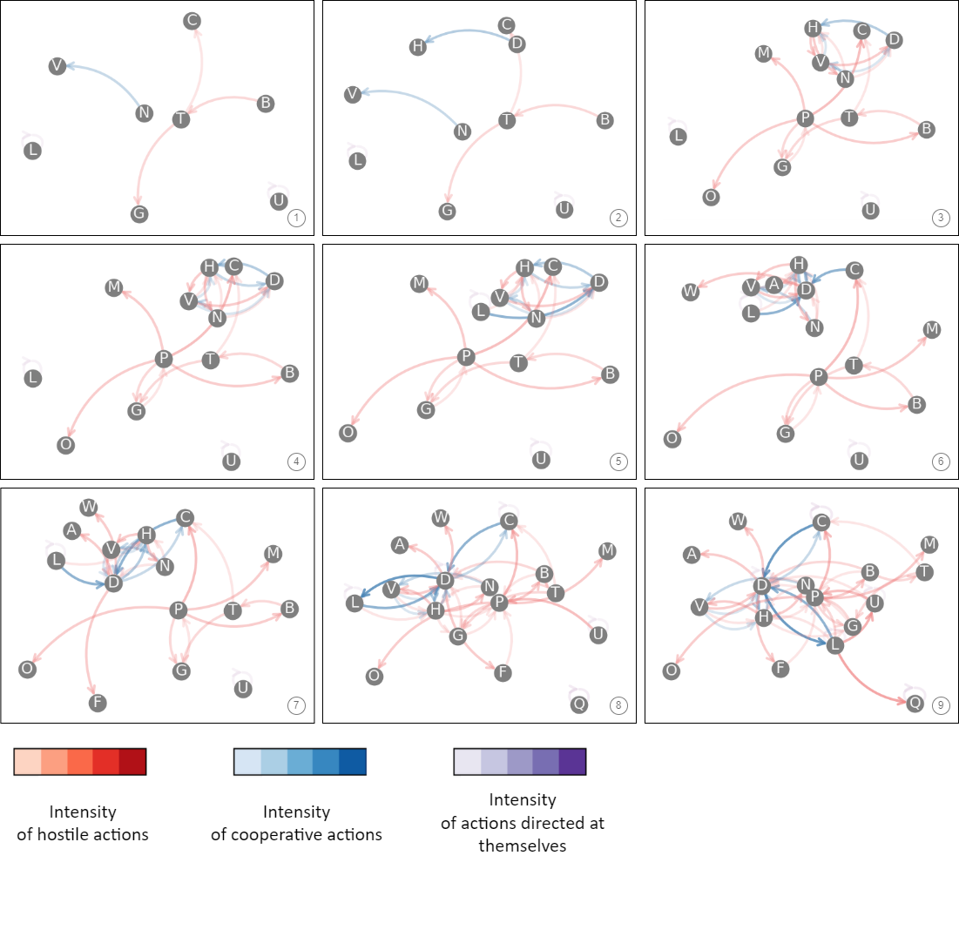
Fig. 32 Season 4, main network 1

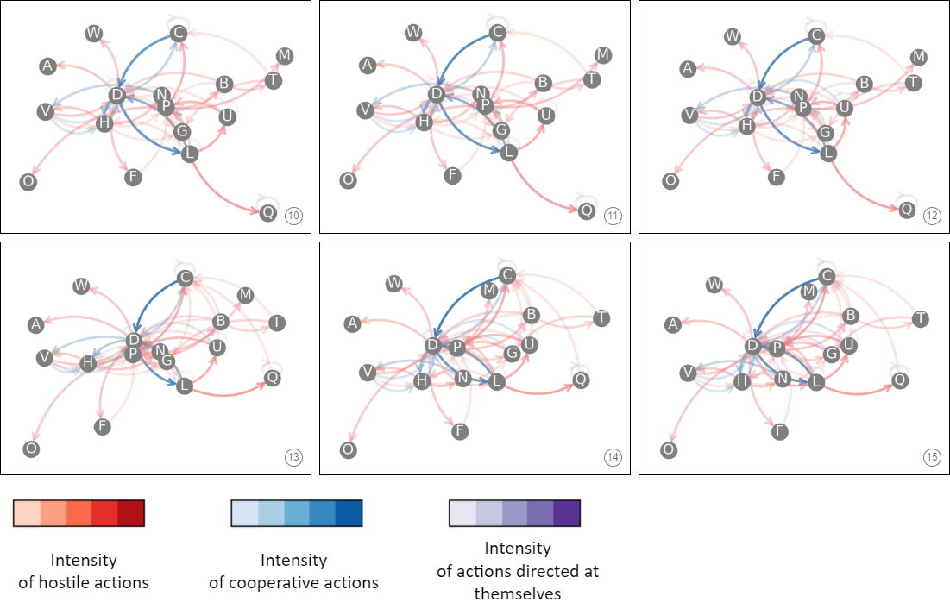
Fig. 33 Season 4, main network 2

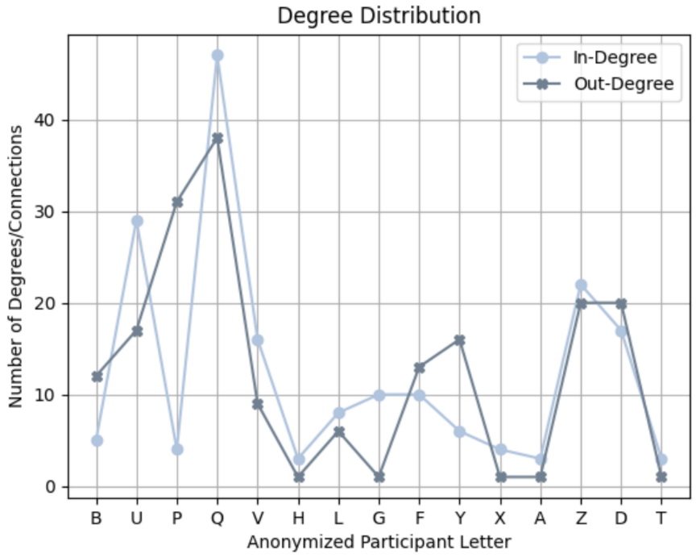
Fig. 34 Season 5, degree distribution

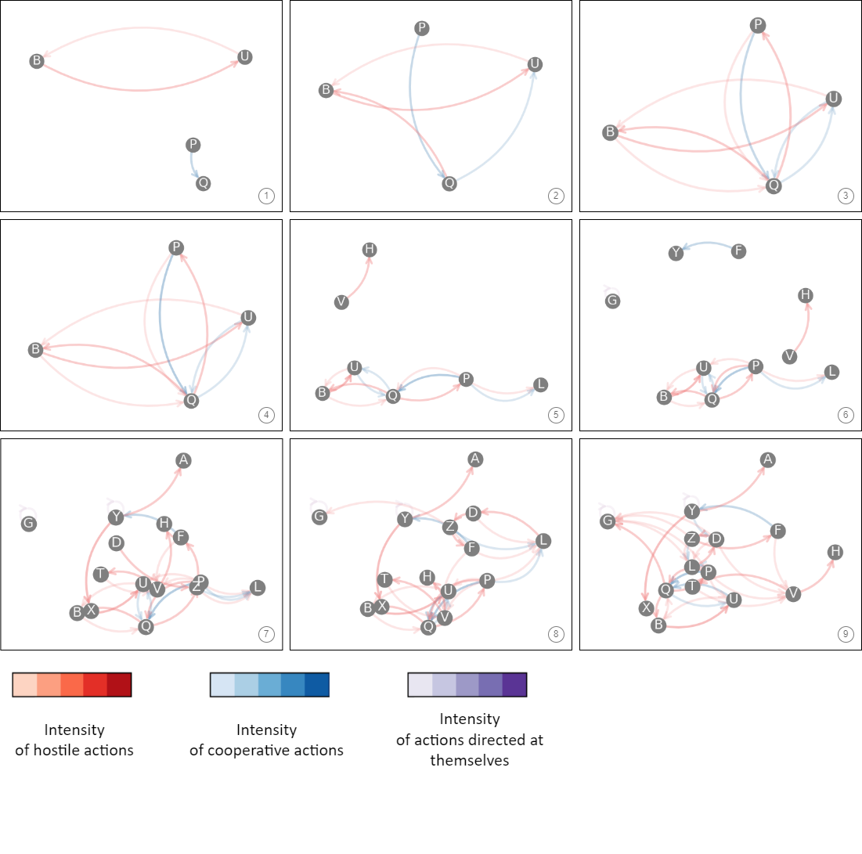
Fig. 35 Season 5, main network 1

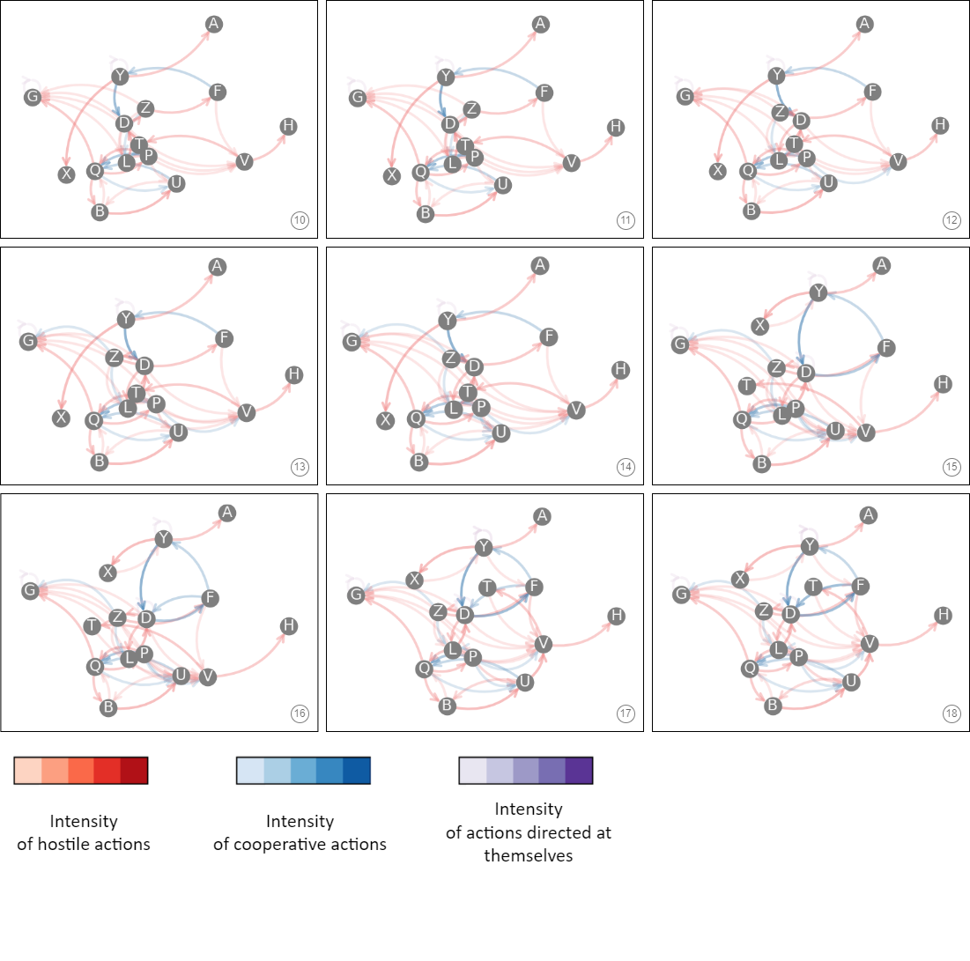
Fig. 36 Season 5, main network 2

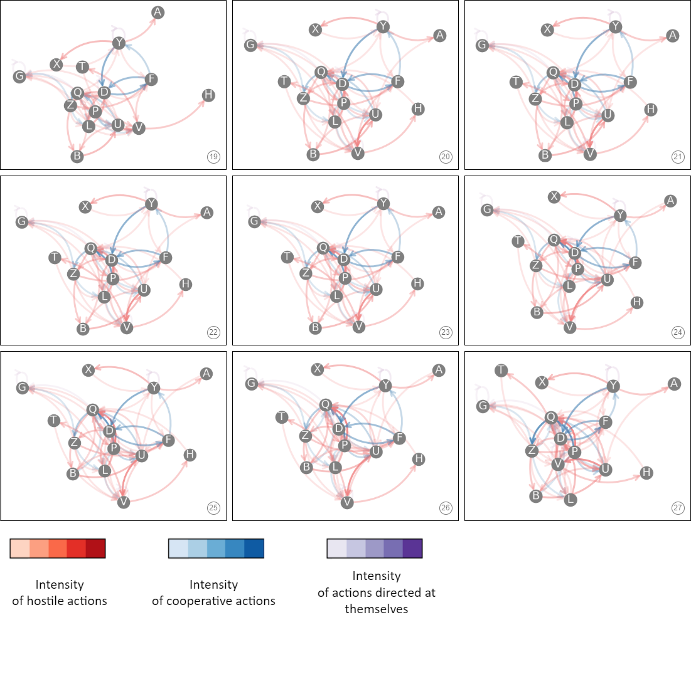
Fig. 37 Season 5, main network 3

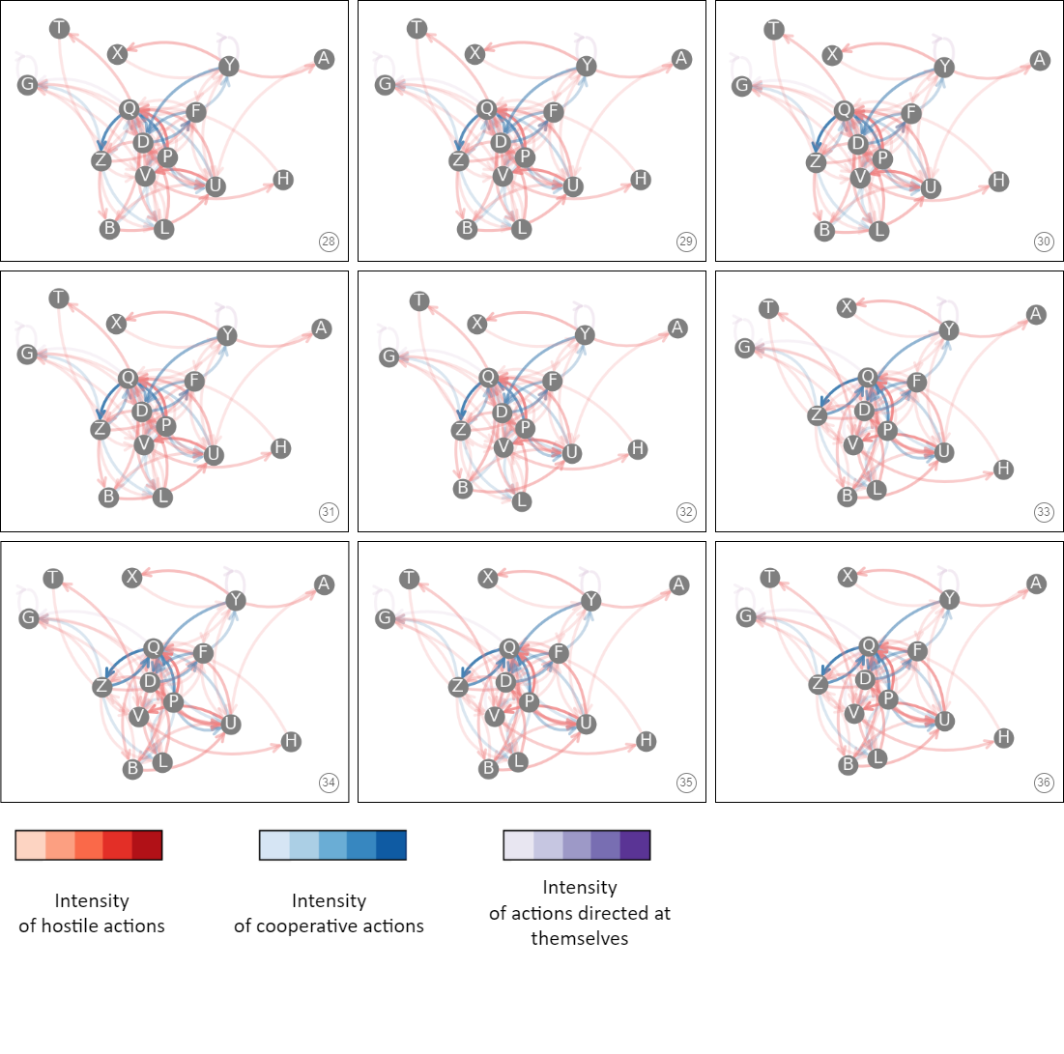
Fig. 38 Season 5, main network 4

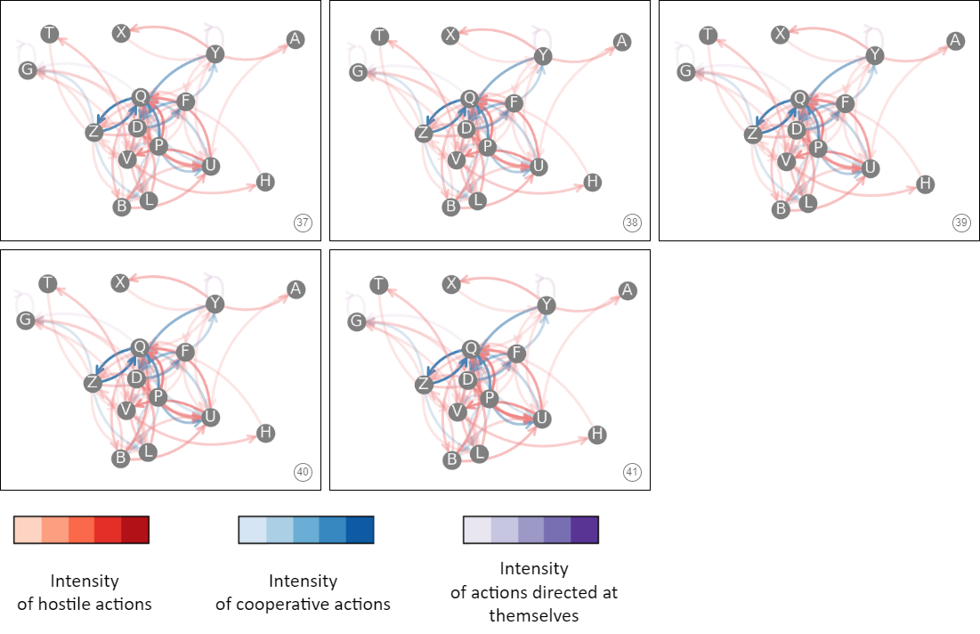
Fig. 39 Season 5, main network 5

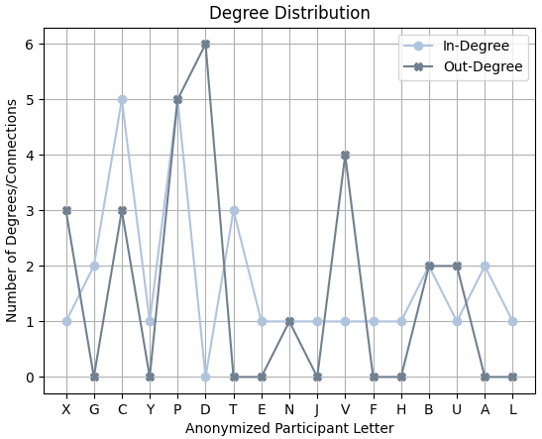
Fig. 40 Season 6, degree distribution

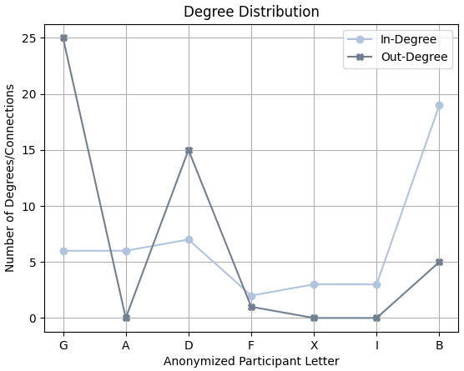
Fig. 41 Quick Rules 1, degree distribution

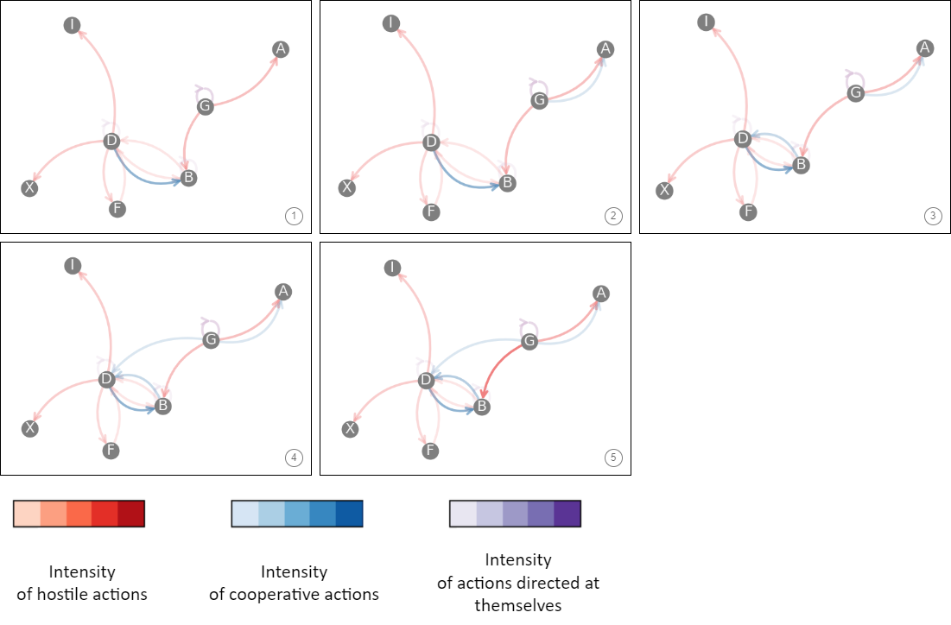
Fig. 42 Quick Rules 1, main network

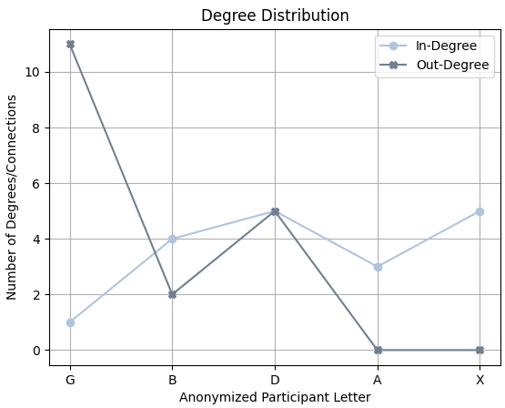
Fig. 43 Quick Rules 2, degree distribution

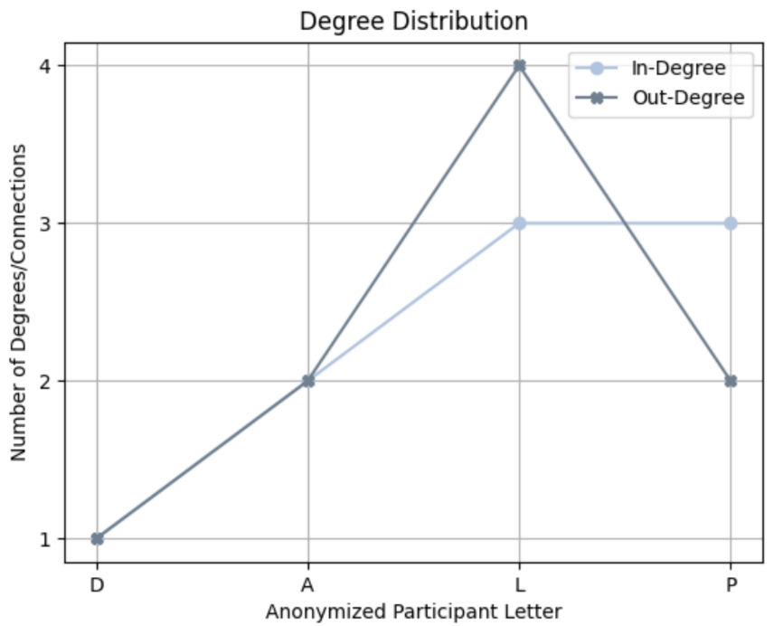
Fig. 44 Quick Rules 3, degree distribution

