Table 3. Forest plot showing individual study and pooled ORs (log scale) for tetracycline resistance in N. gonorrhoeae and exposure to tetracycline PEP. The tetracycline resistance threshold was ≥1 mg/L for the Molina study and ≥2 mg/L for the other two studies.

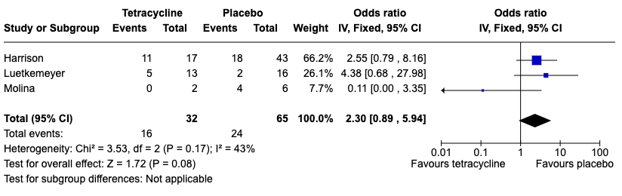

Table 4. Forest plot showing individual study ORs (log scale) for tetracycline resistance (≥2 mg/L) in commensal Neisseria species and exposure to tetracycline PEP.

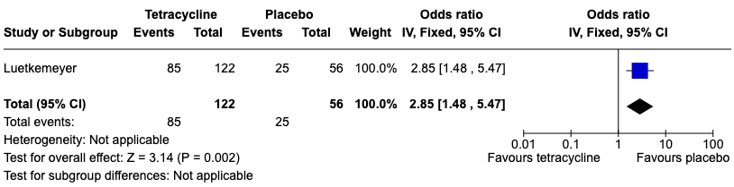

Table 5. Forest plot showing individual study ORs (log scale) for tetracycline resistance (≥2 mg/L) in S. aureus and exposure to tetracycline PEP.

