Appendix 2
Due to the lack of information about how to apply the tips of the caliper while measuring the DRA, we conducted a pilot trial with 10 participants. The upper and the lower tips of the caliper were used in random order. The lower tips are designed to measure the outer boundaries of a firm subject. In the setting of this study, this would be the outer boundaries of the linea alba. The upper tips of the caliper are designed to measure the inner boundaries of a firm subject, which in the present study would be the inner edges of the rectus abdominis. We found a mean difference of −2.32 mm (SD 2.47) between the upper and the lower tips. Moreover, measuring with the upper tips caused more discomfort for the participant, and more insecurity for the investigator regarding the subjective estimation of how much to draw in the inner edge of the rectus abdominis. Thus, it was decided to palpate the outer edges of the linea alba with the fingers, and to measure this distance with the lower tips (Fig. 1).
Fig. 1 Application of the caliper for DRA measurement
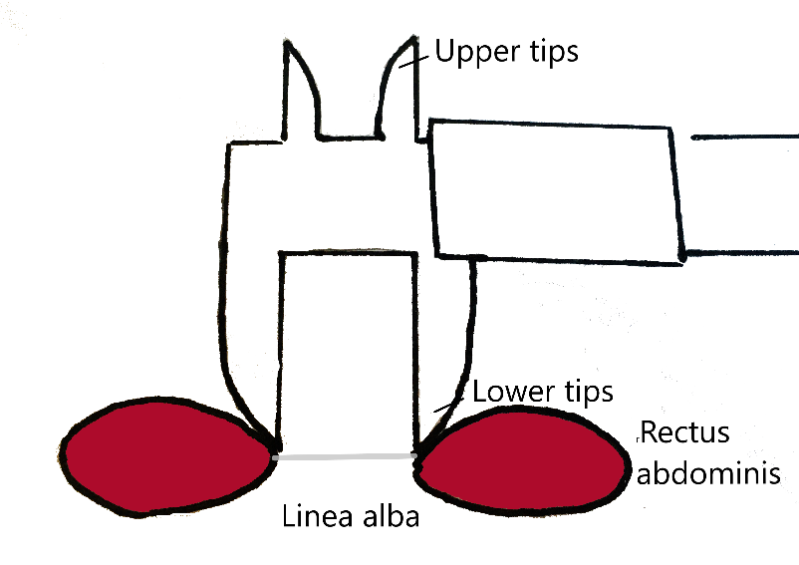

Two months after start of the study in September 2018, the investigators expressed a strong uncertainty regarding the right technique for using the caliper. Thus, we conducted an additional training for all centers. At this point in time, rehabilitation center 3 had not yet started their assessments. In the additional training, the investigators identified three important confounders while measuring:
- Accurate lift of the head (2–3 cm) was an important factor for correct measurement.
- Pre-activation in the abdominal muscles impeded the measurement.
- It was easier to palpate the junction between the rectus abdominis and linea alba during the eccentric movement of lowering the head.
After the additional training, the protocol was set as follows:
- The investigators used a water-soluble marker to mark the three measurement points: at the umbilicus, and 4.5-cm above and 4.5-cm below the umbilicus.
- For accurate assessment, the participant had to lift her head 2–3 cm from the plinth. Before the assessment was started, the investigator assured that the participant knew how it felt to lift her head 2–3 cm, by performing several repetitions.
- In the next step, the participant was asked to lift her head and then slowly lower it. During this concentric and eccentric movement, the investigator palpated the outer edges of the linea alba with the index and middle finger
- In the last step, the participant was asked to lift her head 2–3 cm from the plinth, without pre-activation

