Supplementary Figures

City-scale monitoring of antibiotic resistance genes by digital PCR and metagenomics
Lucia Maestre-Carballa^{1,2}, Vicente Navarro³, and Manuel Martinez-Garcia^{1,2}*

¹Department of Physiology, Genetics, and Microbiology, University of Alicante, Carretera San Vicente del Raspeig, San Vicente del Raspeig, Alicante, 03690, Spain
²Instituto Multidisciplinar para el Estudio del Medio Ramon Margalef, University of Alicante, San Vicente del Raspeig, Alicante, 03690, Spain
³Clinical Microbiology and Infectious Disease Unit, Hospital Universitario Vinalopó, Elche, Spain.

This Supplementary material contains 10 supplementary figures.

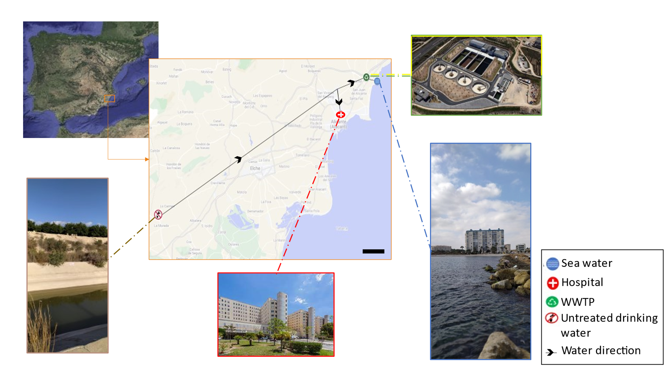
Supplementary Figure S1. Sampling locations in Alicante city that were used in this study. Water and air samples were collected from various locations in the city of Alicante considered as hot spots for ARGs dispersion. Water samples were obtained from untreated drinking water of the Crevillente’s channel (38°11'23.4"N, 0°58'13.5"W), wastewater of the Hospital General Universitario Dr. Balmis, (38°21'47.9"N, 0°29'08.6"W) and from the wastewater treatment plant (WWTP) l'Alacantí Nord (38°25'38.5"N, 0°25'03.5"W) and seawater (38°25'08.6"N, 0°23'16.7"W) near the outlet of the mentioned WWTP. Air samples were obtained from the hospital (roof and main entrance) and the WWTP (in situ and two points out but near) named above. Picture obtained from Google Maps. Scale bar: 5 km.

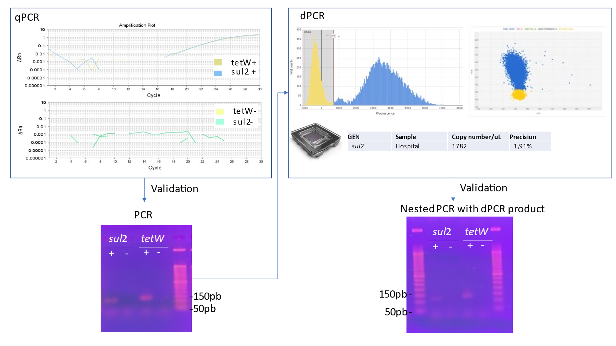
Supplementary Figure S2. qPCR and dPCR process for the ARGs tetW and sul2.
dPCR primers and probes designed for the ARGs tetW and sul2 were first tested by qPCR (same conditions as the dPCR) in the Hospital wastewater sample, and the PCR products were observed in an electrophoresis gel. Then, a chip-based dPCR was run for both genes and different water samples. Only dPCR results with precision ≤10% were considered for our results as recommended for dPCR, similarly to qPCR best practices. To verify the proper amplification of the dPCR product, a second PCR (nested PCR) was run with the primers, and the product was analyzed by gel electrophoresis (TBE, 2%). Ladder used: Gene Ruler 1 kb+. This confirms that the detection signal obtained from probes using during dPCR was fully specific as shown in the histogram and dot plot of dPCR detection of targeted genes (blue color).

Supplementary Figure S3. ARGs relative abundance (hits per Gb) in the different water samples of Alicante. The abundance of ARG in each water sample was studied through metagenomics for both unassembled and assembled data. Hospital wastewater and WWTP input had the highest abundance of ARGs. For the assembled fraction, all contigs from the <0,2 μm and ≥0,2 μm fraction in each sample that were classified as viral according to VirSorter (see methods), were grouped in the category putative viral fraction.

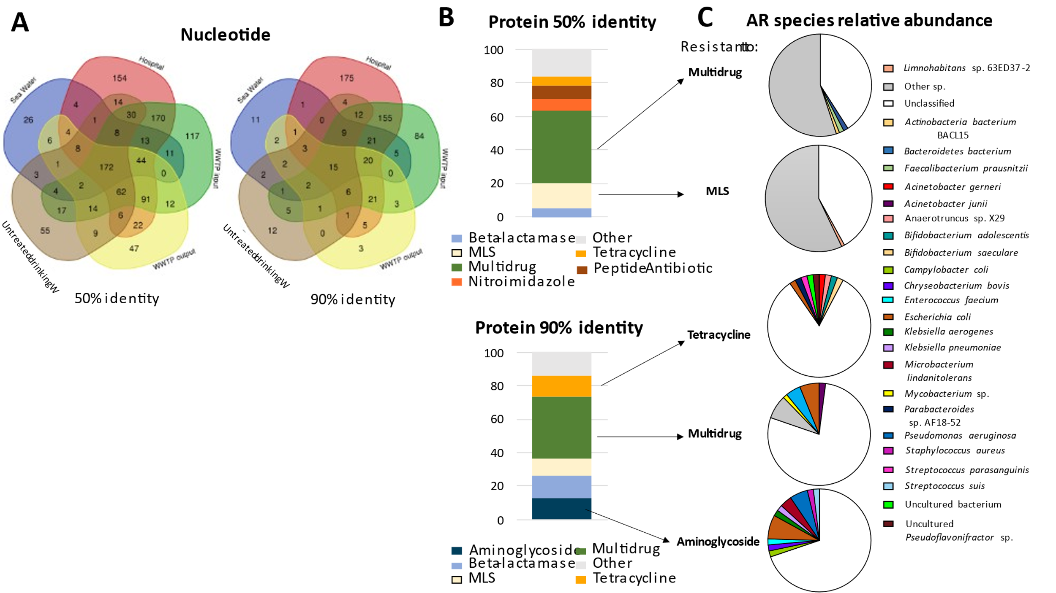
Supplementary Figure S4. ARGs distribution, relative abundance, and bacterial carriers in the different water samples of Alicante. Number of ARGs shared by the different water samples: seawater (blue), Hospital (red), WWTP input (green), WWTP output (yellow), and untreated drinking water (brown) (A). For assembled data, different categories of ARG (conferring resistance to multidrug, MLS, tetracycline, and aminoglycoside) were found to be more frequent in Alicante’s water samples at two different protein identity thresholds (≥50 and ≥90%) (B). Identification of the most abundant bacteria (>1%) present in the waters of Alicante that had (at least) an ARG that belonged to the most common categories found in the waters of Alicante (C).

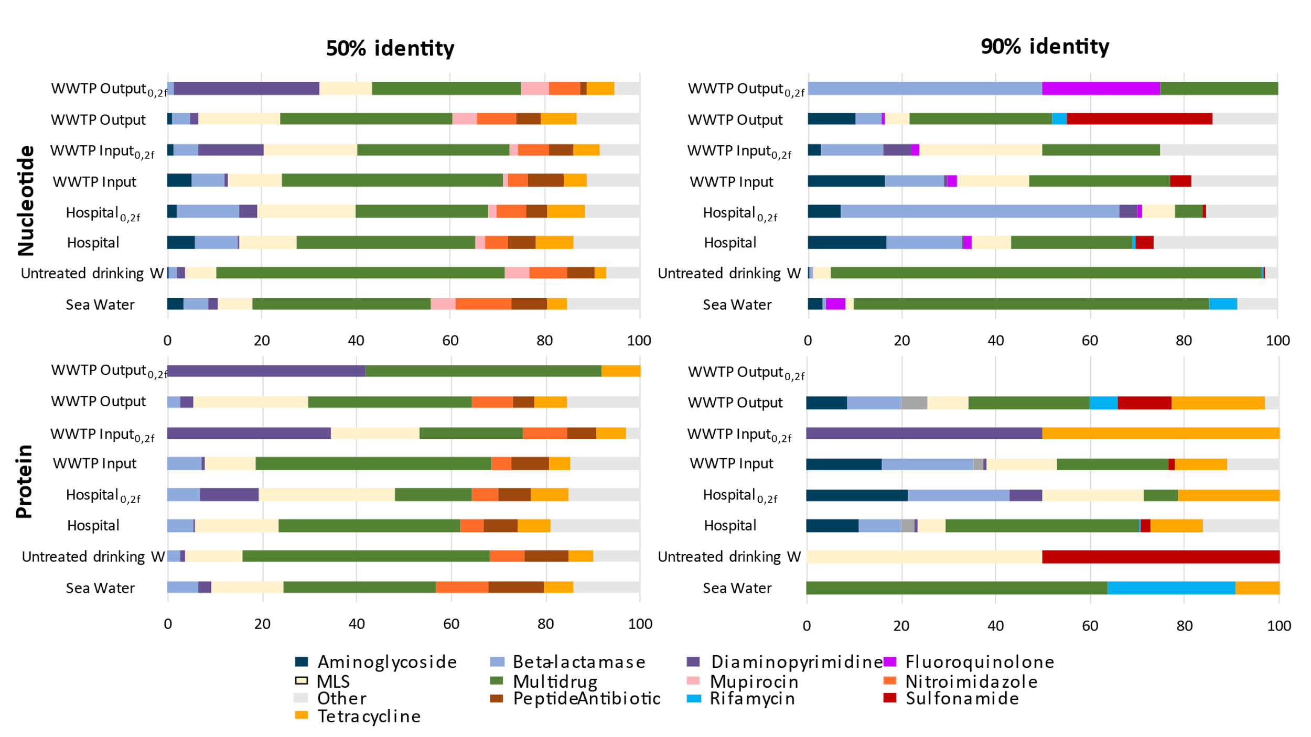
Supplementary Figure S5. ARGs relative abundance for assembled and unassembled data in water samples of Alicante city. ARGs were grouped by the class of antibiotic they confer resistance to, for both unassembled data (nucleotide) and assembled data (protein) at two different blast identities (≥50 and ≥ 90%). Only those classes of antibiotics with a relative frequency ≥ 5% were represented. _{0,2f} refers to the 0,2µm-filtered fraction.

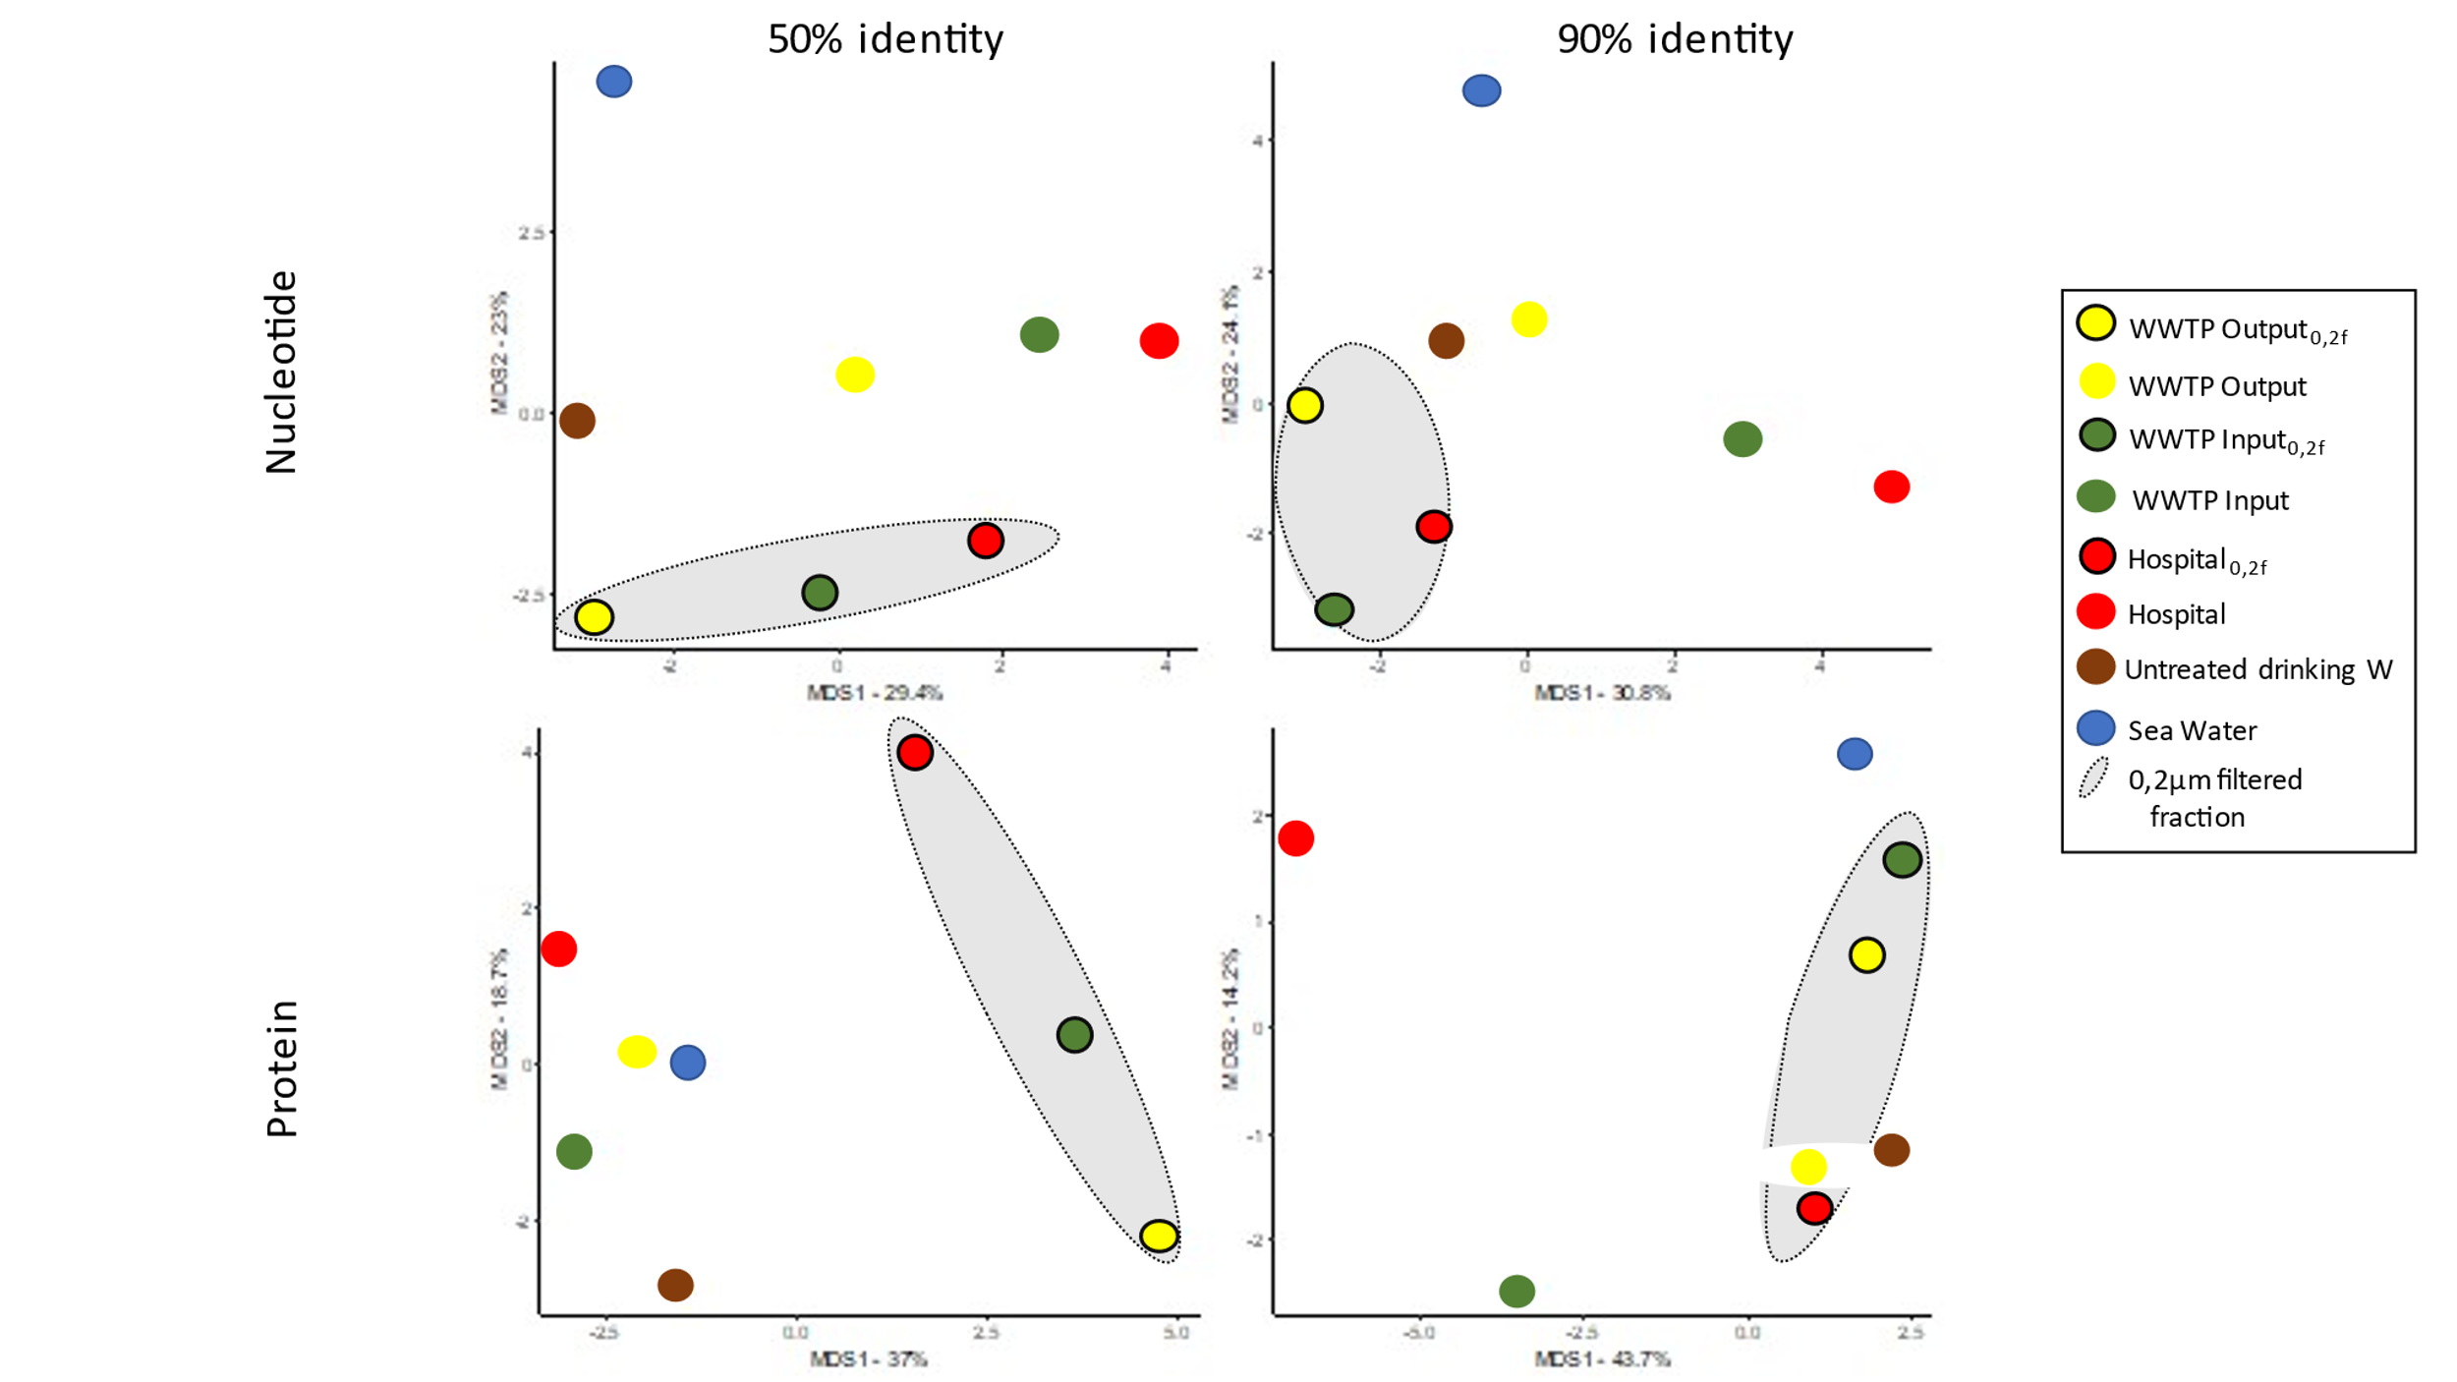
Supplementary Figure S6. PCoA of the resistome in water samples of Alicante. PCoA representation of the different water samples of Alicante according to the relative abundance of ARG found for both the assembled (protein) and unassembled (nucleotide) data at two different blast identities (≥50 and ≥90%). 0,2µm-filtered fractions (_{0,2f}) are highlighted with a black circle and a grey area.

Supplementary Figure S7. Comparison of ARGs found in RNA and DNA viral fraction. Abundance of ARGs detected in the assembled viral fraction obtained from RNA (WWTP input and output (02/19/20) and DNA (hospital (05/14/19), WWTP input and output (02/19/20) samples. Two different blast protein identities were tested (ID) ≥50% and ≥ 90%. Red bars indicate the abundance of ARGs per assembled Mb in the 0,2 µm fraction; inside them, the blue color indicates ARGs/Mb found in the viral fraction associated in silico with viral contigs. White space indicates ARG/Mb that could not be associated with viral contigs.
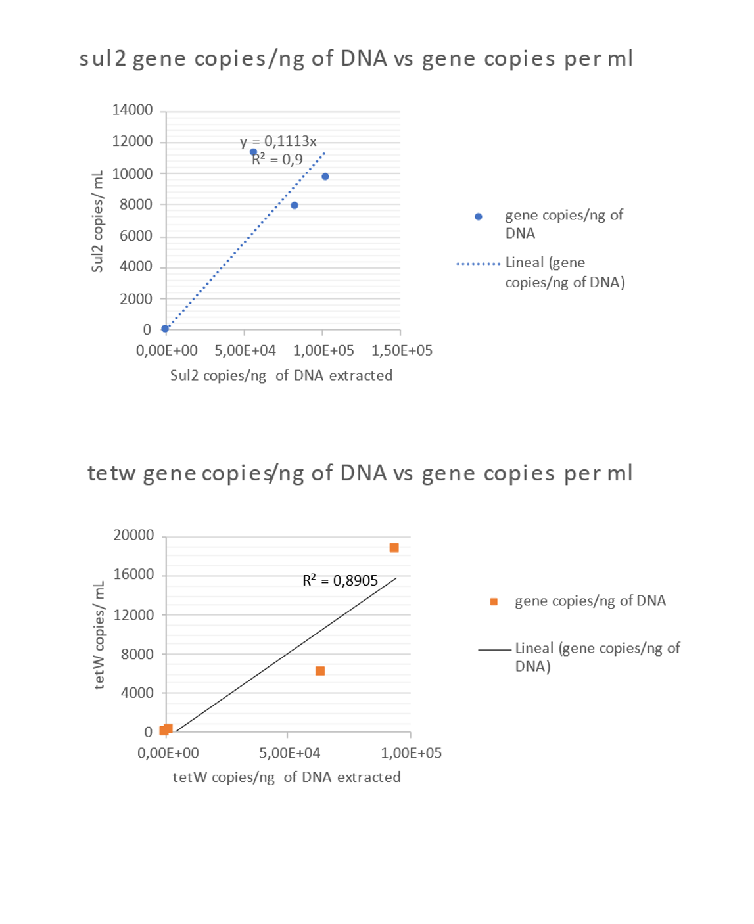
Supplementary Figure S8. Correlation for the ARG tetW and sul2 comparing the number of gene copies per ng of DNA versus the number of copies found per mL of sample. dPCR results (copies of tetW or sul2) were extrapolated to the number of copies per mL or number of copies per extracted ng of DNA giving a R² ≈0.9 for both genes.
Supplementary Figure S9. dPCR results for tetW and sul2 in water samples. Number of copies of tetW or sul2 per mL of water sample. TetW in the WWTP input had the highest number of copies per mL, while the rest of the analyzed samples (hospital, WWTP output and seawater) had less than 4.5X10⁶ copies/ mL.

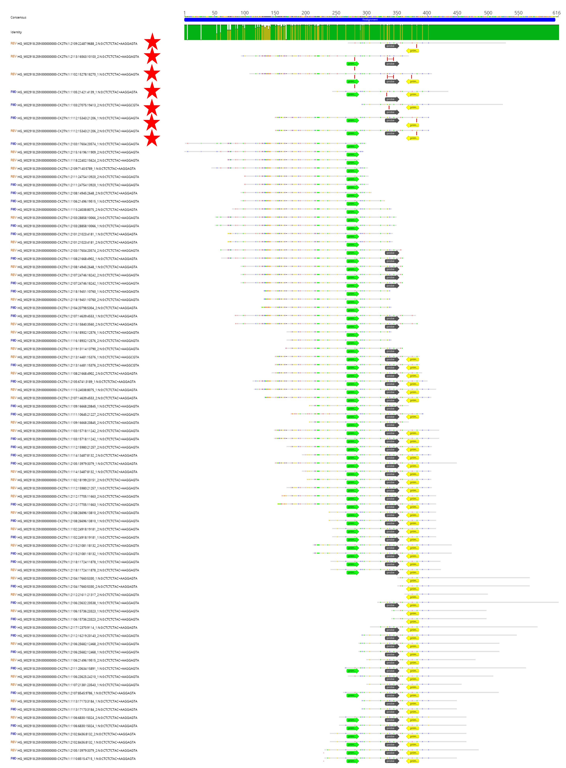
Supplementary Figure S10. Alignment of metagenomic reads of tetW gene. The figure shows the detected forward (green), probe (grey), and reverse (yellow) sequences used for dPCR. Note that some reads showed mismatches that might preclude PCR amplification and/or detection by the probe and primers during dPCR (denoted by a red star). All reads aligned showing the overall percentage of nucleotide identities >90%.

