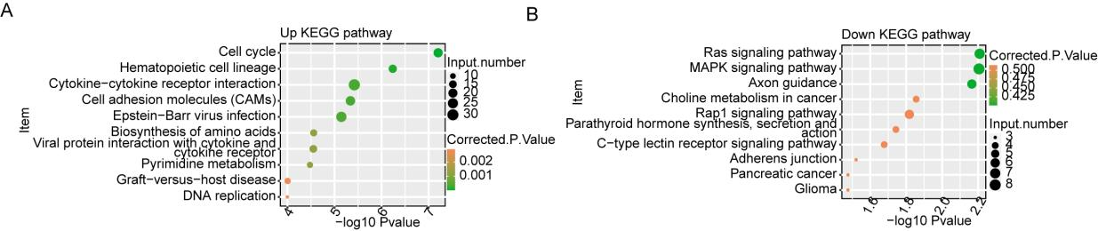
Figure S1. RNA-seq analysis of differentially expressed genes (DEGs) between SAH and Sham
samples.
(A)The up-regulated genes' KEGG pathway results on the scatter plot were the most enriched..
(B) The results of the down-regulated genes' KEGG pathways that appeared on the scatter plot were the most enriched.
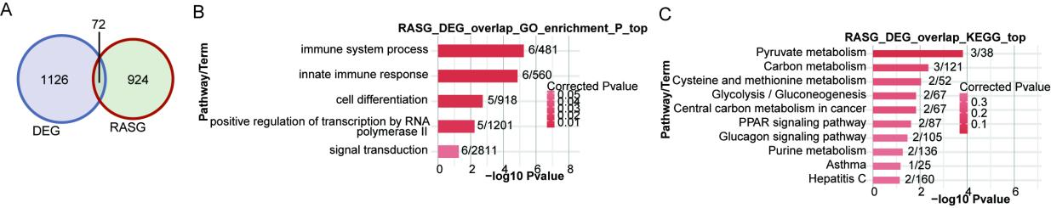
Figure S2. The identification of abnormal alternative splicing events in Subarachnoid
hemorrhages.
- A Venn diagram depicts RASG and DEG overlap genes.
B.The highest enriched GO biological process results of overlap genes in A were displayed in a bar plot.
C. The most enriched KEGG pathway results of overlap genes in A were displayed in a bar plot.
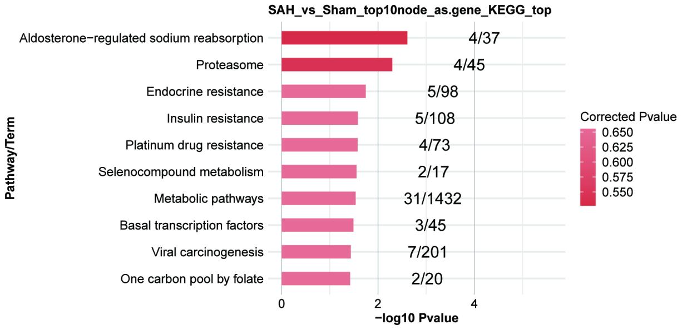
Figure S3. Construction of co-disturbed network between SAH-RASRNA-binding proteins (RBP) and RNA-binding proteins (RBP) .
A. Scatter plot showing the top10 enriched KEGG pathways results of RASGs co-distrubed by top
10 hub DE RBPs.
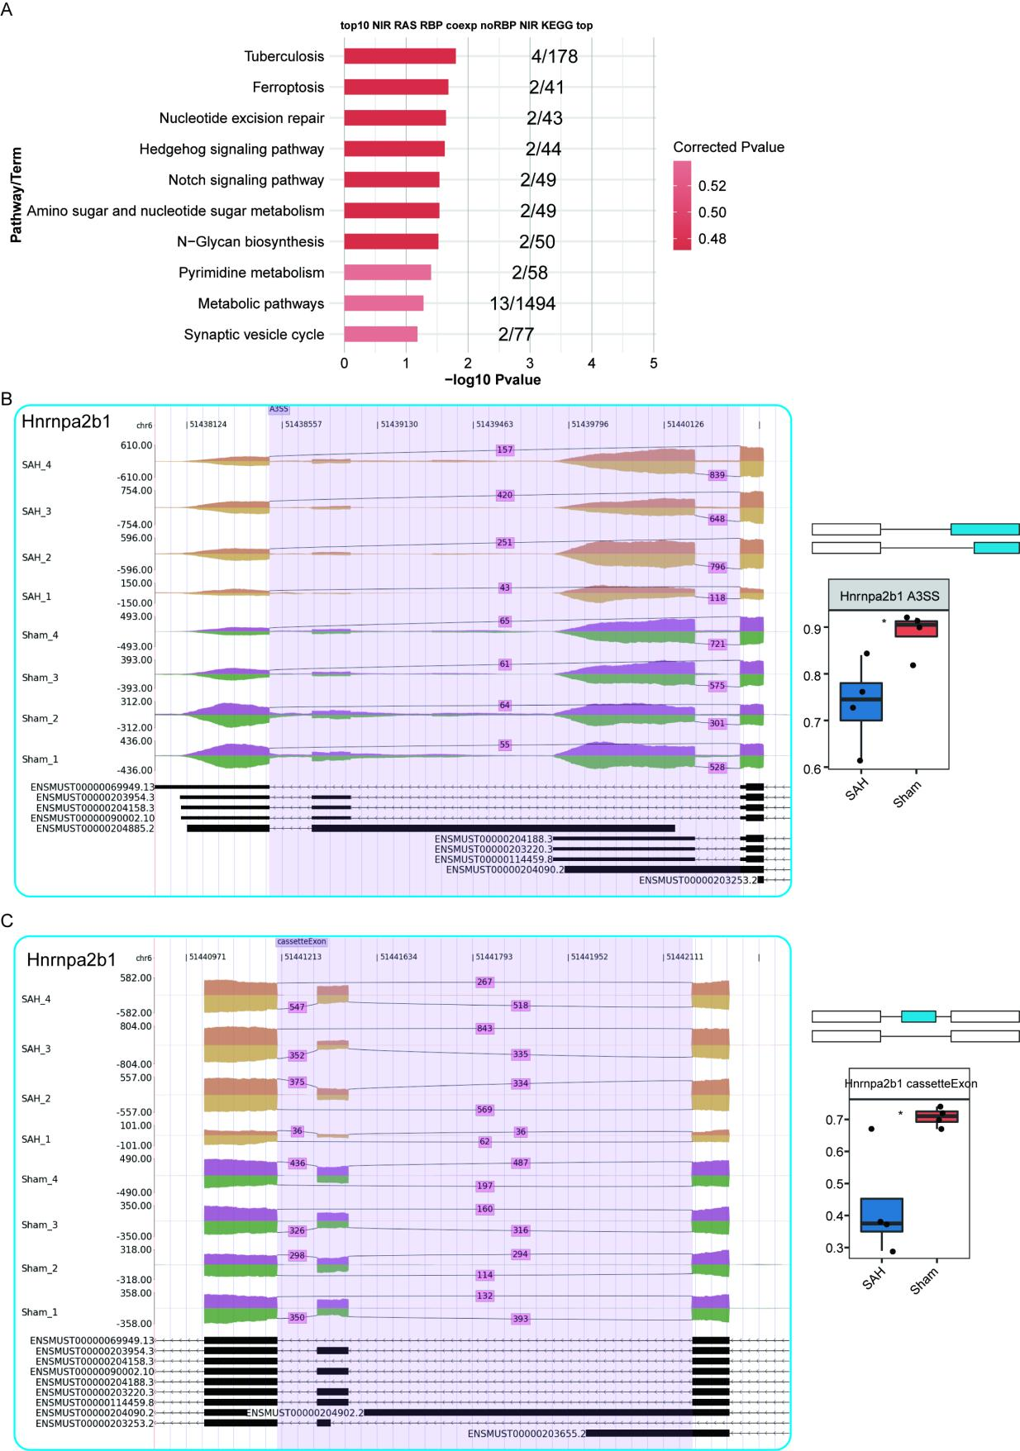
Figure S4. Correlation analysis of RNA binding proteins (RBPs) with alternative splicing,
differential alternative splicing without RBP.
(A) Scatter plot showing the top10 enriched KEGG pathways results of top10RBP regulated of
non-RBP.
(B-C)The transcripts for the gene are displayed below, and IGV-sashimi graphs demonstrate AS variations in SAH and Sham. The architecture of ASEs are shown schematically (right, top). White boxes indicate constitutive exon sequences, whereas horizontal lines indicate intron sequences, while
blue-boxed alternate exons. A quantification of ASEs using RNA-seq is displayed at the bottom of the
correct panel. The formula: alternative was used to compute the altered ratio of AS events in RNA-seq.
alternative splice junction reads plus model splice junction reads; splice junction reads. Error bars
represent mean ± SEM. ***P-value < 0.001, ** P-value < 0.01, * P-value < 0.05.

