Heavy Metals | F1 | F2 | F3 | F4 | F5 | F6
Heavy Metals | (Mean ± SD)
Zone 1
Cr | 6.86 ± 5.36 | 9.50 ± 4.89 | 43.31 ± 7.87 | 12.14 ± 6.29 | 16.83 ± 7.34 | 57.46 ± 17.42
Cd | 0.33 ± 0.17 | 3.31 ± 1.08 | 5.44 ± 0.54 | 0.77 ± 0.63 | 0.61 ± 0.56 | 0.73 ± 0.28
Ni | 2.13 ± 1.50 | 27.10 ± 5.50 | 37.89 ± 6.27 | 17.67 ± 12.08 | 26.16 ± 9.80 | 19.35 ± 5.01
Cu | 1.38 ± 0.70 | 3.57 ± 2.10 | 9.79 ± 1.98 | 3.83 ± 2.60 | 40.81 ± 32.26 | 6.75 ± 3.61
Pb | 0.56 ± 0.32 | 45.00 ± 6.30 | 30.99 ± 7.20 | 10.43 ± 4.49 | 6.98 ± 5.47 | 9.96 ± 2.74
Zone 2
Cr | 7.17 ± 3.53 | 9.86 ± 5.00 | 42.23 ± 5.33 | 9.68 ± 6.44 | 16.83 ± 5.00 | 56.96 ± 13.65
Cd | 0.28 ± 0.14 | 3.00 ± 071 | 5.55 ±0.84 | 0.54 ± 0.48 | 0.81 ± 0.57 | 0.86 ± 0.20
Ni | 1.74 ± 1.27 | 30.05 ± 4.93 | 38.91 ± 5.37 | 19.60 ± 25.13 | 27.96 ± 10.42 | 19.50 ± 4.62
Cu | 1.24 ± 0.69 | 3.18 ± 1.56 | 9.82 ± 2.02 | 3.53 ± 1.92 | 39.50 ± 33.76 | 8.15 ± 3.31
Pb | 0.35 ± 0.21 | 42.70 ± 4.45 | 38.68 ± 22.56 | 8.72 ± 3.67 | 9.41 ± 6.12 | 13.31 ± 7.52

Table S1. Fractionation of soil samples in terms of HMs content. F1: water-soluble fraction, F2: exchangeable fraction, F3: carbonate fraction, F4: oxide phases fraction, F5: organic matter fraction, F6: sulphides phase fraction.

Heavy Metals | Constant | β₁ | β₂ | FIAM-HQ | SAMOE-TCR | HMs in Grain (mg/kg) | SAMOE
Cr | -0.89 | 0.05 | 0.11 | 2.87E-01 | 5.90E-03 | 11.3 | 0.006
Ni | 0.77 | 0.01 | -0.37 | 1.08E-01 | 7.58E-03 | 9.58 | 0.03
Cd | 1.7 | 0.03 | 0.08 | 1.49E-02 | 1.16E-05 | 0.05 | 0.82
Pb | 1.9 | -0.14 | -0.01 | 1.88E-01 | 1.15E-05 | 3.2 | 0.24
Cu | 0.5 | -0.26 | 0.74 | 1.27E-03 |  | 4.11 | 45.09

Table S2. FIAM parameters for predicting HMs uptake by rice as a function of pH, Walkley Black organic-C and DTPA extractable HMs, FIAM-HQ for intake of HMs through consumption of rice grains grown on soils, and dietary risk (SAMOE-TCR and SAMOE) of HMs from contaminated rice grains.

HMs | CF | ERF | Igeo | PLI
Zone 1
Pb | 2.79 | 13.97 | 0.76 | 1.28
Cr | 5.76 | 28.82 | 1.85 | 1.28
Cu | 0.97 | 4.89 | -0.82 | 1.28
Cd | 0.29 | 1.47 | -2.37 | 1.28
Ni | 4.58 | 22.9 | 1.55 | 1.28
Zone 2
Pb | 2.66 | 13.33 | 0.75 | 1.16
Cr | 5.43 | 27.18 | 1.79 | 1.16
Cu | 0.67 | 3.35 | -1.26 | 1.16
Cd | 0.27 | 1.35 | -2.47 | 1.16
Ni | 4.4 | 22.04 | 1.5 | 1.16

Table S3. Non carcinogenic risk values of two zones (zone 1 and zone 2). CF: contamination factor, PLI: pollution load index, ERF: ecological risk factor, I_{geo}: geo accumulation factor.

Heavy Metals | Zone 1 |  | Zone 2
Heavy Metals | Adult | Children | Adult | Children
Heavy Metals | CR |  | CR
Pb | 1.38E-06 | 1.61E-06 | 1.26E-06 | 1.47E-06
Cr | 1.37E-06 | 1.60E-06 | 2.41E-05 | 2.81E-05
Cd | 3.70E-05 | 4.32E-05 | 1.26E-06 | 1.47E-06
Ni | 1.32E-06 | 1.54E-06 | 3.56E-05 | 4.15E-05
TCR = ΣCR | 6.53E-05 | 7.63E-05 | 6.23E-05 | 7.27E-05

Table S4. Carcinogenic risk (three exposure pathway) values on adults and children. CR: cancer risk, TCR: total cancer risk

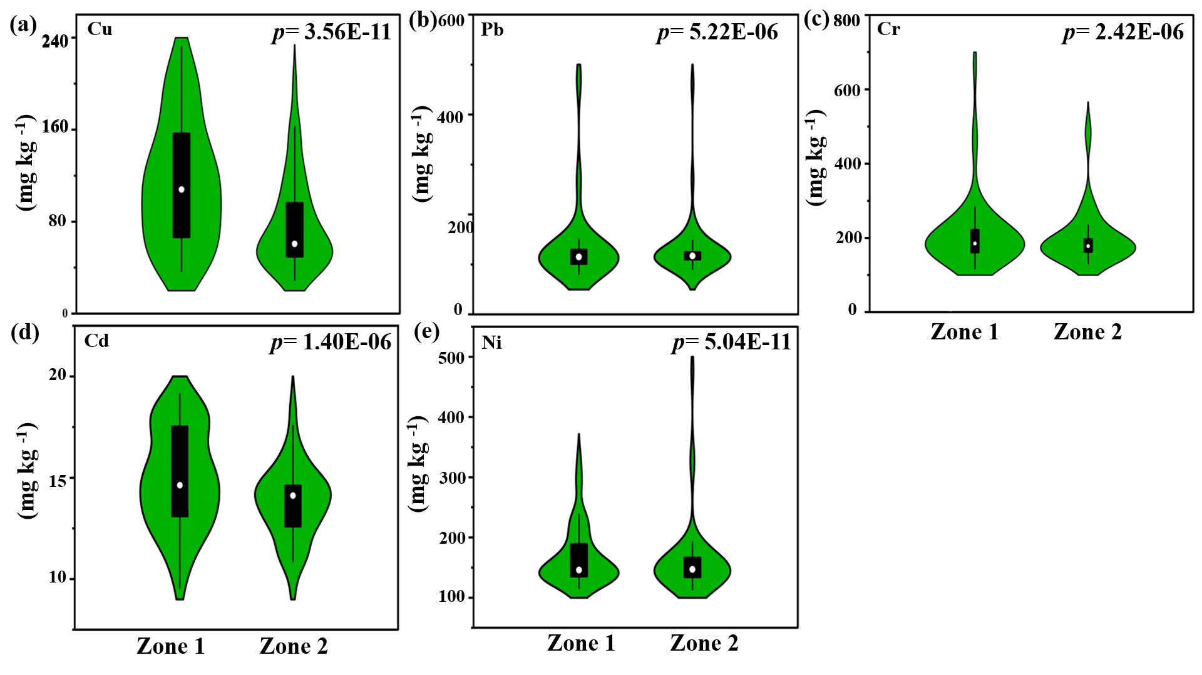
Fig S1. Violin plot demonstrating total HMs concentration in soil of the two zones .

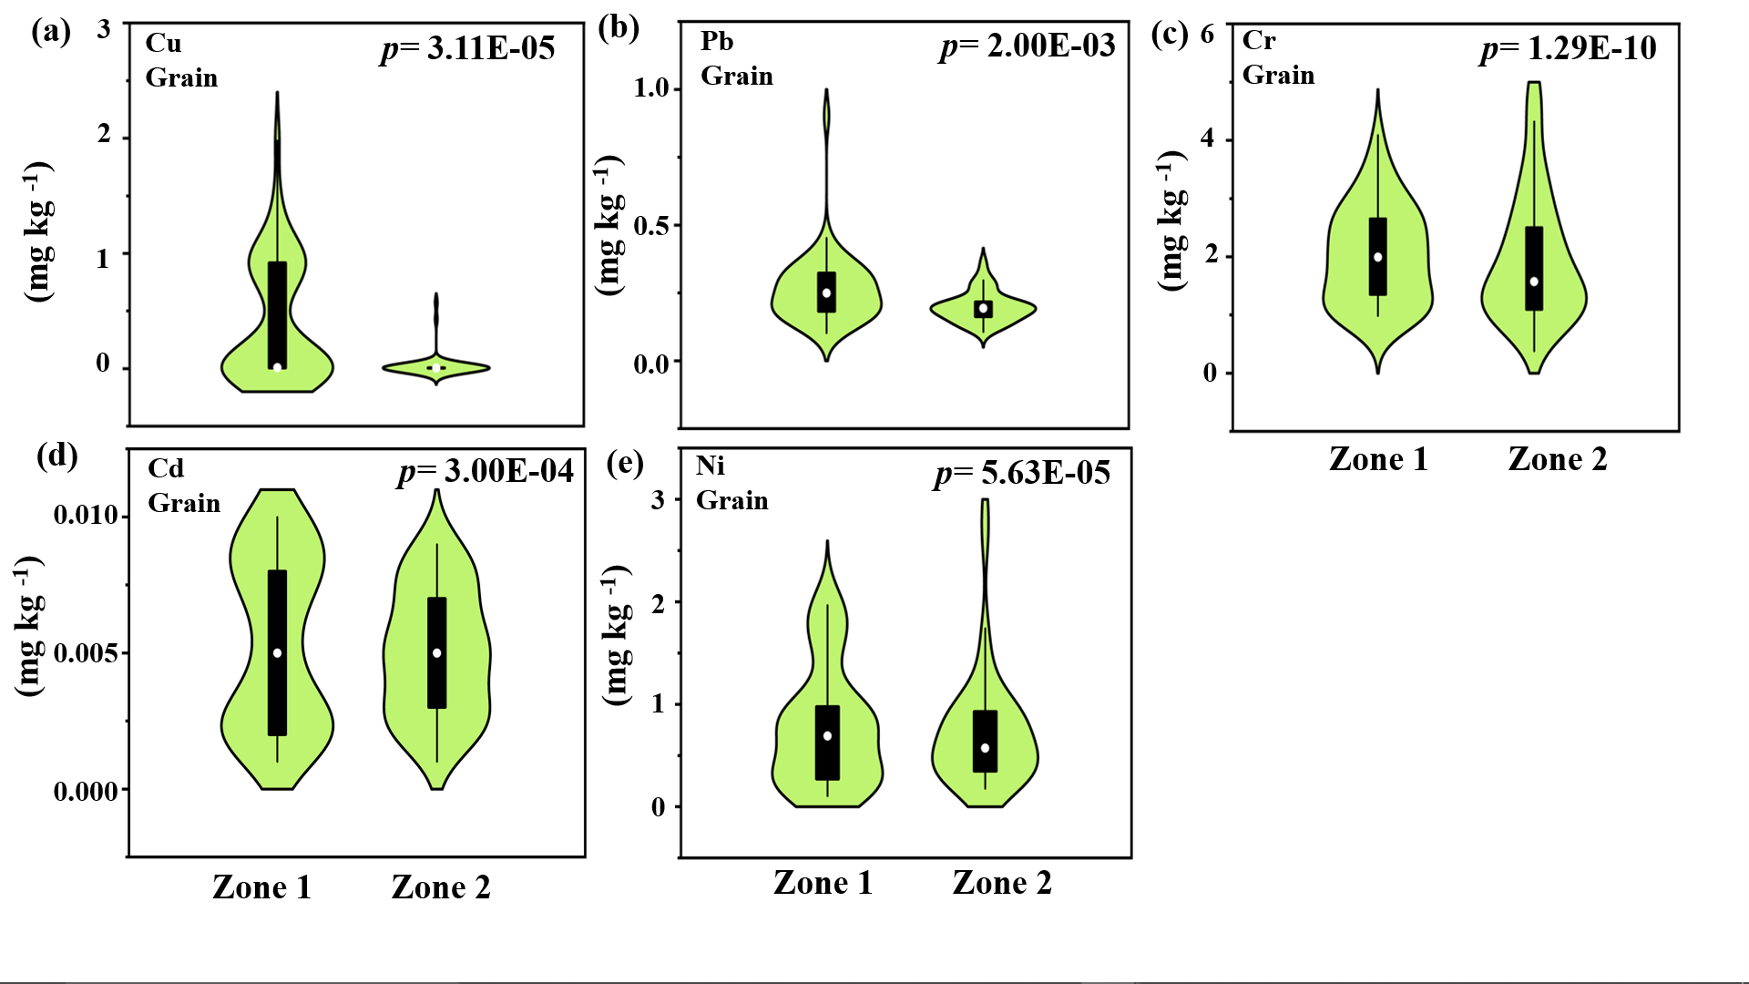
Fig S2. Violin plot demonstrating the comparison between the two zones in terms of HMs content in grain.

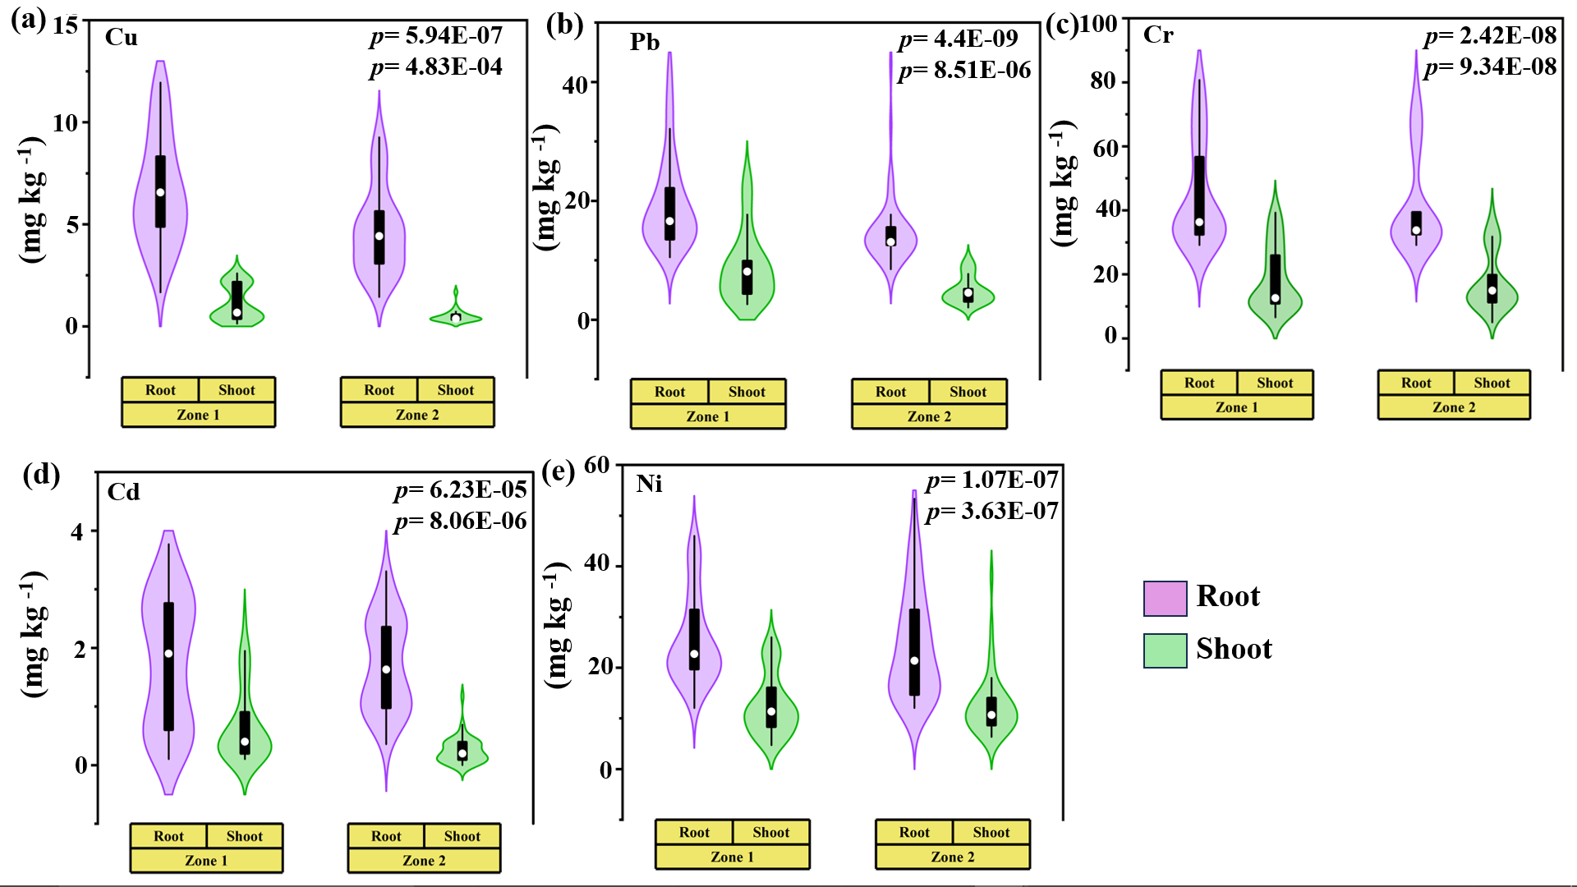
Fig S3. Violin plot demonstrating the comparison between the two zones in terms of HMs content in rice root and shoot.

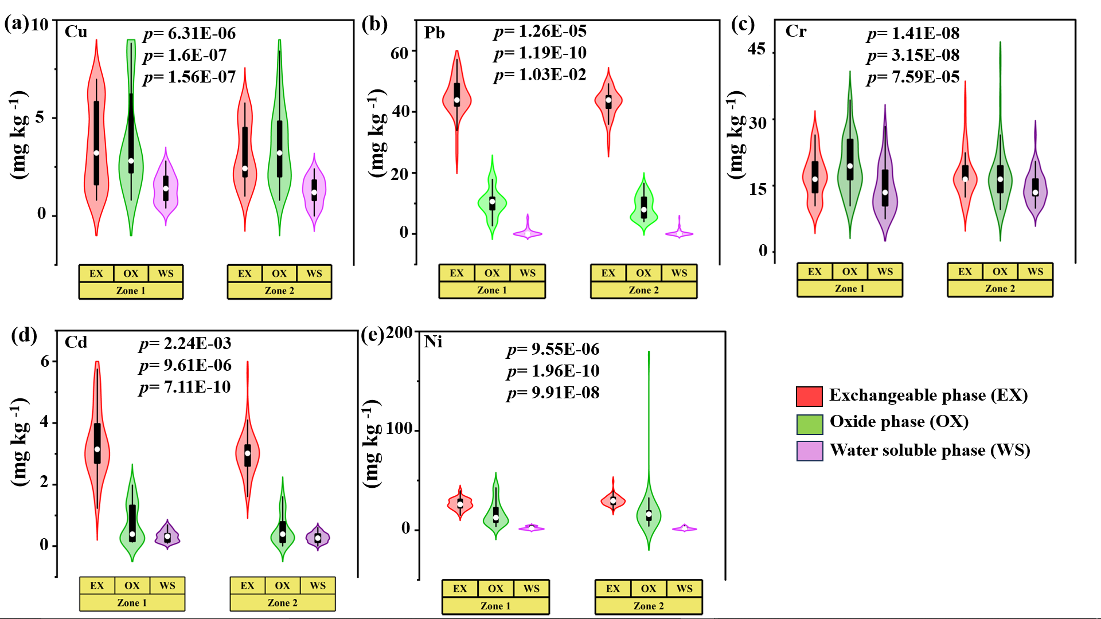

Fig S4. Violin plot demonstrating the comparison between the two zones in terms of HMs content in rice root, shoot and grain.

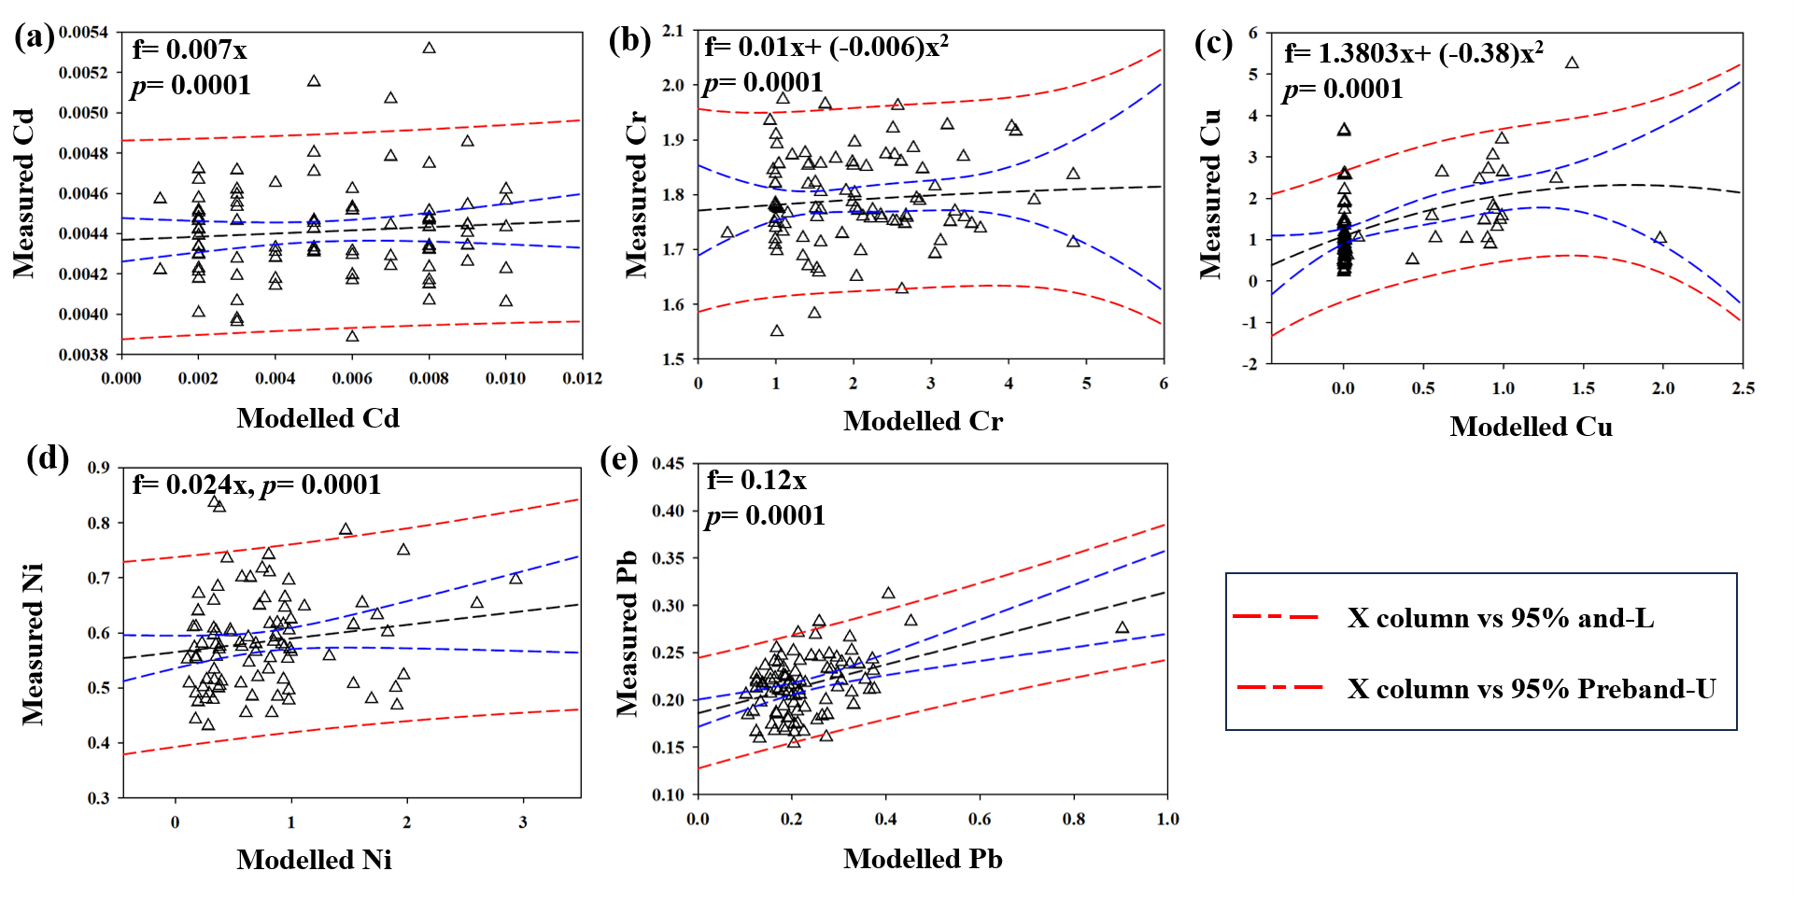
Fig S5. FIAM analysis showed the comparison between measured and predicted HMs (Cd, Cr, Cu, Ni, Pb) content in rice grain in contaminated soil.
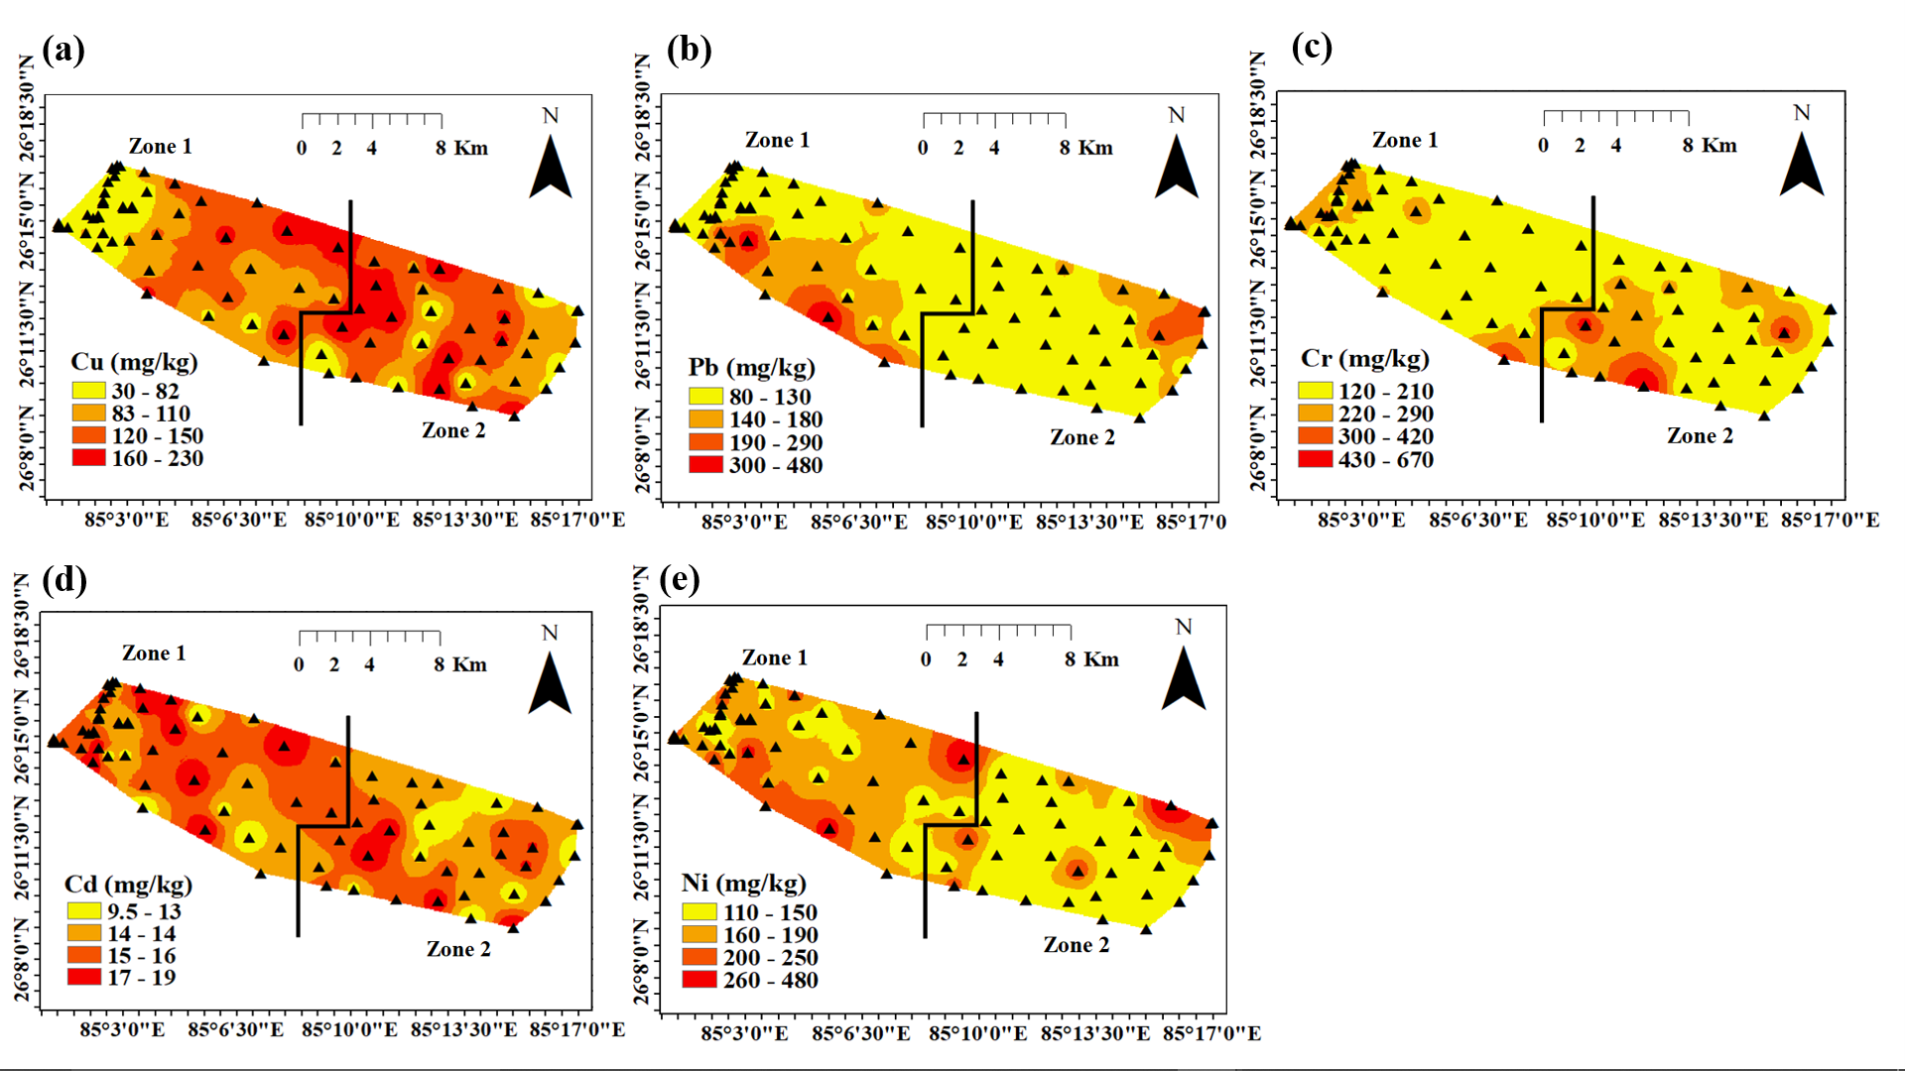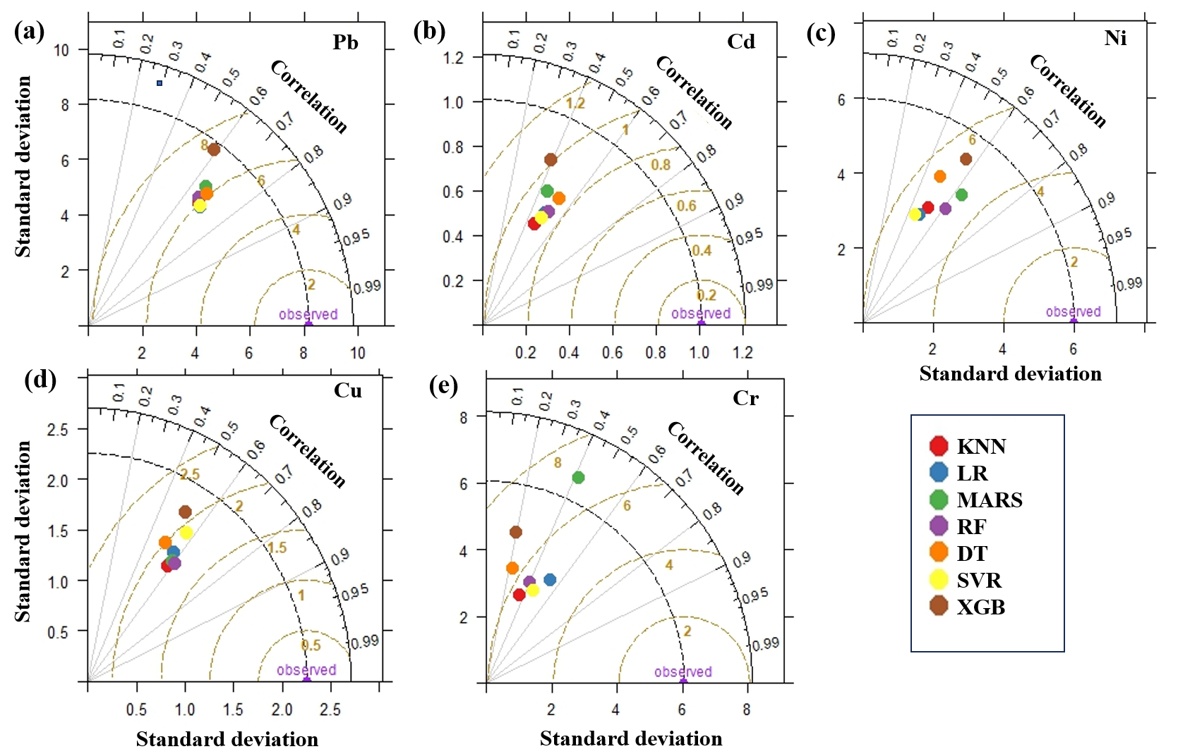
Fig S6. Maps showing the spatial distribution of total HM (Cu, Pb, Cr, Cd, Ni) for contaminated soil.

Fig S7. Taylor diagram showing the accuracy of the different models based on r and RMSE.
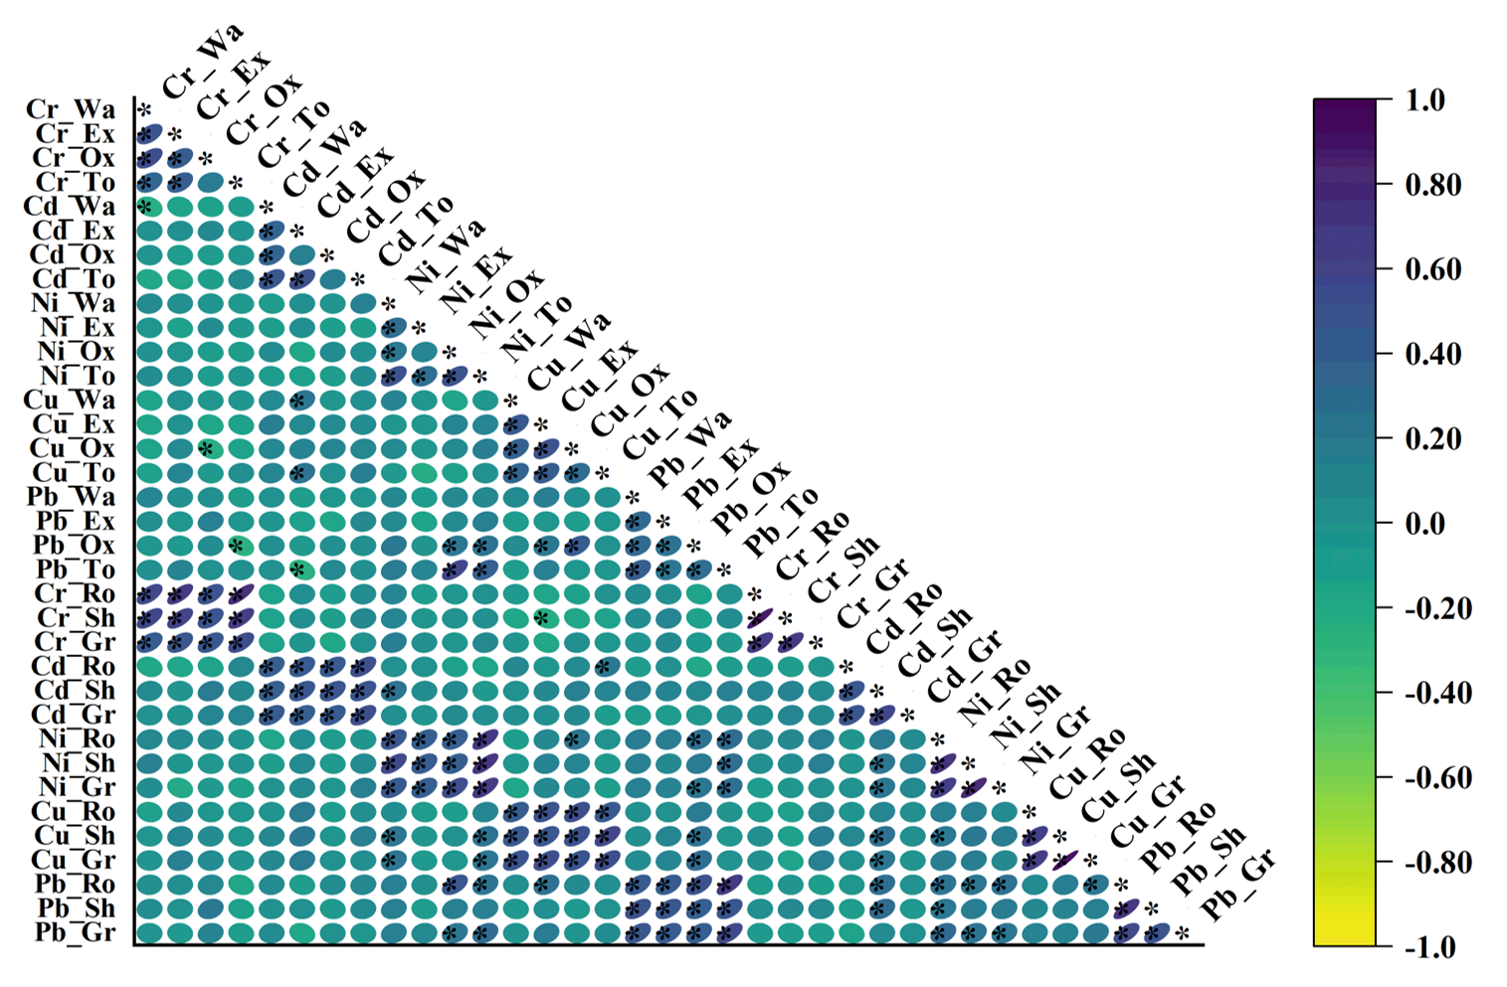
Fig S8. Interactions between different soil parameters with microbial and enzymatic activity are based on Pearson correlation (p<0.05)

