Appendix File 2
File 2A. Haplotype maps and networks extracted from Rhipicephalus turanicus.

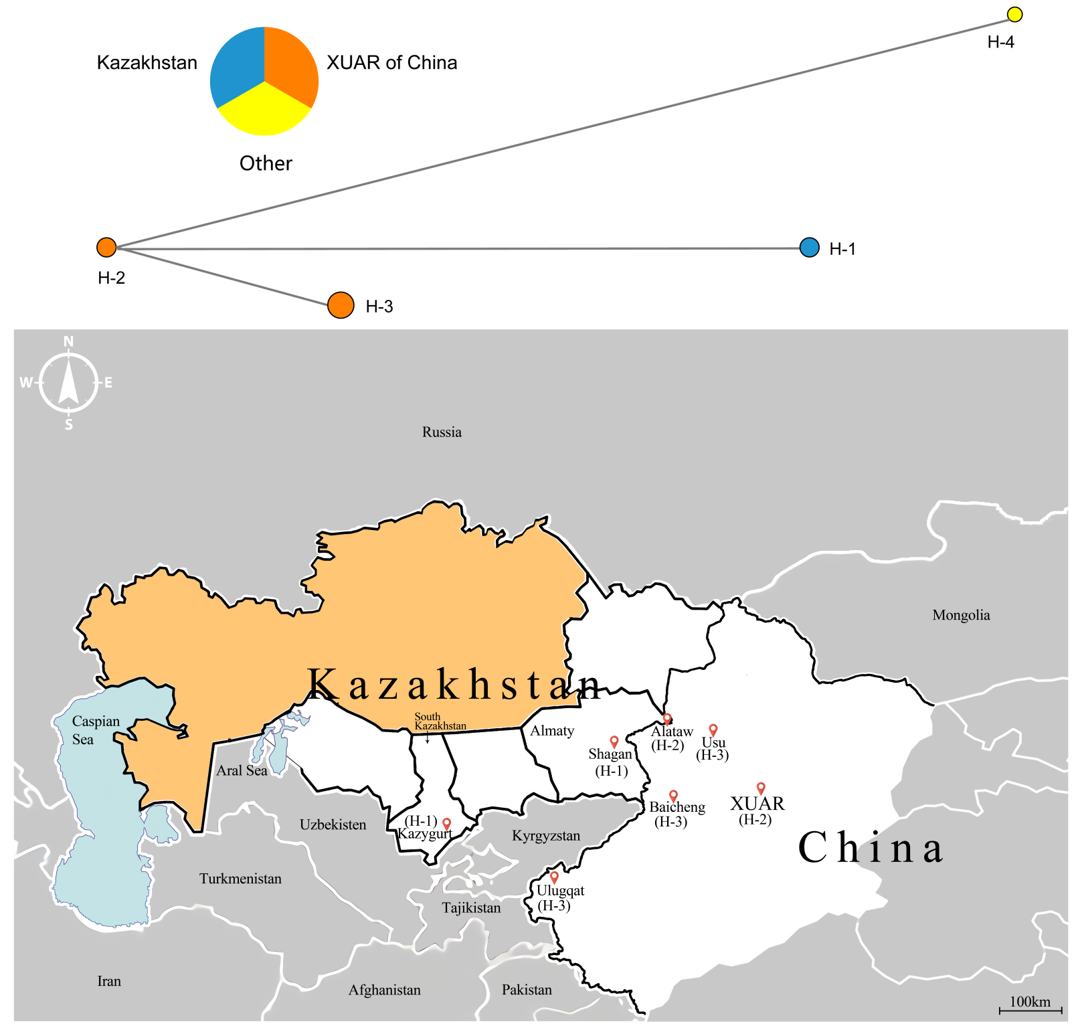
File 2B. The information on geographical distribution, accession numbers and origination for all kinds of haplotypes extracted from Rhipicephalus turanicus.
Haplotype | Country | Oblast/Province | District | Accession number | Tick species | Origination
H-1 | Kazakhstan | Almaty | Shagan City | MN853166 | Rh. turanicus | Cattle
H-1 | Kazakhstan | South Kazakhstan | Kazygurt County, | MN841462 | Rh. turanicus | Shepherd Dog
H-2 | China | XUAR | Alataw City | KU364303 | Rh. turanicus | Sheep
H-2 | China | XUAR | / | KY996841 | Rh. turanicus | Sheep
H-3 | China | XUAR | Baicheng County | MF002579 | Rh. turanicus | Sheep
H-3 | China | XUAR | Usu City | MF002580 | Rh. turanicus | Sheep
H-3 | China | XUAR | Ulugqat County | MF002581 | Rh. turanicus | Sheep
H-4 | Israel | / | / | KF219748 | Rh. turanicus | /

