Appendix File 1
File 1A. Haplotype maps and networks extracted from Hyalomma asiaticum.
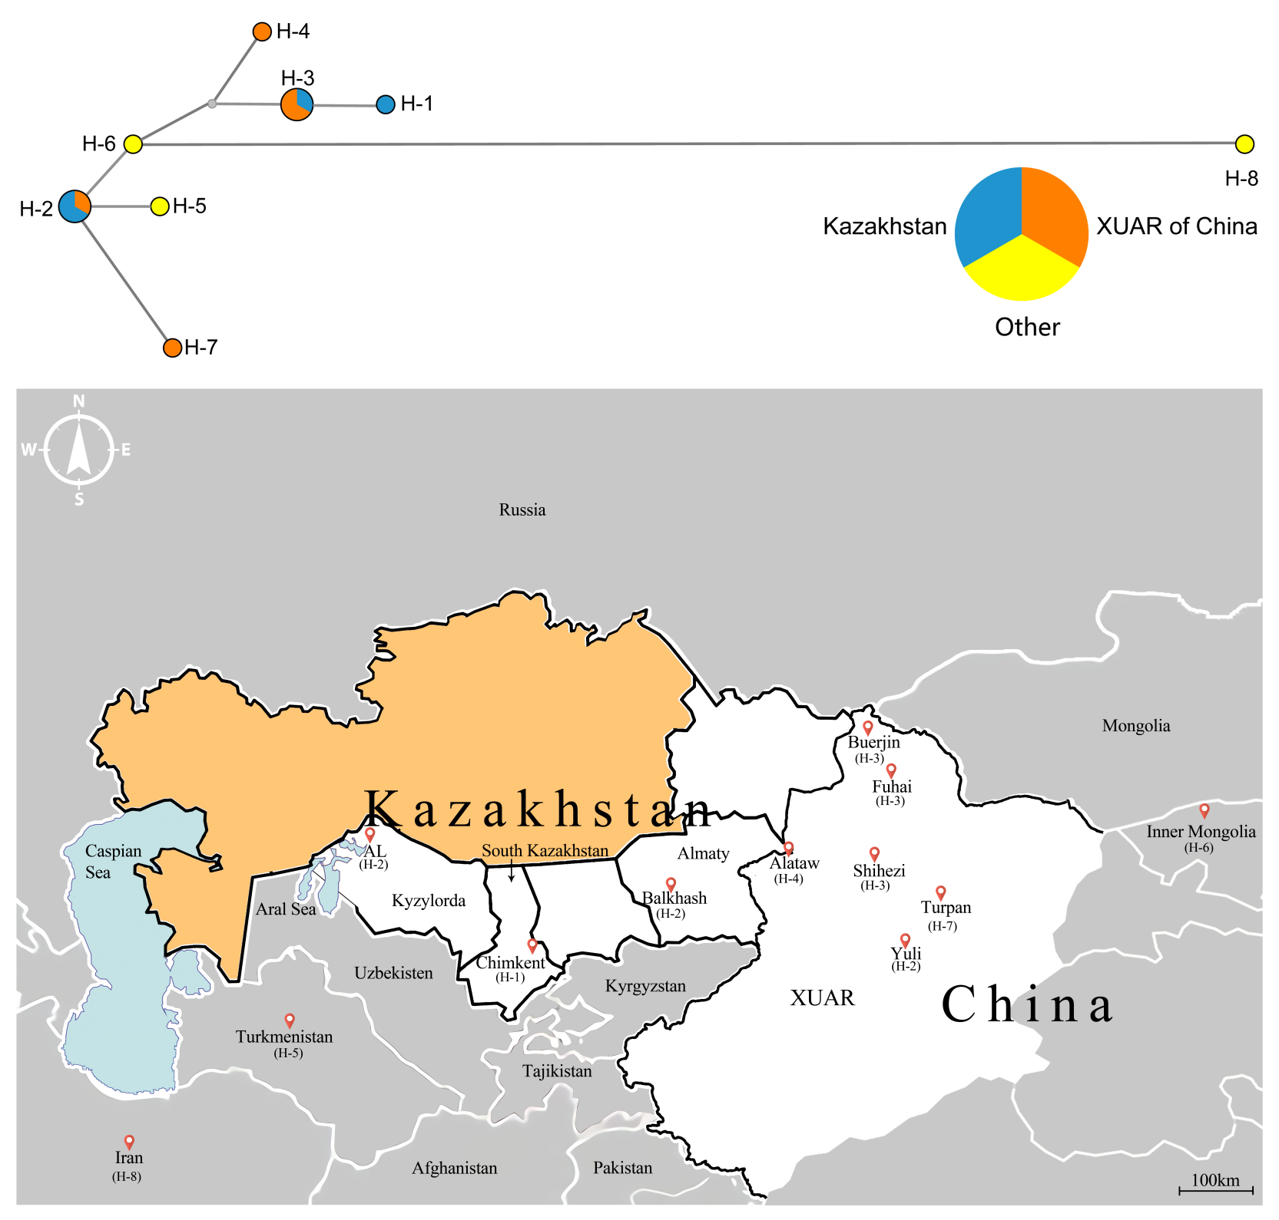
File 1B. The information on geographical distribution, accession numbers and origination for all kinds of haplotypes extracted from Hyalomma asiaticum.
Haplotype | Country | Oblast/Province | District | Accession number | Tick species | Origination
H-1 | Kazakhstan | South Kazakhstan | Chimkent City | MN865123 | Hy. Asiaticum | Cattle
H-2 | Kazakhstan | Almaty | Balkhash County | MN892553 | Hy. Asiaticum | Off host
H-2 | Kazakhstan | Kyzylorda | Aralsk County | MN961479 | Hy. Asiaticum | Camel
H-2 | China | XUAR | Yuli County | KF527440 | Hy. Asiaticum | /
H-3 | China | XUAR | Burqin County | MK610453 | Hy. Asiaticum | Sheep
H-3 | China | XUAR | Shihezi City | MK307807 | Hy. Asiaticum | Sheep
H-3 | China | XUAR | Fuhai County | MK213071 | Hy. Asiaticum | Camel
H-4 | China | XUAR | Alataw City | KX882100 | Hy. Asiaticum | Sheep
H-5 | Turkmenistan | / | / | KU130586 | Hy. Asiaticum | /
H-6 | China | Inner Mongolia | / | JX051135 | Hy. Asiaticum | /
H-7 | China | XUAR | Turpan | KF583578 | Hy. Asiaticum | /
H-8 | Iran | / | / | KR075985 | Hy. Asiaticum | camel

