Supplementary Material

Low-density neutrophils and myeloid-derived suppressor cell subsets as immune indicators of early diagnosis and prognosis in patients with sepsis
Juanjuan Cui, MS¹; Wen Cai, MM¹; Jing Lin, MD¹; Li Zhang, BM²; Youhan Miao, MD³; Ying Xu, MM¹; Weifeng Zhao, MM^{1*}
* Correspondence: Weifeng Zhao Zhaoweifeng@suda.edu.cn

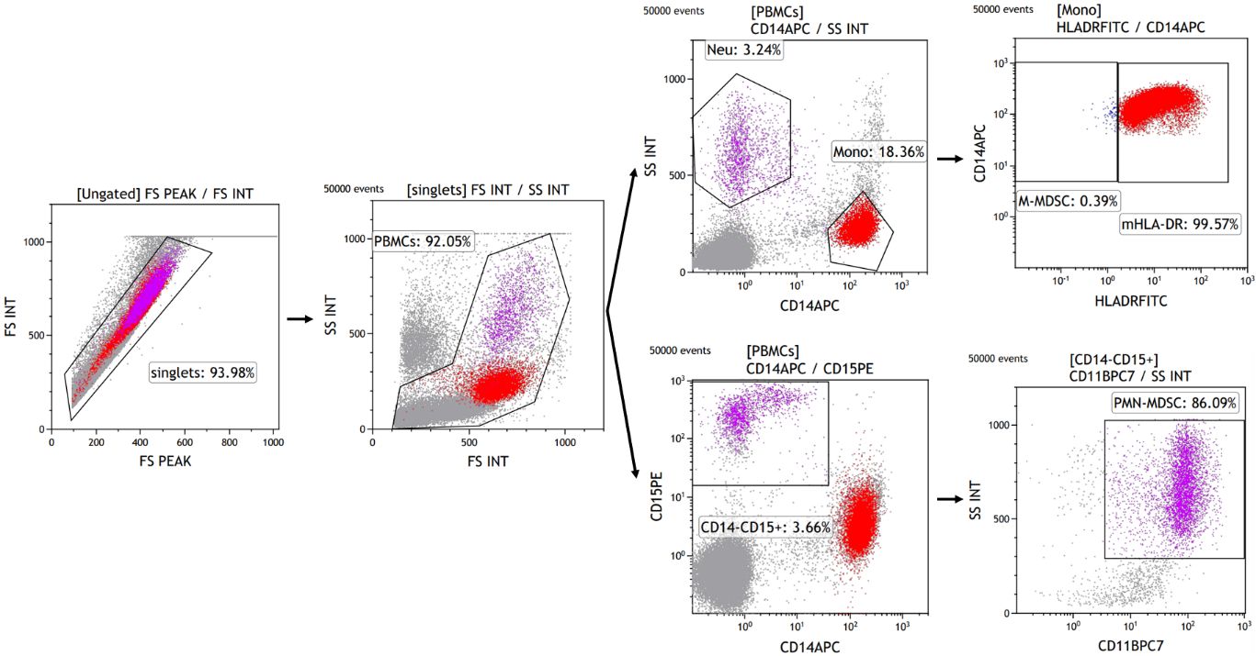
Fig. S1
Gating strategy for the identification of LDNs, M-MDSCs, and PMN-MDSCs. Cell debris and doublets are excluded. Monocytes and neutrophils are gated based on CD14 and SSC parameters. CD14⁺ monocytes are divided into HLA-DR⁺ and HLA-DR⁻ subsets using FMO control. CD14⁺HLA-DR^{-/lo} cells are defined as M-MDSCs. CD14⁻CD15⁺ cells are divided into CD11b⁺ and CD11b⁻ subsets using FMO control. CD14⁻CD15⁺CD11b⁺ cells are defined as PMN-MDSCs. Abbreviations: LDNs, low-density neutrophils; M-MDSCs, monocytic myeloid-derived suppressor cells; PMN-MDSCs, polymorphonuclear myeloid-derived suppressor cells; MDSCs, myeloid-derived suppressor cells.

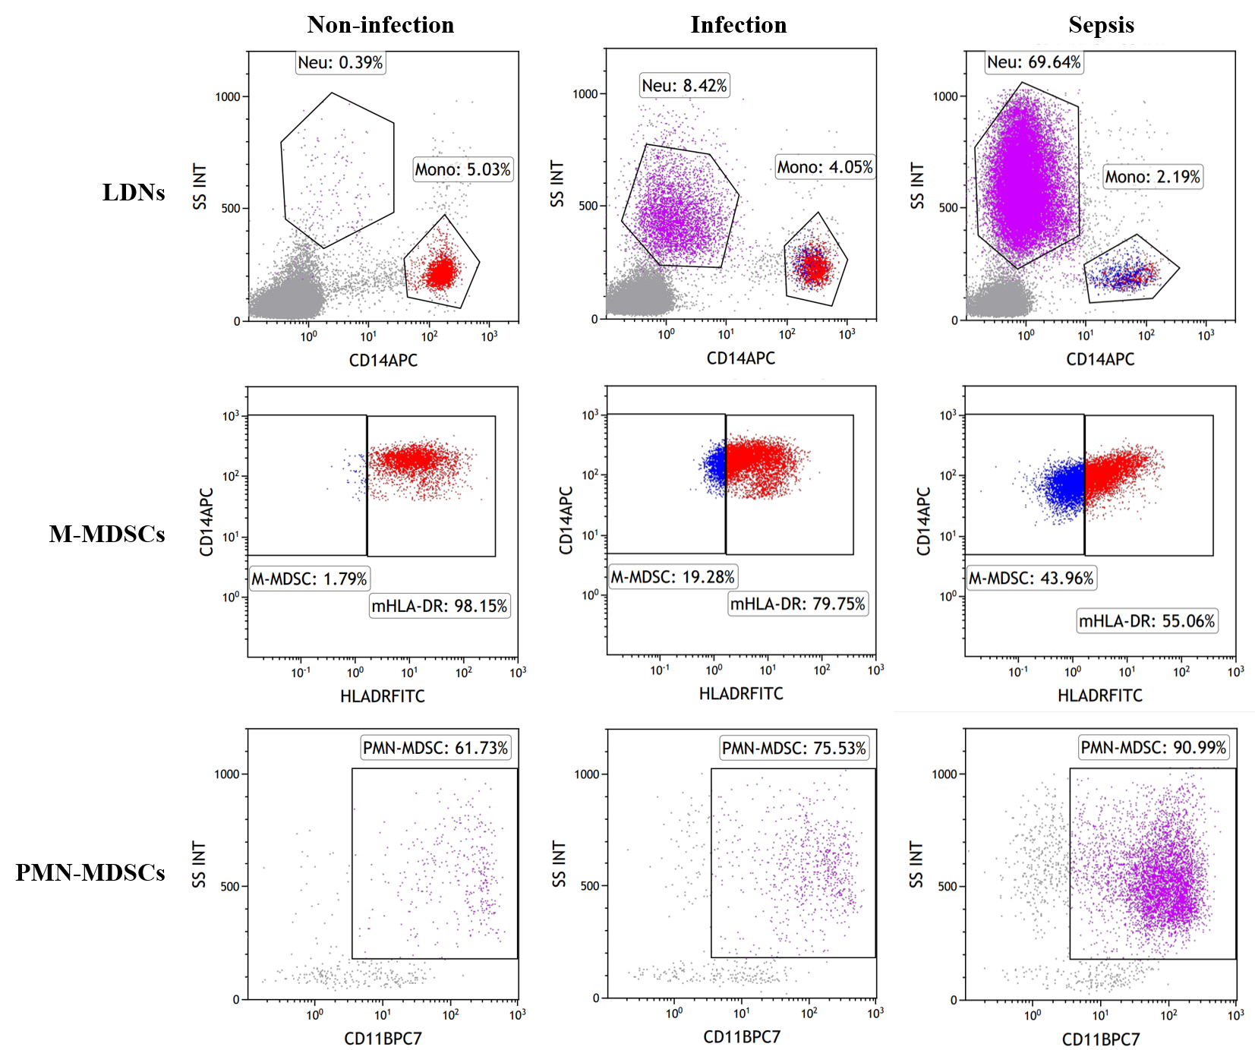
Fig. S2
Typical flow diagrams of LDNs, M-MDSCs, and PMN-MDSCs in healthy controls, infection, and sepsis groups are shown separately. Abbreviations: LDNs, low-density neutrophils; M-MDSCs, monocytic myeloid-derived suppressor cells; PMN-MDSCs, polymorphonuclear myeloid-derived suppressor cells.

Fig. S3
Comparison of LDNs (A), M-MDSCs (B), PMN-MDSCs (C), MDSCs (D), CRP (E), and PCT (F) between patients with sepsis in the non-shock and shock groups. Abbreviations: LDNs, low-density neutrophils; M-MDSCs, monocytic myeloid-derived suppressor cells; PMN-MDSCs, polymorphonuclear myeloid-derived suppressor cells; MDSCs, myeloid-derived suppressor cells; CRP, C-reactive protein; PCT, procalciton.

