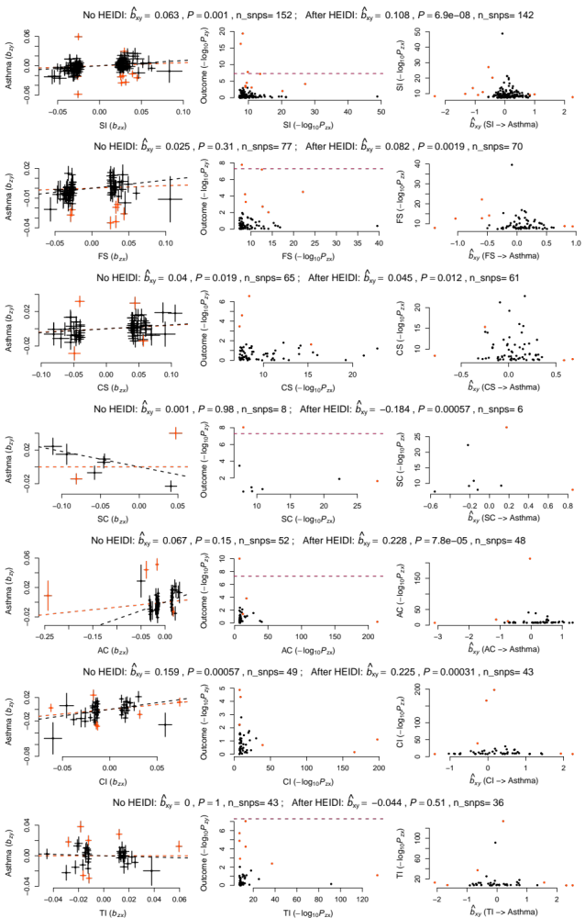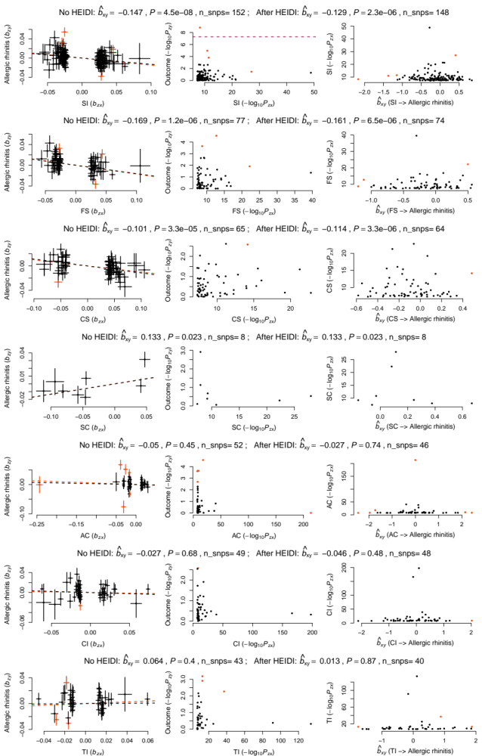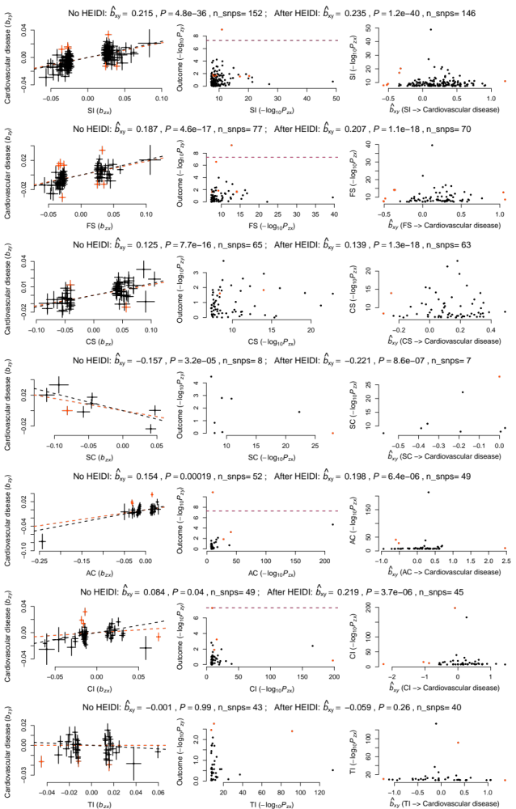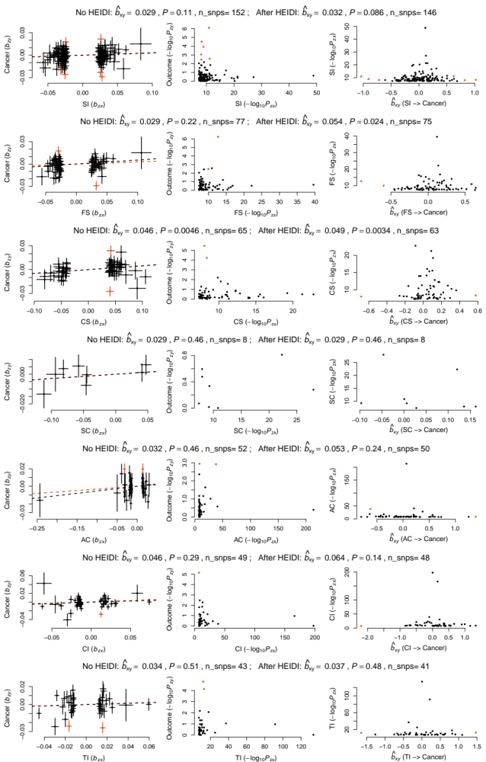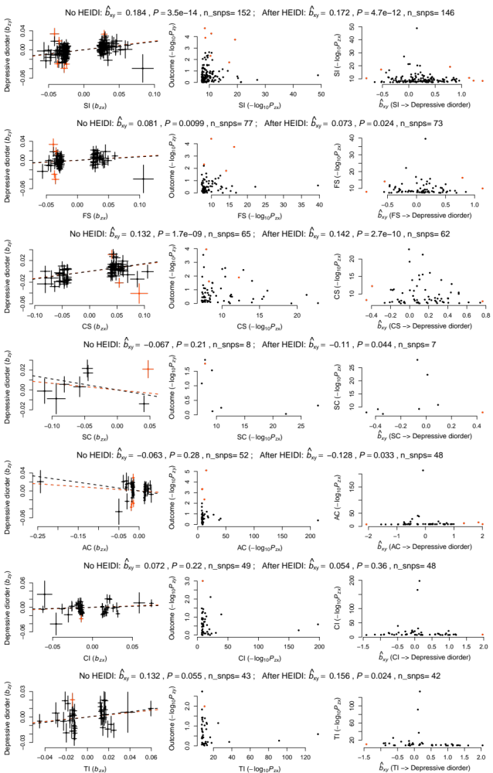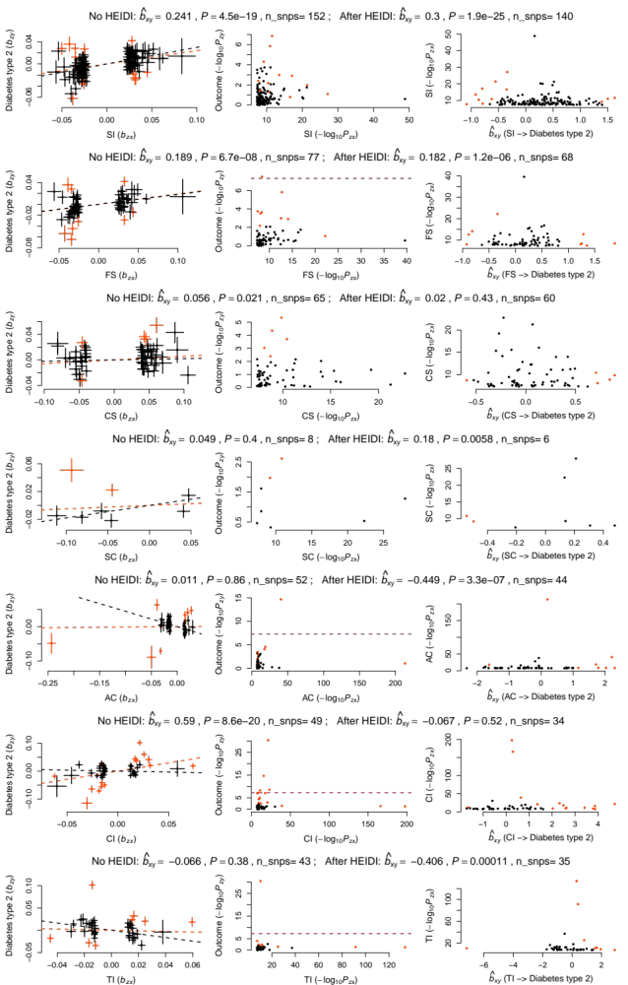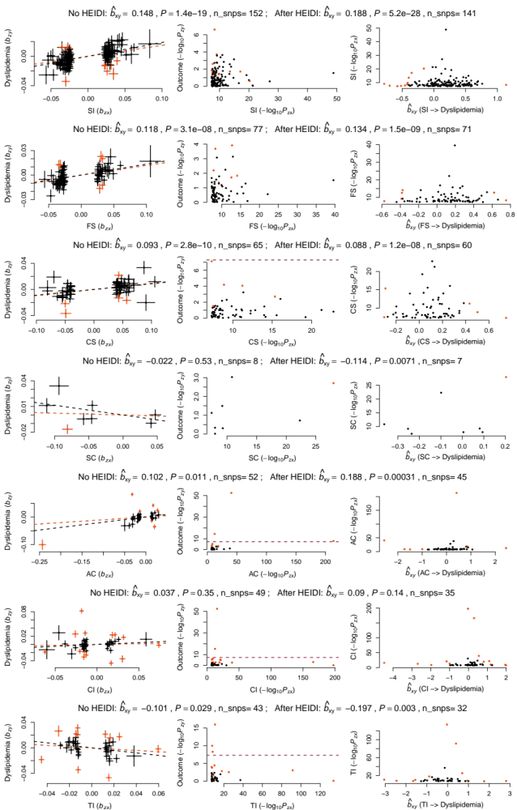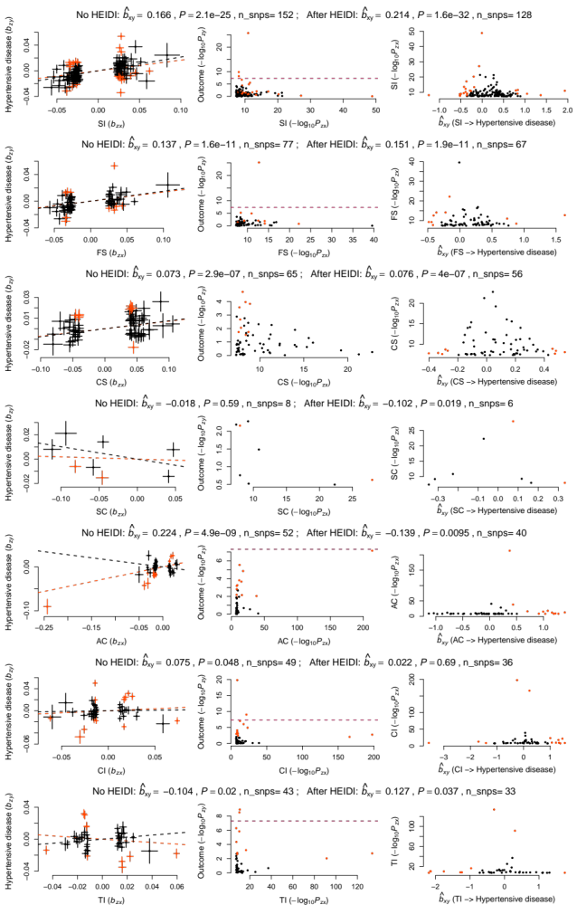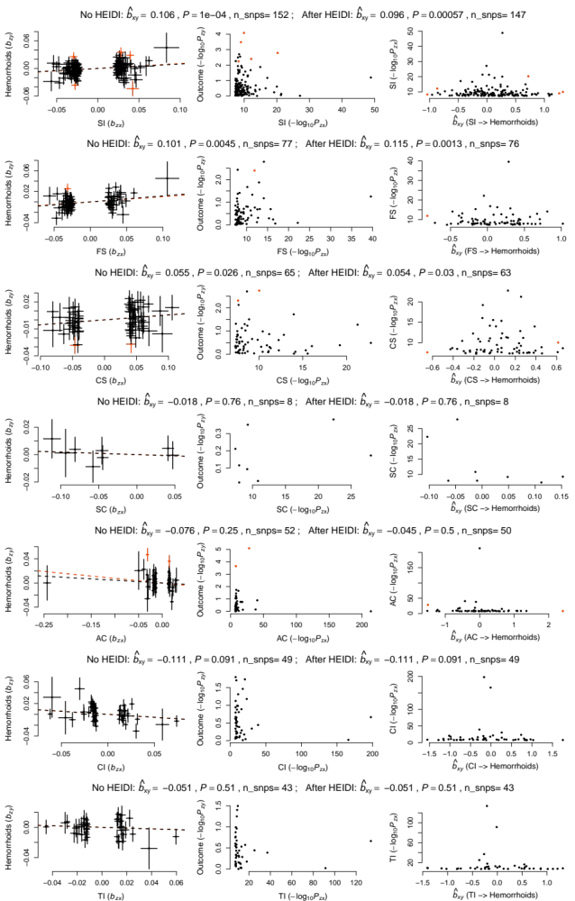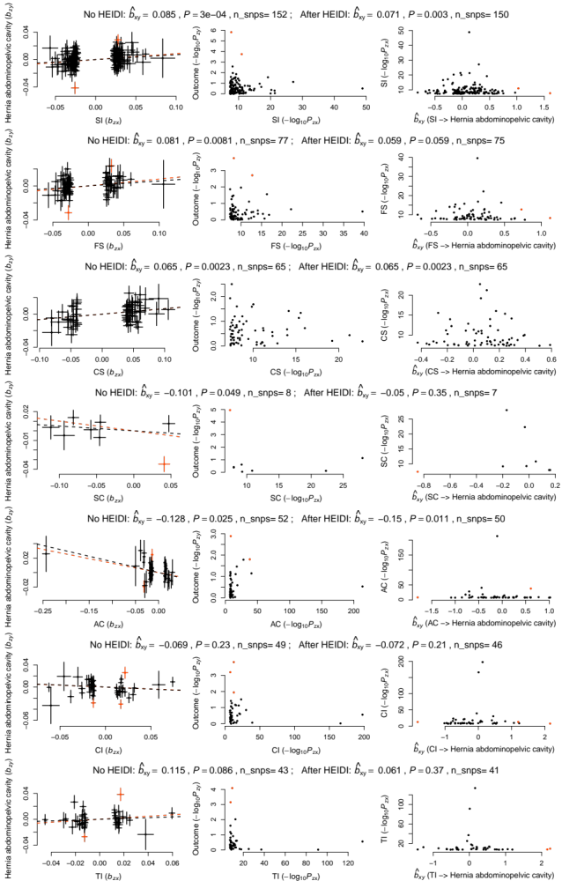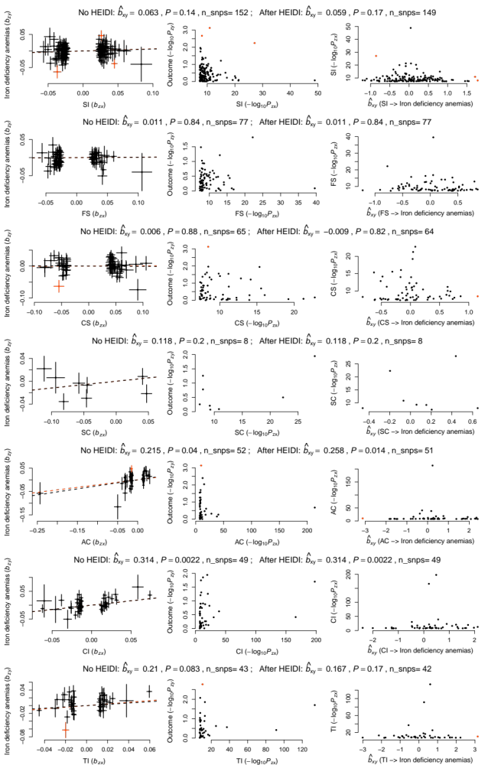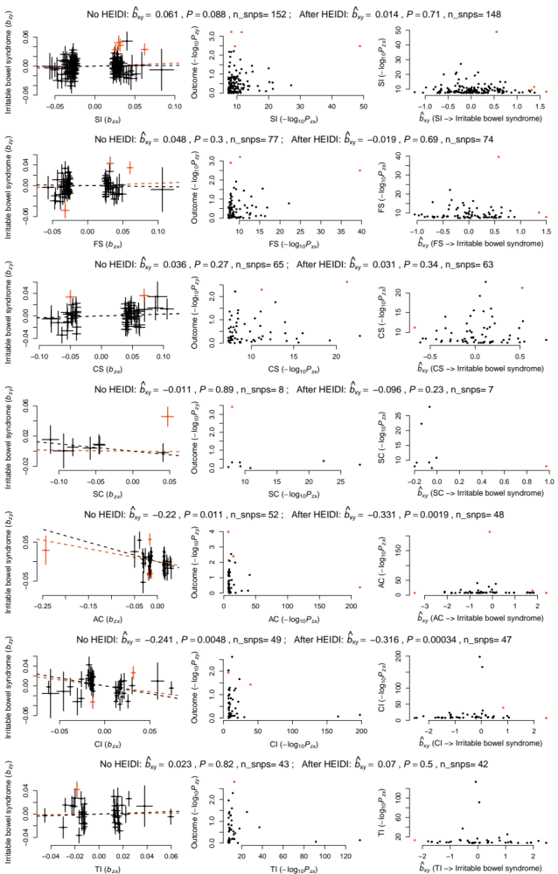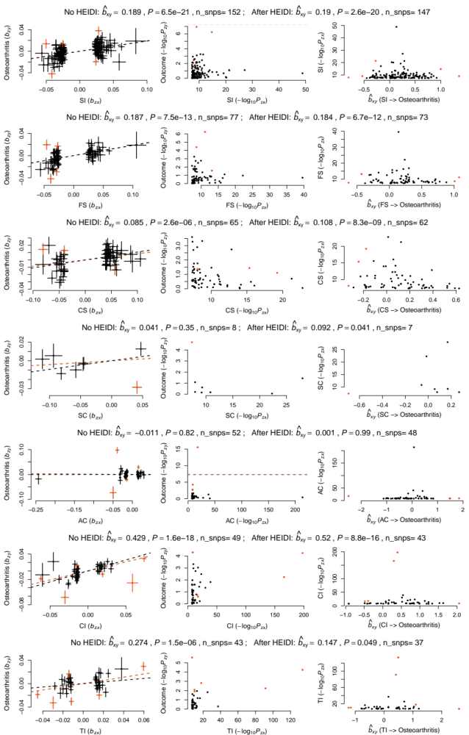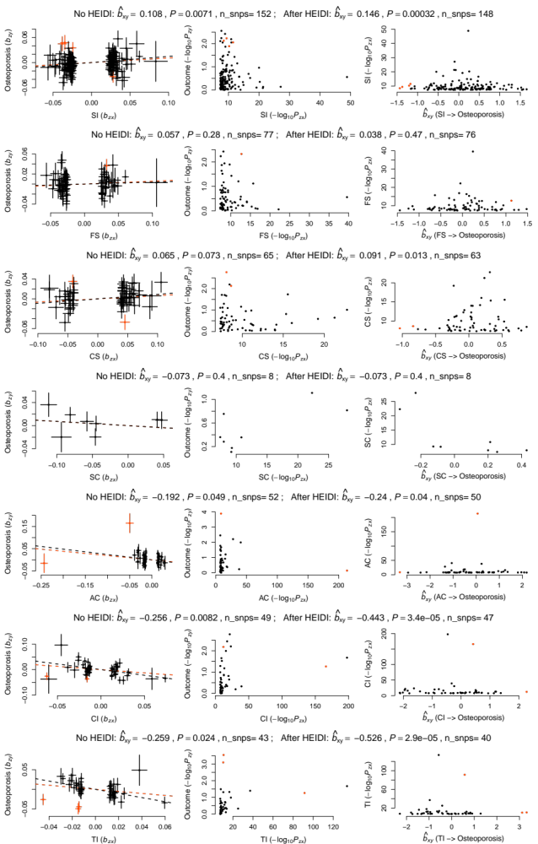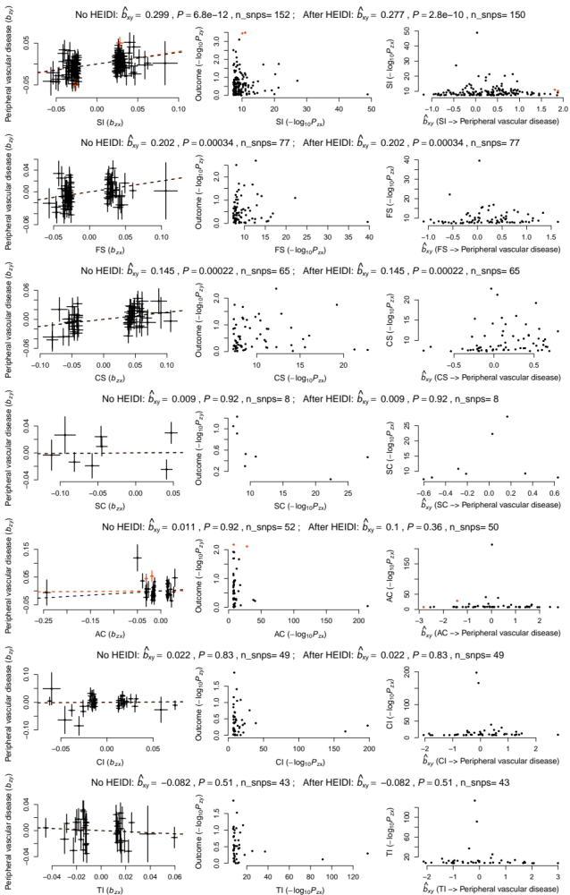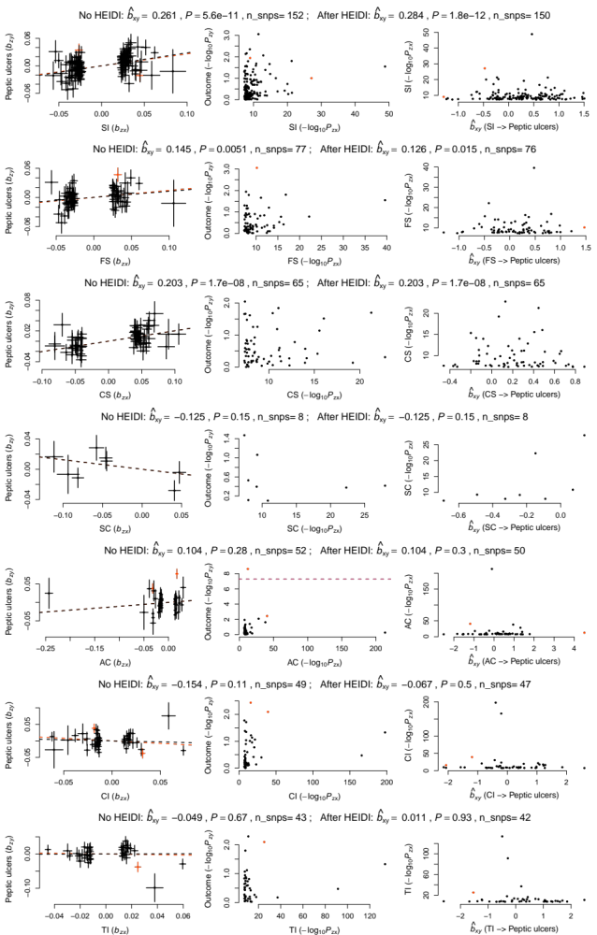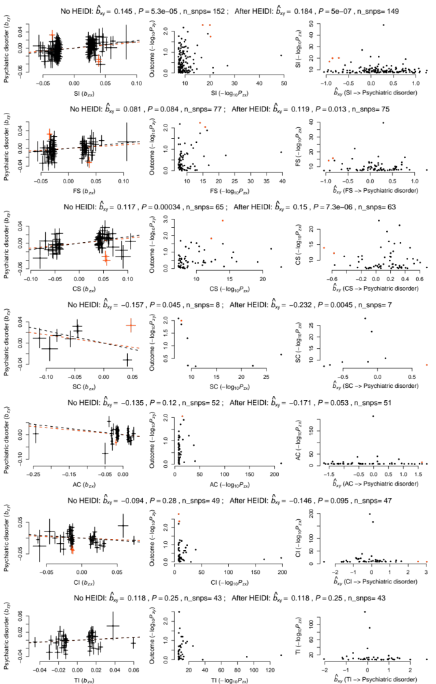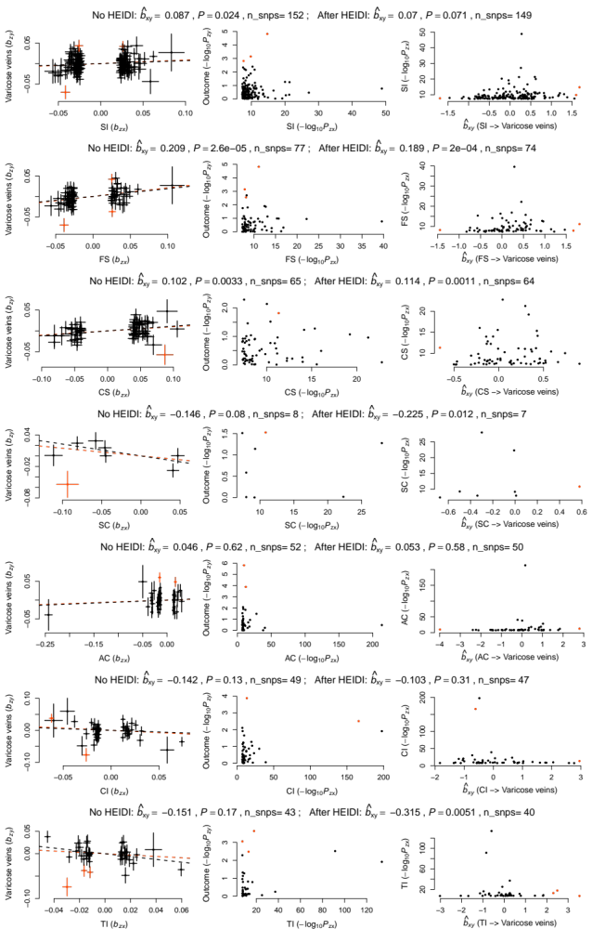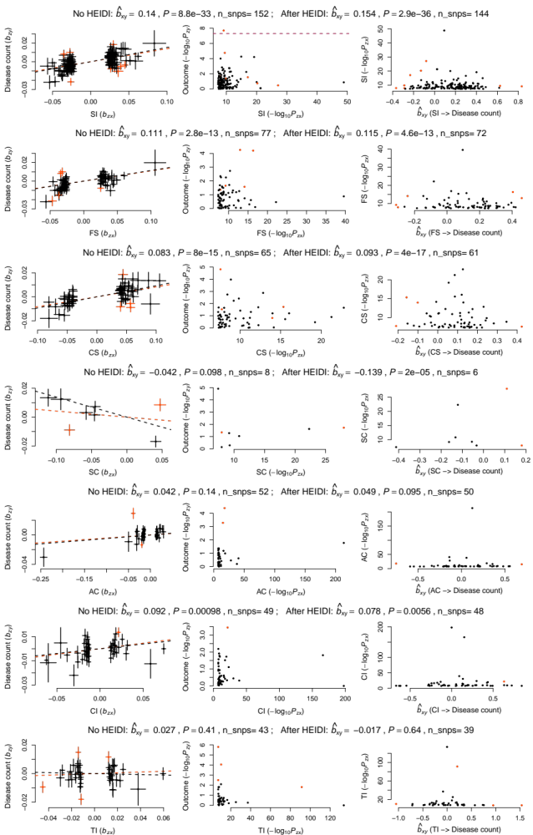
Supplementary Data 1. Causal effect of substance use behaviours on common diseases estimated at individual IVs. Each page indicates one outcome, respectively. The subtitle on the top of each layer shows the causal estimate before and after the HEIDI-outlier filtering. The pleiotropic IVs detected by the HEIDI-outlier test are highlighted in red. In each layer within in one page, the left column shows the SNP effect estimates for the exposure (x-axis) plotted against those for the outcome (y-axis). Each error bar indicates the s.e. of the SNP effect estimate. The slope of the red and black dashed line indicates ${\hat{b}}_{xy}$ before and after HEIDI-outlier filtering, respectively. The middle column shows the -log₁₀(P) of each IV for exposure (x-axis) against that for outcome (y-axis). The right column shows ${\hat{b}}_{xy}$ for each IV (x-axis) against the corresponding GWAS -log₁₀(P) for the exposure (y-axis).

