A Maximal Overlap Discrete Wavelet Packet Transform Coupled with an LSTM Deep Learning Model for Improving Multilevel Groundwater Level Forecasts
Supplementary Information
Environmental Processes

Dilip Kumar Roy^{1,2,3*}, Ahmed A. Hashem^{1,4,5}, Michele L. Reba², John Nowlin¹, Deborah L. Leslie⁶

¹College of Agriculture, Arkansas State University, Jonesboro, AR 72467, United States
²United States Department of Agriculture, Agricultural Research Service Delta Water Management Research Unit, Jonesboro, AR 72467, United States
³Irrigation and Water Management Division, Bangladesh Agricultural Research Institute, Gazipur-1701, Bangladesh
⁴The University of Arkansas System Division of Agriculture, Little Rock, AR 72467, United States
⁵Center for No-Boundary Thinking, Arkansas State University, Jonesboro, AR 72467, United States
⁶Department of Earth Sciences, University of Memphis, Memphis, Tennessee 38152, United States

*Corresponding author: Dilip Kumar Roy, email: dilip.roy@my.jcu.edu.au

LSTM Architecture
A straightforward LSTM architecture may be illustrated by the block diagram presented in Fig. S1.
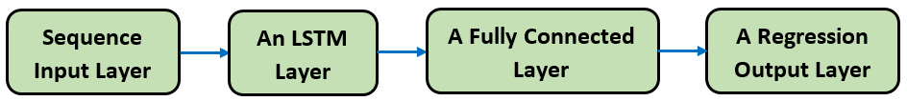
Fig. S1 A simple LSTM architecture to solve regression tasks

By incorporating additional LSTM layers, a deeper and more intricate LSTM network is produced. To prevent model overfitting, dropout layers are frequently added after each new LSTM layer. The architecture of an LSTM network layer showing the propagation of a time series $X$ with $C$ features (channels) of dimension $S$ can be illustrated as presented in Fig. S2.
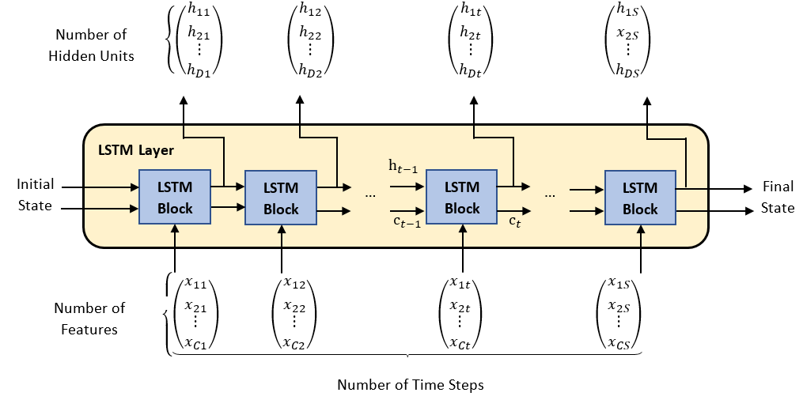
Fig. S2 An LSTM layer architecture (adapted from Roy 2021). C_{t} represents the cell state at the time step t, whereas the concealed state, i.e. the output state at time step t is illustrated by h_{t}

The following four elements are incorporated to guide the hidden and cell states of an LSTM layer:
- Input gate ($i$): Updating cell state at a controlled level;
- Forget gate ($f$): Resetting cell state at a controlled level (forget);
- Cell candidate ($g$): Fill in the cell state with information;
- Output gate ($o$): This gate acts as a cell state regulation level to be added to the hidden state.
The mechanism of forgetting, updating, and producing outputs of the cells and hidden states by the gates of an LSTM architecture is presented in Fig. S3.
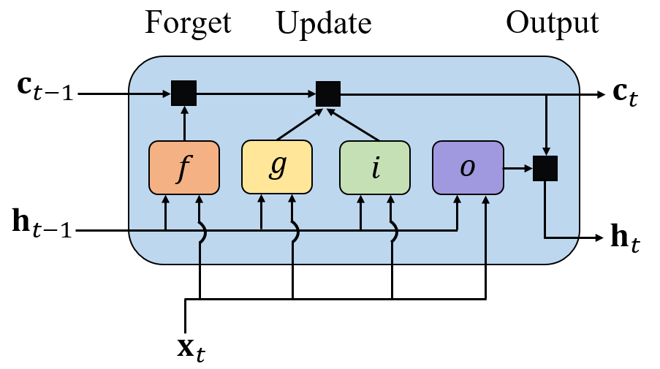
Fig. S3 The process through which gates are updated, forget, and generate output of the cell and hidden states at step t. Here, $X_{t}$ represents input, $h_{t}$ denotes the hidden state, $C_{t}$ is the cell state, $f$ represents the forget gate, $g$ is the memory cell, $i$ and $o$ are the input and output gates, respectively

Sequence-ordered Wavelet Packet Tree
Fig. S4 illustrates a sequence-ordered wavelet packet tree along with the generated coefficients when a time series is wavelet decomposed using the MODWPT.
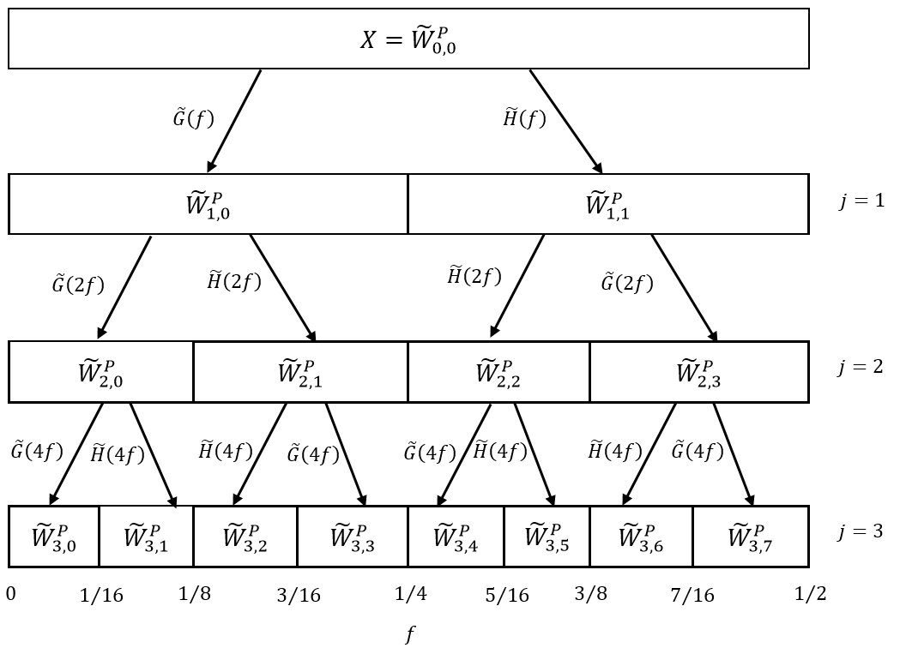
Fig. S4 A sequence-ordered wavelet packet tree representing wavelet decomposition via Maximal Overlap Discrete Wavelet Packet Transform. It shows the wavelet packet transform of $X$ into ${\tilde{W}}_{i,j}^{P}$, $n=0,…,2^{j}-1, for j=1, 2 and 3.$ $\tilde{G}\left(f\right)$ represents the corresponding transfer function of the low-pass filter $\left\{\hat{g_{l}}\right\}$, and $\tilde{H}\left(f\right)$ represents the corresponding transfer function of the high-pass filter $\left\{\hat{h_{l}}\right\}$. $f$ denotes the frequency, which spans over 0 to $\frac{1}{2}$ in the $x$-axis. $j$ represents the decomposition level

For a specified wavelet decomposition level $j \left(j=1,2, and 3\right)$ in Figure S4, the MODWPT returns a set of wavelet packets. Obviously, as the level of decomposition rises, the amount of the generated wavelet packet increases exponentially. As such, a suitable input variable selection method must be conducted to only use the most important wavelet packets while predicting the output variable (Quilty and Adamowski, 2021).

