Supplementary Information for

Prominent tauopathy and intracellular β-amyloid accumulation triggered by genetic deletion of cathepsin D: Implications for Alzheimer disease pathogenesis

Heather M. Terron¹, Sagar J. Parikh¹, Samer O. Abdul-Hay², Tomoko Sahara², Dongcheul Kang²,
Dennis W. Dickson², Paul Saftig³, Frank M. LaFerla^{1,4}, Shelley Lane¹, and Malcolm A. Leissring^{1,2,*}

¹ Institute for Memory Impairments and Neurological Disorders, University of California, Irvine (UCI MIND), Irvine, CA 92697, USA
² Department of Neuroscience, Mayo Clinic Florida, Jacksonville, FL 32224, USA
³ Institut für Biochemie, Christian-Albrechts-Universität zu Kiel, D-24098 Kiel, Germany
⁴ Department of Neurobiology and Behavior, University of California, Irvine, Irvine, CA 92697, USA
Contents
Page Figure Title .
2 Sup Fig. 1 Aβ plaque burden in older APP+ mice and Aβ levels in older APP- mice.
3 Sup Fig. 2 Quantitation of immunohistochemical staining in WT- and KO- mice.
4 Sup Fig. 3 Phospho-tau immunostaining in WT- and KO- mice.
Sup Figure 1

Aβ plaque burden in older APP+ mice and Aβ levels in older APP- mice. (A-C) Amyloid plaque number per section (A) and Aβ-positive area expressed in absolute terms (B) and as a percentage of total tissue area (C). Data are mean ± SEM, n=14-17 brains per genotype. (D,E) Steady-state levels of insoluble (D) and soluble (E) endogenous murine cerebral Aβ40 (left) and Aβ42 (right) in 10-month-old WT- and HET- mice. Data are normalized to WT- mice and are expressed as mean ± SEM, n=6 brains per genotype. ns=not significant.

Sup Figure 2

Quantitation of immunohistochemical staining in WT- and KO- mice. (A-E) Relative intensity of immunostaining for CatD (A), total Aβ (B), ubiquitin (C), and GFAP (D), and relative intensity of Gallyas silver staining (E) in cortex (CTX) and hippocampal CA1 (CA1) and dentate gyrus (DG) regions of WT- and KO- mouse brain sections determined using QuPath [62]. Data are mean ± SEM, n=3-6 sections per genotype and are normalized to WT- levels. (F) Relative thioflavin-S fluorescence in 3-week-old WT- and KO- (n=6-7) and 12-week-old Krabbe A (n=3) brains determined from ImageJ analysis of scanned thioflavin S (Thio S) fluorescence (λ_{ex}=485 nm, λ_{em}=515 nm) images. Data are mean ± SEM normalized to WT- controls. *P<0.05; ***P<0.001; ****P<0.0001; ns=not significant.

Sup Figure 3

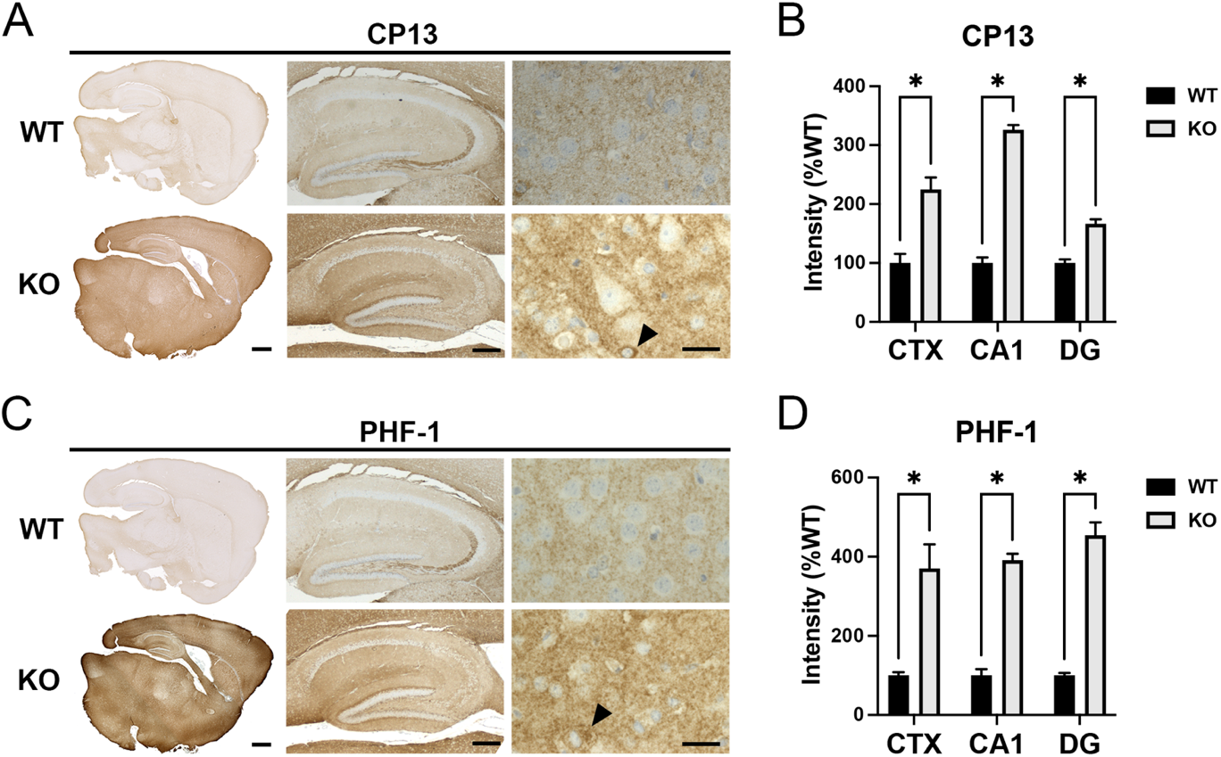

Phospho-tau immunostaining in WT- and KO- mice. (A,B) Representative images (A) and quantitation of multiple images (B) of WT- and KO- brains stained with the phospho-tau antibody, CP13, in cortex (CTX) and hippocampal CA1 (CA1) and dentate gyrus (DG) regions. (C,D) Representative images (C) and quantitation of multiple images (D) of WT- and KO- brains stained with the phospho-tau antibody, PHF-1, in cortex (CTX) and hippocampal CA1 (CA1) and dentate gyrus (DG) regions. Note that KO- brains stained for both CP13 (A) and PHF-1 (B) feature intense perinuclear phospho-tau staining evident at high resolution (bottom right panels, arrowheads). Scale bars are 1 mm (left panels), 500 µm (middle panels), and 50 µm (right panels). Data in (B) and (D) are mean ± SEM, n=6 per genotype. *P<0.05

