Table S1 Mathematical definitions of the global parameters of a given network G (N, M) with N nodes and M edges. The detailed descriptions of these network parameters can also be found in Rubinov and Sporns (2010).
Global parameters | Definitions | Descriptions
Clustering coefficient ($C_{p}$) | $$C_{p}=\frac{1}{Ns_{i}(k_{i}-1)}\sum_{j,h∈G}{\frac{(w_{ij}+w_{ih})}{2}}a_{ij}a_{ih}a_{jh}$$ | The w_{ij} is the weight between node i and j in a network and s_{i} is the strength of node i. C_{p} is the mean of the weighted clustering coefficients over all nodes in a network, which indicates the extent of local interconnectivity or cliquishness in a network.
Characteristic path length ($L_{p})$ | $$L_{p}=\frac{1}{N(N-1)}\sum_{i=1}^{N}{\sum_{j=1, j≠i}^{N}{L_{ij}}}$$ | N is the total number of nodes. L_{ij} is the characteristic path length between nodes i and j. L_{w} measures a harmonic mean length between all pairs of nodes and quantifies the ability for information propagation in parallel over the whole network.
Global efficiency ($E_{glob})$ | $$E_{glob}=1/{L_{p}}$$ | E_{glob} is the inverse of the harmonic mean of the characteristic path length between each pair of nodes within the network. E_{glob} measures the global efficiency of parallel information transfer in the network.
Local Efficiency ($E_{loc})$ | $$E_{loc}=\frac{1}{N}\sum_{i=1}^{N}{E_{glob}\left(G_{i}\right)}$$ | E_{glob} (G_{i}) indicates the global efficiency of the subgraph G_{i} composed of the neighbors of node i. E_{loc} is the average of the local efficiencies across all nodes. It reflects how the communication efficient changes among the neighbors of node i when node i is removed.
Nodal strength ($S_{i}^{w}$) | $$S_{i}^{w}=\sum_{j∈N}{W_{ij}}$$ | $S_{i}^{w}$ is the sum of the edge weights of all the connections of node i. It quantifies the extent to which a node is relevant to the graph.
Nodal efficiency ($E_{i}^{w}$) | $$E_{i}^{w}=\frac{1}{N-1}\sum_{j≠i∈G}{\frac{1}{L_{ij}}}$$ | $L_{ij}$ is the weighted characteristic path length between nodes i and j in the network.

Table S2 Cluster locations and peak coordinates corresponding to the significant difference in the whole-brain map of subcortical region between high creativity group (HCG) and low creativity group (LCG). The statistical significance is set at p <0.05 (Threshold-Free Cluster Enhancement correction, TFCE-correction). Abbreviation: THA, thalamus; INS, insula; PAL, pallidum; FFG, fusiform; MTG, middle temporal gyrus; PHG, parahippocampal gyrus; ORBmid, middle frontal gyrus (orbital part); L (R), left (right) hemisphere.
Seed region  (Subcortical ROI) | Cluster location | peak coordinate |  |  | Number of voxel  (# voxels) | t value
Seed region  (Subcortical ROI) | Cluster location | x | y | z | Number of voxel  (# voxels) | t value
L.THA | L.INS | -27 | 24 | 3 | 672 | 4.62
R.PAL | L.FFG | -30 | -30 | -21 | 78 | 3.73
 | L.MTG | -48 | -39 | 0 | 2022 | 4.21
 | R.PHG | 30 | -30 | 18 | 55 | 4.54
 | L.PHG | -12 | 12 | 42 | 1342 | 4.45
 | L.ORBmid | -33 | 54 | -3 | 146 | 3.77

Table S3 Significant differences in functional connectivity (FC) within subcortical network between high creativity group (HCG) and low creativity group (LCG). The statistical significance is set at p < 0.05 (false discovery rate correction, FDR-correction). Each FC is given as mean ± SD. Abbreviation: PUT, putamen; THA, thalamus; PAL, pallidum; L (R), left (right) hemisphere.
FC within subcortical network | HCG | LCG | p-value | effect size  (cohen’s d)
L.PUT – R.PUT | 0.93 ± 0.02 | 0.90 ± 0.05 | 0.0012 | 0.78
L.PUT – R.PAL | 0.80 ± 0.07 | 0.72 ± 0.08 | 0.0006 | 1.06
L.THA – R.PUT | 0.59 ± 0.12 | 0.47 ± 0.13 | 0.0002 | 0.96
L.THA – R.PAL | 0.63 ± 0.14 | 0.50 ± 0.13 | 0.0010 | 0.96
R.PUT – R.PAL | 0.83 ± 0.06 | 0.76 ± 0.07 | 0.0014 | 1.07

Table S4 Differences in global parameters of the subcortical networks between high creativity group (HCG) and low creativity group (LCG). The statistical significance is set at *p <0.05 (uncorrected). Each parameter is given as mean ± SD.
Global parameters | HCG | LCG | p-value | effect size  (cohen’s d)
Clustering coefficient ($C_{p}$) | 0.57 ± 0.06 | 0.53 ± 0.08 | 0.0330* | 0.57
Characteristic path length ($L_{p}$) | 1.95 ± 0.46 | 2.07 ± 0.29 | 0.1584
Local efficiency ($E_{loc}$) | 0.60 ± 0.05 | 0.56 ± 0.07 | 0.0190* | 0.66
Global efficiency ($E_{glob}$) | 0.53 ± 0.09 | 0.49 ± 0.07 | 0.0550

Table S5 Significant differences in averaged dynamic functional connectivity (dFC) within subcortical network between high creativity group (HCG) and low creativity group (LCG). The statistical significance is set at p <0.05 (false discovery rate correction, FDR-correction). Each averaged dFC is given as mean ± SD. Abbreviation: PUT, putamen; THA, thalamus; PAL, pallidum; L (R), left (right) hemisphere.
dFC within subcortical network | Averaged dFC |  | p-value | effect size  (cohen’s d)
dFC within subcortical network | HCG | LCG | p-value | effect size  (cohen’s d)
L.PUT – R.PUT | 0.92 ± 0.03 | 0.88 ± 0.05 | 0.0002 | 0.97
L.PUT – R.PAL | 0.78 ± 0.08 | 0.70 ± 0.09 | 0.0014 | 0.94
L.THA – R.PUT | 0.57 ± 0.12 | 0.44 ± 0.13 | 0.0010 | 1.04
L.THA – R.PAL | 0.61 ± 0.13 | 0.49 ± 0.11 | 0.0006 | 1.00
R.PUT – R.PAL | 0.81 ± 0.07 | 0.74 ± 0.08 | 0.0014 | 0.93
R.THA – R.PAL | 0.66 ± 0.11 | 0.55 ± 0.12 | 0.0006 | 0.96
R.THA – R.PUT | 0.60 ± 0.12 | 0.49 ± 0.13 | 0.0010 | 0.88

Table S6 Significant differences in variance of dynamic functional connectivity (dFC) within subcortical network between high-creativity group (HCG) and low-creativity group (LCG). The statistical significance is set at p < 0.05 (false discovery rate correction, FDR-correction). Each variance of dFC is given as mean ± SD. Abbreviation: AMY, amygdala; PUT, putamen; THA, thalamus; PAL, pallidum; HIPP, hippocampus; L (R), left (right) hemisphere.
dFC within subcortical network | Variance of dFC |  | p-value | effect size  (cohen d)
dFC within subcortical network | HCG | LCG | p-value | effect size  (cohen d)
L.AMY – L.PAL | 0.21 ± 0.05 | 0.26 ± 0.06 | 0.0002 | 0.91
L.AMY – L.THA | 0.20 ± 0.06 | 0.26 ± 0.06 | 0.0012 | 1.00
L.AMY – R.THA | 0.21 ± 0.06 | 0.27 ± 0.06 | 0.0002 | 1.00
L.HIPP – R.PAL | 0.25 ± 0.05 | 0.30 ± 0.05 | 0.0020 | 1.00
L.HIPP – R.PUT | 0.26 ± 0.05 | 0.31 ± 0.06 | 0.0008 | 0.91
L.PAL – R.AMY | 0.22 ± 0.06 | 0.27 ± 0.05 | 0.0024 | 0.91
L.THA – R.THA | 0.05 ± 0.02 | 0.07 ± 0.03 | 0.0024 | 0.78
R.THA – R.AMY | 0.21 ± 0.05 | 0.26 ± 0.07 | 0.0016 | 0.82
R.HIPP – R.PAL | 0.25 ± 0.05 | 0.30 ± 0.06 | 0.0008 | 0.91

Table S7 The variance of global parameters of subcortical network for both high creativity group (HCG) and low creativity group (LCG). Each parameter is given as mean ± SD. *p <0.05 (FWE-corrected)

Global parameters | HCG | LCG | p-value | effect size (cohen’s d)
Clustering coefficient ($C_{p}$) | 0.08 ± 0.01 | 0.09 ± 0.02 | 0.0588
Characteristic path length ($L_{p}$) | 0.32 ± 0.12 | 0.40 ± 0.14 | 0.0058* | 0.61
Local efficiency ($E_{loc}$) | 0.07 ± 0.01 | 0.08 ± 0.02 | 0.0052* | 0.63
Global efficiency ($E_{glob}$) | 0.09 ± 0.01 | 0.09 ± 0.02 | 0.0616

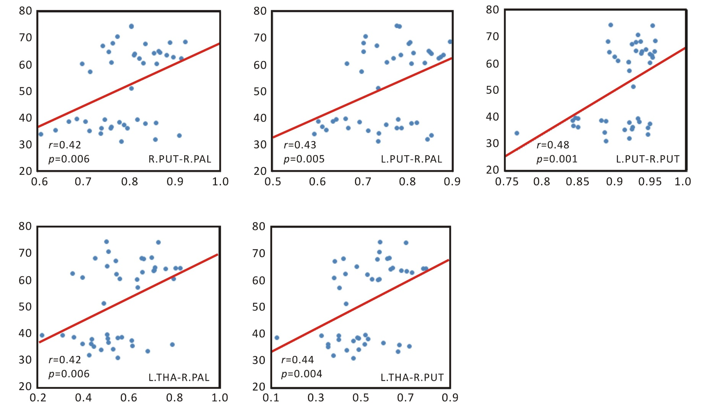
Figure S1 Correlation between the functional connectivity (FC) and the figural Torrance Tests of Creative Thinking (f-TTCT) scores. Both FC were significantly (p <0.05, FDR-correction) positively correlated with the f-TTCT scores.

