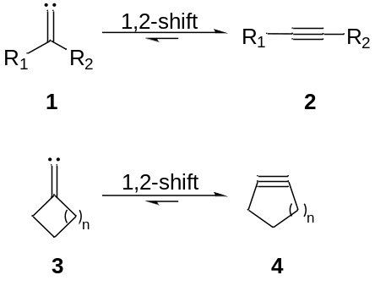
Scheme 1. Fritsch–Buttenberg–Wiechell (FBW) of acyclic and exocyclic alkylidene carbenes

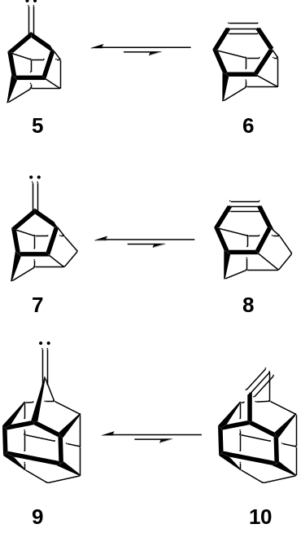
Scheme 2. Polycyclic alkylidene carbenes for which FBW rearrangements are thermodynamically unfavorable
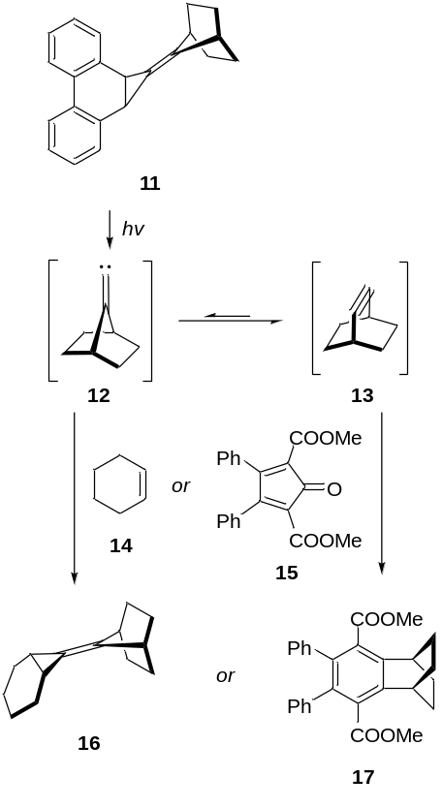
Scheme 3. Photochemical generation and trapping of the 7-norbornylidenecarbene 12 and bicyclo[2.2.2]oct-2-yne (13)

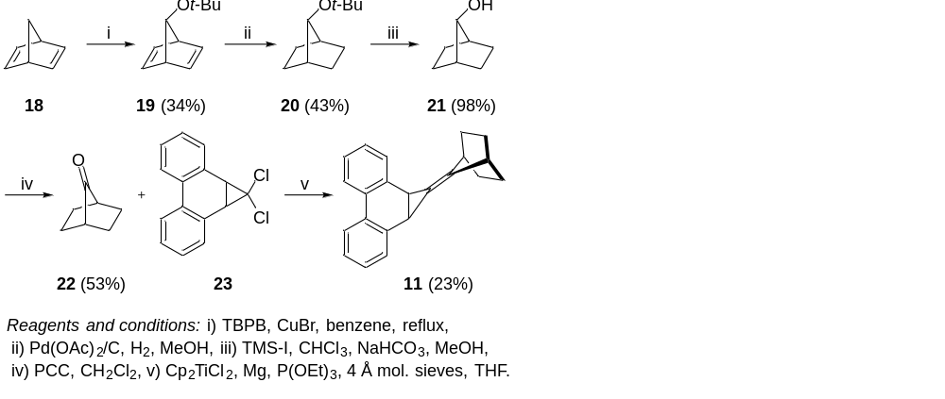
Scheme 4. Synthesis of alkylidenecarbene precursor 11

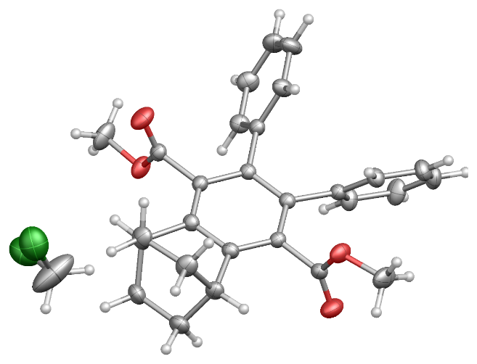
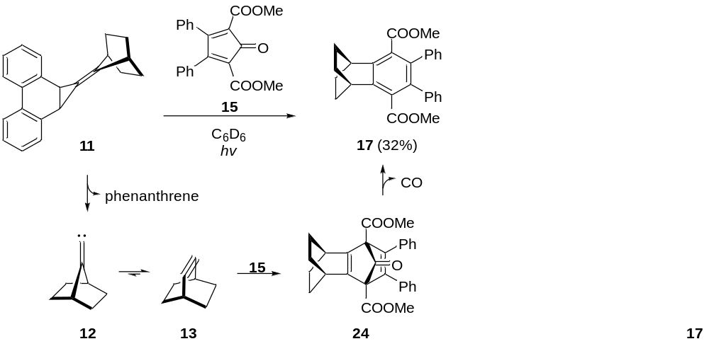
Scheme 5. Trapping of bicyclo[2.2.2]octyne (13), and confirmation of the identity of product 17 by X-ray crystallography (ellipsoids set at 50% probability)

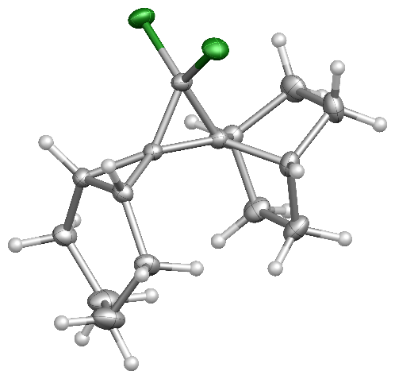
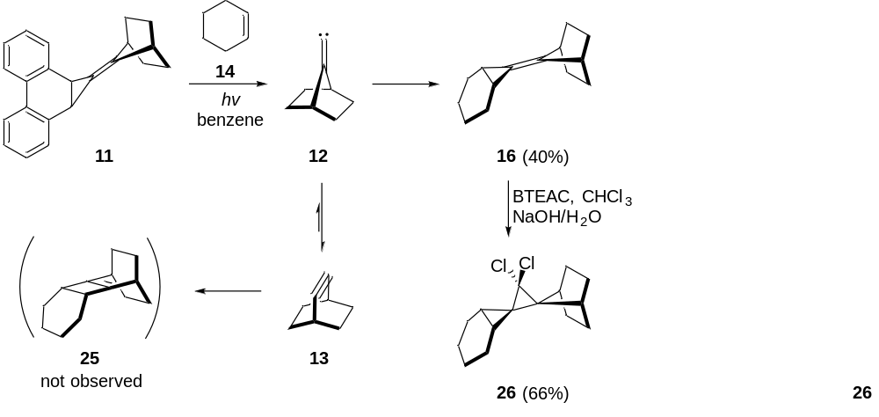
Scheme 6. Trapping of norbornylidenecarbene 12, and confirmation of the identity of product 26 by X-ray crystallography (ellipsoids set at 50% probability)

