Supplemental material
Table 1. Echocardiographic measurements in mice.
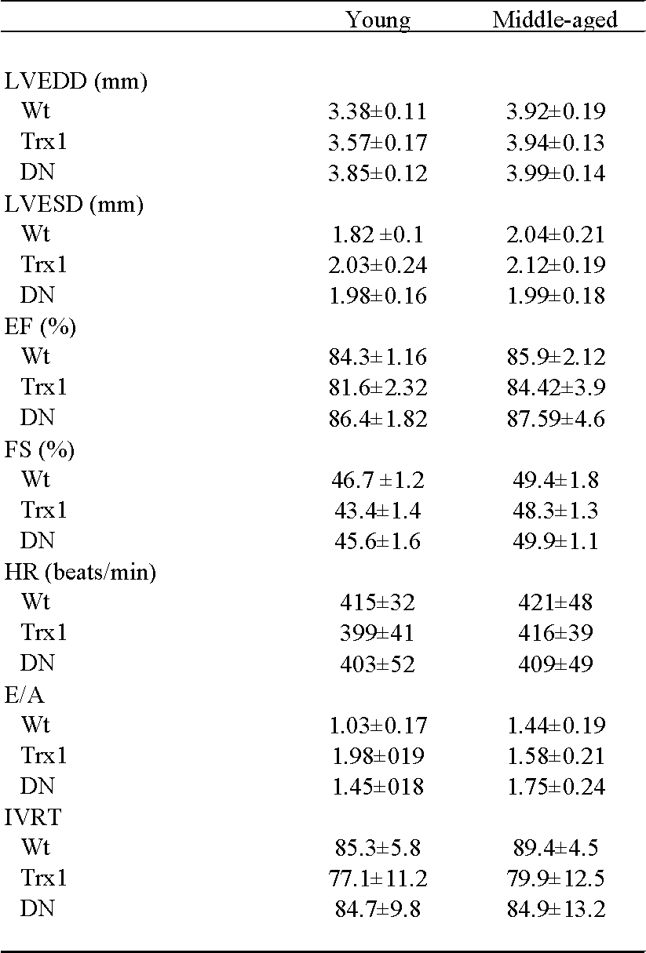
Notes. LVEDD: Left ventricular end-diastolic diameter; LVESD: Left ventricular end-systolic diameter; EF%: Ejection fraction; FS%: Fractional shortening. HR: Heart rate; E/A: ratio of peak velocity of early to late filing of mitral inflow; IVRT: isovolumetric relaxation time. Wt: wild type; Trx1: transgenic mice thioredoxin-1 overexpression; DN: transgenic mice dominant negative thioredoxin overexpression. n= 4 each group.
Table 2. Left Ventricular function in mice.
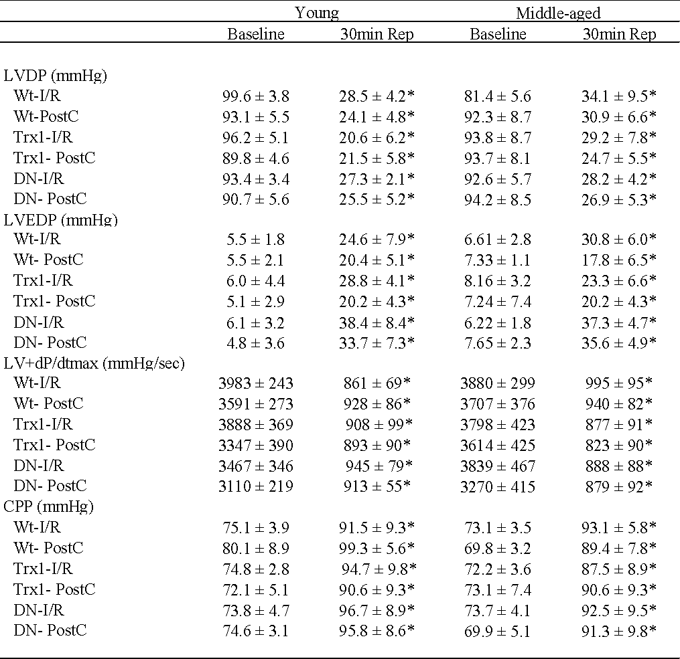
Notes. LVDP: Left ventricular developed pressure; LVEDP: Left ventricular end diastolic pressure;LV +dP/dt_{max}: Left ventricular maximal rate of pressure increase; CPP: coronary perfusion pressure. Rep: Reperfusion. Wt: wild type; Trx1: transgenic mice thioredoxin-1 overexpression; DN: transgenic mice dominant negative thioredoxin overexpression; I/R: Ischemia/Reperfusion; PostC: ischemic postconditioning. Wt groups: n= 9 in I/R Y, n=8 in others; Trx1 groups: n=9 in I/R Y, n=6 in PostC MA and n=8 in others and DN-Trx1 groups: n=9 in I/R Y, n=8 in PostC Y, n=7 in I/R MA and n=6 in PostC MA.

