Microbial Ecology
Supplementary material

“A genetically modified anti-Plasmodium bacterium is harmless to the stingless bee Partamona helleri (Apidae: Meliponini)”

Thaís Andrade Viana; Wagner Faria Barbosa; Lorena Lisbetd Botina Jojoa; Rodrigo Cupertino Bernardes; Juliana Soares da Silva; Marcelo Jacobs-Lorena; Gustavo Ferreira Martins

Corresponding author:

gmartins@ufv.br

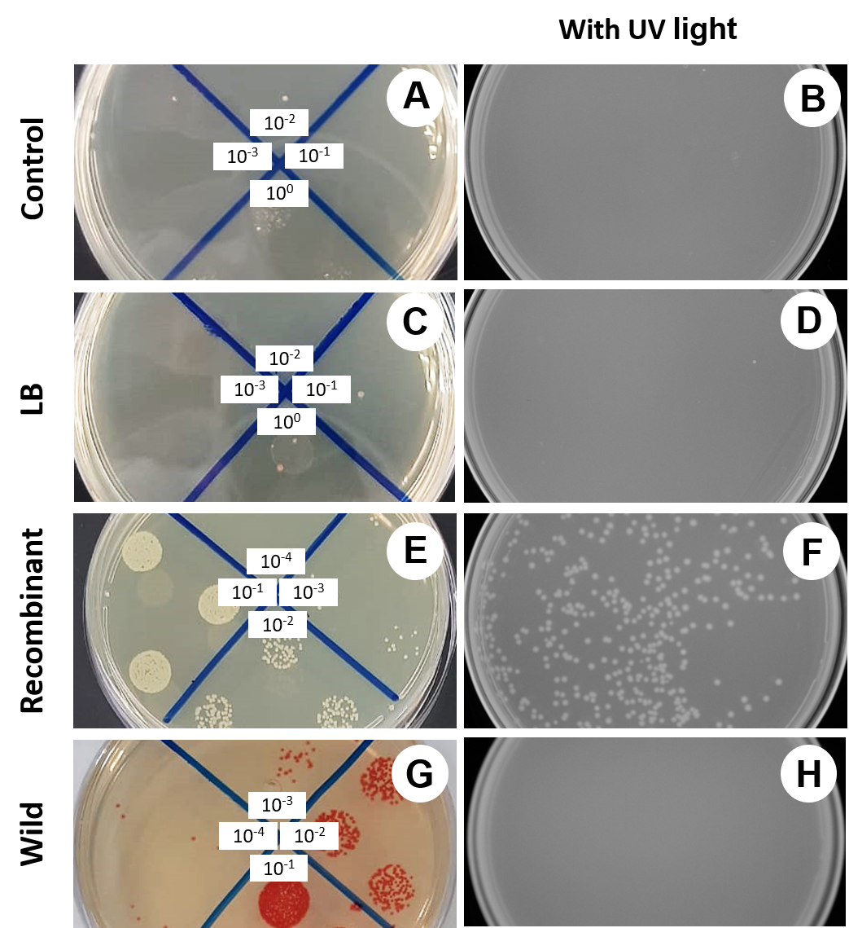
Supplementary fig. 1 Homogenates of the digestive tract (midgut + hindgut) of worker of Partamona helleri plated on LB with or without kanamycin (100 μg/mL), 24 h after ingestion of different sucrose solutions (food). (A, B) No bacteria added to the food (control). (C, D) Workers fed sterile LB (1:1). (E, F) Workers fed Serratia eGFP AS1 (recombinant). (G, H) Workers fed Serratia marcescens (wild). Left plates: different dilutions plated, as indicated. Right plates: UV illumination to detect GFP fluorescence

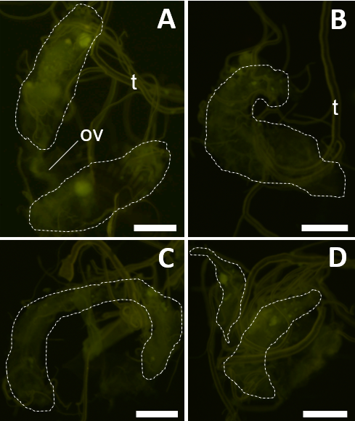
Supplementary fig. 2 Ovary of workers of Partamona helleri after the ingestion of different sucrose solutions. (A) Ovary after the ingesting of not inoculated sucrose solution (control). (B) Ovary after the ingesting of food with sterile LB (1:1). (C) Ovary after the ingestion of food with Serratia marcescens (wild). (D) Ovary after the ingestion of food with Serratia eGFP AS1 (recombinant). Ovary (ov), trachea (t). Bar: 200 μm

Supplementary Tab. 1 Results of the analysis of variance of walking distance of Partamona helleri workers fed different sucrose solutions (food). Control = not inoculated food, LB = not inoculated with sterile LB (1:1), SE = Standard error F = F value, df_{treat.}= treatment degrees of freedom, df_{res,}= degrees of freedom of residuals, P = p-value, R²_{adj.} = adjusted coefficient of determination
Behavioral variables | Food | mean | SE |  | F | df_{treat.} | df_{res.} | P | R²_{adj.}
Resting time (s) | Control | 50.15 | 15.82 |  | 0.2 | 3 | 16 | 0.9 | 0.15
 | LB | 58.21 | 13.85
 | Recombinant strain | 48.23 | 6.11
 | Wild strain | 47.56 | 13.16
Medium activity time (s) | Control | 491.4 | 19.07 |  | 0.9 | 3 | 16 | 0.5 | 0.013
 | LB | 448.16 | 12.37
 | Recombinant strain | 467.28 | 19.45
 | Wild strain | 474.58 | 22.48
Fast activity time (s) | Control | 30.19 | 8.03 |  | 0 | 3 | 16 | 1 | 0.18
 | LB | 32.57 | 6.73
 | Recombinant strain | 31.62 | 6.25
 | Wild strain | 30.44 | 5.98
Walked distance (cm) | Control | 2205 | 294.4 |  | 0.3 | 3 | 16 | 0.9 | 0.13
Walked distance (cm) | LB | 2283.8 | 340.6
Walked distance (cm) | Recombinant strain | 2078.5 | 294.1
Walked distance (cm) | Wild strain | 1947.2 | 196.5

Supplementary videos. The walking activity of Partamona helleri workers fed different sucrose solutions. The different letters represent the identity of the individuals.
Supplementary video 1 (link). Bees fed sucrose solution (control)
Supplementary video 2 (link). Bees fed sucrose solution with sterile LB (1:1).
Supplementary video 3 (link). Bees fed sucrose solution with Serratia eGFP AS1 (recombinant).
Supplementary video 4 (link). Bees fed sucrose solution with S. marcescens (wild).

