Supplementary Information
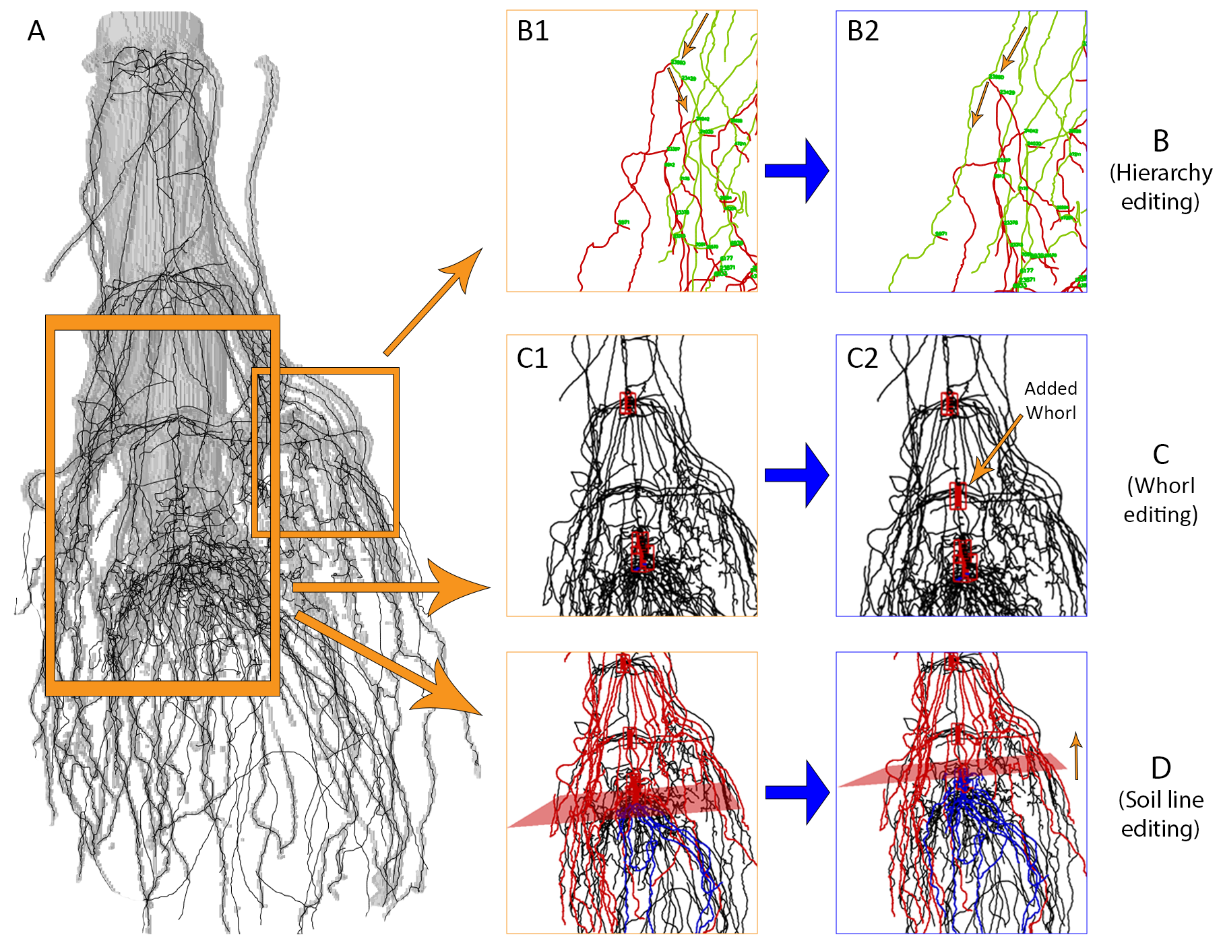Supplementary Figure 1: Graphics User Interface (GUI) to view and edit root hierarchy, whorls and soil line. A: The segmented root shape (shown in transparency) and its skeleton. B: Fixing An incorrect root hierarchy by changing how the root continues at a junction (pointed by the top arrow in B1) from following the right branch to following the left branch (B2). C: Adding a missing whorl (in C1) by selecting a group of junctions on the root stem and creating a new whorl from them (C2). D: Shifting the soil plane upward.
Supplementary Table 1: TopoRoot’s computed traits
Groups | Trait | Description
Global traits | Total length | Sum of the lengths of stem, nodal roots, and lateral roots.
Global traits | Number of roots | Total number of roots across all hierarchy levels.
Global traits | Average length | Total length divided by number of roots.
Stem traits | Average stem thickness | Average thickness of the vertices along the stem path.
Stem traits | Stem length | Length of the stem path.
Per-level traits | Level n root count | The number of level n roots.
Per-level traits | Total level n root length | Sum of the lengths of level n roots. The length is the skeleton distance from the beginning of the root to its tip.
Per-level traits | Average level n root length | Total level n root length divided by level n root count.
Per-level traits | Level n root tortuosity | Length of a root (skeleton distance) divided by the Euclidean distance from the beginning to the tip, averaged across all level n roots.
Per-level traits | Level n root thickness | Thickness associated with the skeleton vertices in the root, averaged across all level n roots.
Per-level traits | Number of level n root children | Number of level 2 roots divided by number of level 1 roots.
Per-level traits | Level n root tip angle | Angle between the stem direction and the vector from the beginning to the tip of a root, averaged across all level n roots.
Per-level traits | Level n root emergence angle | Angle between the stem direction and the vector from the beginning to 30 vertices along the skeleton of a root, averaged across all level n roots.
Per-level traits | Level n root midpoint angle | Angle between the stem direction and the vector from the beginning of a root to the halfway point of the root, averaged across all level n roots.
Aggregated lateral root traits | Total lateral length | Sum of the lengths of lateral roots whose hierarchy level is greater than or equal to 2.
Aggregated lateral root traits | Number of lateral roots | Number of lateral roots whose hierarchy level is greater than or equal to 2.
Aggregated lateral root traits | Average lateral root length | Average length of lateral roots whose hierarchy level is greater than or equal to 2.
Whorl-related traits | Internode distance | Distance between the neighboring whorls from the youngest to the oldest
Whorl-related traits | Number of whorls | Total number of the computed whorls
Per Whorl Trait | Number of roots | Total number of roots at each whorl across all hierarchy levels
Per Whorl Trait | Level n root count | The number of level n roots at each whorl
Per Whorl Trait | Total level n root length | Sum of the lengths of level n roots at each whorl. The length is the skeleton distance from the beginning of the root to its tip.
Per Whorl Trait | Average level n root length | Total level n root length divided by level n root count at each whorl
Per Whorl Trait | Level n root tortuosity | Length of a root (skeleton distance) divided by the Euclidean distance from the beginning to the tip, averaged across all level n roots at each whorl.
Per Whorl Trait | Level n root thickness | Thickness associated with the skeleton vertices in the root, averaged across all level n roots at each whorl.
Per Whorl Trait | Number of level n root children | Number of level 2 roots divided by number of level 1 roots for all roots emerged at each whorl.
Per Whorl Trait | Level n root tip angle | Angle between the stem direction and the vector from the beginning to the tip of a root, averaged across all level n roots emerged at each whorl.
Per Whorl Trait | Level n root emergence angle | Angle between the stem direction and the vector from the beginning to 30 vertices along the skeleton of a root, averaged across all level n roots emerged at each whorl.
Per Whorl Trait | Level n root midpoint angle | Angle between the stem direction and the vector from the beginning of a root to the halfway point of the root, averaged across all level n roots emerged at each whorl.
Soil Line related traits | Total length above or below the soil line | Sum of the lengths of stem, nodal roots, and lateral roots above or below the soil line
Soil Line related traits | Root Length Density | the total length of nodal roots and lateral roots per unit soil volume for each centimeter depth under the soil line, considering all roots in a “virtual” soil core - a cylinder whose axis is aligned with the root stem and whose radius covers 95% of all roots in our data set.
Soil Line related traits | Average length above or below the soil line | Total length above or below the soil line divided by the number of roots above or below the line
Soil Line related traits | Average stem thickness above or below the soil line | Average thickness of the vertices above or below the soi line along the stem path.
Soil Line related traits | Stem length | Length of the portion of the stem path above or below the soil line.
Soil Line related traits | Number of roots | Total number of roots above or below the soil line
Soil Line related traits | Level n root count | The number of level n roots above or below the soil line
Soil Line related traits | Total level n root length | Sum of the lengths of level n roots above or below the soil line.
Soil Line related traits | Average level n root length | Total level n root length divided by level n root count above or below the soil line.
Soil Line related traits | Level n root tortuosity | Length of a root (skeleton distance) divided by the Euclidean distance from the beginning to the tip, averaged across all level n roots above or below the soil line.
Soil Line related traits | Level n root thickness | Thickness associated with the skeleton vertices in the root, averaged across all level n roots above or below the soil line.
Soil Line related traits | Number of level n root children | Number of level 2 roots divided by number of level 1 roots for all roots above or below the soil line.
Soil Line related traits | Level n root tip angle | Angle between the stem direction and the vector from the beginning to the tip of a root, averaged across all level n roots emerged at each whorl.
Soil Line related traits | Level n root emergence angle | Angle between the stem direction and the vector from the beginning to 30 vertices along the skeleton of a root, averaged across all level n roots above or below the soil line.
Soil Line related traits | Level n root midpoint angle | Angle between the stem direction and the vector from the beginning of a root to the halfway point of the root, averaged across all level n roots above or below the soil line.

