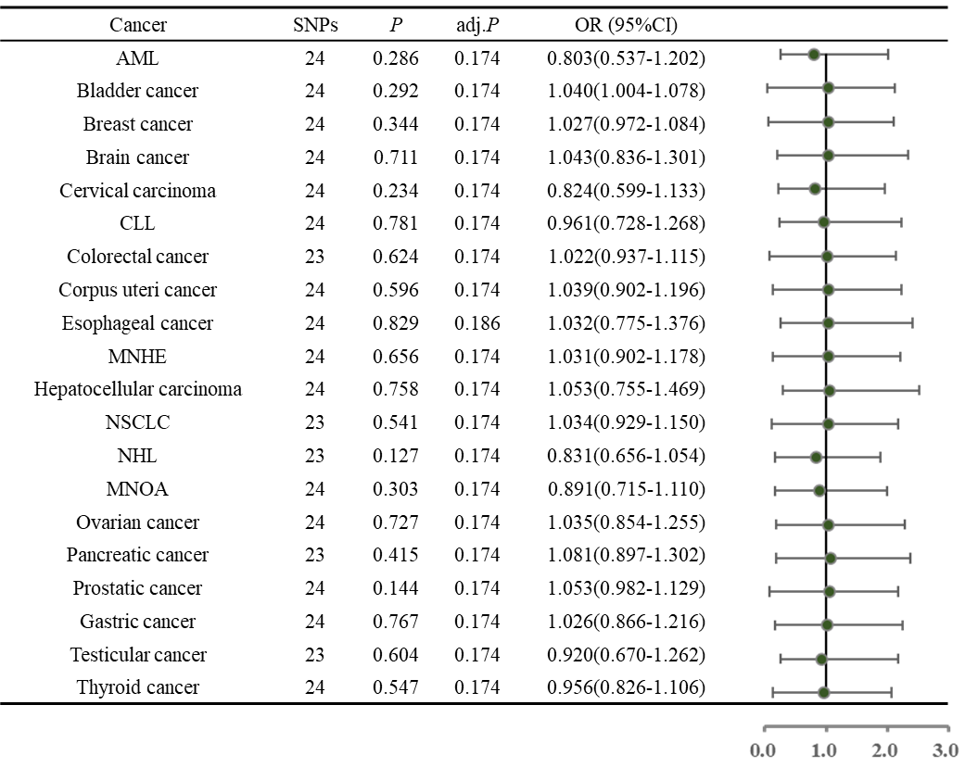
Table 2 The causal effect of cannabis use disorder on the risk of several types of cancer derived from inverse variance weighted.

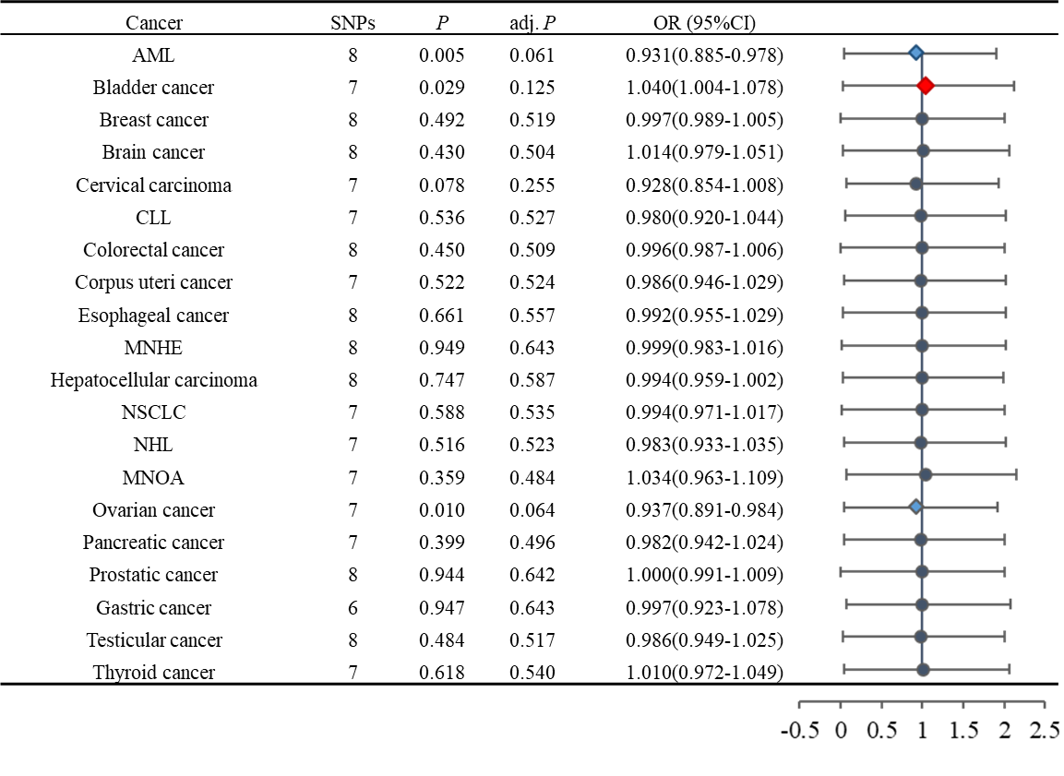
Table 4 The causal effect of opioids use disorder on the risk of several types of cancer derived from inverse variance weighted

