Supplementary Information
Supplementary Table 1 MSC donor information
 | Age | Sex
Donor 1 | 20 | f
Donor 2 | 19 | m
Donor 3 | 25 | m

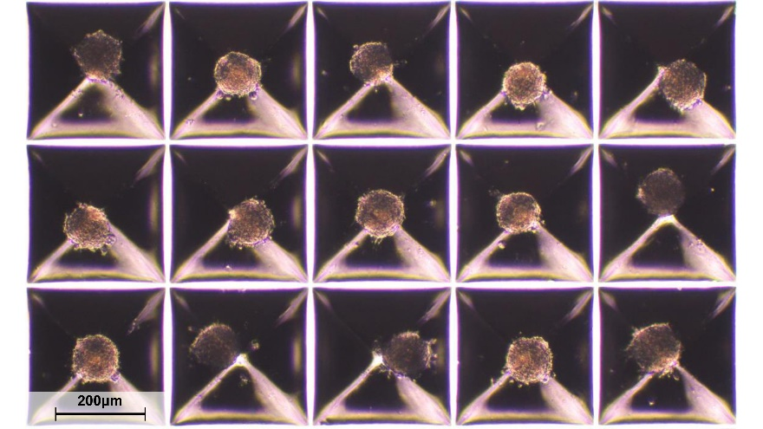
Supplementary Fig. 1 Representative image of 3D culture primed MSCs in Kugelmeiers SP5D at 48 h post-seeding.
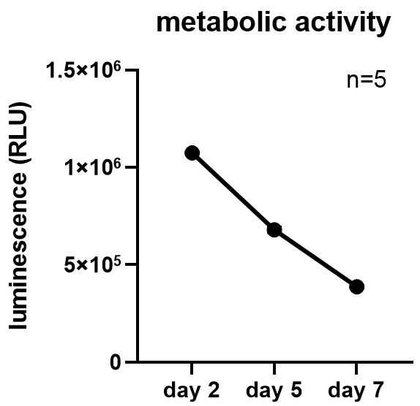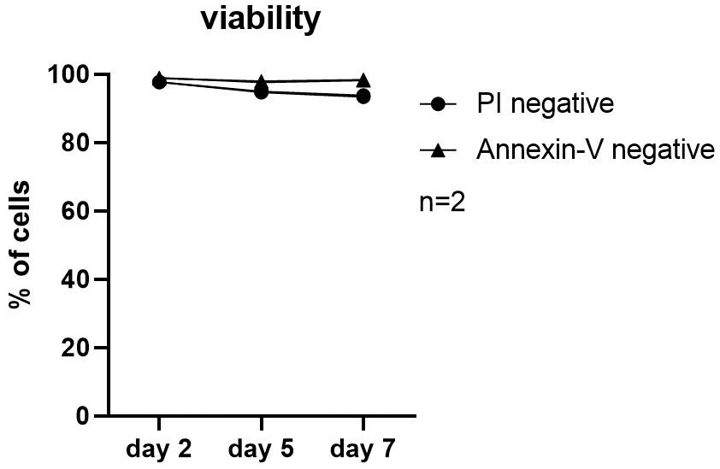
Supplementary Fig. 2 Metabolic activity and viability of MSCs cultured as spheroids over one week.
Supplementary Table 2 Top 10 immunomodulation-associated DEGs
pro-inflammatory |  |  | hypoxic |  |  | 3D culture
gene | log₂FC | FDR | gene | log₂FC | FDR | gene | log₂FC | FDR
CXCL9 | 13.92 | 1.13E-18 | PIK3R5 | 5.91 | 2.76E-3 | TNFSF11 | 6.37 | 3.32E-3
CCL5 | 9.82 | 3.49E-60 | PTGS2 | 5.31 | 1.23E-51 | BMP2 | 5.56 | 9.41E-40
CXCL11 | 8.63 | 1.51E-9 | APLN | 5.20 | 4.03E-34 | BMP6 | 4.20 | 1.75E-11
HLA-DRB5 | 7.12 | 8.08E-6 | IL1A | 4.65 | 1.86E-2 | NFILZ | 4.20 | 2.64E-2
CXCL10 | 6.99 | 4.34E-5 | CCL28 | 3.93 | 2.01E43 | PRG4 | 3.94 | 1.09E-13
HLA-DQA1 | 6.32 | 4.07E-3 | PRG2 | 3.74 | 1.41E-2 | LIF | 3.48 | 1.46E-14
CD74 | 5.70 | 1.06E-6 | ACKR3 | 3.50 | 2.22E-5 | PTGS2 | 3.29 | 8.12E-13
HLA-DRA | 5.62 | 5.79E-3 | PIK3R3 | -5.33 | 5.41E-35 | THBS1 | -4.37 | <1E-99
HLA-DRB1 | 5.34 | 1.93E-8 | HLA-DRA | -4.00 | 7.99E-9 | PTX3 | -3.49 | 2.72E-21
IL-32 | 5.34 | 2.24E-16 | TLR3 | -3.67 | 1.22E-14 | JCHAIN | -3.36 | 3.49E-5

Supplementary Table 3 Primers used for qPCR amplification
Gene | Forward sequence (5'-3') | Reverse sequence (5'-3')
CCL5 (RANTES) | CCTGCTGCTTTGCCTACATTGC | ACACACTTGGCGGTTCTTTCGG
CXCL9 (MIG) | CCAGTAGTGAGAAAGGGTCGC | AGGGCTTGGGGCAAATTGTT
CXCL10 (IP10) | GGTGAGAAGAGATGTCTGAATCC | GTCCATCCTTGGAAGCACTGCA
CXCL11 (I-TAC) | AAGGACAACGATGCCTAAATCCC | CAGATGCCCTTTTCCAGGACTTC
CXCL8 (IL8) | GAGAGTGATTGAGAGTGGACCAC | CACAACCCTCTGCACCCAGTTT
IL6 | AGACAGCCACTCACCTCTTCAG | TTCTGCCAGTGCCTCTTTGCTG
CD74 (HLA-DR) | GATGACCAGCGCGACCTTATC | GTGACTGTCAGTTTGTCCAGC
PTGS2 (COX-2) | CGGTGAAACTCTGGCTAGACAG | GCAAACCGTAGATGCTCAGGGA
LIF | CCAACGTGACGGACTTCCC | TACACGACTATGCGGTACAGC
IL1RN | CATTGAGCCTCATGCTCTGTT | CGCTGTCTGAGCGGATGAA
CD274 (PD-L1) | TGCCGACTACAAGCGAATTACTG | CTGCTTGTCCAGATGACTTCGG
PDCD1LG2 (PD-L2) | ATTGCAGCTTCACCAGATAGC | AAAGTTGCATTCCAGGGTCAC
IDO1 | TCATCTCACAGACCACAAGTCA | GCAAGACCTTACGGACATCTCC
CCL2 (MCP1) | CAGCCAGATGCAATCAATGCC | TGGAATCCTGAACCCACTTCT
TNFAIP6 (TSG6) | TCACCTACGCAGAAGCTAAGGC | TCCAACTCTGCCCTTAGCCATC
LEP | GCTGTGCCCATCCAAAAAGTCC | CCCAGGAATGAAGTCCAAACCG
HMOX1 | CCAGGCAGAGAATGCTGAGTTC | AAGACTGGGCTCTCCTTGTTGC
LGALS1 | TCGCCAGCAACCTGAATCTC | GCACGAAGCTCTTAGCGTCA
TGFB1 | TACCTGAACCCGTGTTGCTCTC | GTTGCTGAGGTATCGCCAGGAA
ICAM1 | AGCGGCTGACGTGTGCAGTAAT | TCTGAGACCTCTGGCTTCGTCA
TBP | TGTATCCACAGTGAATCTTGGTTG | GGTTCGTGGCTCTCTTATCCTC
CCL5 (C-C motif chemokine ligand 5), CXCL9 (C-X-C motif chemokine ligand 9), CXCL10 (C-X-C motif chemokine ligand 10), CXCL11 (C-X-C motif chemokine ligand 11), CXCL8 (C-X-C motif chemokine ligand 8), IL6 (interleukin 6), CD74 (major histocompatibility complex class II invariant chain), PTGS2 (prostaglandin-endoperoxide synthase 2), LIF (leukemia inhibitory factor), IL1RN (interleukin 1 receptor antagonist), CD274 (programmed cell death 1 ligand 1), PDCD1LG2 (programmed cell death 1 ligand 2), IDO1 (indoleamine 2,3-diogygenase 1), CCL2 (C-C motif chemokine ligand 2), TNFAIP6 (TNF alpha induced protein 6), LEP (leptin), HMOX1 (heme oxygenase 1), LGALS1 (galectin 1), TGFB1 (transforming growth factor beta 1), ICAM1 (intercellular adhesion molecule 1), TBP (TATA-box binding protein)

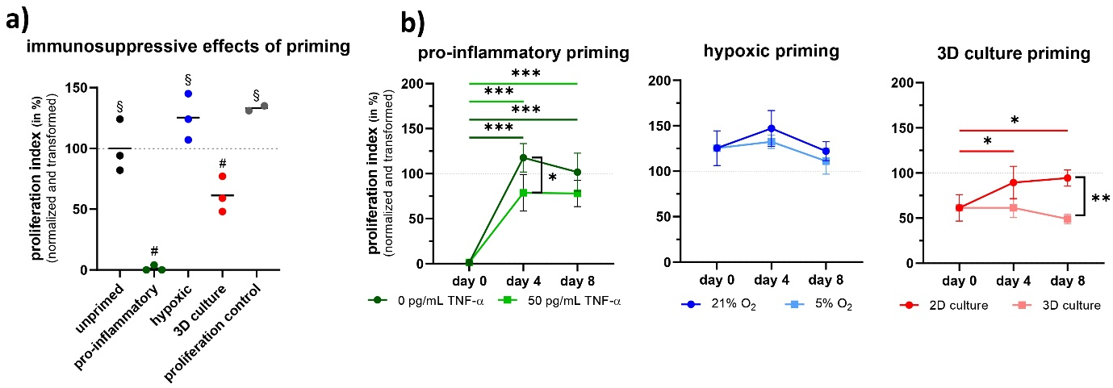
Supplementary Fig. 3 CD4⁺ T-helper cells: The effects of each priming strategy on the immunosuppressive potential of MSCs were measured by an in vitro functional potency assay following 48 h of priming. A normalized transformed proliferation index of 0% corresponds to the complete suppression of T cell proliferation. A value of 100% indicates that the T cells proliferated equivalent to T cells co-cultured with unprimed MSCs (grey dashed horizontal lines). a) Different priming strategies enhance the T cell suppressive capacity of MSCs. b) priming effects fade over time but are partially preserved by translationally relevant conditions. The proliferation control represents the proliferation of T cells in the absence of co-cultured MSCs. # indicate significant differences (p < 0.001, except unprimed vs. 3D culture primed p = 0.03) against all other conditions. § indicate significant differences(p < 0.001) against pro-inflammatory and 3D culture priming. not significant: p > 0.05; *: p ≤ 0.05; **: p ≤ 0.01; ***: p ≤ 0.001

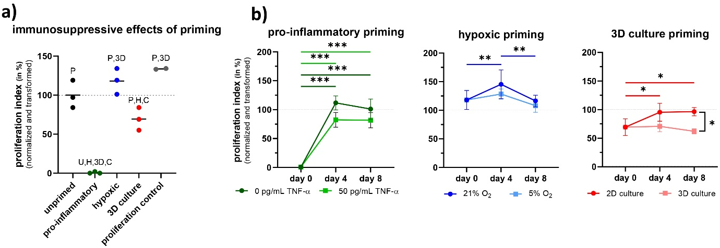
Supplementary Fig. 4 CD8⁺ cytotoxic T cells: The effects of each priming strategy on the immunosuppressive potential of MSCs were measured by an in vitro functional potency assay following 48 h of priming. A normalized transformed proliferation index of 0% corresponds to the complete suppression of T cell proliferation. A value of 100% indicates that the T cells proliferated equivalent to T cells co-cultured with unprimed MSCs (grey dashed horizontal lines). a) Different priming strategies enhance the T cell suppressive capacity of MSCs. b) priming effects fade over time but are partially preserved by translationally relevant conditions. The proliferation control represents the proliferation of T cells in the absence of co-cultured MSCs. Letters indicate significant differences (p < 0.001, except unprimed vs. 3D culture primed p = 0.03) between conditions. U = unprimed, P = pro-inflammatory, H = hypoxic, 3D = 3D culture, C = proliferation control. not significant: p > 0.05; *: p ≤ 0.05; **: p ≤ 0.01; ***: p ≤ 0.001
Supplementary Table 4 shared DEGs: pro-inflammatory and hypoxic primed MSCs
ACSL5 | CXCL2 | IFIH1 | PLCL1 | SULF2
ADH1B | CXCL6 | IFIT2 | PLD6 | SYTL3
ADRA2A | DDIT4 | IL11 | PPL | TENM2
ANGPT2 | DDIT4L | IL15RA | PRSS35 | TMEM150C
APOB | EFHC2 | JCHAIN | PSMB9 | TNFSF13B
APOE | EGR3 | KCND2 | PWWP2B | TP63
APOL1 | EPSTI1 | KCNK15 | QPCT | TRIM14
APOL3 | ESM1 | LRP4 | RCOR2 | TSPAN11
ARMCX5-GPRASP2 | ETV7 | MAF | REPS2 | WARS1
ASPN | FGF7 | MGLL | RIPOR3 | XAF1
BDKRB1 | FMO2 | MGP | RPP25 | ZCCHC2
BST2 | FMO3 | MX2 | RTN4RL1
C15orf39 | GJD3 | NCKAP5 | SELENOP
C15orf48 | GPR88 | NPIPB13 | SEMA6B
CD74 | H1-0 | NTN1 | SEMA6D
CFB | H4C14 | OAS2 | SERPINB2
CFI | HDAC9 | OASL | SFRP4
CHI3L1 | HERC6 | OGN | SLC15A3
CIITA | HHIP | OMD | SLC40A1
CLCA2 | HLA-DRA | OSCAR | SLC44A3
CLDN1 | IBSP | PDE1A | SMAD9
COL14A1 | ICAM1 | PDE2A | SNED1
COL21A1 | ICAM5 | PDE5A | ST8SIA2
CXCL1 | IFI35 | PDGFD | STAT1
CXCL12 | IFI44L | PDGFRL | STC2

Supplementary Table 5 shared DEGs: pro-inflammatory and 3D culture primed MSCs
ADH1B | CMPK2 | IL11 | NTN1 | SELENOP
ADRA2A | CTAGE4 | IL1B | OAS1 | SEMA6B
AMIGO2 | CXCL6 | IL4I1 | ODF3B | SERPINB2
ANKRD1 | DCLK1 | IL6 | OGN | SFRP4
APCDD1 | DDIT4L | JCHAIN | OMD | SLC40A1
APOB | DLX2 | KCND2 | PDCD1LG2 | SYTL2
APOE | FGF7 | KCNK15 | PDE2A | SYTL3
APOL1 | FMO2 | LEPR | PDE5A | TENM2
ASPN | FMO3 | LIF | PLCL1 | TFPI2
BDKRB1 | GDF15 | MGP | QRICH2 | TMEM132A
C15orf48 | GPC4 | NDNF | RGS4 | TSPAN11
CFI | HLA-DRB1 | NPIPB13 | RPP25 | TYMP
CHI3L1 | ICAM5 | NPR3 | RSAD2

Supplementary Table 6 shared DEGs: hypoxic and 3D culture primed MSCs
ABAT | CPE | GPR68 | NEDD9 | SERPINE1
ADCY8 | CRLF1 | GRAMD2B | NEXN | SFRP4
ADGRG1 | CTXN1 | GREB1 | NGFR | SGMS2
ADH1B | CXCL6 | GRIA3 | NKAIN1 | SHC3
ADM | CYGB | GYG2 | NLGN1 | SLC16A6
ADRA2A | DAAM2 | H2AC18 | NLRP10 | SLC17A7
AKAP5 | DAPK1 | H2AC19 | NMB | SLC22A23
ALPK2 | DCHS1 | H2BC4 | NOTCH3 | SLC22A3
ANGPT1 | DDIT3 | HAPLN1 | NPAS1 | SLC23A3
ANGPTL4 | DDIT4L | HIC2 | NPIPB13 | SLC37A2
APOB | DMD | HMOX1 | NPTX1 | SLC40A1
APOE | DSG2 | HS3ST2 | NR4A2 | SLC46A3
APOL1 | E2F7 | HSF4 | NR4A3 | SLC5A3
ARNT2 | ECM2 | ICAM5 | NTN1 | SLC6A15
ARRDC2 | EFEMP1 | IER3 | NUAK2 | SLC7A14
ARRDC4 | ENPP5 | IGFBP5 | OGN | SMCO4
ASGR1 | ENSG00000279117 | IL11 | OMD | SMIM43
ASPN | ENSG00000279118 | INSYN2A | OSGIN1 | STXBP6
ATP6V0D2 | ENSG00000279773 | ITGA2 | P2RY11 | SYNPO2
B3GALT2 | ENSG00000279881 | JAM2 | PCSK1 | SYT7
B4GALNT2 | ENSG00000280138 | JCHAIN | PDE2A | SYTL3
BAIAP2L1 | ENSG00000280351 | KCNC3 | PDE4C | TC2N
BCL11B | ENSG00000284540 | KCND2 | PDE5A | TENM2
BCL2L11 | ERMN | KCNK15 | PGF | TENT5B
BDKRB1 | ESCO2 | KCNK2 | PHLDA1 | TGFB3
BMP2 | ETV4 | KCNS1 | PLAAT4 | THBD
C11orf87 | FCGBP | KCTD4 | PLCL1 | THBS1
C12orf56 | FER1L6 | KDM7A | PLEKHG4B | TICRR
C15orf48 | FGD4 | KIRREL3 | PLIN2 | TLL1
C1orf115 | FGF7 | KLRD1 | PLPP2 | TLR3
C1orf198 | FHIP1A | KRT19 | PODN | TM4SF19
C4orf47 | FILIP1L | KRTAP1-1 | PPFIA3 | TMEM240
CA9 | FKBP5 | KSR1 | PSAT1 | TMEM26
CAMK2N1 | FMO2 | KY | PTGES | TNFAIP6
CAPS | FMO3 | LACC1 | PTGS2 | TNFRSF11B
CASP1 | FMO4 | LEF1 | PTPRN | TPBGL
CCN2 | FOXQ1 | LMOD1 | PTPRQ | TPD52L1
CD200 | FRY | LOX | RANBP3L | TRIM9
CDKN2B | FZD5 | LRRC66 | RASEF | TSPAN11
CEMIP | FZD8 | LSAMP | RCAN2 | UAP1L1
CFI | GALNT18 | MALL | RIMS1 | VLDLR
CH25H | GBP1 | MARCHF4 | RNF144A | VSTM4
CHI3L1 | GDF5 | MCHR1 | ROS1 | WNK4
CHL1 | GDF6 | MCM10 | RPP25 | WNT7B
CLK1 | GEM | MEGF6 | SCRG1 | ZNF423
CMKLR1 | GFRA1 | MEOX2 | SELENOP
COL24A1 | GOLGA8T | MGP | SEMA6B
CPA4 | GPR35 | MYBL1 | SERPINB2

Supplementary Table 7 shared DEGs: pro-inflammatory and hypoxic and 3D culture primed MSCs
ADH1B | CFI | IL11 | OMD | SFRP4
ADRA2A | CHI3L1 | JCHAIN | PDE2A | SLC40A1
APOB | CXCL6 | KCND2 | PDE5A | SYTL3
APOE | DDIT4L | KCNK15 | PLCL1 | TENM2
APOL1 | FGF7 | MGP | RPP25 | TSPAN11
ASPN | FMO2 | NPIPB13 | SELENOP
BDKRB1 | FMO3 | NTN1 | SEMA6B
C15orf48 | ICAM5 | OGN | SERPINB2

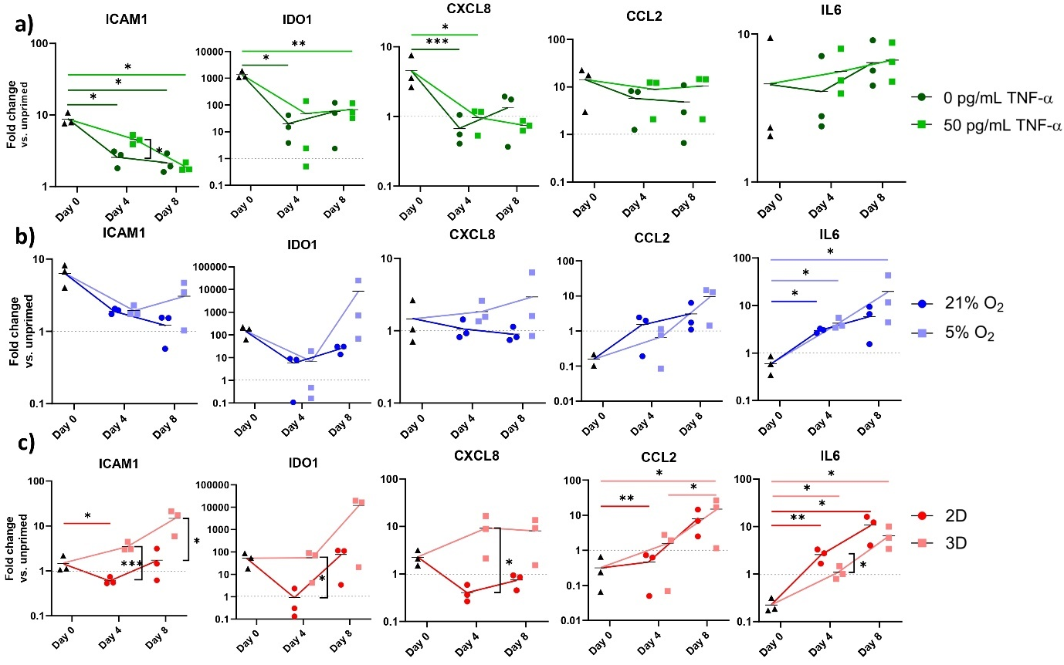
Supplementary Fig. 5 Fading of frequently used immunomodulatory potency markers. The effects of each priming approach on the transcriptome of MSCs were semi-quantified by qPCR at three time points: day 0 (directly following 48 h of priming), day 4, and day 8. Fold changes are shown and represent the gene expression levels of primed MSCs compared to the gene expression levels of unprimed MSCs at time point day 0. The significance levels for the gene expression differences between each time point and condition, compared to the gene expression directly after priming at day 0 are shown. Additionally, for each time point separately, significant gene expression differences between primed MSCs cultured under standard conditions and primed MSCs cultured under translationally relevant conditions are highlighted by significance indicators (not significant: p > 0.05; *: p ≤ 0.05; **: p ≤ 0.01; ***: p ≤ 0.001).

