Table S1. List of primers used in this study.
Primer name | Sequences (5’-3’) | Purpose | Reference
SWP-1F | TTGCAGAGTGTTGTTAAGGGTTT | Nested PCR for detection of EHP replication | Jareonlak, et al. 2016
SWP-1R | CACGATGTGTCTTTGCAATTTTC | Nested PCR for detection of EHP replication | Jareonlak, et al. 2016
SWP-2F | TTGGCGGCACAATTCTCAAACA | Nested PCR for detection of EHP replication | Jareonlak, et al. 2016
SWP-2R | GCTGTTTGTCTCCAACTGTATTTGA | Nested PCR for detection of EHP replication | Jareonlak, et al. 2016
PTP2-dsRNAF | TCAAAGCCAATTCAAAAGCC | dsRNA synthesis | This study
PTP2-dsRNAR | CCAGATGGTAAGGTAAGGTGGTTGG | dsRNA synthesis | This study
PTP2-dsRNAT7F | taatacgactcactatagggTCAAAGCCAATTCAAAAGCC | dsRNA synthesis | This study
PTP2-dsRNAT7R | taatacgactcactatagggCCAGATGGTAAGGTAAGGTGGTTGG | dsRNA synthesis | This study
PTP2-F | CGTAAACAGGGCAGGAGATATG | RT-PCR for PTP2 transcript detection | This study
PTP2R | CATTGGATCGCATGTGTTCTTG | RT-PCR for PTP2 transcript detection | This study
Pv-actin_F | TTCCGACTCCAAGAACGACC | Internal control gene amplification | This study
Pv-actin-R | GAGCAGTGTGGCAATCAAGC | Internal control gene amplification | This study

Supplementary figures

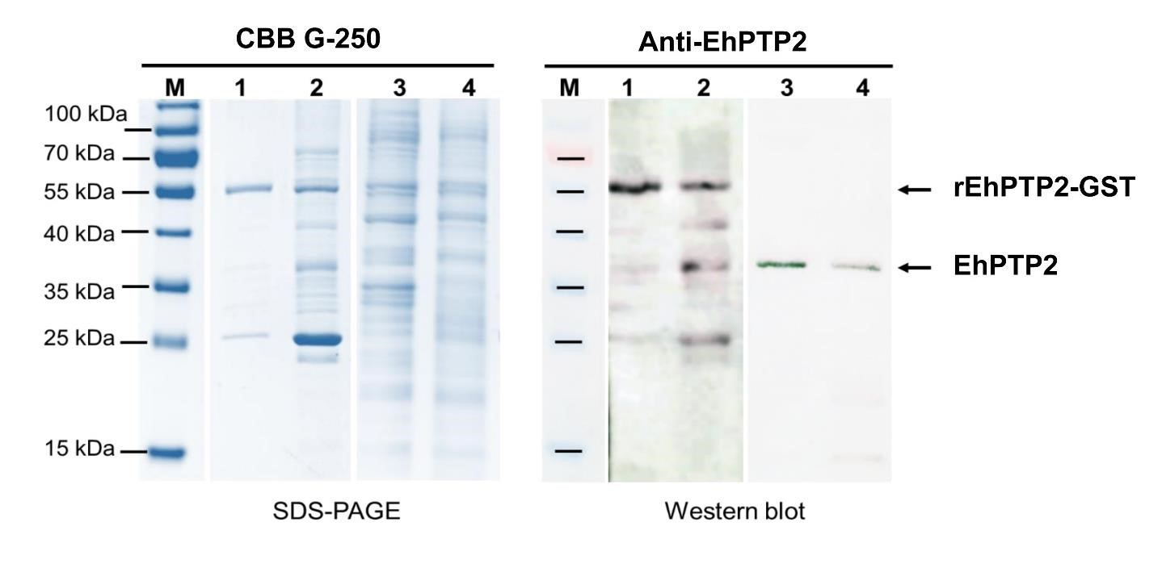
Supplementary Figure S1. Validation of the anti-EhPTP2 polyclonal antibody by Western blot analysis. The protein extracts of polar tubes and whole EHP spores were separated. The presence of EhPTP2 was determined by Western blot analysis. The Left panel is SDS-PAGE stained with CBB-G250 and shows (Lane 1) the purified EhPTP2 recombinant protein tagged with GST (rEhPTP2-GST) before protease cleavage of GST tag and (Lane 2) the same after cleavage, which were used as the positive controls for antibody detection; (Lane 3) the protein extract derived from whole spore; and (Lane 4) the polar tube fraction. The Right panel is the Western blot of the same gel for the EhPTP2 protein of approximately 37 kDa showing (Lane 3) the whole EHP spore protein extract and (Lane 4) the polar tube portion.

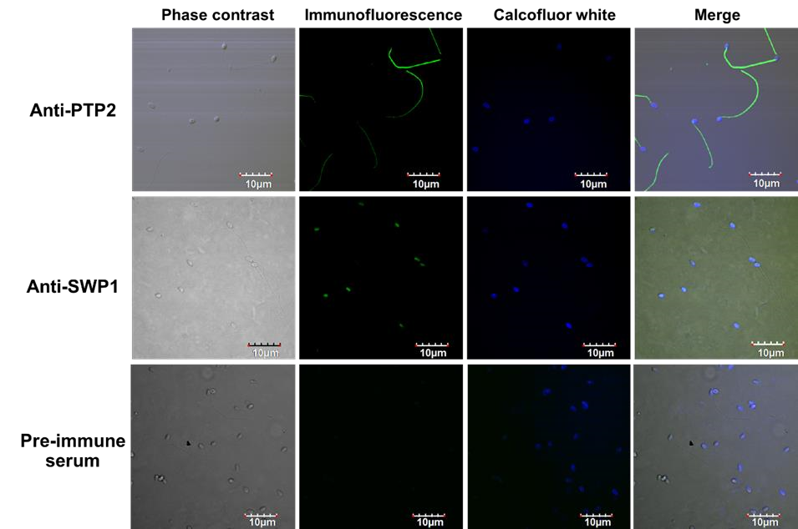

Supplementary Figure S2. EhPTP2 localized along extruded polar tubes. Germinated EHP spores were incubated with an anti-EhPTP2 antibody or an anti-spore wall protein 1 (SWP1) antibody as a primary antibody and with a fluorescence dye-conjugated secondary antibody (Alexafluor-488, Cell Signaling) followed by counter staining with calcofluor white and visualized under a fluorescence microscope. The green signals represent EhPTP2 localization on polar tubes, but not spores. Only SWP1 signals are visible on EHP spore wall.

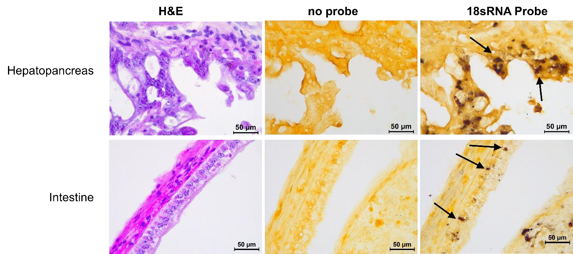

Supplementary Figure S3. Detection of EHP by in situ hybridization in the shrimp digestive tract post cohabitation. Naïve shrimp cohabitated with EHP-infected shrimp at day 7 were collected to confirm EHP infection by in situ hybridization using an 18sRNA probe. The hepatopancreas and intestine tissue sections were subjected to in situ hybridization method following a previous report (Tang et al., 2015). The positive signals of EHP infection (indicated by dark brown color, arrows) were observed in both tissue but not in the stomach which correspond to EhPTP2 detection using the IHC method.

