Supplementary file 2
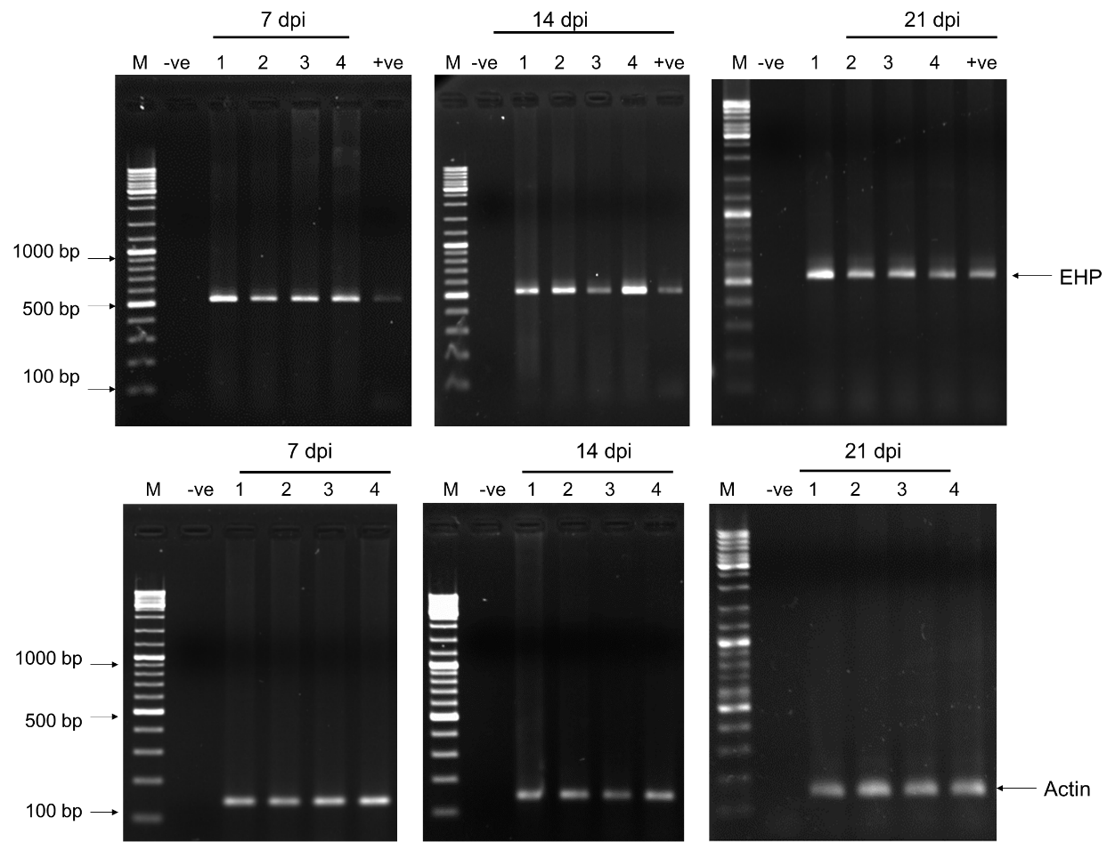

Figure 1. Representative agarose gel electrophoresis of EHP detection in shrimp by PCR. Upper panel, the PCR amplicons represent EHP replication based on SWP-PCR detection using SWP primer set. Three sample groups were demonstrated based on time-points post EHP infection under control condition. Lower panel, the amplicons represent internal control gene amplification using actin primer. The letters “-ve” and “+ve” represent negative and positive control reaction for each sample sets of PCR analysis, respectively. List of numbers indicate individual shrimp sample. The latter “M” indicates 100 bp-DNA ladder.

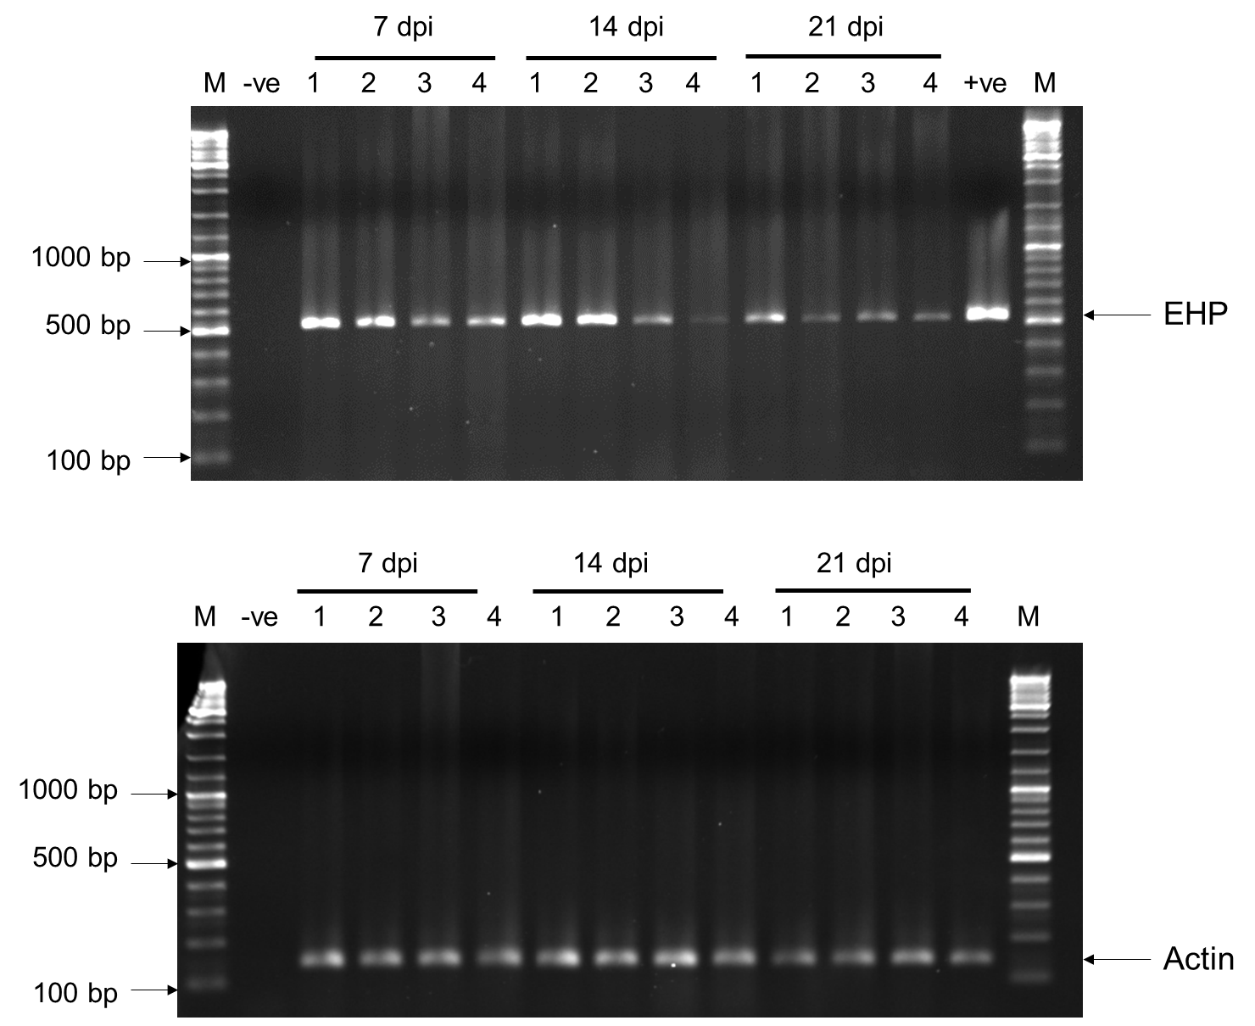
Figure 2. Representative agarose gel electrophoresis of EHP detection in shrimp by PCR. Upper panel, the PCR amplicons represent EHP replication based on SWP-PCR detection using SWP primer set. Three sample groups were demonstrated based on time-points post EHP infection under EGFP-dsRNA injection. Lower panel, the amplicons represent internal control gene amplification using actin primer. The letters “-ve” and “+ve” represent negative and positive control reaction for each sample sets of PCR analysis, respectively. List of numbers indicate individual shrimp sample. The latter “M” indicates 100 bp-DNA ladder.

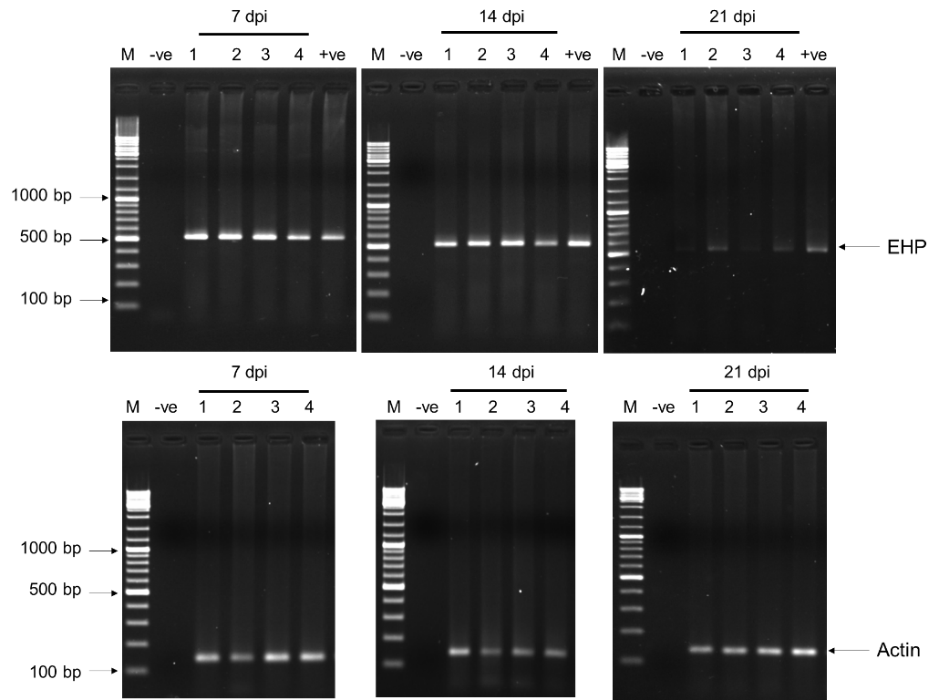

Figure 3. Representative agarose gel electrophoresis of EHP detection in shrimp by PCR. Upper panel, the PCR amplicons represent EHP replication based on SWP-PCR detection using SWP primer set. Three sample groups were demonstrated based on time-points post EHP infection under PTP2-dsRNA injection. Lower panel, the amplicons represent internal control gene amplification using actin primer. The letters “-ve” and “+ve” represent negative and positive control reaction for each sample sets of PCR analysis, respectively. List of numbers indicate individual shrimp sample. The latter “M” indicates 100 bp-DNA ladder.

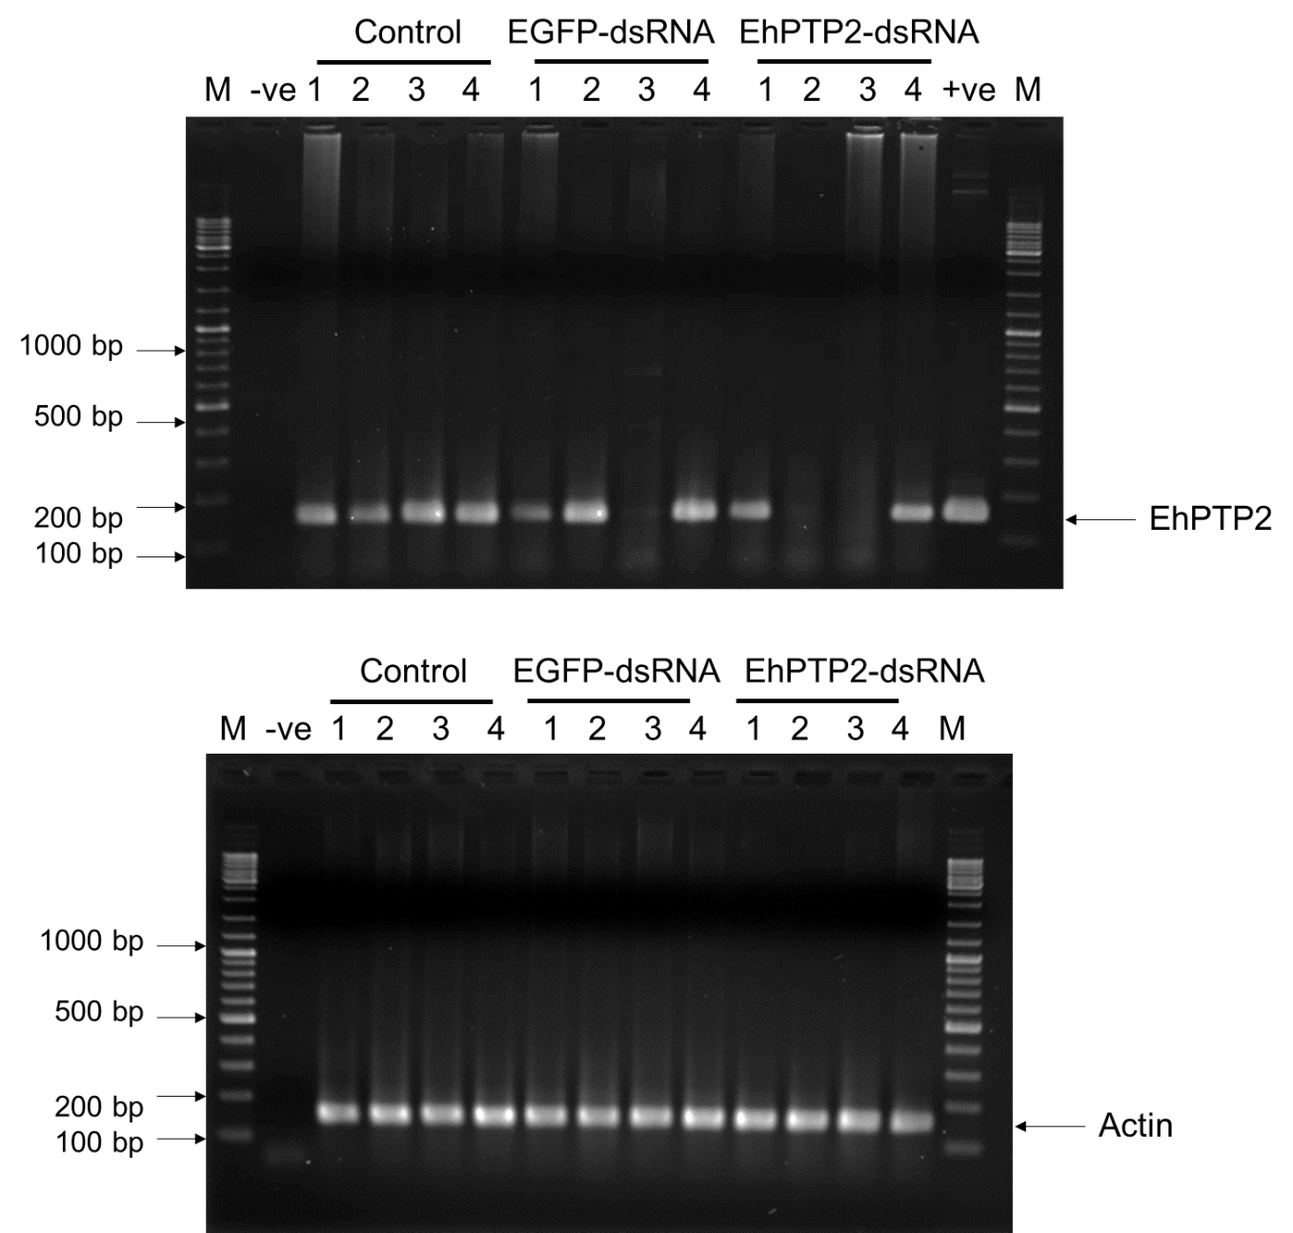

Figure 4. Representative agarose gel electrophoresis of EhPTP2 mRNA detection in shrimp by RT-PCR. Upper, PCR gel and amplicons represent EhPTP2 mRNA expression in individual shrimp comparing among three testing conditions. Lower, the gel and amplicons indicate internal control gene detection using actin primer. The letters “-ve” and “+ve” represent negative and positive control reaction for each sample sets of PCR analysis, respectively. List of numbers indicate individual shrimp sample. The latter “M” indicates 100 bp-DNA ladder.

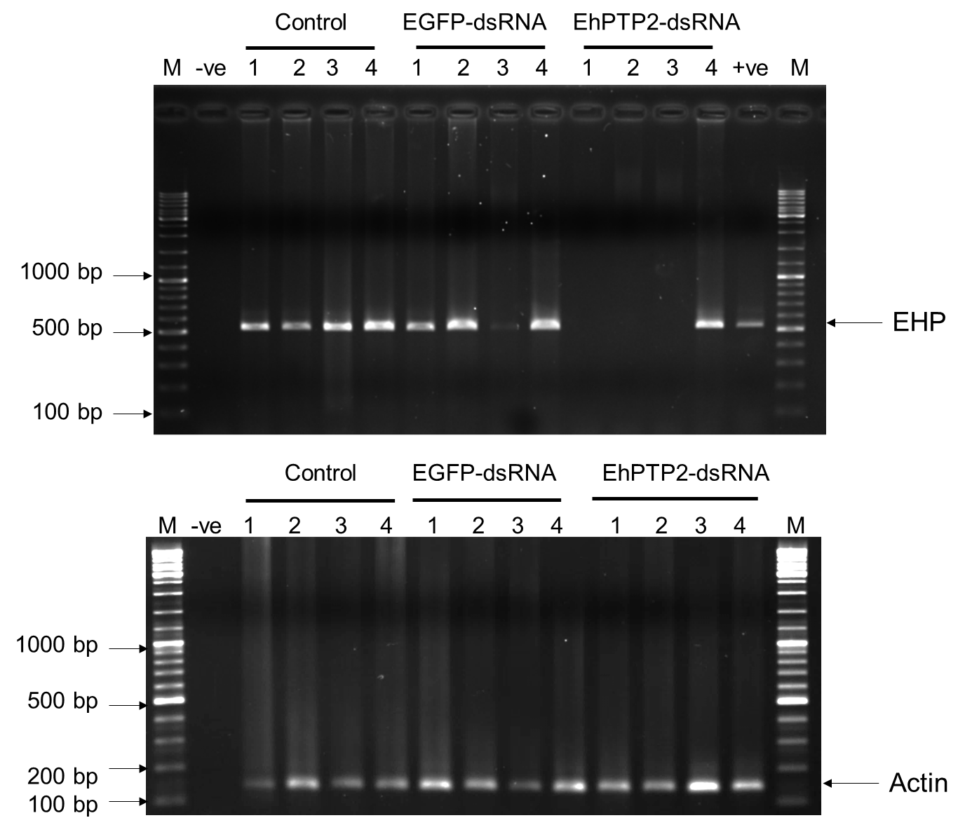

Figure 5. Representative agarose gel electrophoresis of EHP detection in shrimp by PCR. Upper panel, PCR gel and amplicons represent EHP replication in individual shrimp comparing among three testing conditions, determined by SWP-PCR primer set. Lower panel, the gel and amplicons indicate internal control gene detection using actin primer. The letters “-ve” and “+ve” represent negative and positive control reaction for each sample sets of PCR analysis, respectively. List of numbers indicate individual shrimp sample. The latter “M” indicates 100 bp-DNA ladder.

