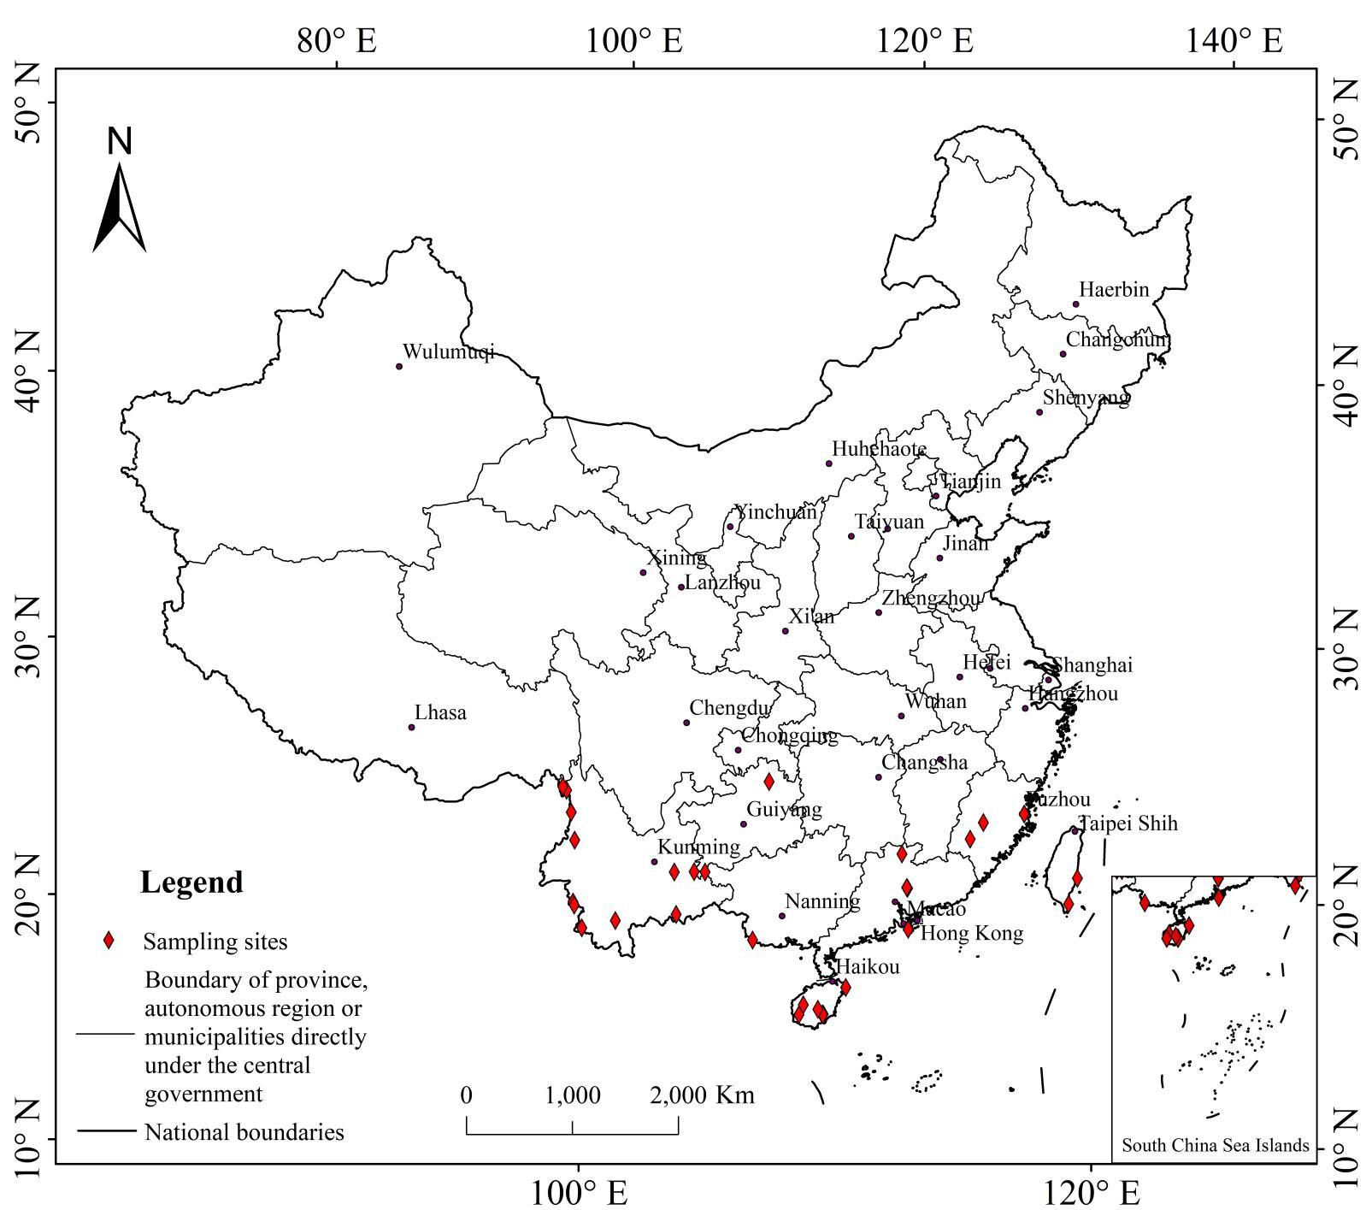
Fig. S1 Sampling sites of 36 species of Quercus section Cyclobalanopsis.

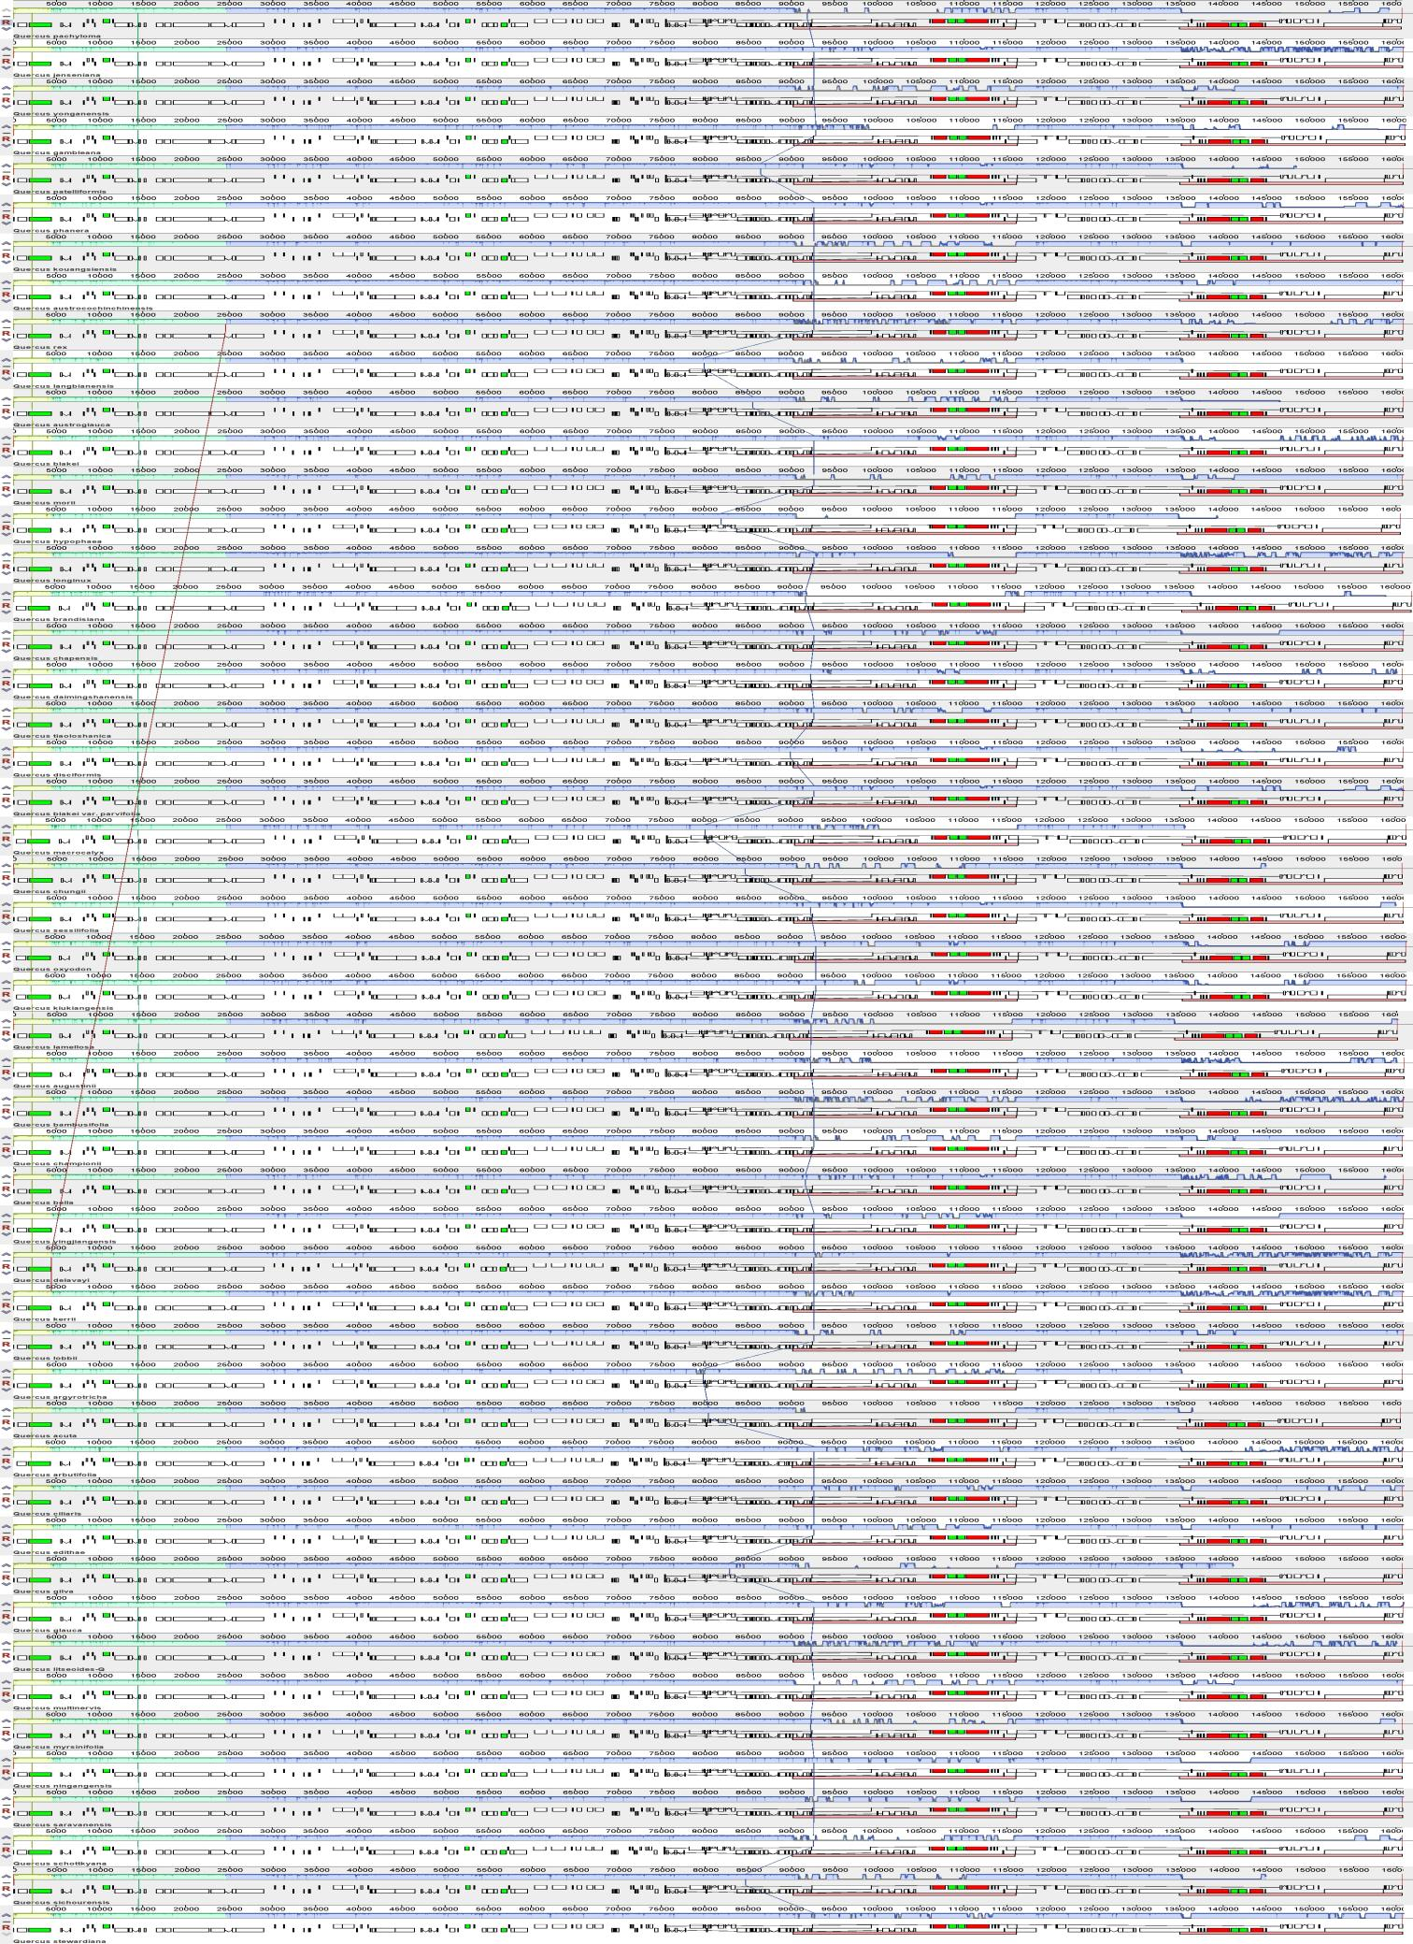
Fig. S2 MAUVE alignment of 50 chloroplast genomes of Quercus section Cyclobalanopsis. The different color blocks represent different locally collinear blocks (LCBs). The box structure under the genome represents the corresponding annotation information: the white rectangle represents protein-coding genes, the red rectangle represents rRNA genes, and the green rectangle represents tRNA genes. The introns are connected by line segments.

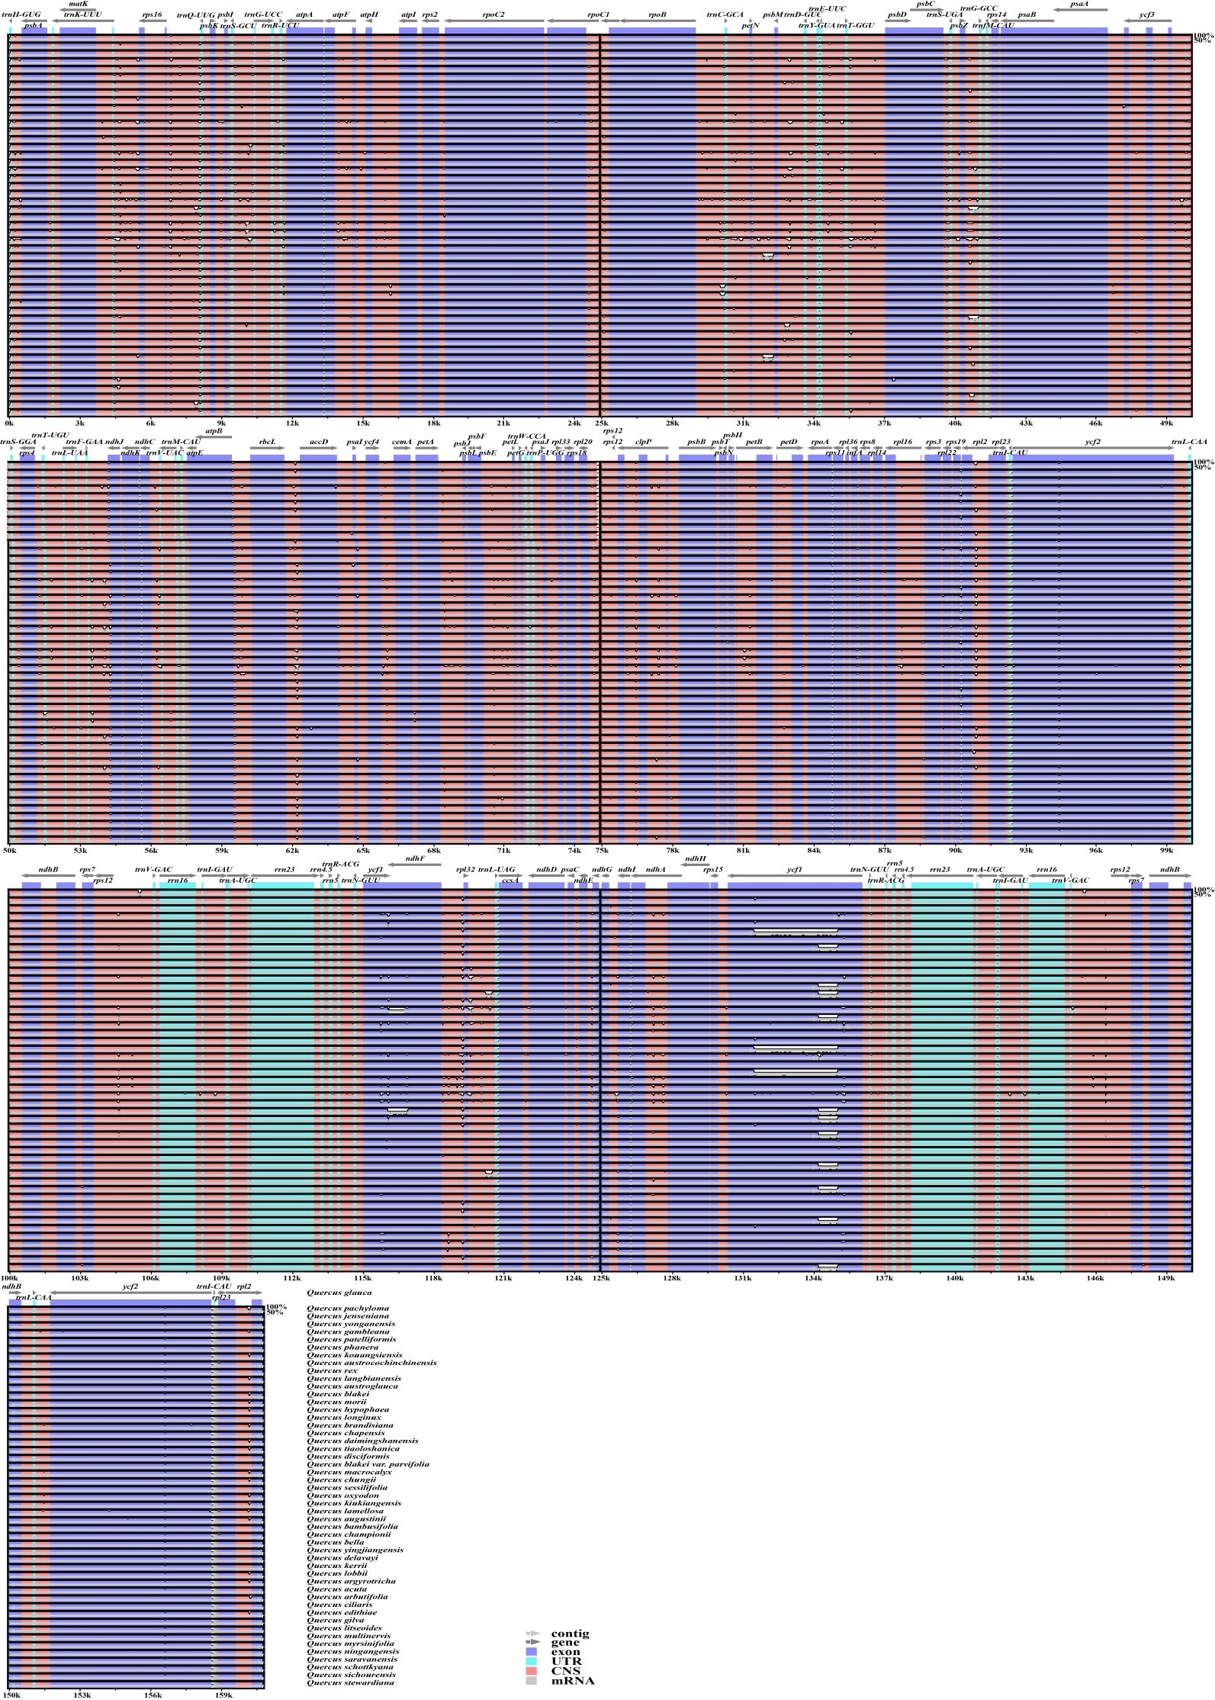
Fig. S3 The complete visualization comparison map of the 50 chloroplast genomes of Quercus section Cyclobalanopsis using mVISTA.
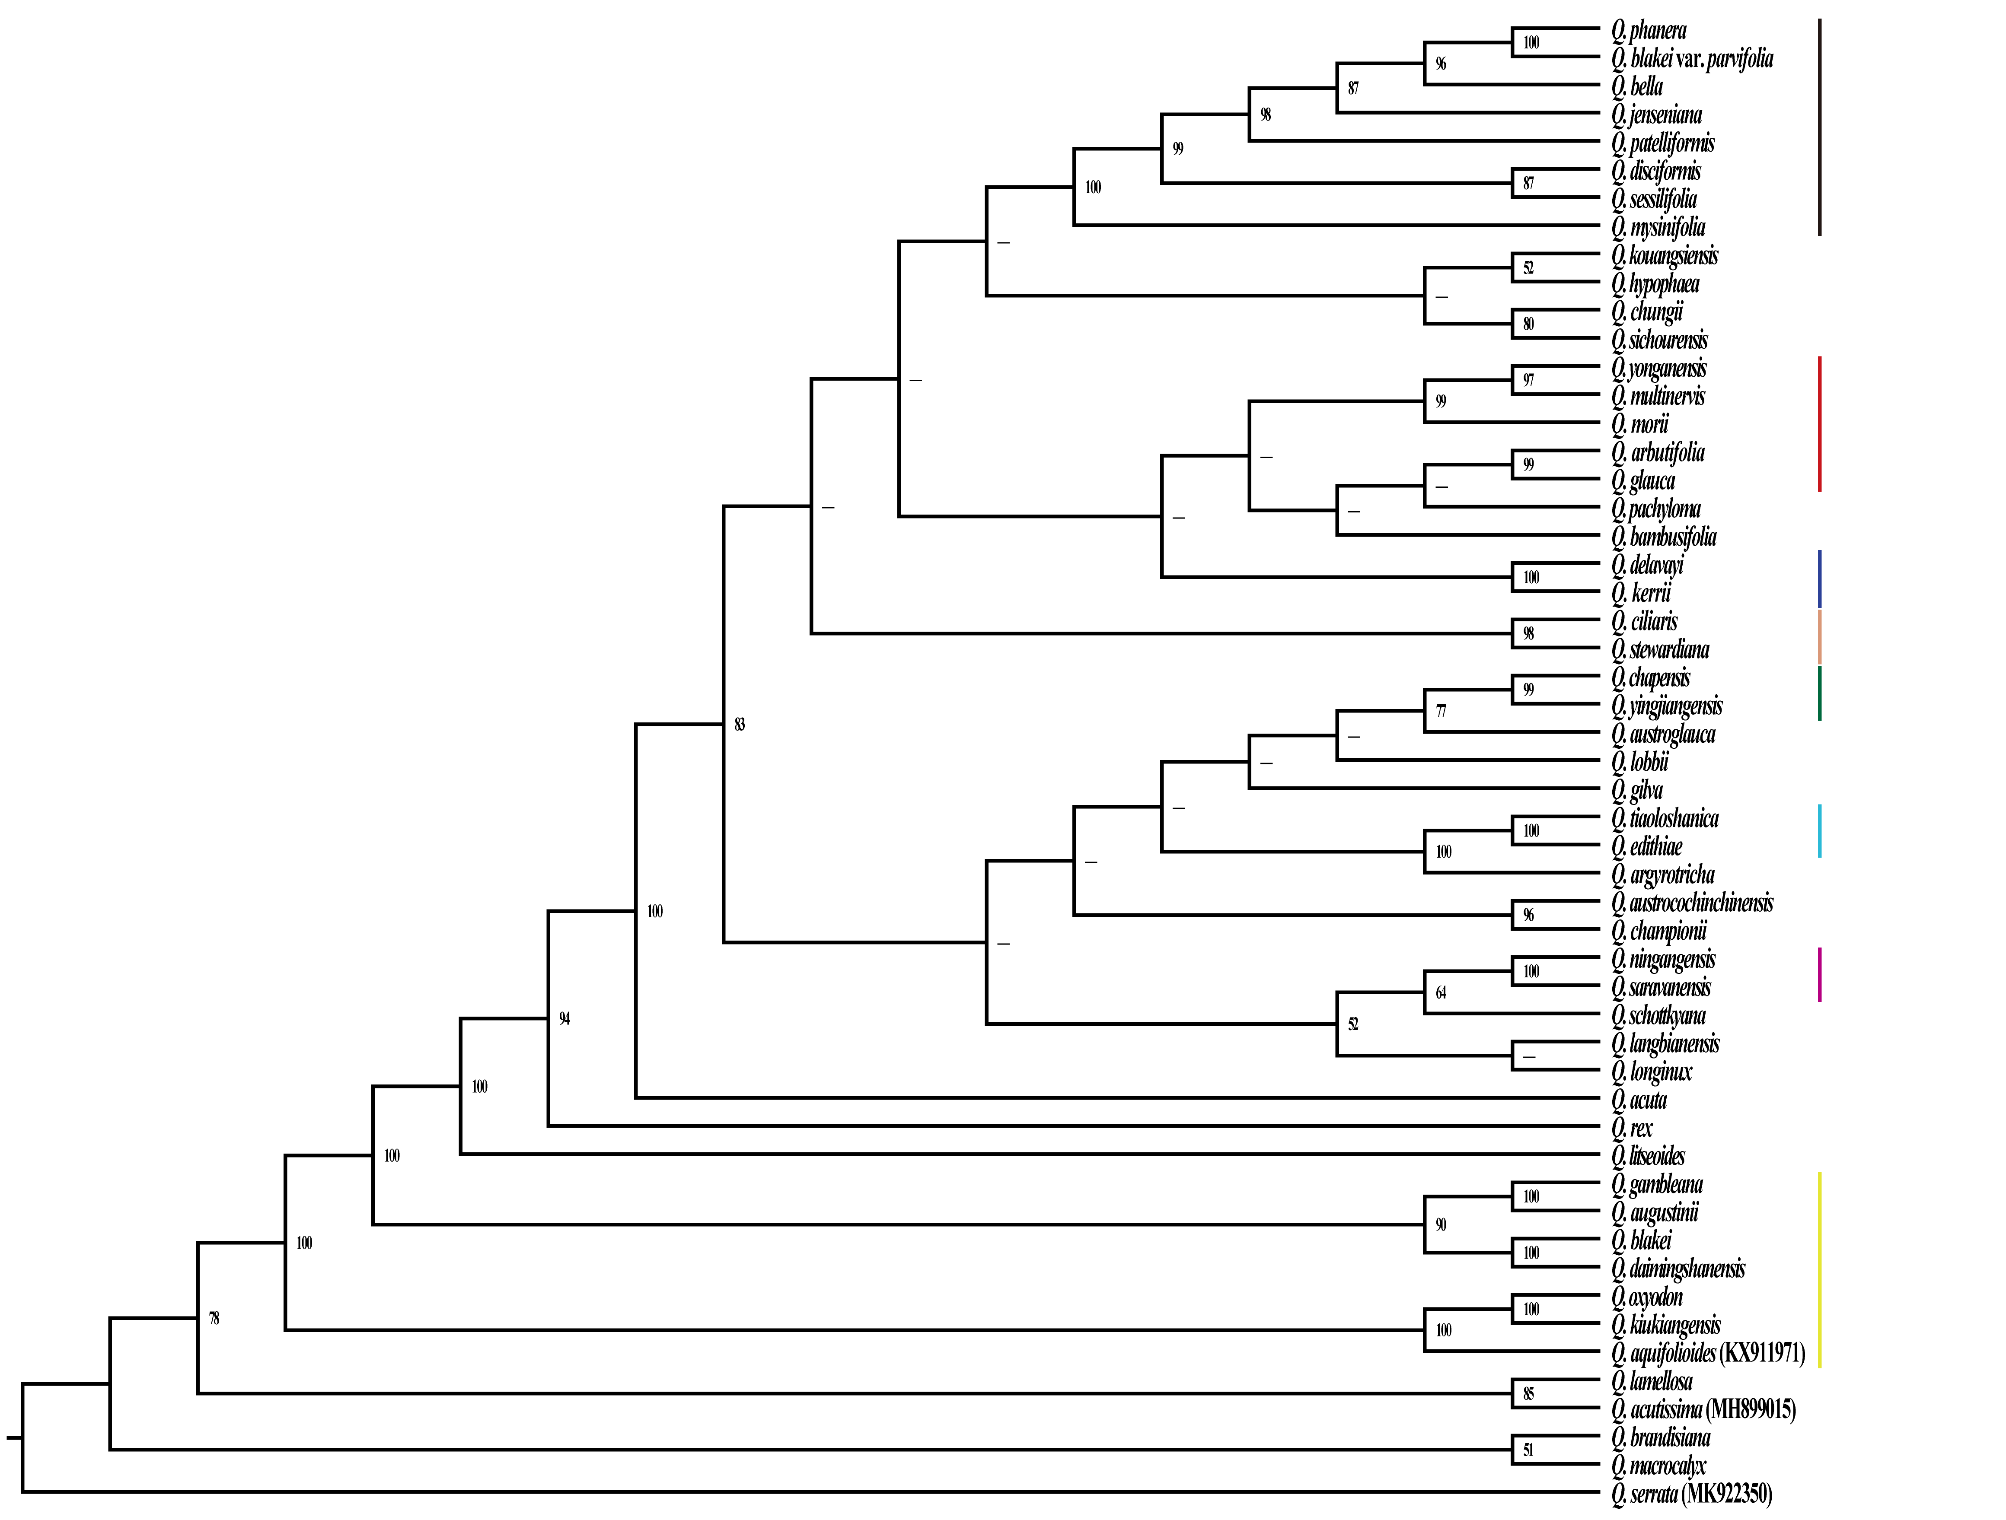
Fig. S4 Phylogenetic tree reconstructed based on the highly divergent regions detected in comparative genomic analyses using maximum likelihood (ML) methods. The bootstrap support values (BS) are labeled at branch in the evolutionary tree, where BS less than 50 % is represented by a “—”.

