Table 2. Top 10 active ingredients of FDJG
Number |  | 2D Structure | MOL ID | Molecule Name | Degree | OB  (%) | DL | Herb
A3 | 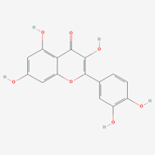 |  | MOL000098 | Quercetin | 888 | 46.43 | 0.28 | Cortex Eucommiae, Fructus Lycii,  Cortex Phellodendri, Radix Astragali,  Radix Achyranthis bidentatae, Radix Notoginseng
A1 | 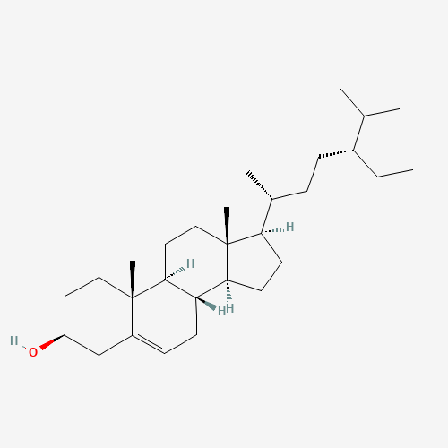 |  | MOL000358 | Beta-sitosterol | 396 | 36.91 | 0.75 | Radix Paeoniae Alba, Radix Angelicae sinensis,  Cortex Eucommiae, Fructus Lycii,  Cortex Phellodendri, Caulis Spatholobi,  Radix Achyranthis bidentatae, Radix Ginseng,  Radix Notoginseng, Radix Clematidis, Radix Dipsaci
A4 | 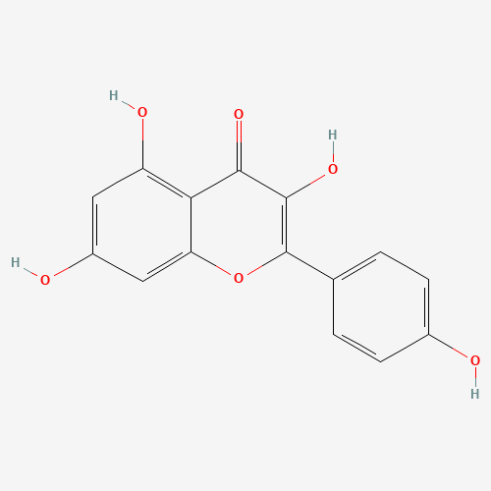 |  | MOL000422 | Kaempferol | 290 | 41.88 | 0.24 | Radix Paeoniae Alba, Cortex Eucommiae,  Radix Astragali, Radix Ginseng,  Radix Achyranthis Bidentatae,
A2 | 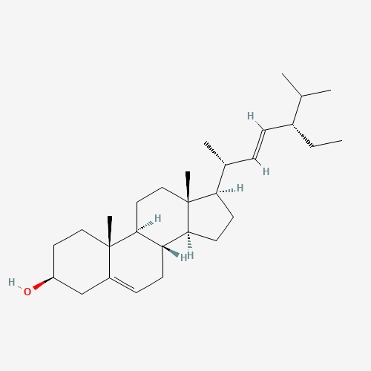 |  | MOL000449 | Stigmasterol | 240 | 43.83 | 0.76 | Radix Angelicae sinensis, Fructus Lycii,  Cortex Phellodendri, Caulis Spatholobi,  Radix Achyranthis Bidentatae,  Radix Ginseng, Radix Notoginseng, Radix Clematidis
JXT16 | 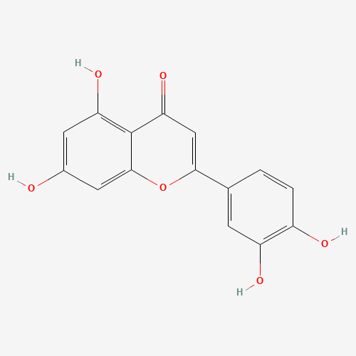 |  | MOL000006 | Luteolin | 55 | 36.16 | 0.25 | Caulis Spatholobi
A13 | 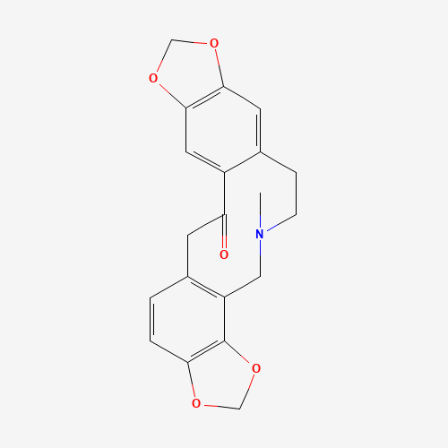 |  | MOL000787 | Fumarine | 50 | 59.26 | 0.83 | Cortex Phellodendri, Radix Ginseng
NX3 | 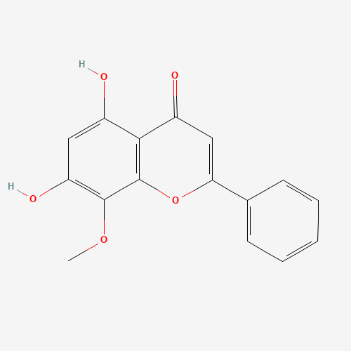 |  | MOL000173 | Wogonin | 43 | 30.68 | 0.23 | Radix Achyranthis Bidentatae
A6 | 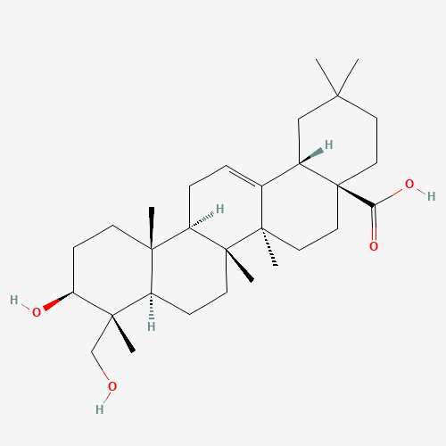 |  | MOL000296 | Hederagenin | 42 | 36.91 | 0.75 | Radix Astragali, Caulis Spatholobi
HQ4 | 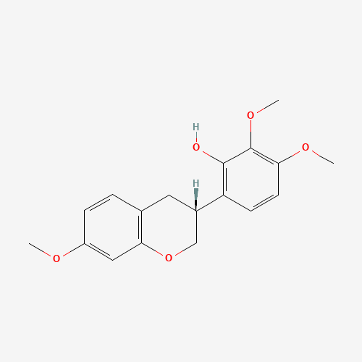 |  | MOL000378 | 7-O-Methylisomucronulatol | 42 | 74.69 | 0.3 | Radix Astragali
DZ11 | 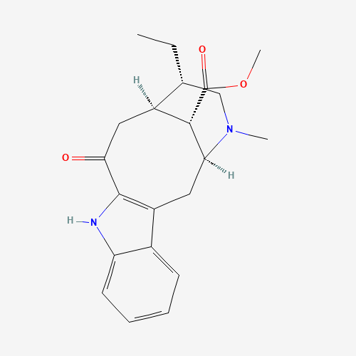 |  | MOL009015 | (-)-Tabernemontanine | 39 | 58.67 | 0.61 | Cortex Eucommiae

