Supplementary Data: Dynamical investigation of Ni_{n}Ag_{m}(n+m=147,309,561) nanoalloys with core-shell orderings
Damla Zehir¹, Songül Taran² and Haydar Arslan^{1,*}
¹Department of Physics, Zonguldak Bulent Ecevit University, 67100 Zonguldak, Turkey.
²Department of Physics, Duzce University, 81620, Duzce, Turkey.

* Corresponding author
E-mail: h.arslan@beun.edu.tr

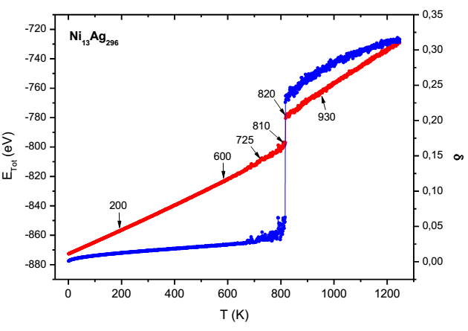 | 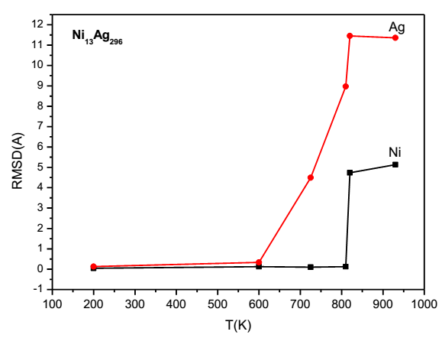
a) | b)
Figure S1. a) Temperature dependence of caloric curve and Lindemann index variation for Ni₁₃Ag₂₉₆ nanoalloy. b) RMSD variation of Ni₁₃Ag₂₉₆ nanoalloy.
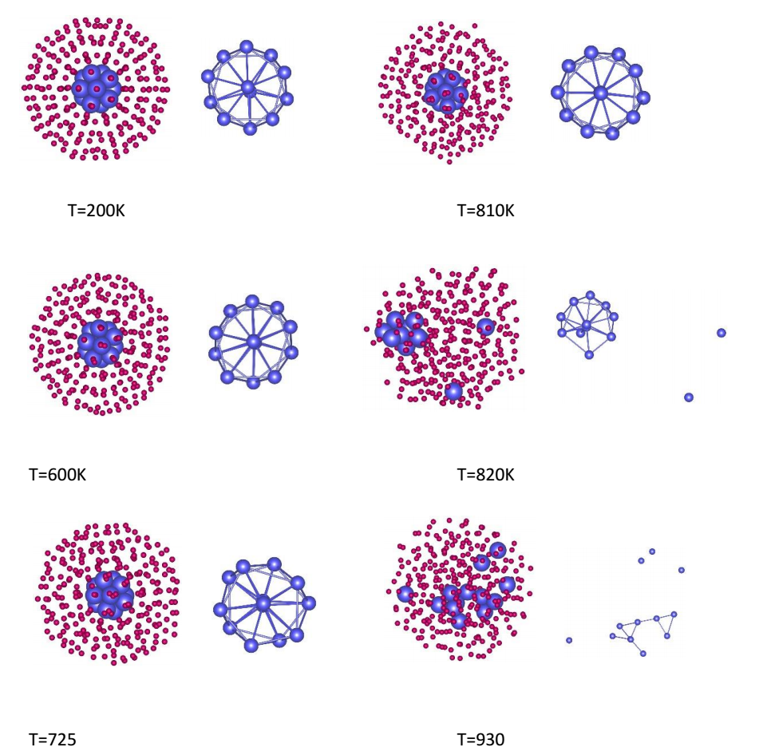
Figure S2. The structures of the Ni₁₃Ag₂₉₆ nanoalloy at defined temperatures on the caloric curve.

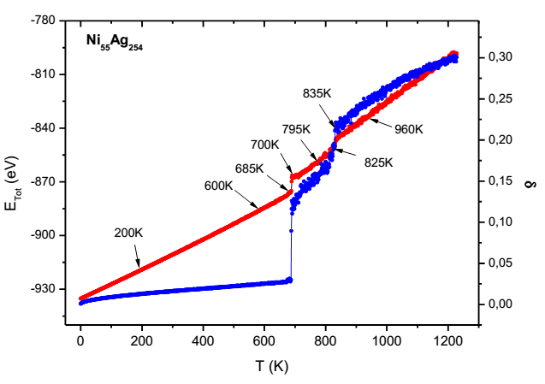 | 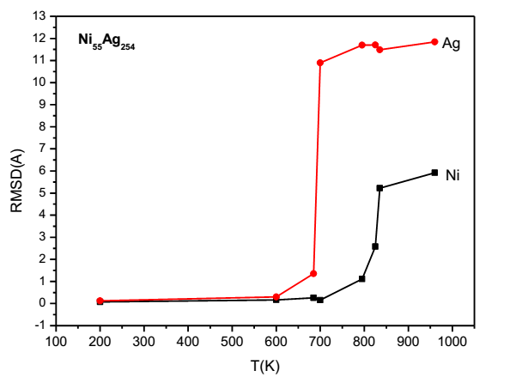
a) | b)
Figure S3. a) Temperature dependence of caloric curve and Lindemann index variation for Ni₅₅Ag₂₅₄ nanoalloy. b) RMSD variation of Ni₅₅Ag₂₅₄ nanoalloy.
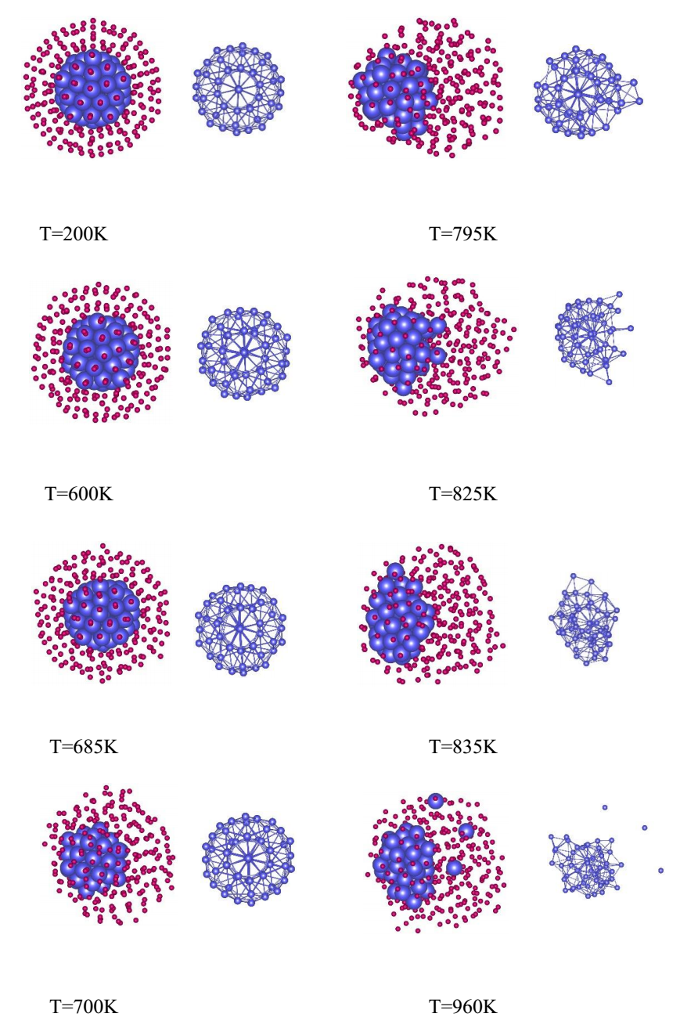
Figure S4. The structures of the Ni₅₅Ag₂₅₄ nanoalloy at defined temperatures on the caloric curve.
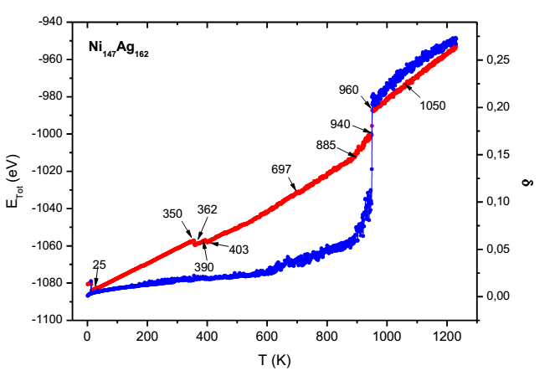 | 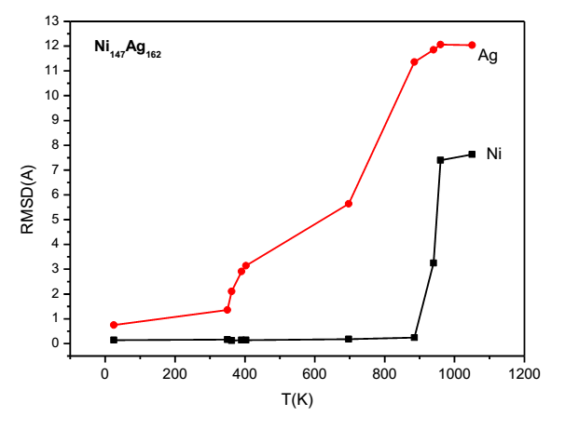
a) | b)
Figure S5. a) Temperature dependence of caloric curve and Lindemann index variation for Ni₁₄₇Ag₁₆₂ nanoalloy. b) RMSD variation of Ni₁₄₇Ag₁₆₂ nanoalloy.
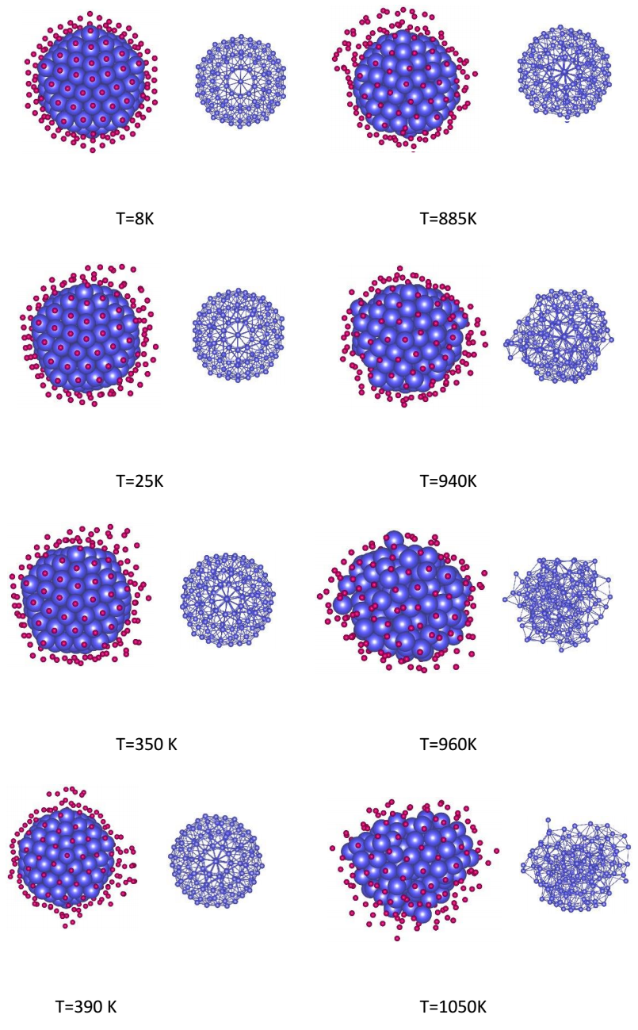
Figure S6. The structures of the Ni₁₄₇Ag₁₆₂ nanoalloy at defined temperatures on the caloric curve.

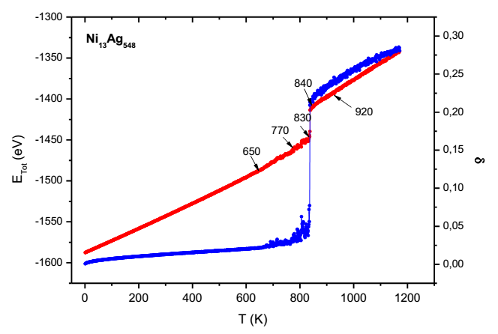 | 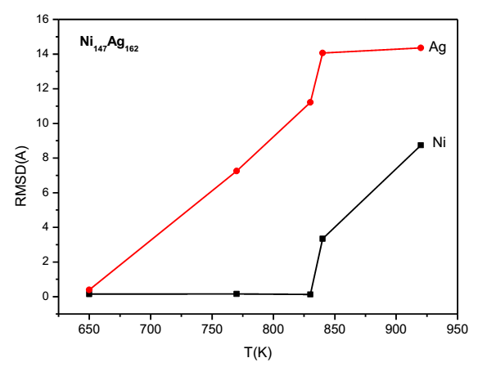
a) | b)
Figure S7. a) Temperature dependence of caloric curve and Lindemann index variation for Ni₁₃Ag₅₄₈ nanoalloy. b) RMSD variation of Ni₁₃Ag₅₄₈ nanoalloy.
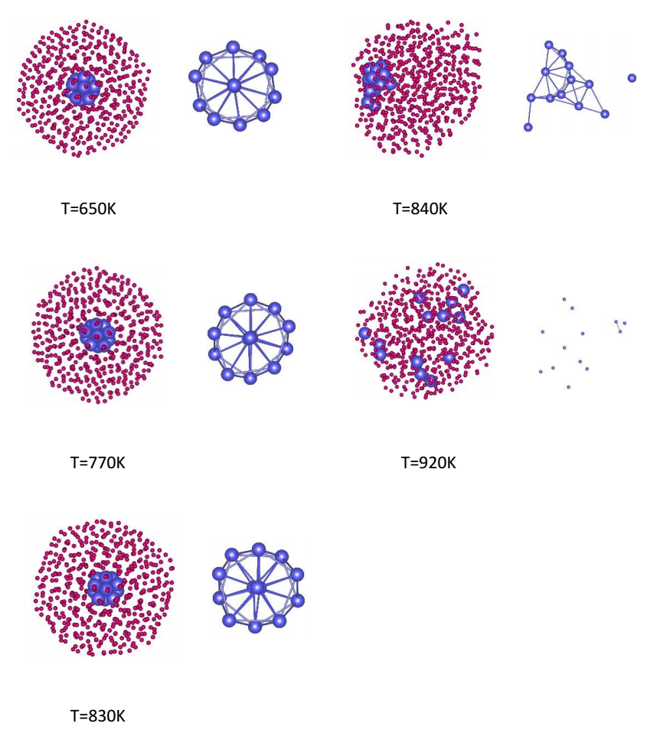
Figure S8. The structures of the Ni₁₃Ag₅₄₈ nanoalloy at defined temperatures on the caloric curve.

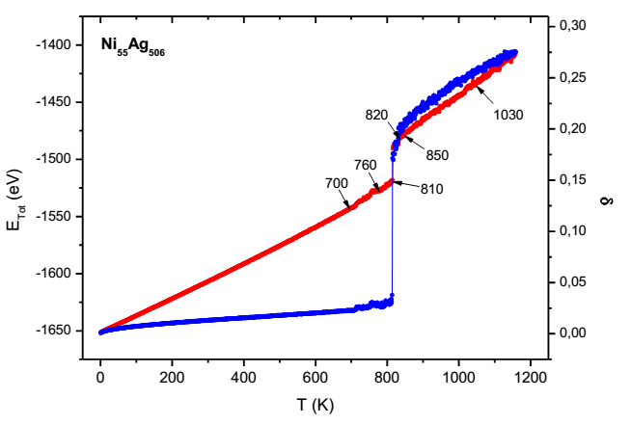 | 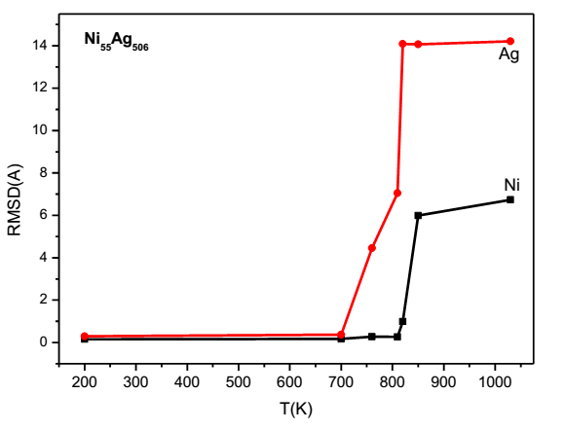
a) | b)
Figure S9. a) Temperature dependence of caloric curve and Lindemann index variation for Ni₅₅Ag₅₀₆ nanoalloy. b) RMSD variation of Ni₅₅Ag₅₀₆ nanoalloy.
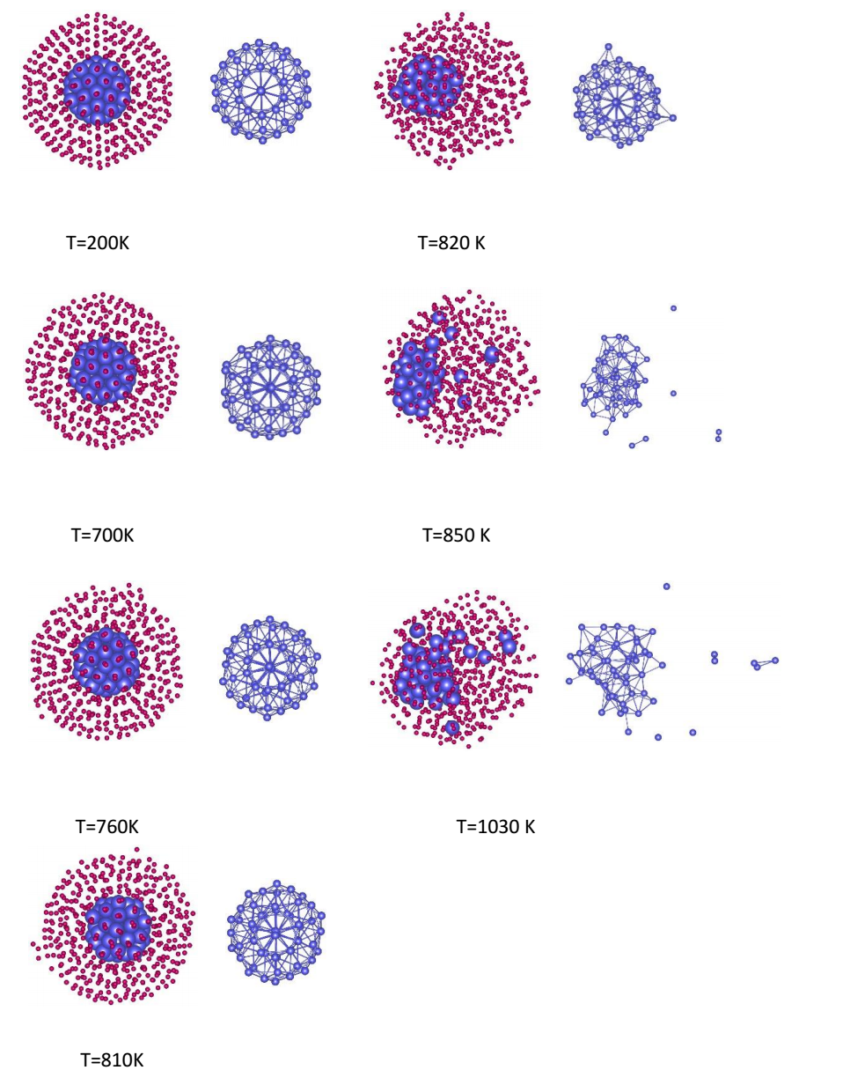
Figure S10. The structures of the Ni₅₅Ag₅₀₆ nanoalloy at defined temperatures on the caloric curve.

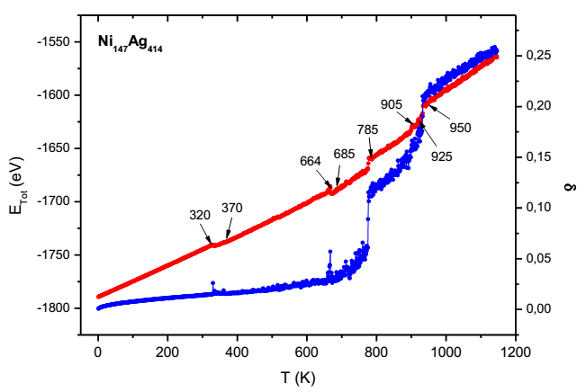 | 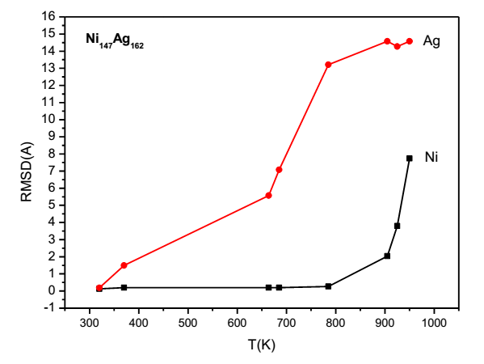
a) | b)
Figure S11. a) Temperature dependence of caloric curve and Lindemann index variation for Ni₁₄₇Ag₄₁₄ nanoalloy. b) RMSD variation of Ni₁₄₇Ag₄₁₄ nanoalloy.
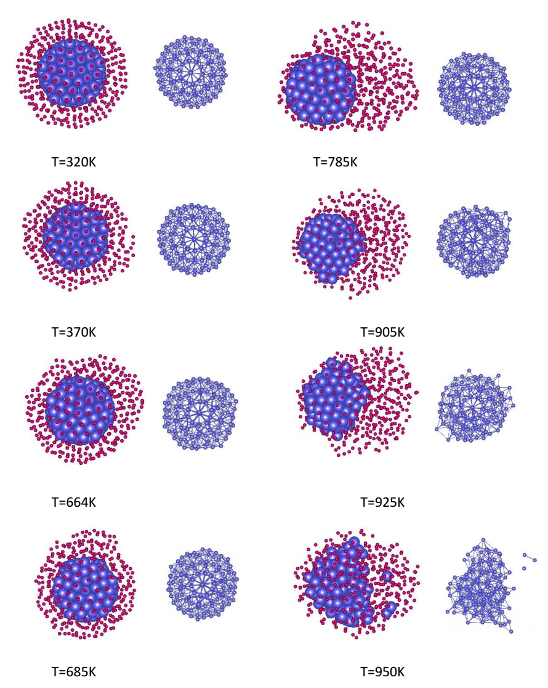

Figure S12. The structures of the Ni₁₄₇Ag₄₁₄ nanoalloy at defined temperatures on the caloric curve.
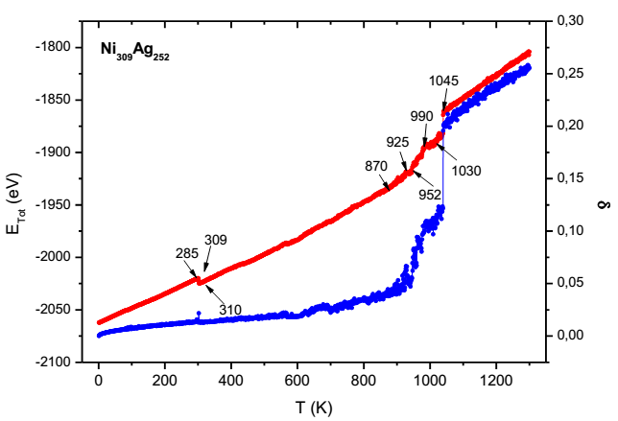 | 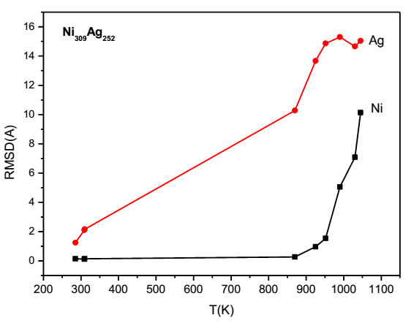
a) | b)

Figure S13. a) Temperature dependence of caloric curve and Lindemann index variation for Ni₃₀₉Ag₂₅₂ nanoalloy. b) RMSD variation of Ni₃₀₉Ag₂₅₂ nanoalloy.
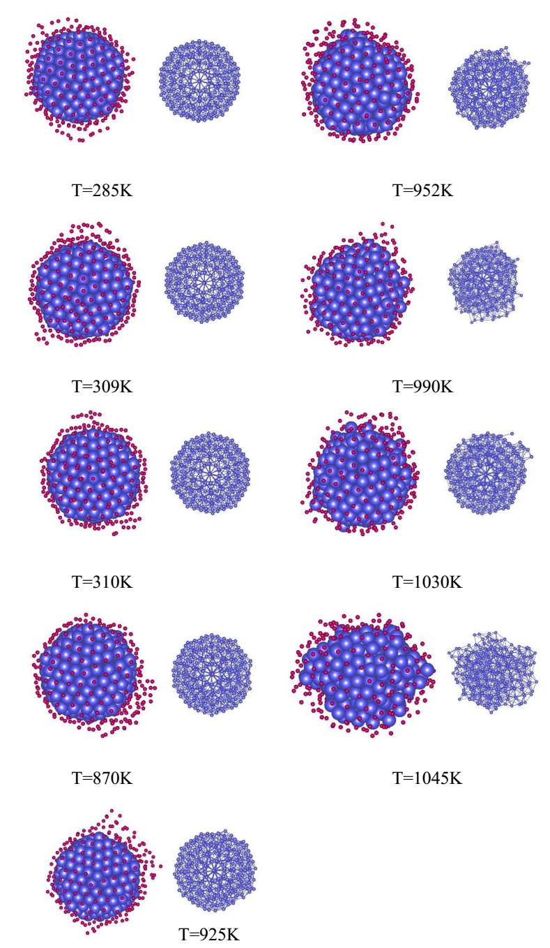
Figure S14. The structures of the Ni₃₀₉Ag₂₅₂ nanoalloy at defined temperatures on the caloric curve.

