Supplementary Material

Species parameters used for TreeMig simulations
Table S1: Species parameters relevant for the study of the 30 species modelled in the TreeMig simulations. Explanations of the parameters can be found in Table S2.
Spp | D_{max} | H_{max} | A_{max} | G | DD_{min} | WiT | DrT | Ls | La | seedGerm | maxSeed | minMat
Abies alba | 187 | 60 | 700 | 171 | 650 | -2 | 0.19 | 3 | 1 | 0.46 | 50000 | 7.0
Larix decidua | 100 | 44 | 850 | 219 | 225 | -11 | 0.40 | 8 | 9 | 0.39 | 133000 | 4.0
Picea abies | 180 | 50 | 930 | 171 | 385 | -7 | 0.19 | 3 | 6 | 0.71 | 96500 | 10.1
Pinus cembra | 165 | 26 | 1050 | 115 | 225 | -11 | 0.28 | 8 | 5 | 0.64 | 1000 | 2.4
Pinus montana | 80 | 23 | 300 | 100 | 330 | -11 | 0.25 | 8 | 9 | 0.54 | 11000 | 1.6
Pinus sylvestris | 80 | 40 | 760 | 243 | 650 | -4 | 0.4 | 7 | 9 | 0.91 | 22000 | 2.6
Taxus baccata | 55 | 22 | 2110 | 171 | 1000 | -5 | 0.05 | 4 | 2 | 0.6 | 23000 | 0.6
Acer campestre | 55 | 23 | 170 | 177 | 1000 | -2 | 0.1 | 5 | 5 | 0.8 | 193000 | 4.1
Acer platanoides | 99 | 32 | 380 | 220 | 1000 | -2 | 0.15 | 2 | 4 | 0.55 | 510000 | 3.1
Acer pseudoplatanus | 121 | 37 | 550 | 240 | 615 | -2 | 0.2 | 3 | 4 | 0.6 | 551500 | 2.6
Alnus glutinosa | 90 | 31 | 240 | 227 | 900 | -2 | 0.05 | 5 | 5 | 0.4 | 218500 | 4.5
Alnus incana | 90 | 22 | 150 | 188 | 675 | 0 | 0.2 | 6 | 7 | 0.33 | 400000 | 2.6
Alnus viridis | 11 | 4 | 100 | 60 | 272 | -11 | 0.05 | 7 | 7 | 0.15 | 47000 | 2.3
Betula pendula | 90 | 29 | 220 | 195 | 541 | 0 | 0.3 | 7 | 9 | 0.19 | 11775000 | 4.5
Carpinus betulus | 90 | 27 | 220 | 202 | 1460 | -5 | 0.1 | 4 | 3 | 0.67 | 154000 | 3.4
Castanea sativa | 198 | 33 | 1510 | 146 | 1200 | 0 | 0.21 | 5 | 5 | 0.58 | 4000 | 2.2
Corylus avellana | 22 | 10 | 70 | 95 | 900 | -5 | 0.2 | 6 | 6 | 0.3 | 6000 | 0.7
Fagus sylvatica | 154 | 45 | 430 | 279 | 620 | -4 | 0.23 | 24 | 1 | 0.71 | 29000 | 14.7
Fraxinus excelsior | 154 | 42 | 350 | 273 | 820 | -2 | 0.23 | 5 | 6 | 0.6 | 42000 | 5.0
Populus nigra | 100 | 36 | 280 | 258 | 1700 | 0 | 0.1 | 6 | 5 | 0.2 | 1890000 | 2.7
Populus tremula | 90 | 30 | 140 | 199 | 850 | 0 | 0.23 | 6 | 7 | 0.4 | 1680000 | 4.8
Quercus petraea | 110 | 45 | 860 | 281 | 900 | 0 | 0.2 | 7 | 7 | 0.69 | 47000 | 10.2
Quercus pubescens | 66 | 25 | 500 | 142 | 1200 | -4 | 0.5 | 7 | 7 | 0.7 | 18000 | 8.7
Quercus robur | 143 | 52 | 1060 | 355 | 1100 | 0 | 0.15 | 5 | 9 | 0.75 | 27500 | 11.6
Salix alba | 220 | 27 | 170 | 121 | 657 | -5 | 0.15 | 6 | 5 | 0.2 | 1512000 | 15.6
Sorbus aria | 70 | 22 | 180 | 171 | 650 | -5 | 0.15 | 6 | 7 | 0.6 | 80500 | 2.6
Sorbus aucuparia | 70 | 19 | 110 | 177 | 500 | -3 | 0.15 | 4 | 7 | 0.7 | 3755000 | 3.6
Tilia cordata | 110 | 30 | 940 | 199 | 950 | 0 | 0.25 | 5 | 5 | 0.45 | 720000 | 2.2
Tilia platyphyllos | 110 | 39 | 960 | 235 | 850 | 0 | 0.2 | 4 | 3 | 0.48 | 380500 | 1.6
Ulmus scabra | 100 | 43 | 480 | 277 | 957 | 0 | 0.15 | 4 | 3 | 0.35 | 372000 | 6.4

Table S2: Definition and unit of species parameters (cf. Table S1).
Parameter | Definition | Unit
D_{max} | Max. diameter at breast height (DBH) | cm
H_{max} | Max. height | m
A_{max} | Max. age | year
G | Max. growth rate | cm/year
DD_{min} | Min. early degree-day sum above 5.5°C | degree-day
WiT | Min. mean temperature of winter months (Dec, Jan, Feb) | °C
DrT | Drought tolerance: prob. of evapotranspiration deficit tolerated
Ls | Sapling light parameter: shade-tolerant (1) to shade-intolerant (9)
La | Adult light parameter: shade-tolerant (1) to shade-intolerant (9)
seedGerm | Seed germination rate | year⁻¹
maxSeed | Max. number of seeds
minMat | Min. height for maturity | m

Parameters for quantification of the elements at risk
Table S3: Standard values for the most frequent object categories of the considered elements at risk according to FOEN (2020).
Object category | Base value | unity
Stable | 80 | CHFm⁻³
Appartment house | 550’000 | CHFappartment⁻¹
Single family house | 650’000 | CHFappartment⁻¹
Industrial building | 280 | CHFm⁻³
Forest road | 700 | CHFm⁻¹
Municipality road | 2300 | CHFm⁻¹
Cantonal road | 4100 | CHFm⁻¹
Railway (single-lane) | 6300 | CHFm⁻¹

Table S4: Vulnerability values for objects (V_{obj}) and persons (V_{pers}) for the most frequent object categories of the element at risks for a low (0-30 kJ), medium (30-300 kJ) and high (> 300 kJ) Intensity based on FOEN (2020).
Object category | V_{obj} (low) | V_{obj} (medium) | V_{obj} (high) | V_{pers} (low) | V_{pers} (medium) | V_{pers} (high)
Shed | 0.01 | 0.8 | 0.9 | 0.0 | 0.03 | 0.5
Apartment house | 0.01 | 0.1 | 0.3 | 0.0 | 0.0002 | 0.06
Single family house | 0.01 | 0.1 | 0.3 | 0.0 | 0.002 | 0.06
Industrial building | 0.01 | 0.1 | 0.3 | 0.0 | 0.0002 | 0.06
Public building | 0.01 | 0.1 | 0.3 | 0.0 | 0.0002 | 0.06
Municipality road | 0.1 | 0.5 | 1 | 0.1 | 0.8 | 1
Cantonal road | 0.1 | 0.5 | 1 | 0.1 | 0.8 | 1
Railway (single lane) | 0.1 | 0.3 | 0.6 | 0.1*V_{pers} (high) | 0.6*V_{pers} (high) | 0.12/(1+exp((124-v)/15)) + 0.004

Evolution of basal area in spin-up simulations
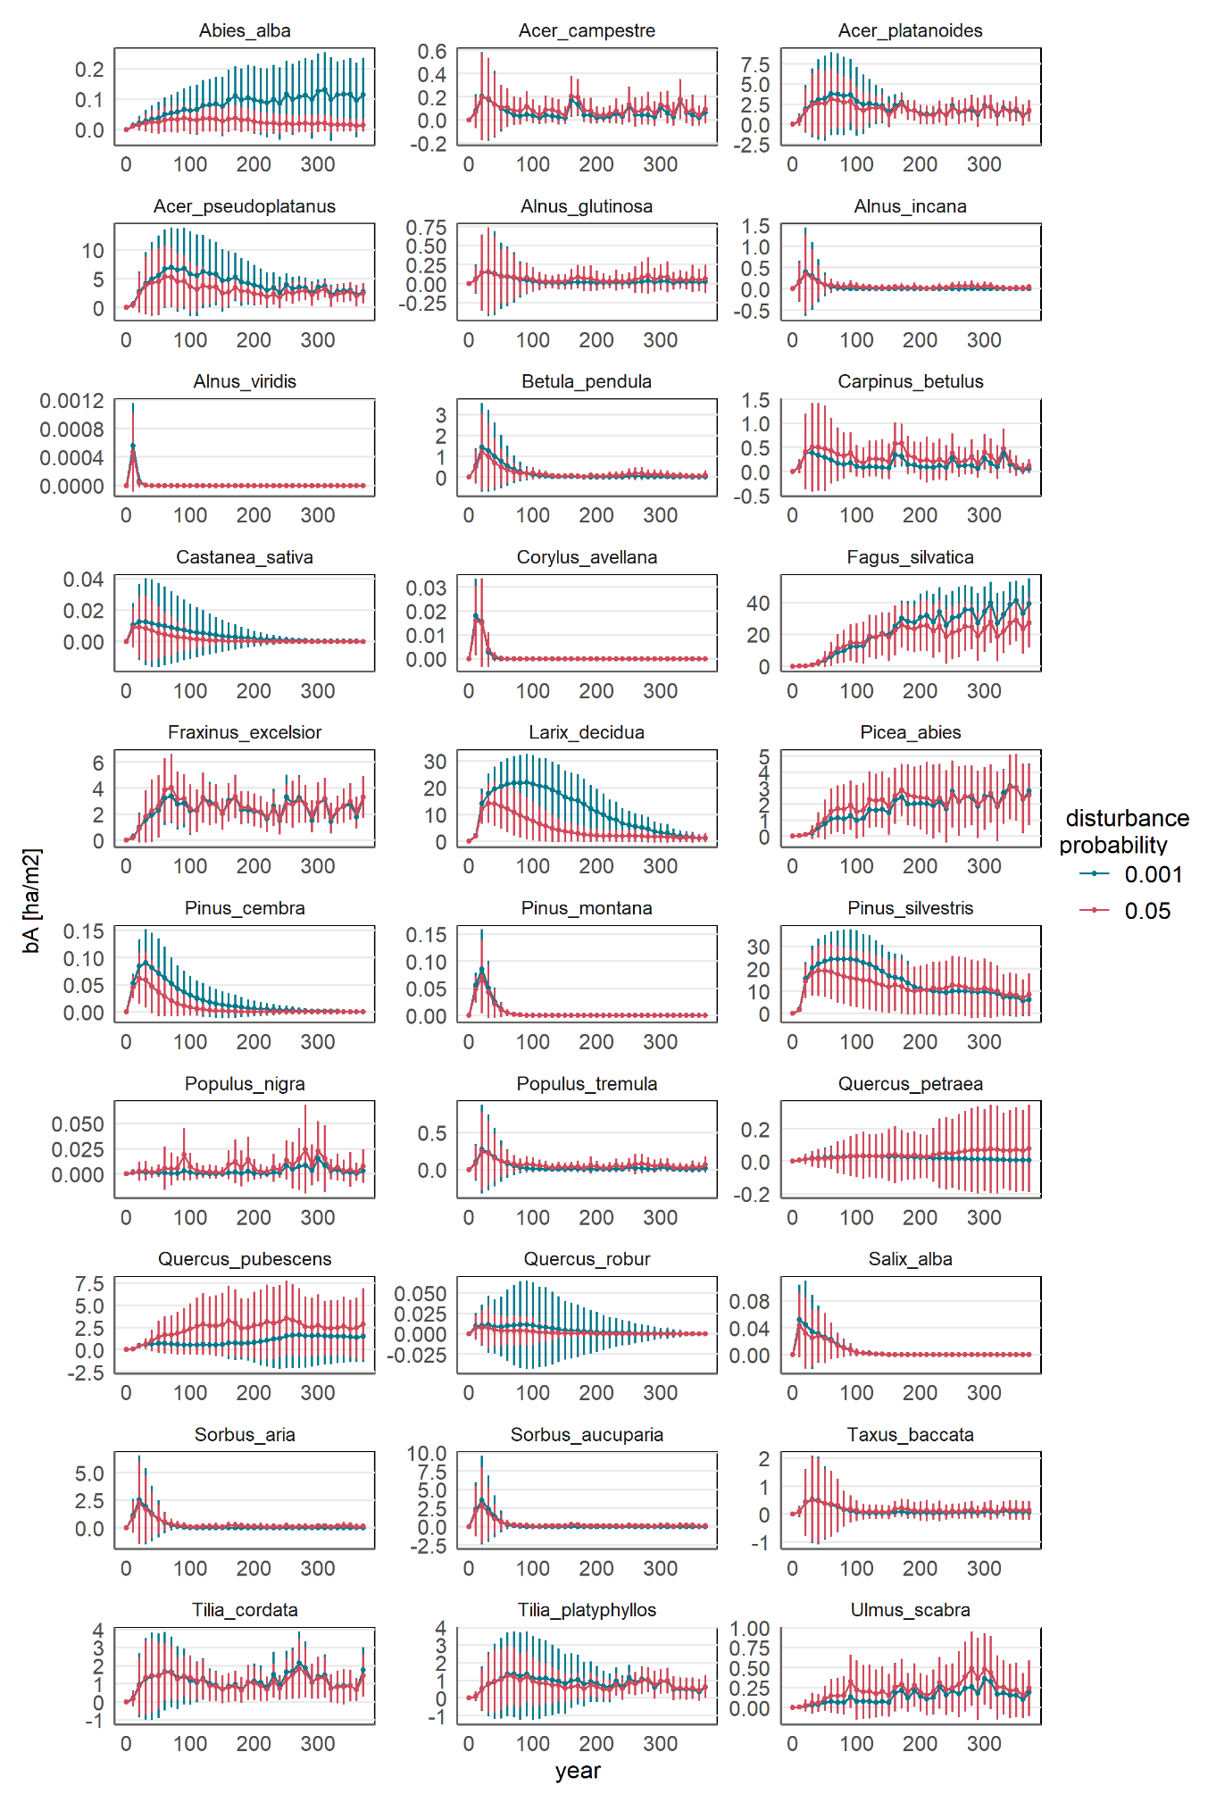
Figure S1: Evolution of basal area of all simulated species in the spin-up simulation with TreeMig (simulation from bare-ground for 400 years).

Regeneration and tree density in intervention areas
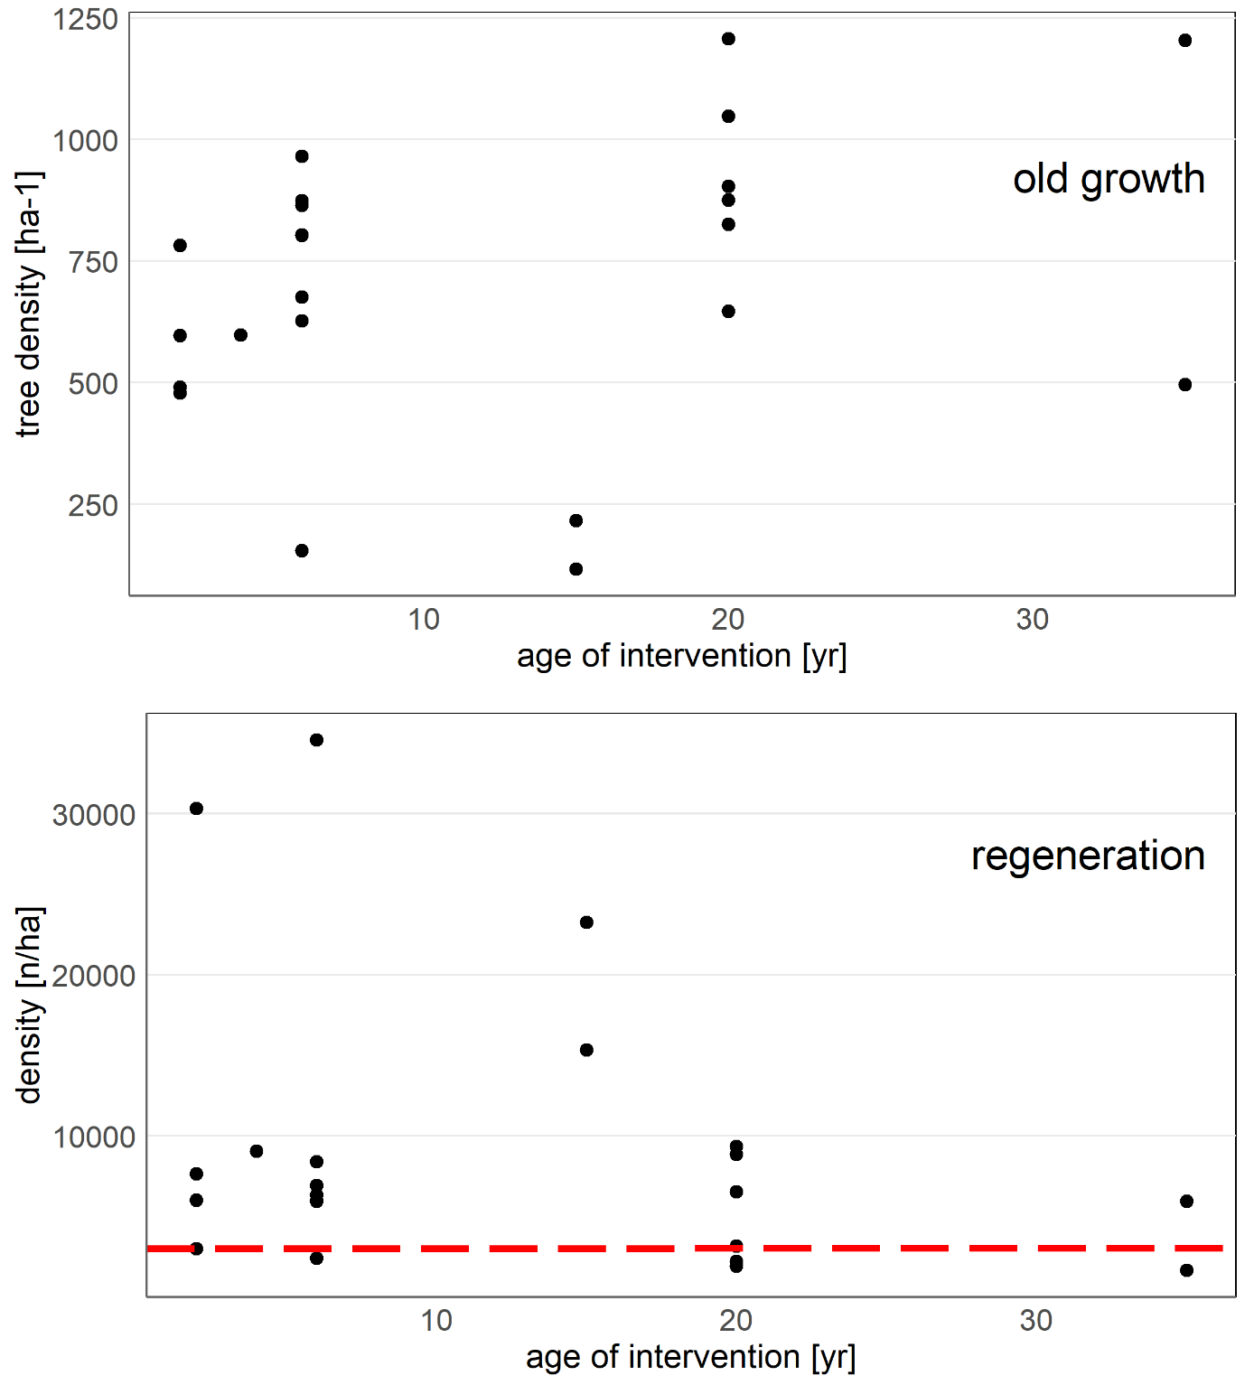
Figure S2: Density of adult trees (above) and of the regeneration in the sample plots depending on the age of intervention. The red line corresponds to a general regeneration target value according to Brang et al. (2020).

Expected risk per type of element at risk
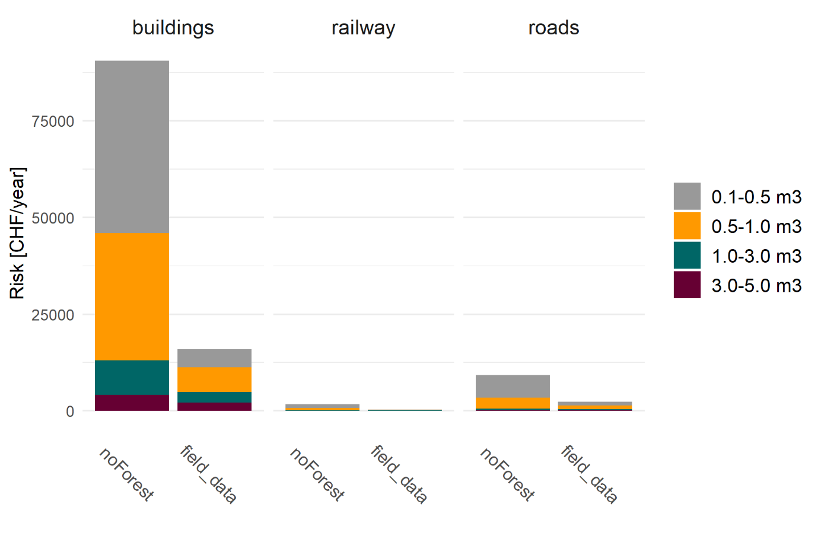
Figure S3: Yearly expected risk per element at risk (buildings, railway, roads) and block volume for the current forest (“field_data”) and the situation without forest (“noForest”).

Risk maps
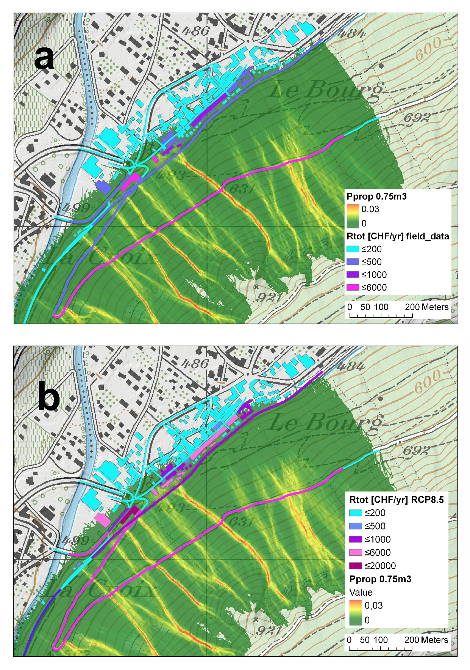
Figure S4: Map of total risk [CHFyr⁻¹] for buildings, roads and railway in Martigny for the current forest based on field data (a) and the modelled forest under climate change scenario RCP8.5 (b), and the propagation probability of blocks with a volume of 0.75 m³.

