Fig. S1. Average monthly maximum and minimum temperature (⁰C) and average monthly rainfall (mm) in 2017 in Sirmour district (Source: Customized Rainfall Information System (CRIS), Hydromet division, IMD).
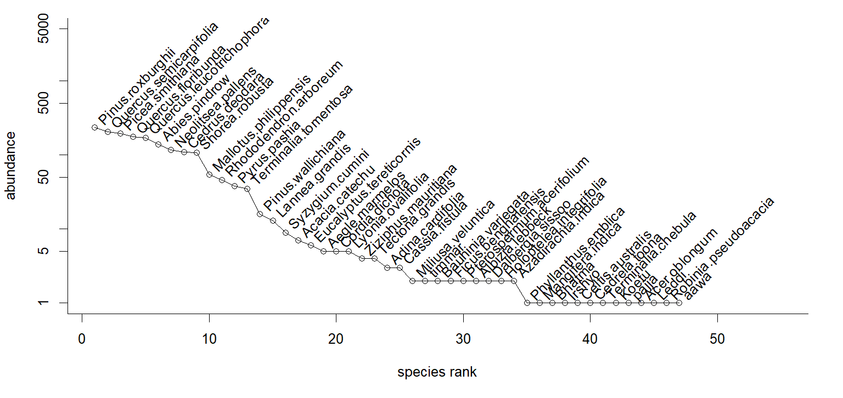
Fig. S2. Rank-abundance curve of tree species in the study site (Species abbreviations: PR: Pinus roxburghii, QS: Quercus semicarpifolia, PS: Picea smithiana, QF: Quercus floribunda, QL: Quercus leucotrichophora, AP: Abies pindrow, NP: Neolitsea pallens, CD: Cedrus deodara, SR: Shorea robusta, MP: Mallotus philippensis, RA: Rhododendron arboreum, PP: Pyrus pashia, TT: Terminalia tomentosa, PW: Pinus wallichiana, LG: Lannea grandis, SC: Syzygium cumini, AC: Acacia catechu, ET: Eucalyptus tereticornis, AM: Aegle marmelos, CD: Cordia dichota, LO: Lyonia ovalifolia, ZM: Ziziphus mauritiana, TG: Tectona grandis, AC: Adina cardifolia, CF: Cassia fistula, MV: Miliusa veluntica, Ti: Timmar, BV: Bauhinia variegate, FB: Ficus benghalensis, PA: Pterospermum acerifolium, AL: Albizzia lebbeck, DS: Dalbergia sissoo, HI: Holoptelea integrifolia, AI: Azadirachta indica, MI: Mangifera indica, Bh: Bhatma, Ir: Irshyo, CA: Celtis australis, TC: Terminalia chebula, Ko: Koetu, Pa: Pajja, AO:Acer oblongum, Le: Leddi, RP: Robinia pseudoacacia, Aa: Aawa).
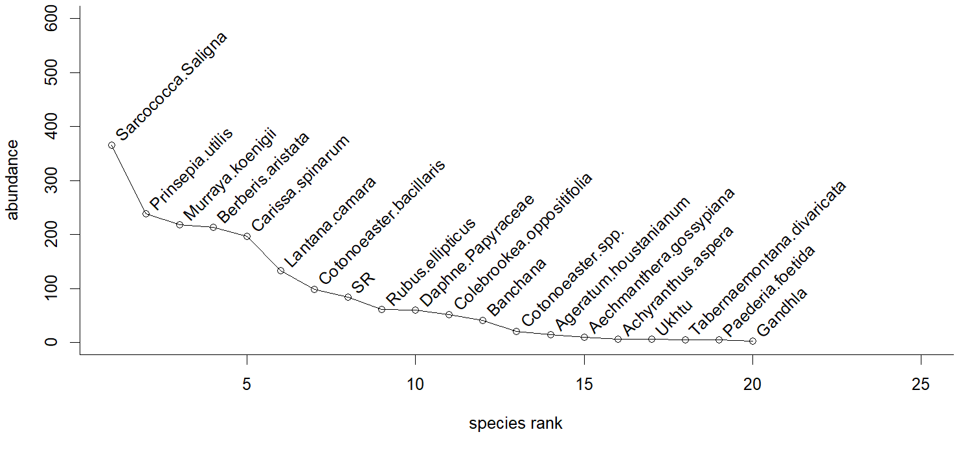
Fig. S3. Rank-abundance curve of shrub species in the study site (Species abbreviations: SS: Sarcococca saligna, PU: Prinsepia utilis, MK: Murraya koenigii, BA: Berberis aristate, CS: Carissa spinarum, LC: Lantana camara, CB: Cotoneaster bacillaris, RE: Rubus ellipticus, DP: Daphne papyraceae, CO: Colebrookea oppositifolia, Ba: Banchana, Cs: Cotoneaster spp., AG: Ageratum gossypiana, AA: Achyranthus aspera, Uk: Ukhtu, TD: Tabernaemontana divaricate, PF: Paederia foetida, Ga: Gandhla.

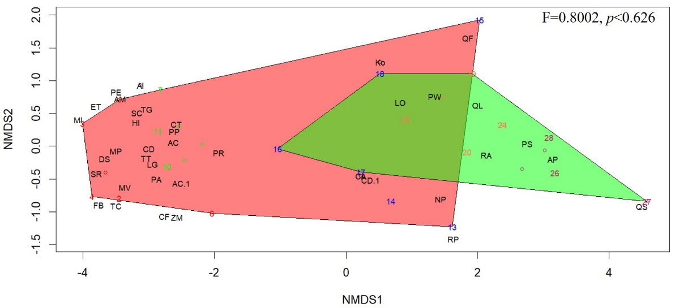
Fig. S4. Non-metric multidimensional scaling (NMDS) for tree layer based on slope aspect. Plots located on different slope aspect were represented based on Bray-Curtis dissimilarity (stress 0.8). Permutational analysis of Variance indicates significant variation among sites (F=0.8, p=0.63. Species abbreviations are mentioned in Fig. S1.
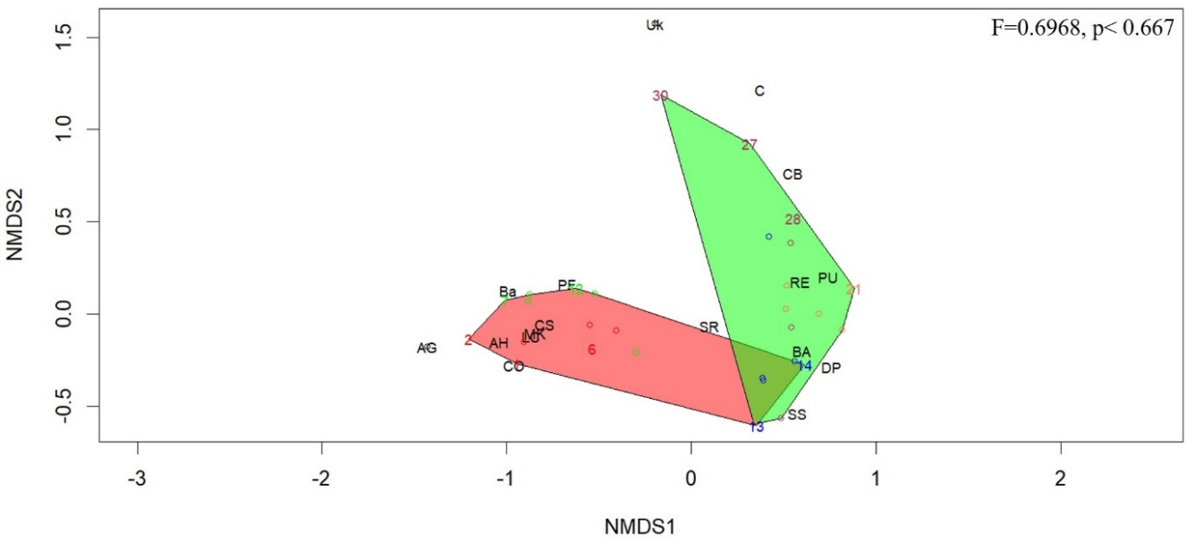
Fig. S5. Non-metric multidimensional scaling (NMDS) for shrub layer based on slope aspect. Plots located on different slope aspect were represented based on Bray-Curtis dissimilarity (stress 0.8). Permutational analysis of Variance indicates significant variation among sites (F=0.8, p=0.63. Species abbreviations are mentioned in Fig. S2.

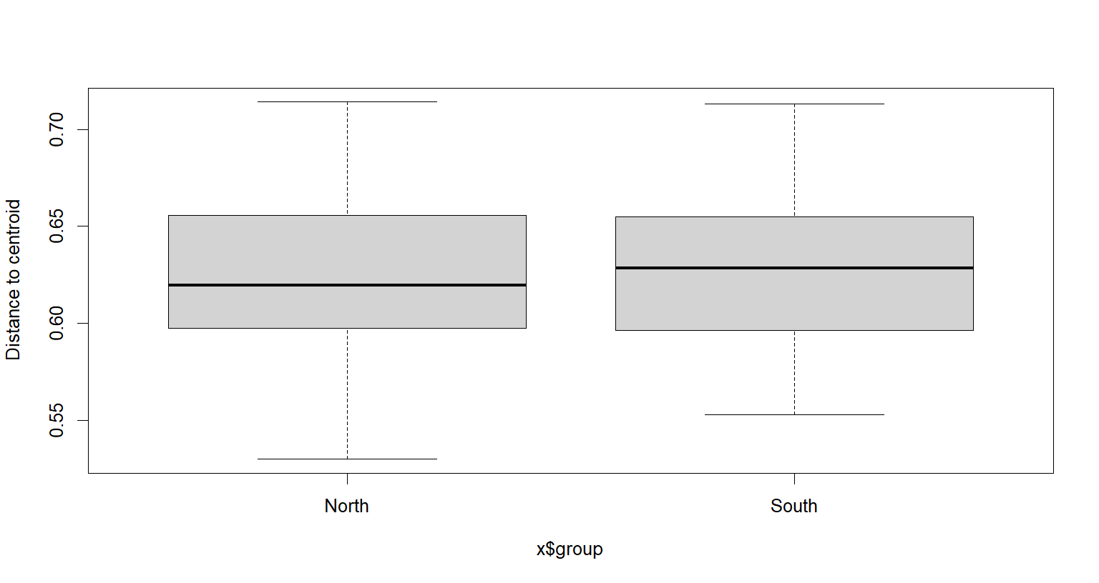
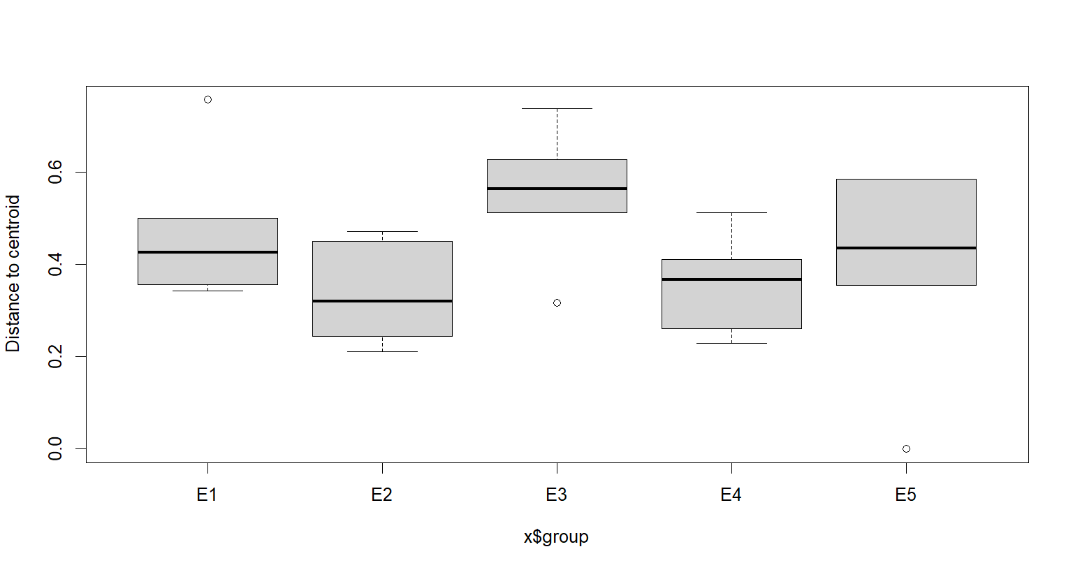

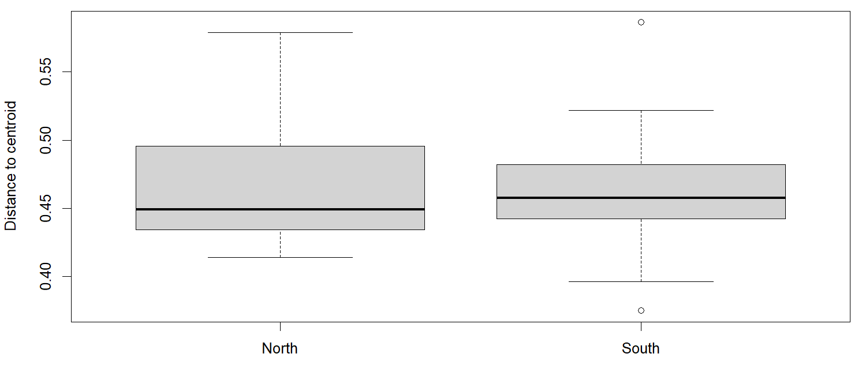
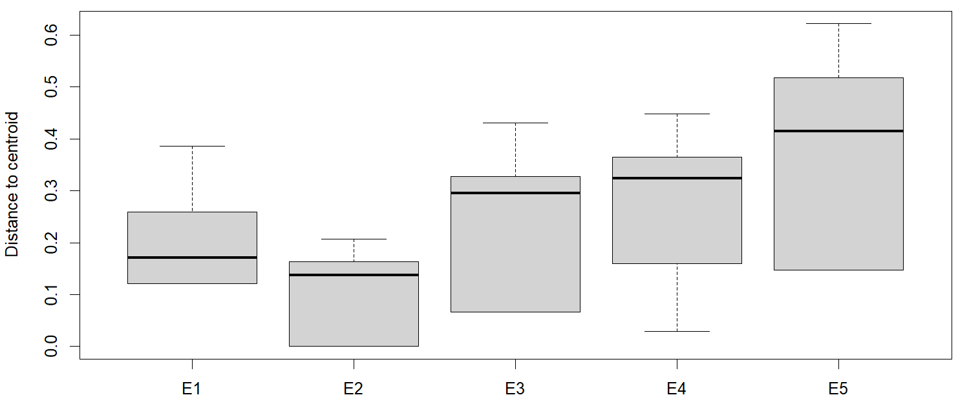
- (ii)

(iii) (iv)
Fig. S6. Comparison of vegetation heterogeneity (β diversity) using distance-to-centroid along elevational scale (left), (i) and (iv) and contrasting slope aspect (right), (ii) and (iv) for tree layer (above) and shrub layer (below). The bold black line in the boxes denote the median value (50th percentile), and 25th to 75th percentiles of dataset. The black whiskers mark the 5th and 95th percentiles, and values beyond these upper and lower bounds are considered outliers.

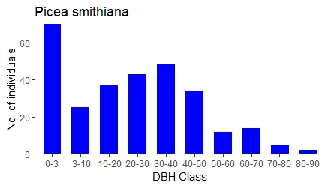
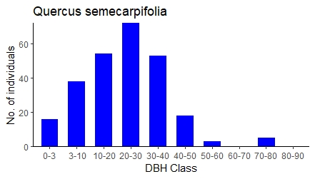
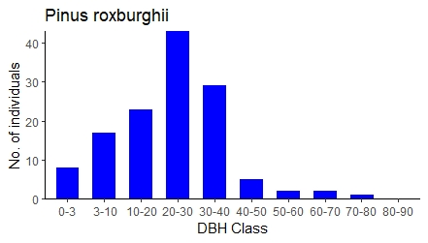

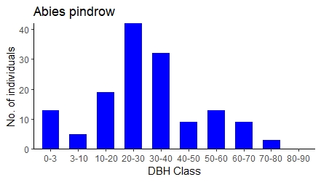
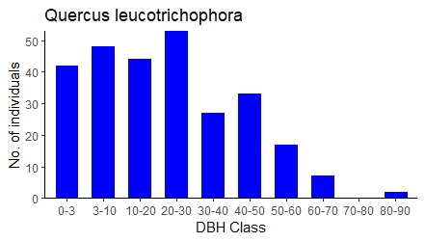
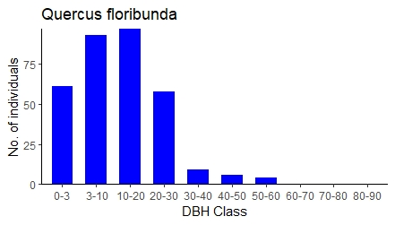

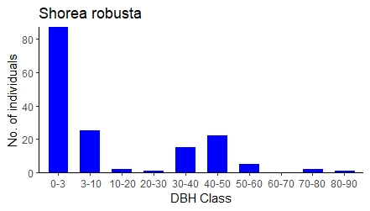
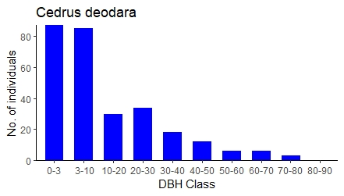
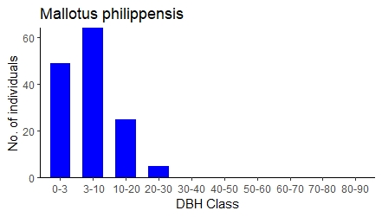
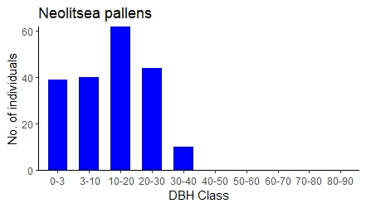

Fig. S7. Population structure of tree species for the dominant species (Pinus roxburghii, Quercus semecarpifolia, Picea smithiana, Quercus floribunda, Quercus leucotrichophora, Abies pindrow, Neolitsea pallens, Cedrus deodara, Shorea robusta and Mallotus philippensis) in the study sites where x-axis represents DBH Class (Diameter at Breast Height) and y-axis represents number of individuals.

Table S1. Results of two-way ANOVA to analyse the effect of elevation and slope aspect on vegetation (tree and shrub) structure and diversity indices among sites.

Parameters | Source of variation | df | SS | MS | F | p-value
Tree Density | Elevation | 4 | 1472580 | 368145 | 13.41 | <0.001***
Tree Density | Aspect | 1 | 44083 | 44083 | 1.60 | 0.22
Tree Density | Elevation:Aspect | 4 | 24567 | 6142 | 0.22 | 0.92
Tree Basal Area | Elevation | 4 | 7196 | 1799 | 22.14 | <0.001***
Tree Basal Area | Aspect | 1 | 182 | 181.8 | 2.23 | 0.15
Tree Basal Area | Elevation:Aspect | 4 | 21 | 5.3 | 0.06 | 0.99
Tree Shannon diversity | Elevation | 4 | 3.34 | 0.83 | 4.55 | 0.008**
Tree Shannon diversity | Aspect | 1 | 0.09 | 0.09 | 0.52 | 0.47
Tree Shannon diversity | Elevation:Aspect | 4 | 0.51 | 0.12 | 0.69 | 0.60
Tree Species Richness | Elevation | 4 | 133.80 | 33.45 | 5.25 | 0.004**
Tree Species Richness | Aspect | 1 | 4.03 | 4.03 | 0.63 | 0.43
Tree Species Richness | Elevation:Aspect | 4 | 15.13 | 3.78 | 0.59 | 0.67
Tree Species Evenness | Elevation | 4 | 0.87 | 0.21 | 3.84 | 0.01*
Tree Species Evenness | Aspect | 1 | 0.001 | 0.001 | 0.03 | 0.08
Tree Species Evenness | Elevation:Aspect | 4 | 0.23 | 0.05 | 1.02 | 0.42
Tree Seedling | Elevation | 4 | 9599609 | 2399902 | 3.89 | 0.008**
Tree Seedling | Aspect | 1 | 2445614 | 2445614 | 3.96 | 0.05*
Tree Seedling | Elevation:Aspect | 4 | 7229996 | 1807499 | 2.93 | 0.03*
Tree Sapling | Elevation | 4 | 4838039 | 1209510 | 3.71 | 0.01*
Tree Sapling | Aspect | 1 | 952900 | 952900 | 2.92 | 0.09
Tree Sapling | Elevation:Aspect | 4 | 2868028 | 717007 | 2.20 | 0.08
Shrub Density | Elevation | 4 | 20458195 | 5114549 | 41.72 | <0.001***
Shrub Density | Aspect | 1 | 151986 | 151986 | 1.24 | 0.27
Shrub Density | Elevation:Aspect | 4 | 154492 | 38623 | 0.31 | 0.86
Shrub Basal Area | Elevation | 4 | 0.77 | 0.19 | 9.51 | <0.001***
Shrub Basal Area | Aspect | 1 | 0.002 | 0.002 | 0.12 | 0.72
Shrub Basal Area | Elevation:Aspect | 4 | 0.04 | 0.012 | 0.59 | 0.67
Shrub Shannon Diversity | Elevation | 4 | 3.84 | 0.95 | 8.81 | <0.001***
Shrub Shannon Diversity | Aspect | 1 | 0.00 | 0.00 | 0.001 | 0.97
Shrub Shannon Diversity | Elevation:Aspect | 4 | 0.65 | 0.16 | 1.48 | 0.24
Shrub Species Richness | Elevation | 4 | 29.80 | 7.45 | 7.45 | <0.001***
Shrub Species Richness | Aspect | 1 | 0.53 | 0.53 | 0.53 | 0.47
Shrub Species Richness | Elevation:Aspect | 4 | 7.13 | 1.78 | 1.78 | 0.17
Shrub Species Evenness | Elevation | 4 | 0.93 | 0.23 | 7.22 | <0.001***
Shrub Species Evenness | Aspect | 1 | 0.002 | 0.002 | 0.07 | 0.78
Shrub Species Evenness | Elevation:Aspect | 4 | 0.11 | 0.02 | 0.87 | 0.49
Abbreviations: df: degrees of freedom, SS: Sum of Squares, MS: Mean sum of Squares. Significance codes: 0 ‘***’ 0.001 ‘**’ 0.01 ‘*’ 0.05.

Table S2. Mean value of soil parameters (±standard error) (n=30) for each site.
Sites | Depth (cm) | E1N | E1S | E2N | E2S | E3N | E3S | E4N | E4S | E5N | E5S
MC (%) | 0-10 | 16.78±3.40 | 7.73±2.42 | 7.06±1.81 | 4.25±0.37 | 28.31±5.07 | 25.59±7.12 | 32.94±5.26 | 31.01±0.81 | 44.57±4.15 | 34.21±2.06
 | 10-20 | 17.02±3.86 | 9.74±3.32 | 7.53±1.82 | 4.62±0.52 | 21.27±1.90 | 20.41±3.12 | 23.66±5.67 | 22.46±1.85 | 41.67±4.33 | 32.04±5.81
 | 20-30 | 28.32±8.09 | 11.70±3.50 | 8.46±3.76 | 5.34±1.33 | 17.82±4.29 | 19.08±7.4 | 21.38±4.0 | 19.69±1.76 | 41.74±5.91 | 41.71±5.56
BD (g cm⁻³) | 0-10 | 0.47±0.07 | 0.63±0.02 | 0.70±0.24 | 0.76±0.21 | 1.07±0.03 | 1.13±0.03 | 1.13±0.03 | 1.16±0.04 | 1.05±0.08 | 1.27±0.07
 | 10-20 | 0.65±0.01 | 0.79±0.09 | 0.70±0.17 | 0.81±0.22 | 1.13±0.02 | 1.27±0.06 | 1.14±0.02 | 1.23±0.06 | 1.15±0.04 | 1.29±0.06
 | 20-30 | 0.78±0.01 | 0.80±0.03 | 0.72±0.24 | 0.95±0.00 | 1.17±0.02 | 1.32±0.03 | 1.25±0.01 | 1.28±0.00 | 1.19±0.06 | 1.32±0.04
Sand (%) | 0-10 | 68.13±3.33 | 68.47±3.75 | 47.86±7.94 | 61.5±2.7 | 61.32±2.03 | 58.89±1.58 | 61.75±2.33 | 60.20±1.94 | 58.01±0.93 | 61.36±2.04
 | 10-20 | 69.13±2.96 | 71.47±2.02 | 45.86±5.94 | 66.5±11.3 | 60.32±1.98 | 57.89±0.43 | 59.27±2.11 | 62.68±2.16 | 57.65±0.3 | 57.17±0.5
 | 20-30 | 74.8±1.73 | 74.8±5.13 | 53.5±1.7 | 66.5±14.3 | 63.20±2.08 | 61.11±0.89 | 59.17±2.46 | 61.75±2.15 | 59.87±2.14 | 61.75±2.33
Clay (%) | 0-10 | 7.2±0 | 7.2±0 | 8.28±1.08 | 8.28±1.08 | 5.76±0.21 | 5.40±0.21 | 5.52±0.48 | 5.28±0.24 | 5.52±0.24 | 5.52±0.24
 | 10-20 | 7.2±0 | 7.2±0 | 9.28±0.08 | 8.28±1.08 | 5.76±0.42 | 5.88±0.12 | 5.76±0.42 | 5.28±0.24 | 5.52±0.24 | 5.88±0.52
 | 20-30 | 7.2±0 | 7.2±0 | 12.28±2.92 | 9.28±2.08 | 5.76±0.42 | 5.76±0.21 | 5.52±0.24 | 5.52±0.24 | 6.00±0.24 | 5.76±0.00
Silt (%) | 0-10 | 24.67±3.33 | 24.33±3.75 | 43.86±31.01 | 30.22±21.36 | 33.16±1.77 | 35.71±1.47 | 32.73±2.61 | 34.52±1.82 | 36.47±0.69 | 33.12±1.98
 | 10-20 | 23.67±2.96 | 21.33±2.02 | 44.86±31.72 | 25.22±17.83 | 34.16±1.65 | 36.23±0.52 | 34.97±2.05 | 32.04±2.25 | 36.83±0.33 | 36.95±0.5
 | 20-30 | 18±1.73 | 18±5.13 | 34.22±24.19 | 24.22±17.12 | 31.28±2.15 | 33.13±2.95 | 35.31±2.61 | 32.73±2.4 | 34.13±2.0 | 32.49±2.33
pH | 0-10 | 6.30±0.12 | 5.91±0.11 | 5.47±0.02 | 5.94±0.34 | 5.90±0.00 | 6.23±0.07 | 6.07±0.26 | 5.97±0.35 | 6.13±0.2 | 6.30±0.12
 | 10-20 | 6.47±0.27 | 6.16±0.19 | 5.58±0.13 | 5.78±0.38 | 5.83±0.19 | 6.33±0.12 | 6.10±0.06 | 6.13±0.32 | 5.83±0.43 | 6.20±0.31
 | 20-30 | 6.59±0.38 | 6.03±0.20 | 5.58±0.01 | 5.86±0.46 | 6.30±0.06 | 6.53±0.15 | 6.20±0.12 | 6.23±0.23 | 6.13±0.33 | 6.40±0.06
OC (%) | 0-10 | 2.13±0.09 | 1.55±0.33 | 3.30±0.10 | 2.60±0.60 | 2.79±0.08 | 2.41±0.03 | 3.34±0.07 | 3.21±0.06 | 3.38±0.03 | 3.24±0.06
 | 10-20 | 1.12±0.37 | 0.93±0.33 | 2.30±0.50 | 1.73±1.08 | 2.52±0.09 | 2.35±0.03 | 3.01±0.04 | 2.58±0.03 | 3.24±0.02 | 2.95±0.06
 | 20-30 | 0.52±0.28 | 0.37±0.12 | 2.10±0.70 | 1.30±0.90 | 2.38±0.04 | 2.43±0.06 | 2.69±0.01 | 2.66±0.03 | 3.10±0.02 | 2.76±0.05
TN (%) | 0-10 | 0.41±0.10 | 0.24±0.04 | 0.28±0.01 | 0.25±0.04 | 0.35±0.05 | 0.24±0.03 | 0.27±0.01 | 0.23±0.02 | 0.37±0.02 | 0.31±0.09
 | 10-20 | 0.25±0.03 | 0.16±0.01 | 0.18±0.06 | 0.18±0.05 | 0.23±0.05 | 0.17±0.02 | 0.16±0.04 | 0.16±0.03 | 0.30±0.02 | 0.23±0.03
 | 20-30 | 0.13±0.02 | 0.12±0.02 | 0.19±0.02 | 0.15±0.04 | 0.13±0.03 | 0.12±0.02 | 0.19±0.02 | 0.13±0.02 | 0.25±0.01 | 0.18±0.00
AK (ppm) | 0-10 | 31.07±5.12 | 22.57±2.31 | 21.6±3.17 | 16.23±4.08 | 54.09±9.63 | 42.84±10.11 | 58.57±19.12 | 40.98±3.71 | 69.81±5.78 | 47.1±12.80
 | 10-20 | 23±2.51 | 16.1±1.49 | 15.57±3.24 | 9.7±2.30 | 29.36±4.69 | 28.32±8.60 | 52.04±12.00 | 24.41±4.85 | 61.17±2.81 | 32.8±10.97
 | 20-30 | 15.63±1.63 | 11.9±1.47 | 13.17±3.51 | 10.87±3.82 | 32.32±3.93 | 23.59±9.24 | 44.28±14.39 | 28.91±6.12 | 46.6±9.60 | 27.55±5.27
AP (%) | 0-10 | 0.035±0.12 | 0.019±0.02 | 0.008±0.23 | 0.011±0.11 | 0.02±0.00 | 0.01±0.00 | 0.06±0.02 | 0.02±0.00 | 0.03±0.01 | 0.01±0.01
 | 10-20 | 0.026±0.27 | 0.019±0.13 | 0.01±0.32 | 0.018±0.19 | 0.01±0.01 | 0.01±0.00 | 0.04±0.01 | 0.01±0.00 | 0.02±0.00 | 0.01±0.00
 | 20-30 | 0.018±0.38 | 0.014±0.01 | 0.009±0.39 | 0.015±0.20 | 0.01±0.01 | 0.01±0.00 | 0.02±0.01 | 0.01±0.00 | 0.02±0.00 | 0.01±0.00

Abbreviations: Moisture Content (MC %), Bulk Density (BD g cm⁻³), pH (unitless), Texture-Sand, Silt and Clay (%), Organic Carbon (OC %), Total Nitrogen (TN %), Available Potassium (AK ppm), Available Phosphorous (AP %).
Table S3. Results of partition of variance (partial CCA) of four variable groups studied.
Individual fraction | Adjusted R-square | R-square | Degree of freedom | Contribution of fraction
a | 0.20 | 0.29 | 1 | 0.39
b | 0.25 | 0.58 | 4 | 0.37
c | 0.19 | 0.37 | 2 | 0.41
d | -0.06 | 0.04 | 1 | 0.18
e | 0.15 | 0.62 | 5 | -0.20
f | 0.19 | 0.46 | 3 | -0.208
g | 0.15 | 0.33 | 2 | -0.258
h | 0.17 | 0.72 | 6 | -0.116
i | 0.23 | 0.65 | 5 | -0.117
j | 0.15 | 0.43 | 3 | -0.117
k | 0.33 | 0.85 | 7 | 0.08
l | 0.10 | 0.70 | 6 | 0.248
m | 0.14 | 0.52 | 4 | 0.078
n | 0.12 | 0.81 | 7 | 0.089
o (All) | 0.51 | 0.94 | 8 | -0.074

