Appendix for
DPSCs Regulate Epithelial-T Cells Interactions in Oral Submucous Fibrosis
S.Y. Wang ^{1, #}, S.J. Zhang^{2, #}, H.F. Meng^{3, #}, H.Q. Xu ^{1, 4}, Z.X. Guo ¹, J.F. Yan¹, J. L. Gao², L. Niu ^{2, *}, S. Wang^{5,6, *} and K. Jiao^{1 *}

*Correspondence:
1. Dr. K . Jiao,
E-mail: kjiao1@fmmu.edu.cn
2. Dr. S. Wang,
Email: slwang@ccmu.edu.cn
3. Dr. L. Niu,
E-mail: niulina@fmmu.edu.cn

This file includes:
Supplementary Table 1
Supplementary Figures and Legends

Appendix Material and Methods
Supplementary Table 1
Characteristics of human samples
Sample ID | Tissue location | Disease status | Assay | Sex | Race | Age
SH99449 | buccal | health | scRNA Seq | F | Asian | 23
SO44884 | buccal | OSF | scRNA Seq | M | Asian | 24
HO23838 | buccal | OSF | Histological staining | M | Asian | 29
HH39760 | buccal | health | Histological staining | F | Asian | 58
HO43888 | buccal | OSF | Histological staining | M | Asian | 26
HO44469 | buccal | OSF | Histological staining | M | Asian | 31
HO11055 | buccal | OSF | Histological staining | M | Asian | 26
HO53469 | buccal | OSF | Histological staining | M | Asian | 23
HO78321 | buccal | OSF | Histological staining | M | Asian | 58
HO96562 | buccal | OSF | Histological staining | M | Asian | 41
HO80279 | buccal | OSF | Histological staining | F | Asian | 55
HO96585 | buccal | OSF | Histological staining | M | Asian | 40
HO44592 | buccal | OSF | Histological staining | M | Asian | 49
HO11193 | buccal | OSF | Histological staining | M | Asian | 22
HO53098 | buccal | OSF | Histological staining | F | Asian | 28
HO09951 | buccal | OSF | Histological staining | M | Asian | 25
HO43298 | buccal | OSF | Histological staining | M | Asian | 32
HO54416 | buccal | OSF | Histological staining | M | Asian | 33
HO54793 | buccal | OSF | Histological staining | M | Asian | 29
HO59569 | buccal | OSF | Histological staining | M | Asian | 26
HO60145 | buccal | OSF | Histological staining | M | Asian | 32
HH77294 | buccal | health | Histological staining | F | Asian | 29
HH86329 | buccal | health | Histological staining | F | Asian | 24
HH95524 | buccal | health | Histological staining | M | Asian | 80
HH77272 | buccal | health | Histological staining | M | Asian | 49
BF10872 | blood | health | Flow cytometer | F | Asian | 25
BF32479 | blood | health | Flow cytometer | F | Asian | 34
BF95103 | blood | health | Flow cytometer | M | Asian | 33
BF64298 | blood | health | Flow cytometer | M | Asian | 26

Supplementary Figures and Legends
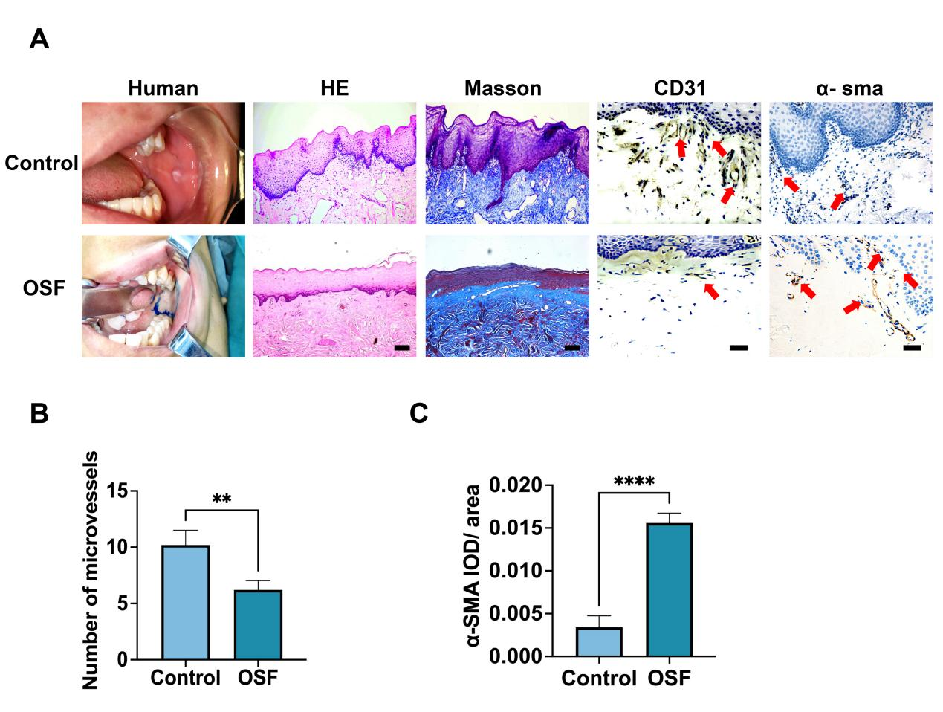
Supplemental Figure 1. Histological characterization of OSF
(A). Histological characterization of clinical samples for sc-RNA sequencing. Includes samples of buccal mucosa for lesion presentation, H&E staining for epithelial morphology, and Masson staining for collagen deposition. Scale bars: 200 μm. Immunohistochemistry for vascular and myofibroblast profiles. The red arrows indicate the positive cells. Scale bars: 50 μm, n = 6. (B). Quantification of the number of microvessels in (A). (C). Quantification of the positive areas of α-SMA in (A). Results are presented as the mean ± S.D. **P < 0.01; ****P < 0.0001.

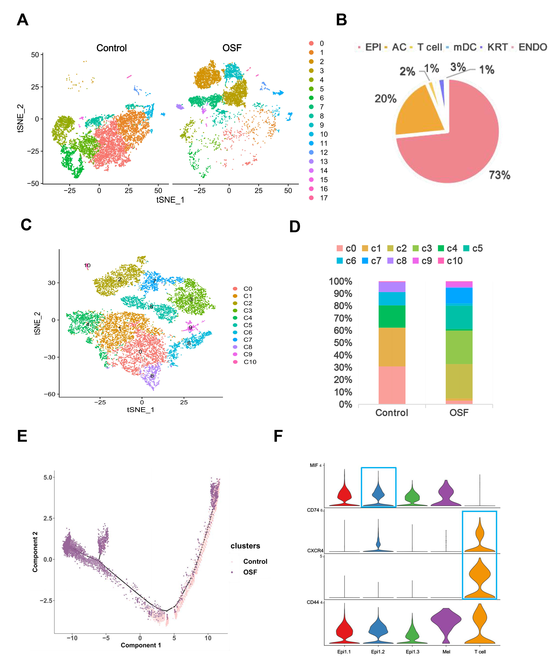
Supplemental Figure 2. Overview of single cell-RNA sequencing including clustering results, cellchat, and the pseudotime analysis.
(A). The tSNE plots presented by the clinical samples. scRNA-seq of oral mucosa cells from the clinical samples. Left: tSNE plot representation of identified cell types (a total of 18 clusters, left: Control, right: OSF, oral mucosa from 1 donor /group). (B). Bar graph of the proportions by cell type. Upper: The definition of the identified cell types. (C). The tSNE plots of epithelial cells (a total of 11 clusters). (D). Proportion of epithelial cell subclusters in the two samples. (E). Pseudotime trajectory plots for the epithelial cells of the two samples. (F). Violin plot of Epi1.2 and T cell receptor-ligand pair distribution. MIF is a ligand located on Epi1.2 and CD74 and CXCR4 are receptors located on T cells. The blue boxes show the ligand and receptors.

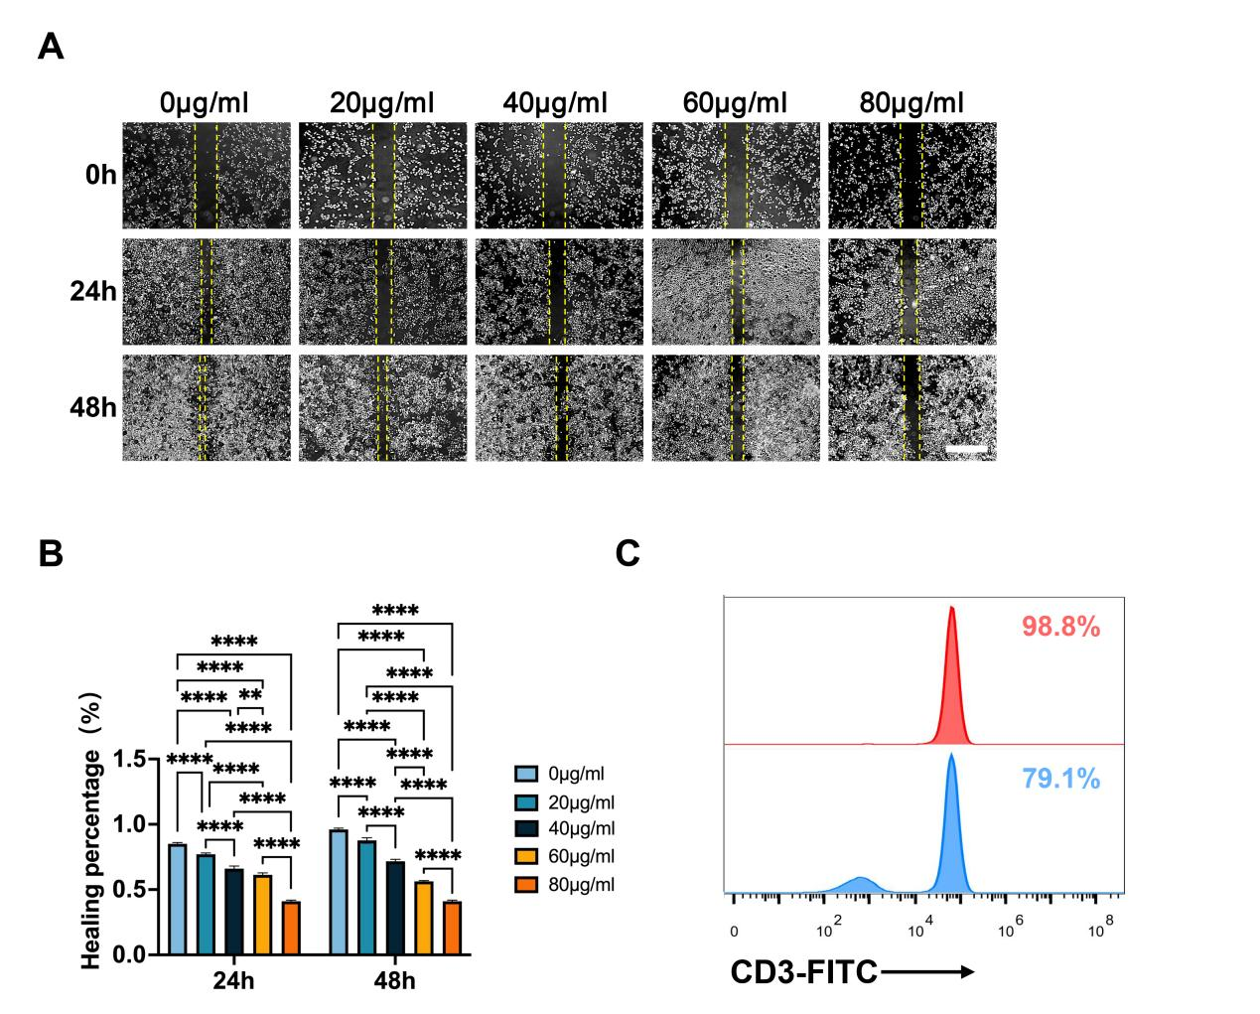
Supplemental Figure 3. Effect of arecoline on epithelial cell migration and flow cytometry results of T cell isolation.
(A). Cell migration of epithelial cells after stimulation with arecoline (0, 20, 40, 60, and 80 μg/mL) for 24 and 48 h. The distance between the two yellow lines indicates the width of the scratch. Scale bar: 500 μm. (B). Semiquantitative analysis according to the results of cell migration. (C). The flow cytometry results of CD3+T cells isolated from PBMCs. Results are presented as the mean ± S.D. **P< 0.01; ****P< 0.0001.

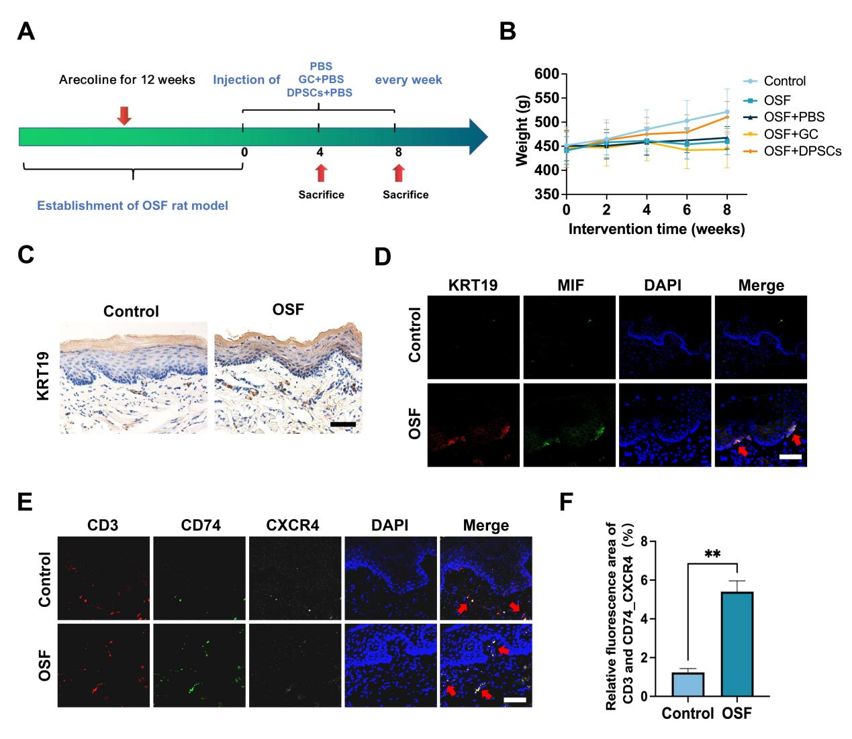
Supplemental Figure 4. The validation of sc-RNA sequencing results in the OSF rat models.
(A). Schematic diagram of OSF rat model establishment and treatment. Eight-week-old male Sprague-Dawley rats were used in the experiments and examined at eight to twelve weeks of age until a stable white lesion was presented. The OSF animal models were then randomly divided into four intervention groups: OSF, OSF+PBS, OSF+GC/PBS, and OSF+DPSCs/PBS (n ≥ 6). The drug was injected once a week, and the animals were harvested at 4 and 8 weeks after the injection. (B). Trend of weight change in rats with different treatments from 0 to 8 weeks post-injection. Results are presented as the mean ± S.D., n ≥ 6. (C). Expression results of Epi1.2 in OSF rat models. KRT19 is the marker of Epi1.2 cells. Scale bar: 50 μm. (D). Expression results of Epi1.2 (red) and its ligands (green) in OSF rat models. The red arrows indicate the positive cells. Scale bar: 200 μm. (E). Expression results of T cells (red) and their receptors (green and blue) in the OSF rat models. The red arrows indicate the positive cells. Scale bar: 200 μm. (F). Quantitative analysis of T cells and their receptors in the OSF rat models. Results are presented as the mean ± S.D. **P < 0.01.

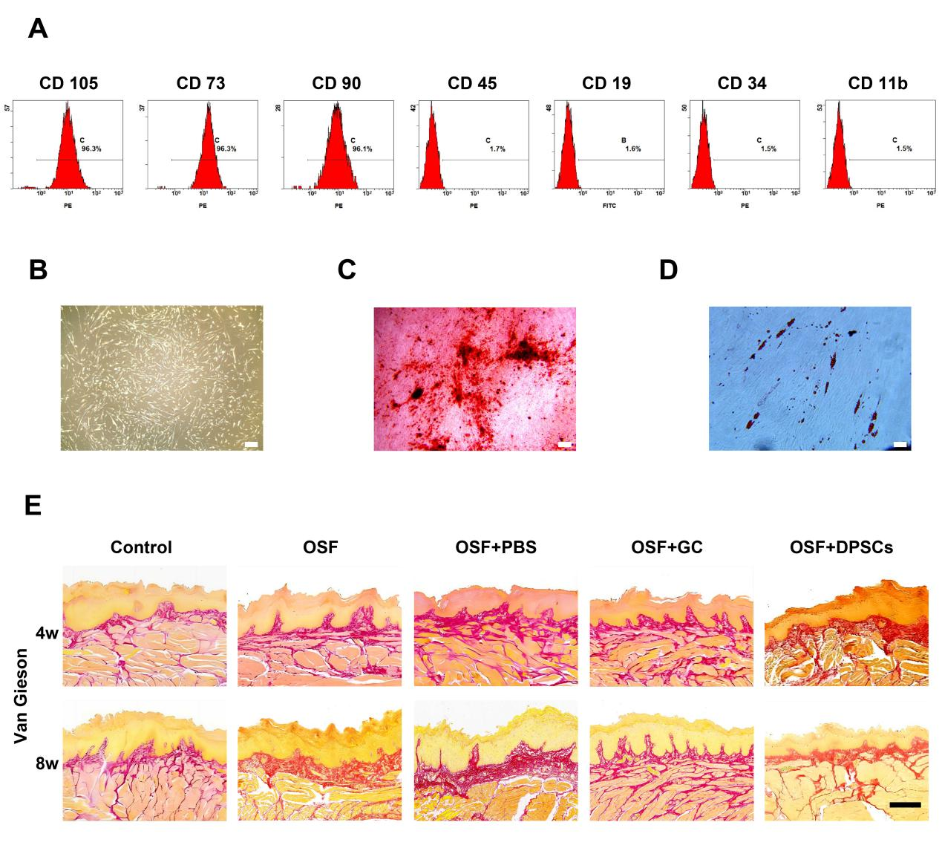
Supplemental Figure 5. Identification of DPSCs.
(A). Results of flow cytometry phenotype identification of DPSCs. (B). Morphology of DPSCs under light microscopy. Scale bar: 200 μm. (C). Images of DPSCs induced for osteogenic differentiation. Scale bar: 200 μm. (D). Image of DPSCs induced for audiogenic differentiation. Scale bar: 200 μm. (E). Representative Van Gieson images of different treatments at 4 and 8 weeks. Scale bar: 500 μm.

