Table 2 Active Break exercises
 | Exercises | Duration
Phase 1 – 1st month | - Spine extension in standing position: Extending arms above the head and reaching up. Straightening the torso until feeling the stretch in the lower spine. The range of arm extension depends on the mobility of the shoulder joints.  - Neutral standing position (lumbo-pelvic upright position)  - Neutral sitting position (lumbo-pelvic upright position) | 30s | 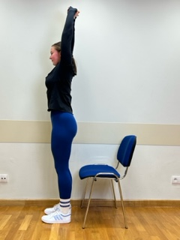  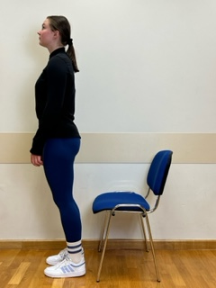  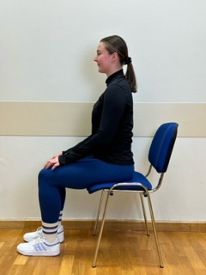
Phase 2 – 2nd month | - Spine extension in standing position: Standing with facing forward, feet on the floor. Extending arms above the head and reaching up. Straightening the torso until feeling the stretch in the lower spine. The range of arm extension depends on the mobility of the shoulder joints.  - Spine hyperextension in standing position: Putting arms behind the neck and keeping together elbows. Performing head retraction (hyperextension) and tilting your head back until feeling the hyperextension in the lower spine. The exercise is intended for participants who do not experience discomfort or increase in back pain caused by hyperextension in lumbar lordosis. Participants sensitive to hyperextension perform this exercise with lumbar extension.  - Neutral standing position (lumbo-pelvic upright position)  - Neutral sitting position (lumbo-pelvic upright position) | 45s | 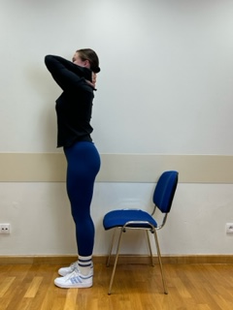
Phase 3 – 3rd month | - Spine hyperextension in the sitting position: Putting arms behind the neck and keeping together elbows. Performing head retraction (hyperextension) and tilting your head back until feeling the hyperextension in the lower spine. The exercise is intended for participants who do not experience discomfort or increase in back pain caused by hyperextension in lumbar lordosis. Participants sensitive to hyperextension perform this exercise with lumbar extension.  - Spine extension in standing position: Standing with facing forward, feet on the floor. Extending arms above the head and reaching up. Straightening the torso until feeling the stretch in the lower spine. The range of arm extension depends on the mobility of the shoulder joints.  - Spine hyperextension in standing position: Putting arms behind the neck and keeping together elbows. Performing head retraction (hyperextension) and tilting your head back until feeling the hyperextension in the lower spine. The exercise is intended for participants who do not experience discomfort or increase in back pain caused by hyperextension in lumbar lordosis. Participants sensitive to hyperextension perform this exercise with lumbar extension.  - Neutral standing position (lumbo-pelvic upright position)  - Neutral sitting position (lumbo-pelvic upright position) | 60s | 