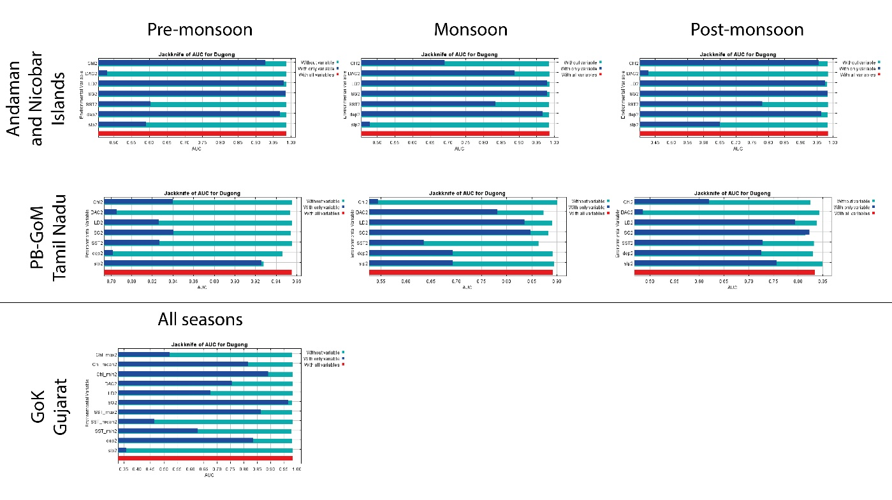
Supplementary Figure F1: Jackknife test results of variable importance using AUC on test data in predicting habitat suitability of dugongs in Andaman and Nicobar Islands, Palk Bay and Gulf of Mannar, Tamil Nadu and Gulf of Kutch, Gujarat.
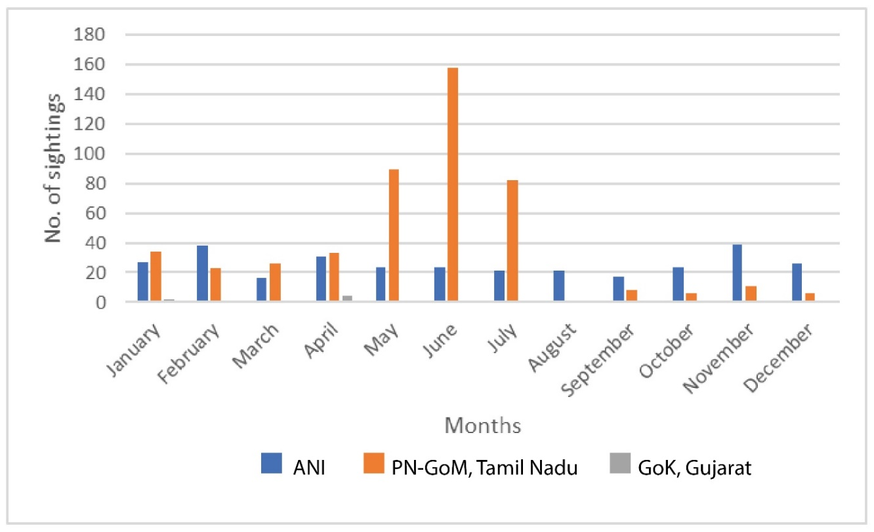
Supplementary Figure F2: Monthly occurrence of dugongs from all three study sites recorded between 2008-2021.
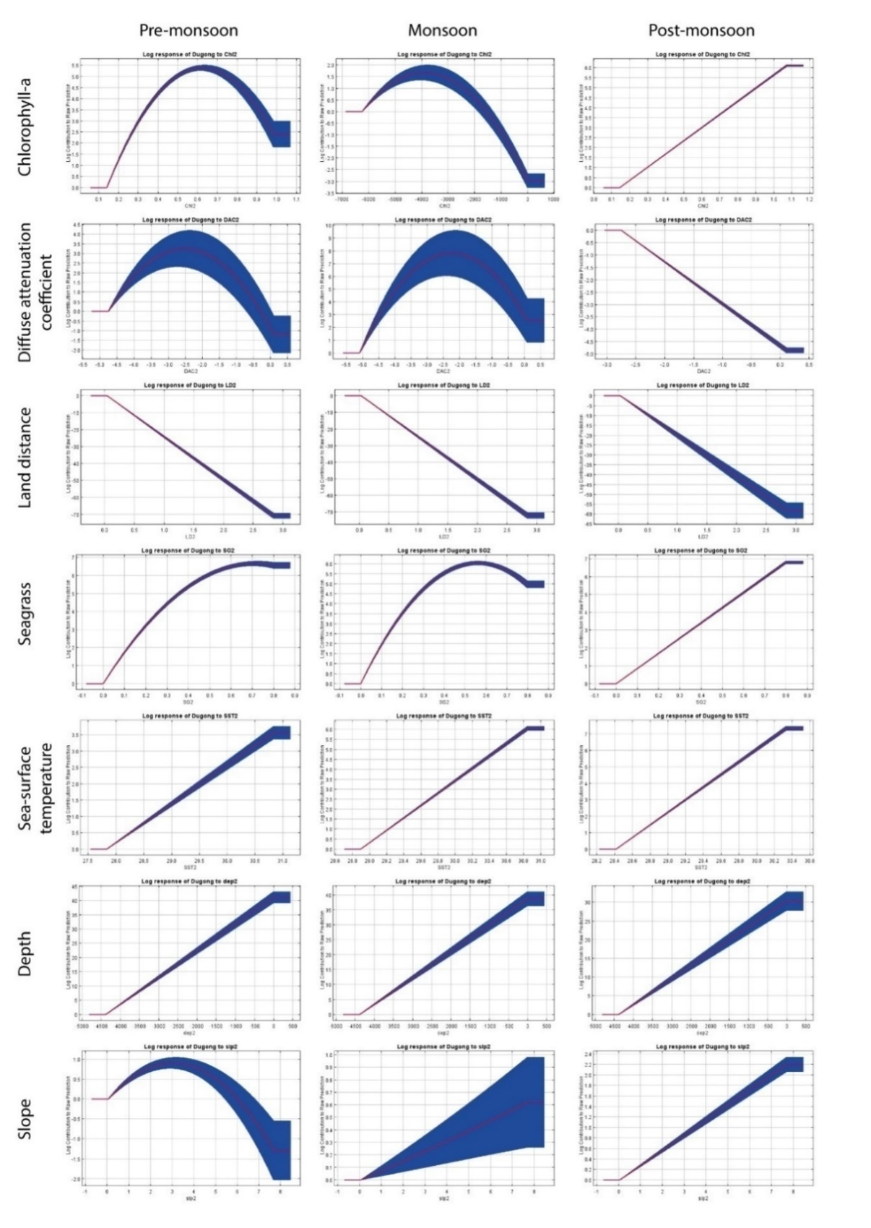
Supplementary Figure F3: Response curves of different variables for habitat suitability modelling during pre-monsoon, monsoon and post-monsoon seasons in Andaman and Nicobar Islands.
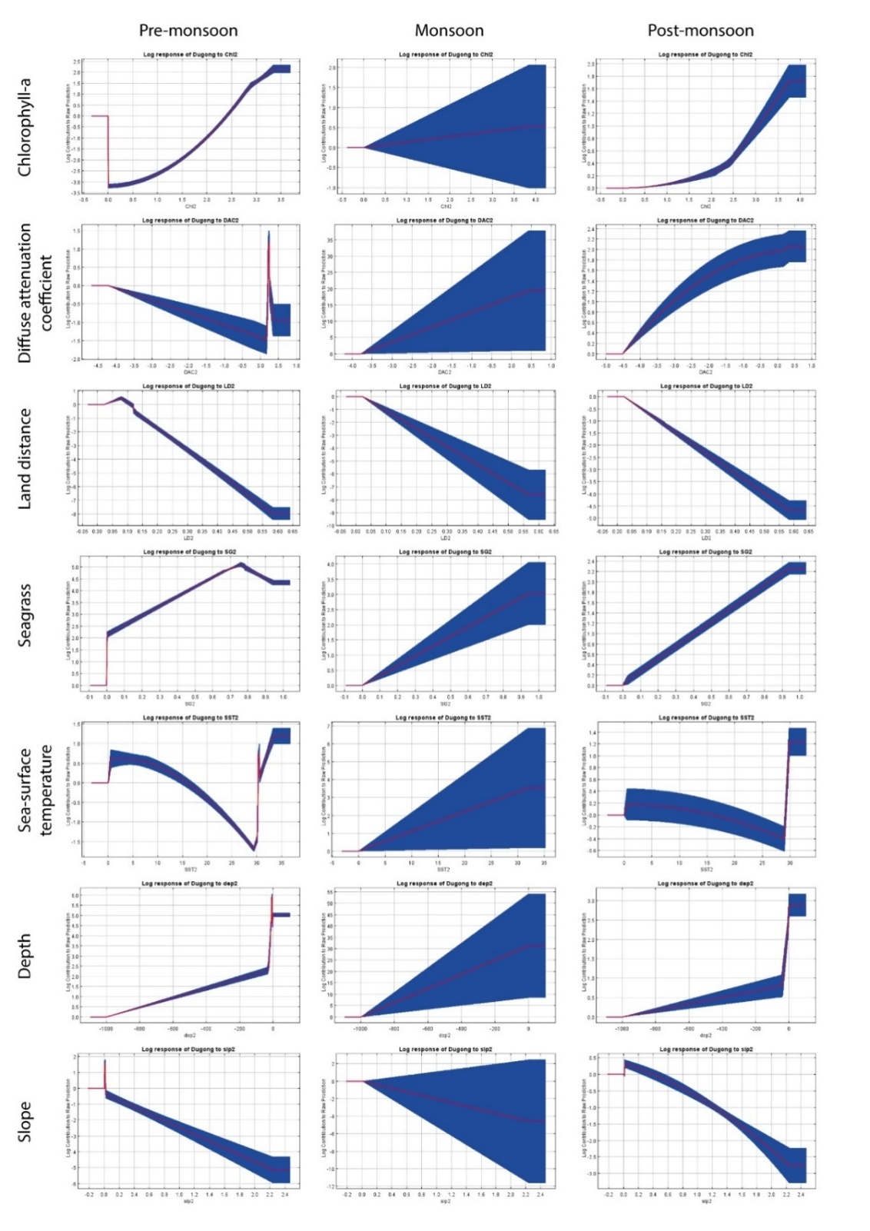
Supplementary Figure F4: Response curves of different variables for habitat suitability modelling during pre-monsoon, monsoon and post-monsoon seasons in Palk Bay & Gulf of Mannar, Tamil Nadu.

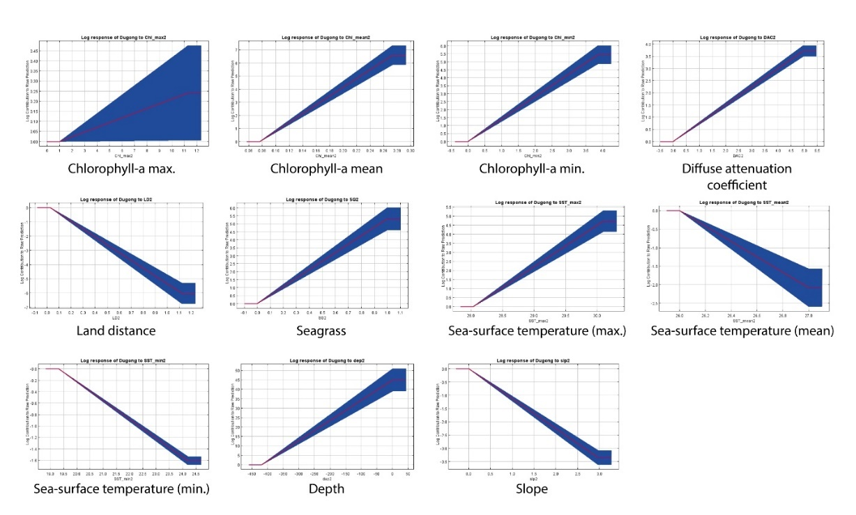
Supplementary Figure F5: Response curves of different variables for habitat suitability modelling in Gulf of Kutch, Gujarat.

Supplementary Table T1: Information on I-statistics correlation matrix for niche similarity of different seasons in Andaman and Nicobar Islands and Palk Bay & Gulf of Mannar, Tamil Nadu.
ANI
Seasons | Pre-monsoon | Monsoon | Post-monsoon
Pre-monsoon | 1 | 0.973923585 | 0.97377396
Monsoon | x | 1 | 0.953475869
Post-monsoon | x | x | 1
PB-GoM, Tamil Nadu
Seasons | Pre-monsoon | Monsoon | Post-monsoon
Pre-monsoon | 1 | 0.780312092 | 0.717974903
Monsoon | x | 1 | 0.958919885
Post-monsoon | x | x | 1

Supplementary Table T2: Classification of seasons with respect to monsoon in Andaman & Nicobar Islands, Palk Bay and Gulf of Mannar, Tamil Nadu.
Sites | Pre-monsoon | Monsoon | Post Monsoon | Reference
ANI (South-west Monsoon) | Jan-Apr | May-Sep | Oct-Dec | Bera et al., 2015; Sahu et al., 2013
Tamil Nadu (North-east Monsoon) | Jun-Sep | Oct-Dec | Jan-May | IMD, 2020

Supplementary Table T3: Best fit maxent settings with least AIC values for modelling dugong distribution in the study sites of Andaman & Nicobar Islands, Palk Bay & Gulf of Mannar, Tamil Nadu and Gulf of Kutch, Gujarat (L = Linear, Q = Quadratic, H = Hinge, P = Product, T = Threshold, CV = Crossvalidate, BS = Bootstrap).
MaxEnt Settings | Andaman & Nicobar Islands |  |  | Palk Bay- Gulf of Mannar |  |  | Gulf of Kutch(n=13)
MaxEnt Settings | Pre-monsoon (n=54) | Monsoon (n=60) | Post-monsoon (n=56) | Pre-monsoon (n=99) | Monsoon (n=18) | Post-monsoon (n=107) | Gulf of Kutch(n=13)
Data partitioning | Random k-fold | Random k-fold | Random k-fold | Random k-fold | Jackknife | Random k-fold | Jackknife
Feature class | LQ | LQ | L | LQHPT | L | LQHPT | L
Output format | Logistic | Logistic | Logistic | Logistic | Logistic | Logistic | Logistic
Replicate run type | CV | CV | CV | CV | BS | CV | BS
No. of replicates | 10 | 10 | 10 | 10 | 18 | 10 | 13
Regularisation Multiplier | 0.5 | 0.5 | 0.5 | 2 | 1.5 | 3 | 0.5
Max. no. of background points | 10000 | 10000 | 10000 | 10000 | 10000 | 10000 | 5000
Max. iterations | 1000 | 1000 | 1000 | 1000 | 1000 | 1000 | 1000
Convergence threshold | 10⁻⁵ | 10⁻⁵ | 10⁻⁵ | 10⁻⁵ | 10⁻⁵ | 10⁻⁵ | 10⁻⁵

