Supporting Information

The host-guest system of resorcinolcalix[4]arene and pyridine-containing compounds: their syntheses, structures, antioxidant and antibacterial activity analyses

Lu-Si Chen, Xin-Min Zhou, Qing Wang, Ai-Quan Jia, Qian-Feng Zhang*

Institute of Molecular Engineering and Applied Chemistry, Anhui University of Technology,
Ma’anshan, Anhui 243002, P. R. China

Figure S1. ¹H NMR spectrum of compound 1

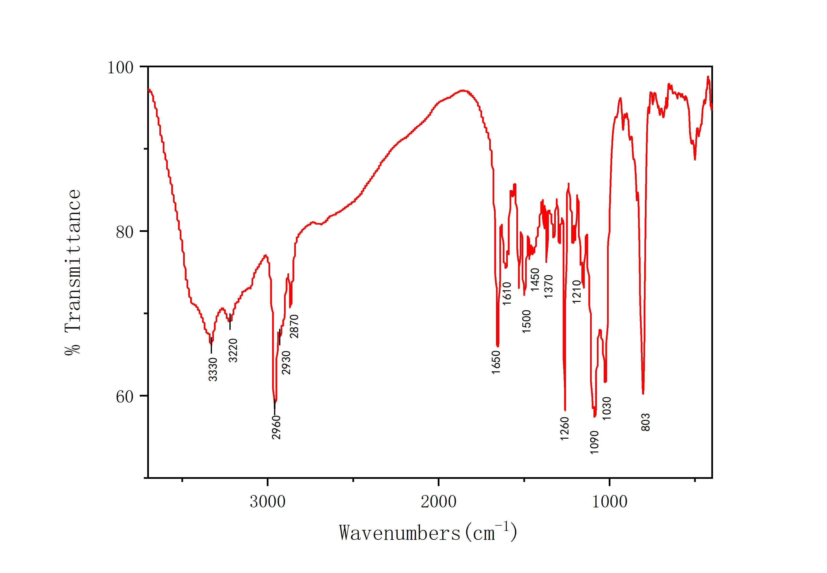
Figure S2. Infrared spectrum of compound 1

Figure S3. ¹H NMR spectrum of compound 2
Figure S4. Infrared spectrum of compound 2

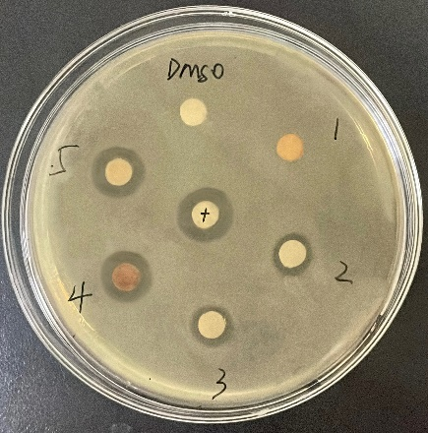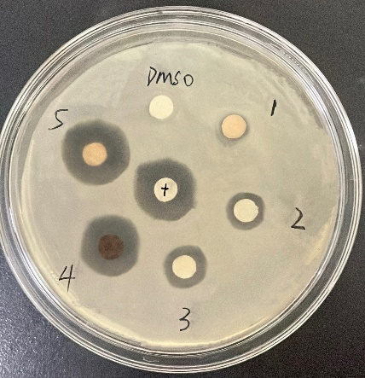
(a) (b)
Figure S5. 100 mg/mL Different Compounds' Antibacterial Effects on Escherichia coli ATCC 25922 (a) and Staphylococcus aureus CMCC (B) 26003 (b)（Numbers 1~5 are compounds CBCR, 4-AP, 3-DMAP, complexes 1 and 2, respectively, The "+" refers to the medication paper of kanamycin solution as a positive control.)

Table S1. Crystal data and structure refinement for complexes 1 and 2
Multi-component complex | 1 | 2
Empirical formula | C₄₉H₆₂N₂O₈ | C₅₈H₈₆N₄O₁₃
Formula weight | 807.00 | 1047.30
Crystal system | Monoclinic | Triclinic
a (Å) | 11.7867(17) | 11.957(7)
b (Å) | 11.8598(18） | 14.242(9)
c (Å) | 33.955(5) | 20.197(12
α (°) | 90 | 72.630(6)
β (°) | 96.331(2) | 89.855(6)
γ (°) | 90 | 65.980(5)
V (Å3) | 4717.6(12) | 2970(3)
Space group | P2₁/n | Pī
Z | 4 | 2
D_{calc.} (mg/m³) | 1.136 | 1.171
Temperature (K) | 296(2) | 296(2)
F (000) | 1736 | 1132
Reflections collected | 71919 | 9929
Independent reflections | 8211 | 12474
Data/restraints/ parameters | 8211 / 647 / 478 | 9929 / 663 / 577
R_{int} | 0.1339 | 0.0713
R1ª, wR2^{b}(I>2σ(I)) | 0.1449, 0.2499 | 0.1159, 0.1887
R1, wR2 | 0.2496, 0.3129 | 0.2838, 0.2250
GoF^{c} | 1.069 | 1.296
Largest diff. peak and hole(e/A⁻³) | 0.72and -0.41 | 0.738 and -0.527
ªR1 = Σ||F_{o}|–|F_{c}||/Σ|F_{o}|.
^{b}wR2 = [Σw(|F_{o}² |–|F_{c}² |)²/Σw|F_{o}²|²]^{1/2}.
^{c}GoF = [Σw(|F_{o}|–|F_{c}|)² /(N_{obs}–N_{param})]^{1/2}.

Table S2. Zone of inhibition and MIC value of compounds against two bacterial strains.
Entry | Compounds | Diameter of inhibition zone (mm) |  | MIC values (mg/mL)
Entry | Compounds | Escherichia coli ATCC 25922 | Staphylococcus aureus CMCC(B) 26003 | Escherichia coli ATCC 25922 | Staphylococcus aureus CMCC(B) 26003
1  2 | CBCR  4-AP | 6.33±0.29  7.50±0.50 | 7.30±0.26  12.27±0.25 | ＞25.00  25.00 | ＞25.00  12.50
3 | 3-DMAP | 8.17±0.29 | 13.43±0.40 | 25.00 | 6.25
4 | 1 | 10.25±0.25 | 14.33±0.31 | 12.50 | 3.12
5 | 2 | 11.27±0.28 | 16.40±0.40 | 12.50 | 1.56
6 | Sterile water | 6.00 | 6.00 | - | -
7 | DMSO | 6.00 | 6.00 | - | -
8 | Kanamycin | 12.33±0.18 | 16.27±0.25 | ＜3.12 | ＜1.56
Note: Data represents mean ± SD of triplicates.

