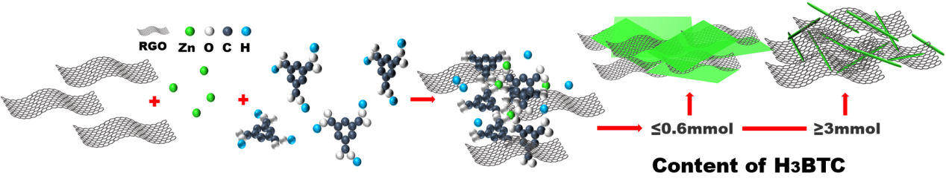
Fig.1. Schematic illustration of the synthesis process of Zn-BTC/rGO nanocomposite with different morphologies
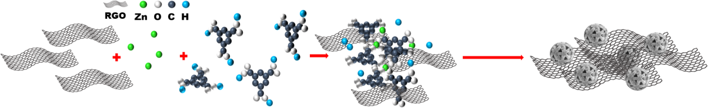
Fig.2. Schematic illustration of the synthesis process of Zn-BTC/rGO-3D nanocomposite
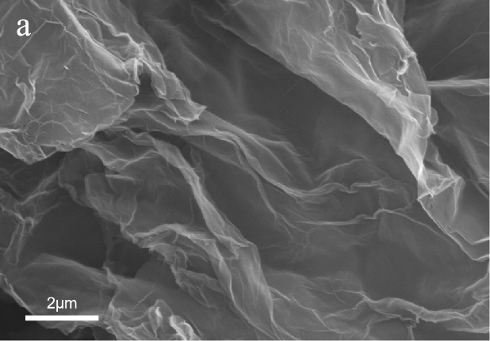 | 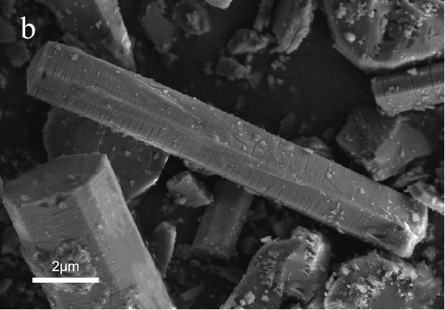
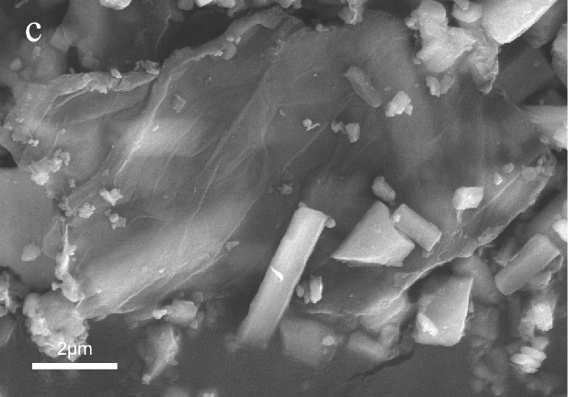 | 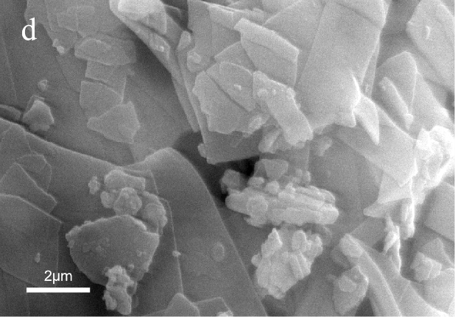
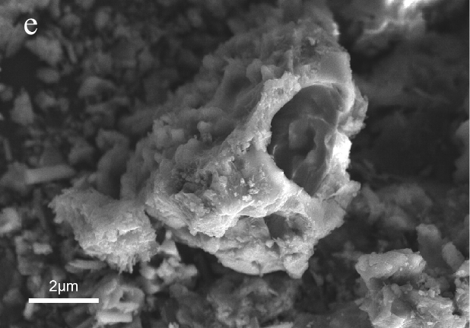
Fig.3. SEM images of (a) rGO; (b) Zn-BTC-1D; (c) Zn-BTC/rGO-1D ;(d) Zn-BTC/rGO-2D and (e) Zn-BTC/rGO-3D
Fig.4. XRD patterns of rGO, Zn-BTC-1D, Zn-BTC/rGO-1D, Zn-BTC/rGO-2D and Zn-BTC/rGO-3D samples
Fig.5. Raman patterns of rGO, Zn-BTC/rGO-1D, Zn-BTC/rGO-2D , Zn-BTC/rGO-3D and Zn-BTC-1D samples

Fig.6. TG curves of Zn-BTC-1D and Zn-BTC/rGO-1D samples

Fig.7. Three-electrode system in 3 M KOH electrolyte: (a) GCD curves of different samples at current density of 1 A g⁻¹; (b-c) GCD curves of Zn-BTC/rGO-1D electrode at different current densities from 1 to 40 A g⁻¹; (d) Specific capacity at various current densities for all electrodes at the current density ranging from 1 to 40 A g⁻¹.
Fig.8. Three-electrode system in 3 M KOH electrolyte: (a) CV curves and (b) Specific capacity of Zn-BTC/rGO-1D electrode at various scan rates (2 ~ 100 mV s⁻¹); (c) linear relationships between log (i) and log (v) for peak A and peak B in CV curves; (d) Separation of storage contribution from the capacitive behavior and diffusioncontrolled processes at 50 mV s⁻¹; (e) the contribution ratio of capacitive behavior and diffusion-controlled process at different scan rates.
Fig.9. (a) Nyquist plot and (b) Specific capacitance and capacitance retention at 1A g⁻¹ after 1000 cycles of rGO, Zn-BTC/rGO-1D, Zn-BTC/rGO-2D, Zn-BTC/rGO-3D and Zn-BTC-1D electrodes

Fig.10 The symmetrical supercapacitor device assembled with Zn-BTC/rGO-1D (a) CV curves at different scanning rates ranging from 2 mV s⁻¹ to 100 mV s⁻¹; (b) GCD curves at different current densities ranging from 1 A g⁻¹ to 20 A g⁻¹; (c) Specific capacity at different current densities ranging from 1 A g⁻¹ to 20 A g⁻¹; (d) Cycling performance after 2000 cycles; (e) Nyquist plot and (d) Ragon plot

