Supplementary Information
for
On-site biosignal amplification using a single high-spin conjugated polymer

Gaoyang Ge^{1,#}, Jingcao Xu^{1,#}, Xinyue Wang², Wenxi Sun¹, Mo Yang², Zi Mei³, Xin-Yu Deng¹, Peiyun, Li¹, Xi-Ran Pan¹, Jia-Tong Li¹, Xue-Qing Wang¹, Zhi Zhang¹, Shixian Lv¹, Xiaochuan Dai², and Ting Lei^{1,*}

¹Key Laboratory of Polymer Chemistry and Physics of Ministry of Education, School of Materials Science and Engineering, Peking University, Beijing 100871, China
²Department of Biomedical Engineering, School of Medicine, Tsinghua University, Beijing 100084, China
³School and Hospital of Stomatology, Peking University, Beijing 100871, China

#These authors contributed equally to this work
*E-mail: tinglei@pku.edu.cn

Table of Contents
1. Experimental Details
2. Supplementary Tables and Figures
3. Synthesis and Characterization of New Compounds
4. Supplementary References

- Experimental Details
Materials
All the chemical reagents were purchased and used as received unless otherwise indicated. All air and water-sensitive reactions were performed under a nitrogen atmosphere. Dichloromethane (DCM), tetrahydrofuran (THF), toluene, and N, N-dimethylformamide (DMF) were dried using a JC Meyer solvent drying system before use. Ultradry solvents were obtained from J&K reagent company.

Chemical structure and optoelectronic property characterization
¹H NMR and ¹³C NMR spectra were recorded on a Bruker ARX-400 (400 MHz) spectrometer. All chemical shifts were reported in parts per million (ppm). ¹H NMR chemical shifts were referenced to CDCl₃ (7.26 ppm), and ¹³C NMR chemical shifts were referenced to CDCl₃ (77.16 ppm). Mass spectra were recorded on a Fourier-transform high-resolution mass spectrometer (FTMS). Thermogravimetric analyses (TGA) were carried out on a TA Instrument Q600 SDT analyzer, and differential scanning calorimetry (DSC) analyses were performed on a TA Instrument Q2000 analyzer. Absorption spectra were recorded on a PerkinElmer Lambda 750 UV-vis spectrometer. Cyclic voltammograms (CV) were measured through an electrochemical workstation SP-300 (BioLogic Science Instruments). A standard three-electrode setup was established by employing glassy carbon as the working electrode (WE), a block of platinum mesh as the counter electrode (CE), and an Ag/AgCl electrode as the reference electrode (RE), further calibrated against ferrocene (Fc/Fc⁺). The measurements were carried out in an aqueous solution with 0.1 M NaCl or in acetonitrile with 0.1 M tetrabutylammonium hexafluorophosphate as the supporting electrolyte with a scan rate of 50 mV/s. HOMO and LUMO energy levels were obtained using the equation: E_{HOMO} = (E_{Ox} – E_{Fc/Fc}⁺ + 4.8) eV, E_{LUMO} = (E_{Red} – E_{Fc/Fc}⁺ + 4.8) eV. Electron paramagnetic resonance (EPR) spectroscopy was conducted on a Bruker E580 spectrometer using ER
4122 SHQE highly sensitive EPR cavity. An Qxford EPR900 cryostat was used for temperature control. The microwave frequency is at 9.37 GHz.

Gel permeation chromatography measurement
Polymer number-average molecular weight (M_{n}) and molecular weight distributions (PDI = M_{w}/M_{n}) were measured by gel permeation chromatography (GPC). HFIP GPC analyses were performed on a Waters 1515 instrument equipped with a PLMIXED 7.5 × 50 mm guard column, two PLMIXED-C 7.5 × 300 columns, and a differential refractive index detector at 35 ºC with a flow rate of 1 mL/min. The instrument was calibrated using 10 PS standards, and chromatograms were processed with Waters Breeze software.

DFT calculations
Geometry optimization, molecular energy level calculations, relaxed potential energy surface scans, ΔE_{ST}, and y₀ were performed at the B3LYP/6-311g(d,p), wB97XD/6-311g(d,p) or UHF/6-311g(d,p) level using Gaussian 16 and Gaussian View 6^{1,2}. The computational results were visualized by Multiwfn³ and VMD⁴.

Spectroelectrochemistry
Spectroelectrochemistry was performed using an ITO-coated glass slide, which was spin-coated with the polymer solution (3 × 10⁻³ M chloroform solution) at a rotating speed of 500 rpm for 45 s. These polymer-coated ITO slides were employed as the working electrode (WE) and immersed in a cuvette filled with a 0.1 M aqueous NaCl solution. A Pt mesh was used as the counter electrode (CE), and an AgCl/Ag pellet served as the reference electrode (RE). A PerkinElmer Lambda 750 UV-vis spectrometer was used, with the beam path passing through the electrolyte-filled cuvette and the polymer-coated ITO samples. A background spectrum was recorded with the cuvette/electrolyte/ITO setup before a potential was applied to the cell. The potential was applied to the WE for 5 s before recording the spectra and was maintained for a certain amount of time until the completion of spectrum scanning.

Cytotoxicity
The sample substrate was preloaded into a 6-well plate. 5 × 10⁵ mouse fibroblasts (L929) were seeded into each well and cultured in high glucose DMEM with 10% fetal bovine serum (FBS, 6021031, DAKEWE), 100 U/mL penicillin (Invitrogen), and 100 U/mL streptomycin (Invitrogen) at 37 °C with 5% CO₂ and 95% humidity. After 24 hours, a live/dead staining assay (cat# 40747ES76, Yeasen) was performed to evaluate the biocompatibility of the substrates. Briefly, cells were washed with 1×Assay Buffer. A working solution was prepared by adding 2 mM Calcein-AM solution and 1.5 mM PI solution to 5 mL of 1×Assay buffer. The working solution and assay buffer were added to the cell culture plates at a ratio of 1:2 and incubated at 37 °C for 15 minutes. Live cells (green fluorescence) and dead cells (red fluorescence) were excited with a 490 ± 10 nm laser (Nikon DS-F).

OECT fabrication and characterization
The fabrication of OECTs involved several steps, including the deposition and patterning of metallic electrodes, the parylene layer, and the polymer in the channel. In detail, silica substrates were thoroughly cleaned by ultrasonication in acetone, DI water, and isopropyl alcohol. This cleaning process was followed by nitrogen blow-drying and a brief oxygen plasma cleaning. Metal pad interconnects and source/drain contacts were patterned. Subsequently, 5 nm of Cr and 35 nm of Au were deposited, and a lift-off process was performed. Metal interconnects and pads were insulated by depositing 1 μm of parylene-C using a PDS 2010 Labcoater-2, along with a 3-(trimethoxysilyl)propyl methacrylate (A-174 silane) adhesion promoter. A 2% aqueous solution of industrial cleaner (Micro-90) was then spin-coated to act as an anti-adhesive for a second sacrificial 1 μm parylene-C film. This second film was used to simultaneously define the active channel area and pattern the underlying parylene layer. Samples were subsequently patterned with a 5 μm thick layer of AZ9260 photoresist and AZ-400K developer. The patterned areas were opened by reactive ion etching with O₂ plasma using an LCCP-6A reactive ion etcher (Leuven Instruments).
The manufacturing process for the vOECT inverter is similar to that of the OECT. Firstly, the bottom layer output end of the inverter was patterned on the cleaned wafer. Next, 5 nm of Cr and 35 nm of Au were deposited and subjected to a lift-off process. A 0.5 μm Parylene-C layer was deposited for insulation using PDS 2010 Labcoater-2, along with 3-(trimethoxysilyl)-propyl methacrylate (A-174 silane) as an adhesion promoter. Then, 5 nm of Cr and 35 nm of Au were deposited again using a similar method and subjected to lift-off, followed by depositing a 0.5 μm insulation layer using PDS 2010 Labcoater-2. The sample was then spin-coated with a 2% aqueous solution of industrial cleaner (Micro-90), followed by depositing 1 μm of Parylene-C for insulation, which served as the sacrificial layer for the vOECT. Next, the sample was patterned using a 5 μm thick layer of AZ9260 photoresist and AZ-400K developer. An LCCP-6A reactive ion etcher (Leuven Instruments) and O₂ plasma were used to open the patterned areas. The flexible vOECT device was fabricated using a similar method, with the difference being that the substrate used a wafer with a deposited 10 μm parylene-C substitute for the cleaned wafer, which can be stripped with tweezers by immersion in a 0.1 M NaCl solution for 30 minutes.
The polymer was dissolved in chlorobenzene at a concentration of 5 mg/ml. The polymer solution was spin-cast onto the etched devices. After a peeling-off process of the second sacrificial parylene layer, the OECTs were ready for measurement. The device characterization was performed on a probe station using a Keithley 4200 SCS analyzer or an Fs-Pro semiconductor parameter analyzer, PDA. An AgCl/Ag pellet (Warner Instruments) was employed as the gate electrode and immersed in a 0.1 M NaCl solution, which covered the polymer film in the channel. The thickness of the film was determined in a dry state using a DEKTAK profilometer (Bruker).

Electrochemical impedance spectra
Electrochemical impedance spectra (EIS) were conducted on the polymer-coated electrodes using the electrochemical workstation SP-300 (BioLogic Science Instruments). Polymer films were patterned as squares with specific areas through the lithography technique. These polymer-coated electrodes with a glass substrate were employed as the working electrode and fully immersed in a 0.1 M NaCl solution. Additionally, a Pt mesh (CE) and an AgCl/Ag pellet (RE) were employed to establish a standard three-electrode system. The capacitances of polymers measured on Au electrodes with various sizes were obtained through the potential-EIS method, with the DC offset voltage set to the maximum achievable doping for each polymer. The AC amplitude of voltage in the form of a sine wave on the WE was set at 10 mV (RMS), and the frequency was scanned from 1 Hz to 100 kHz. The resulting Bode plots and Nyquist plots were fitted to an equivalent circuit, specifically Randle’s circuit Rs (Rp ||C), using the EC-Lab view software. The thickness of the film was determined in a dry state after testing with a DEKTAK profilometer (Bruker).

Simulated EEG monitoring
The amplifier and the Au electrode, both with the same effective area on the same flexible device, were positioned on an agar model (2 wt%). An AgCl/Ag electrode was inserted into the model to simulate the EEG signal source. The signals from the Au electrode and amplifier were recorded using the Fs-Pro semiconductor parameter analyzer, PDA. MATLAB was used for software filtering. The signals were digitally filtered using a 50 Hz notch filter.

Preparation for in vivo ECoG recording
For the in vivo experiments, mature female C57BL/6 mice, 8 weeks of age (Charles River Laboratories), were used throughout this study. The mice were maintained at 22 ±1 °C with humidity ranging from 30% to 70% and were kept on a 12-hour light/dark cycle, with ad libitum access to food. All 910 experiments were supervised and approved by the Animal Care & Use Committees at Tsinghua University (THU-LARC-2023-008). During the surgery, the mice were anesthetized with oxygen-vaporized isoflurane (3% for induction, 1.5-2% for maintenance, 0.5 L/min). Body temperature was maintained at 37 °C. Craniotomies (1 mm²) were performed on the skull to expose the cortical surface without removing the dura mater. One silver wire coated with silver chloride was inserted into the cortex to a depth of about 0.5 mm through the craniotomies, serving as the ground electrode. The flexible amplifier was placed in another opening. The craniotomy where the flexible amplifier was positioned was done in different locations revealing various cortical areas such as the motor (M1), somatosensory (S1), and primary visual (V1) cortices. During subsequent tests, a metal bar was affixed to the mouse’s skull using dental methacrylate to stabilize the mouse’s brain. The FPC connected to the flexible amplifier was secured to the metal fixed bar to prevent the device from moving on the mouse’s brain.

Signal acquisition and processing
A function generator, Keithley 3390, was used to bias the inverter. A PDA Source Meter was utilized to continuously record the output voltage of the amplifiers and the voltage from the AgCl/Ag electrode at a sampling rate of 1 kHz. MATLAB was used for software filtering. The signals were digitally filtered using a 50 Hz notch filter to eliminate interfering noise. Then, a bandpass filter ranging from 3 to 45 Hz was applied to focus on the significant frequency band.

AFM and GIWAXS characterization
Atomic force microscopy (AFM) measurements were carried out using the Dimension icon ScanAsyst (Bruker). Two-dimensional grazing incidence wide-angle X-ray scattering (2D-GIWAXS) measurements were conducted on a Xenocs-SAXS/WAXS system with an X-ray wavelength of 1.5418 Å and an incidence angle of 0.2°. A Pilatus 300 K was used as a 2D detector. Data processing was performed using GIWAXS-Tools (2.3.1) software⁵.

- Supplementary Tables and Figures

Table S1. Calculated energy levels and ΔE_{ST} values of P(TII-T), P(TII-2T), and P(TII-TT) with different repeating units (n).
 | P(TII-T) |  |  | P(TII-TT) |  |  | P(TII-2T)
 | HOMO (eV) | LUMO (eV) | ΔE_{ST} (kcal/mol) | HOMO (eV) | LUMO (eV) | ΔE_{ST} (kcal/mol) | HOMO (eV) | LUMO (eV) | ΔE_{ST} (kcal/mol)
n=1 | −5.08 | −2.81 | −18.27 | −5.06 | −2.86 | −17.76 | −5.00 | −2.86 | −17.33
n=2 | −4.80 | −3.11 | −13.25 | −4.81 | −3.13 | −13.51 | −4.79 | −3.09 | −13.55
n=3 | −4.69 | −3.24 | −11.14 | −4.72 | −3.24 | −12.14 | −4.72 | −3.18 | −12.83
n=4 | −4.65 | −3.31 | −10.47 | −4.68 | −3.30 | −11.79 | −4.70 | −3.22 | −14.75

Table S2. Summary of the optical and electrochemical properties of the polymers
polymer | λ_{sol} ª (nm) | λ_{film} ^{b} (nm) | HOMO ^{c}  (eV) | LUMO ^{c}  (eV) | E_{g, opt} ^{b}  (eV) | HOMO ^{d}  (eV) | LUMO ^{d}  (eV) | ΔE_{ST} ^{d}  (kcal/mol)
P(TII-T) | 949 | 1017 | −4.59 | −3.99 | 0.87 | −4.69 | −3.24 | −11.14
P(TII-2FT) | 929 | 923 | −4.76 | −4.05 | 0.95 | −4.84 | −3.41 | −11.32
P(TII-2ClT) | 922 | 941 | −4.89 | −4.03 | 0.92 | −5.03 | −3.38 | −13.62
ª in CF solution; ^{b} in thin film; ^{c} obtained by CV measurement; ^{d} estimated from DFT calculations.

Table S3. Summary of the OECTs performances.
polymer | polarity | g_{m, norm}  (S cm⁻¹)ª | V_{Th} (V)^{b} | μC*  (F cm⁻¹ V⁻¹ s⁻¹)^{c} |  | C*  (F cm⁻³) | μ_{h/e}^{d}  (cm² V⁻¹ s⁻¹) | τ_{on} (ms) | τ_{off}  (ms)
P(TII-T) | p | 38.2 ± 2.2 | −0.14 | 122.2 ± 9.9 | 157 |  | 0.78 | 5.69 | 5.78
P(TII-T) | n | 3.6 ± 1.6 | 0.61 | 16.4 ± 1.5 | 203 |  | 0.08 | 3.22 | 2.05
P(TII-2FT) | p | 50.1 ± 2.0 | −0.39 | 158.6 ± 21.4 | 88 |  | 1.07 | 1.32 | 0.94
P(TII-2FT) | n | 37.5 ± 1.9 | 0.64 | 147.4 ± 13.2 | 138 |  | 1.80 | 4.07 | 1.53
P(TII-2ClT) | p | 25.5 ± 2.3 | −0.50 | 96.4 ± 5.9 | 180 |  | 0.54 | 3.09 | 1.25
P(TII-2ClT) | n | 7.8 ± 1.2 | 0.68 | 63.0 ± 5.2 | 214 |  | 0.30 | 5.12 | 2.30
ªThe W/L of all the devices is 100/10 µm. All the OECT devices were operated in a 0.1 M NaCl aqueous solution; ^{b}V_{th} was determined by extrapolating the corresponding I_{DS}^{1/2} vs. V_{GS}; ^{c}Six devices were tested and computed for each polymer. ^{d}μ was calculated from μC* and the measured volumetric capacitance C*.

Table S4. Summary of reported n-type and ambipolar OECT performances.
Polymer | Number | Polarity | HOMO ª  (eV) | LUMO ª  (eV) | μC*  (F cm⁻¹ V⁻¹ s⁻¹) | Ref
BBL₁₅₂ | 1 | n | −6.12 | −4.37 | 25.9 | 6
f-BTI2TEG-FT | 2 | n | −5.59 | −3.82 | 15.2 | 7
P(C-T) | 3 | n | −5.53 | −4.25 | 7.6 | 8
p(gTDPP2FT) | 4 | n | −5.20 | −3.86 | 54.8 | 9
f-BTI2g-TVTCN | 5 | n | −5.57 | −3.81 | 41.3 | 10
p(C2F-V) | 6 | n | −6.12 | −4.45 | 108 | 11
f-BTI2g-TVTF | 7 | n | −5.60 | −3.70 | 90.2 | 12
P(gNDI-gT2) | 8 | p | −4.83 | −4.12 | N/A | 13
P(gNDI-gT2) | 8 | n | −4.83 | −4.12 | 0.18 | 13
2DPP-OD-TEG | 9 | p | −5.08 | −3.82 | 31.8 | 14
2DPP-OD-TEG | 9 | n | −5.08 | −3.82 | 6.8 | 14
P(C4-T2-C0-EG) | 10 | p | −5.0 | −4.0 | 0.13 | 15
P(C4-T2-C0-EG) | 10 | n | −5.0 | −4.0 | 0.16 | 15
P(C4-T2-C0-EG) | 11 | p | −5.0 | −4.0 | ~0.2 | 16
P(C4-T2-C0-EG) | 11 | n | −5.0 | −4.0 | 0.22 | 16
PrC60MA:p(g2T-TT) (95:5) | 12 | p |  |  | 22.8 | 17
PrC60MA:p(g2T-TT) (95:5) | 12 | n |  |  | 11.8 | 17
PBBTL:BBL | 13 | p |  |  | 2.72 | 18
PBBTL:BBL | 13 | n |  |  | 1.36 | 18
P(TII-2FT) | 14 | p | −4.76 | −4.05 | 158.6 | This work
P(TII-2FT) | 14 | n | −4.76 | −4.05 | 147.4 | This work
P(TII-T) | 15 | p | −4.59 | −3.99 | 122.2 | This work
P(TII-T) | 15 | n | −4.59 | −3.99 | 16.4 | This work
P(TII-2ClT) | 16 | p | −4.89 | −4.03 | 96.4 | This work
P(TII-2ClT) | 16 | n | −4.89 | −4.03 | 63.0 | This work
ª CV measurement results.

Table S5. Comparison of the molecular packing parameters of the polymers under different operating conditions
Samples |  | (100) |  |  | (010)
 |  | q  (Å⁻¹) | d_{lamellar} (Å) | CL  (Å) | q  (Å⁻¹) | d_{π-π}  (Å) | CL  (Å)
P(TII-T) | pristine | 0.24 | 26.23 | 79.88 | 1.76 | 3.57 | 60.79
P(TII-T) | NaCl_{(aq)} soaked | 0.24 | 26.14 | 73.76 | 1.77 | 3.54 | 46.02
P(TII-T) | n-doped | 0.24 | 26.17 | 72.52 | 1.76 | 3.56 | 43.36
P(TII-T) | p-doped | 0.24 | 26.07 | 77.64 | 1.78 | 3.52 | 47.38
P(TII-2FT) | pristine | 0.24 | 26.26 | 85.36 | 1.79 | 3.51 | 40.94
P(TII-2FT) | NaCl_{(aq)} soaked | 0.24 | 26.38 | 83.97 | 1.81 | 3.47 | 39.97
P(TII-2FT) | n-doped | 0.24 | 26.69 | 98.66 | 1.80 | 3.48 | 49.00
P(TII-2FT) | p-doped | 0.24 | 26.69 | 96.86 | 1.81 | 3.46 | 46.97
P(TII-2ClT) | pristine | 0.23 | 27.09 | 87.61 | 1.80 | 3.48 | 42.12

Table S6. Summary of the reciprocal of the effective area (W × L) and the normalized gain (gain_{max}/V_{DD}) of the reported n-type and ambipolar complementary OECT inverters.
Polymer | Entry | Inverter configuration | Supply voltage (V) | Maxinum gain | Normalized gain | Densityª (mm⁻²) | Ref
P(TII-2FT) | 1 | Ambipolar | 0.8 | 809 | 1011 | 10000.00 | This work
95:5 (w:w) PrC60MA:p(g2T-TT) | 2 | Ambipolar | 0.9 | 82 | 91.1 | 16.67 | 17
p(C4-T2-C0-EG) | 3 | Ambipolar | 0.8 | 28 | 35 | 8333.33 | 15
PBBTL:BBL (3:1) | 4 | Ambipolar | 0.6 | 42 | 70 | 1000.00 | 18
2DPP-OD-TEG | 5 | Ambipolar | 1.4 | 50 | 0.028 | 500.00 | 14
PIDTC16-BT, DCNBT-IDT | 6 | Complementary | 0.7 | 1.1 | 1.57 | 309597.52 | 19
PIDTPEG-BT, DCNBT-IDT | 7 | Complementary | 0.4 | 1.2 | 3 | 296735.91 | 19
BBL, P3HT | 8 | Complementary | 0.7 | 46 | 65.7 | 500.00 | 20
BBL, P3CPT | 9 | Complementary | 0.6 | 12 | 20 | 1.15 | 21
PNDI2TEG-2Tz, Pg2T-TT | 10 | Complementary | 0.6 | 23.4 | 39 | 0.02 | 22
CNg4T2-CNT2, g4T2-T2 | 11 | Complementary | 0.8 | 45 | 56.25 | 333.33 | 23
f-BTI2g-TVT, g4T2-T2 | 12 | Complementary | 1.4 | 148 | 105.7 | 500 | 12
P3HT | 13 | Unipolar | 0.75 | 8.7 | 11.6 | 5.00 | 24
PEDOT: PSS | 14 | Unipolar | 1.3 | 12.5 | 9.6 | 41.67 | 25
PEDOT: PSS | 15 | Unipolar | 0.6 | 82 | 136.7 | 2.40 | 26
P3HT | 16 | Unipolar | 0.85 | 10 | 11.8 | 500.00 | 20
P3HT, PEDOT: PSS | 17 | Unipolar | 0.85 | 24 | 28.2 | 833.33 | 20
PEDOT: PSS | 18 | Unipolar | 0.8 | 107 | 133.8 | 1.00 | 27
ª Density is defined as the number of devices that can be accommodated per square millimeter, and a single device is calculated according to the effective area (W × L).

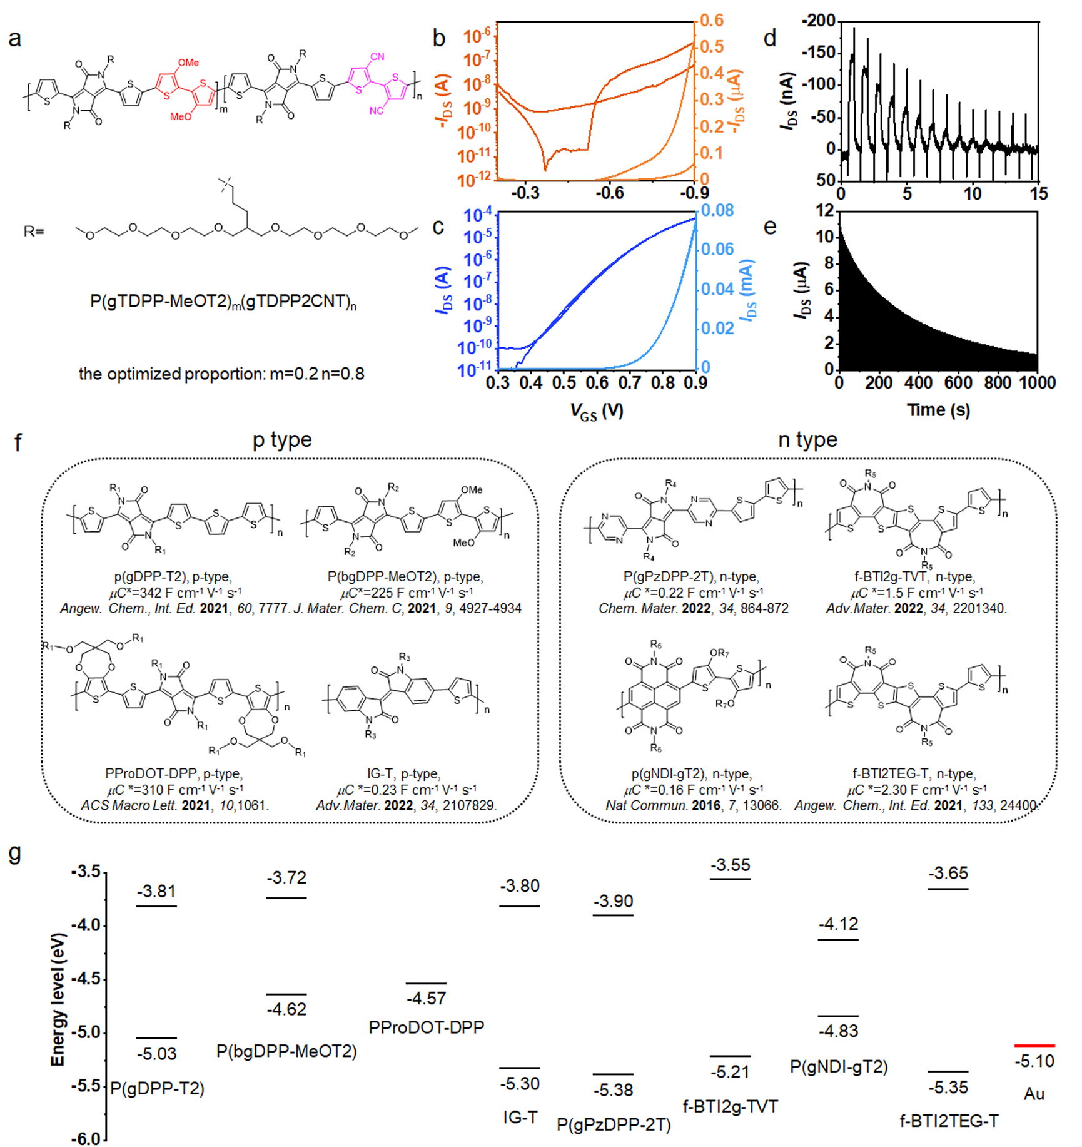
Fig. S1 The relationship between molecular energy levels and the OECT performance. a Chemical structures of a copolymer, P(gTDPP-MeOT2)_{m}(gTDPP2CNT)_{n}, consisting of p-type and n-type polymer part. b p-type and c n-type transfer characteristics of P(gTDPP-MeOT2)_{0.2}(gTDPP2CNT)_{0.8}. d p-type and e n-type operational stability tests for P(gTDPP-MeOT2)_{0.2}(gTDPP2CNT)_{0.8}. f Chemical structures of some p-type and n-type OECT polymers with the donor-acceptor design. The ethylene glycol (EG) side chains of each polymer are omitted for better clarity. g Corresponding HOMO and LUMO energy levels of the polymers (CV measurements).
Traditionally, high-lying HOMO energy levels are beneficial for reducing the energy barrier between p-type materials and gold electrodes, facilitating efficient hole injection. Similarly, low-lying LUMO energy levels are advantageous for efficient electron injection. Therefore, designing conjugated polymers with donor-acceptor (D-A) structures could effectively reduce the HOMO-LUMO gap and lead to favorable ambipolar transport performance in organic field effect transistors (OFETs). However, this approach is not applicable to OECTs. In Fig. S1a, we designed and synthesized a copolymer, P(gTDPP-MeOT2)_{m}(gTDPP2CNT)_{n}, which includes two different types of OECT polymers: P(gTDPP-MeOT2) (p-type) and P(gTDPP2CNT) (n-type). Based on OECT measurements, the optimized ratio of the polymer is m = 0.2 and n = 0.8. Nevertheless, the unbalanced ambipolar performance and poor stability (Fig. S1b-e) suggest that balanced and stable ambipolar OECTs cannot be realized solely through engineering the molecular energy levels.
To further understand the relationship between molecular energy levels and the transport type of OECT materials, we compiled a list of polymers with D-A structures and their respective transport types, along with their molecular energy levels reported in recent literature for comparison (Fig S1f-g). For instance, compared to the p-type polymer IG-T, the f-BTYI2g-TVT exhibits a pure n-type OECT performance, even though it has a relatively higher HOMO energy level, which should be a p-type OECT polymer. A similar concern applies to P(gDPP-T2), which is a p-type OECT material with a lower LUMO energy level than n-type OECT polymers, f-BTYI2g-TVT, and f-BTI2TEG-T. Among them, P(gNDI-gT2) is a narrow bandgap ambipolar polymer mainly dominated by n-type behavior. However, its OECT performance is not outstanding due to the influence of the doped state, primarily caused by its twisted backbone and strong charge localization. Despite some deviations in the energy level values from different CV test conditions, these results still reveal that energy levels are essential for determining the charge transport type in OECT. Nevertheless, other crucial factors, such as molecular planarity and stability in the doped state, have not been adequately considered. We have discussed these aspects in the main text.

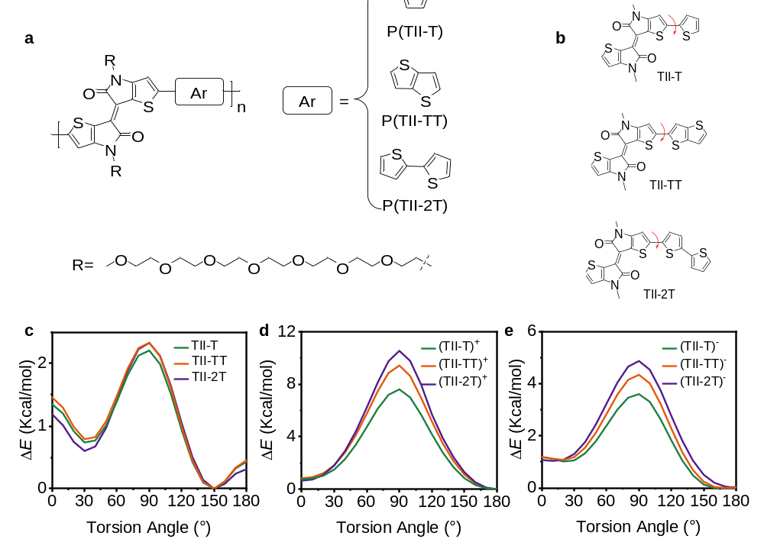
Fig. S2 Relaxed PES scans. a Chemical structures of the three polymers: P(TII-T), P(TII-TT) and P(TII-2T). b Molecular structures of the three monomers: TII-T, TII-TT, and TII-2T. The EG side chains were replaced with methyl groups to simplify the calculation. Comparison of the relaxed PES scans of the torsion angles for the monomers under c neutral, d positively, and e negatively charged states. The torsion angles are the dihedral angles marked in Fig. S2b.
The three monomers (TII-T, TII-TT, and TII-2T) exhibit similar planarity in their neutral or charged states. However, as the repeating units of P(TII-2T) increase, the conjugated backbone of the polymer P(TII-2T) becomes twisted and non-planar due to the presence of torsional angles between the bithiophene (2T) units. Consequently, an anomalous ΔE_{ST} value occurs when the repeating units reach 4 (Fig. 2d and Table S1). Compared to P(TII-2T) and P(TII-TT) with the same repeating unit, P(TII-T) displays the largest ΔE_{ST} value, which led us to choose TII and T for constructing the polymer.

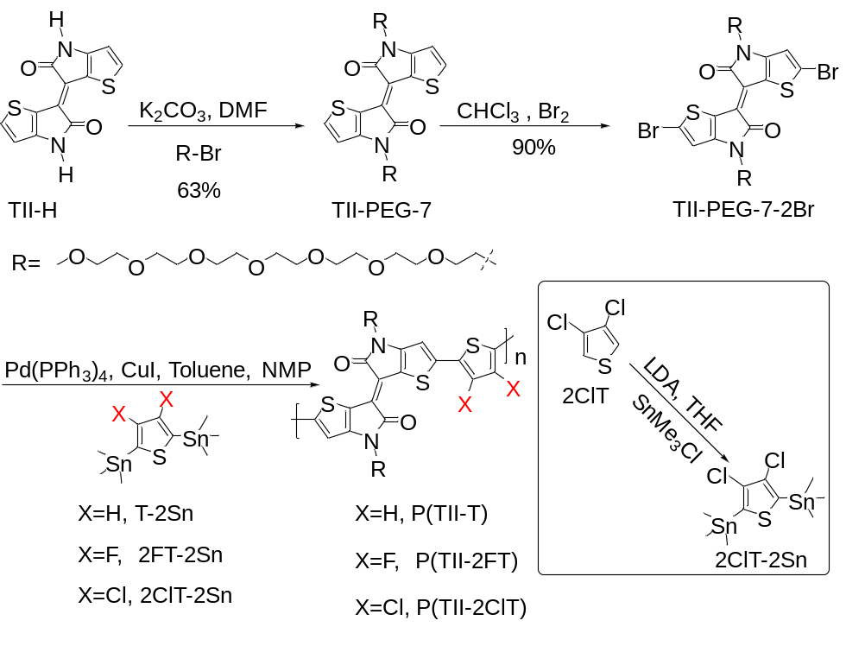
Fig. S3 Synthetic routes to the three polymers. P(TII-T), P(TII-2FT), and P(TII-2ClT).

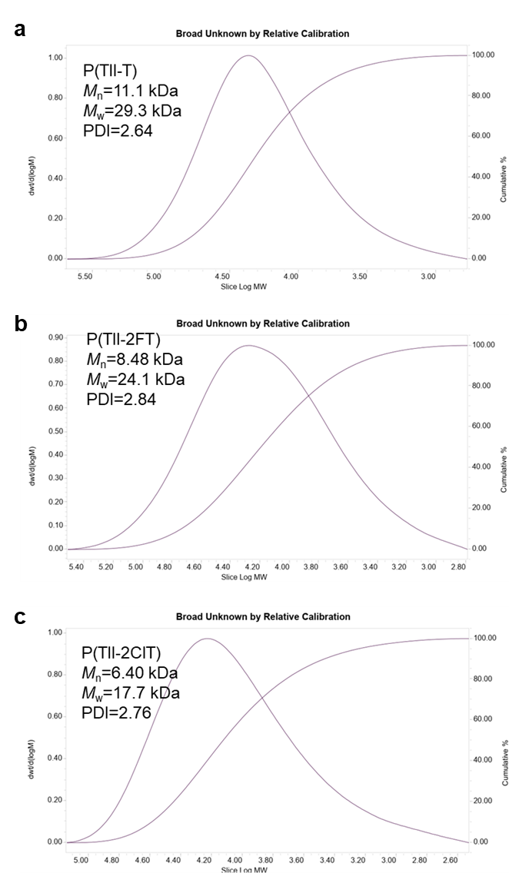
Fig. S4 Molecular weights and polymer dispersity index (PDI) of the polymers. a P(TII-T), b P(TII-2FT), and c P(TII-2ClT), measured by GPC with hexafluoroisopropanol (HFIP) as the eluent.

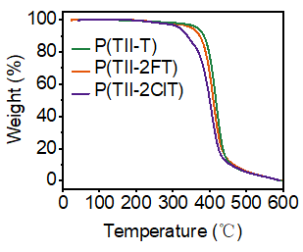
Fig. S5 Thermogravimetric analysis (TGA) of the polymers. T_{d, P(TII-T)} = 365 ℃; T_{d, P(TII-2FT)} = 350 ℃; T_{d, P(TII-2ClT)} = 317 ℃.

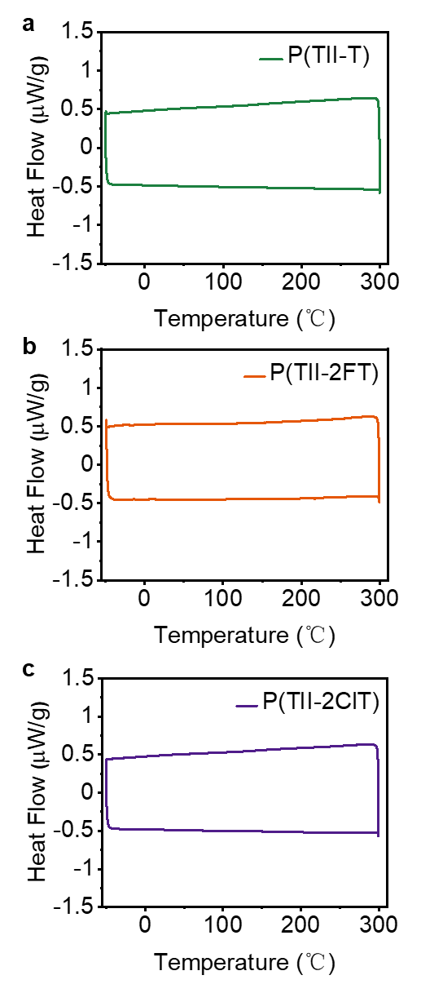
Fig. S6 Differential scanning calorimetry (DSC) of the polymers. a P(TII-T), b P(TII-2FT), and c P(TII-2ClT). All polymers do not show obvious endothermic or exothermic peaks form −50 ℃ to 300 ℃.

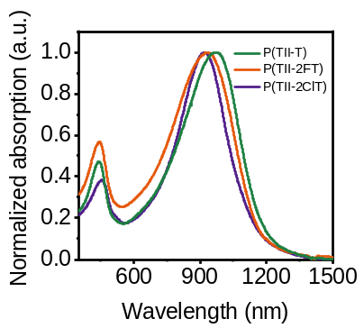
Fig. S7 The normalized UV-vis-NIR absorption spectra of the polymers. P(TII-T), P(TII-2FT), and P(TII-2ClT), in chloroform solution.

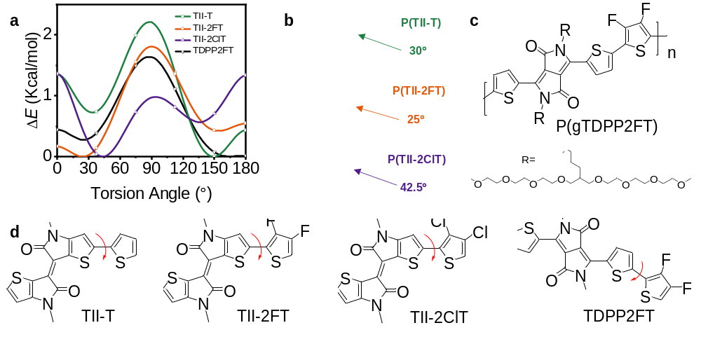
Fig. S8 Relaxed PES scans and optimized backbone structures. a Comparison of the relaxed PES scans of the torsion angles for the monomers: TII-T, TII-2FT, TII-2ClT, and TDPP2FT. The torsion angles are the dihedral angles marked in Fig. S8d. b Optimized backbone structures and dihedral angles for the monomers of P(TII-T), P(TII-2FT), and P(TII-2ClT). c Chemical structure of polymer P(gTDPP2FT). d Molecular structures of the four monomers: TII-T, TII-2FT, TII-2ClT, and TDPP2FT. The EG side chains were replaced with methyl groups to simplify the calculation.

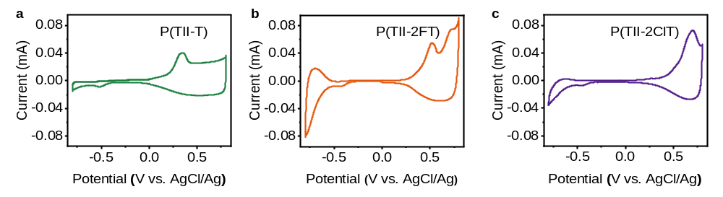
Fig. S9 Cyclic voltammograms of the polymers. a P(TII-T), b P(TII-2FT), and c P(TII-2ClT), in acetonitrile solution with a 0.1 M NaCl aqueous solution as the electrolyte.

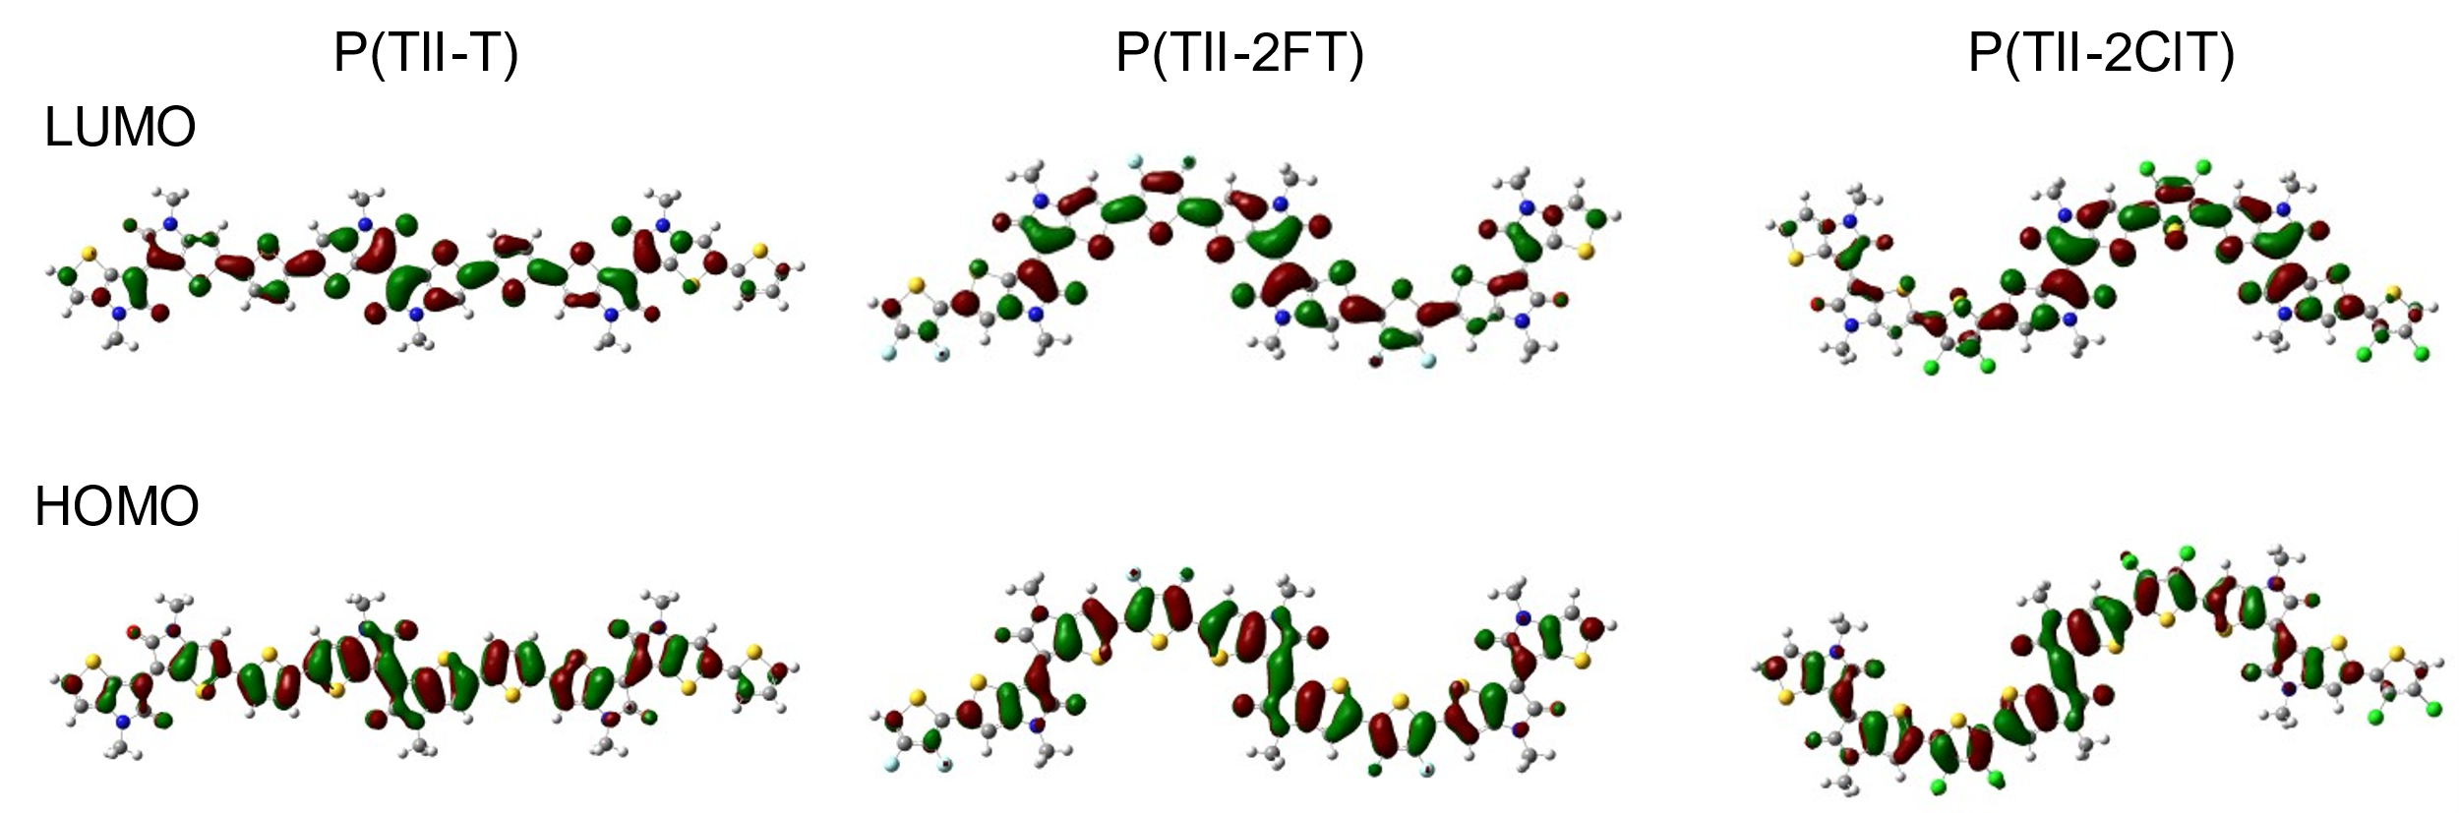
Fig. S10 DFT-optimized geometries and molecular frontier orbitals of the trimers. The EG side chains were replaced with methyl groups to simplify the calculation.

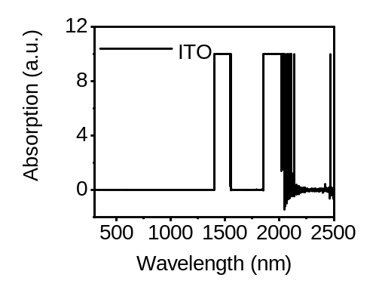
Fig. S11 The absorption spectrum of indium tin oxide (ITO) glass. Due to the strong absorption of the ITO glass at wavelengths greater than 1400 nm, the absorption bands of these generated polarons/bipolarons from the polymers are partially obscured in the long-wavelength region.

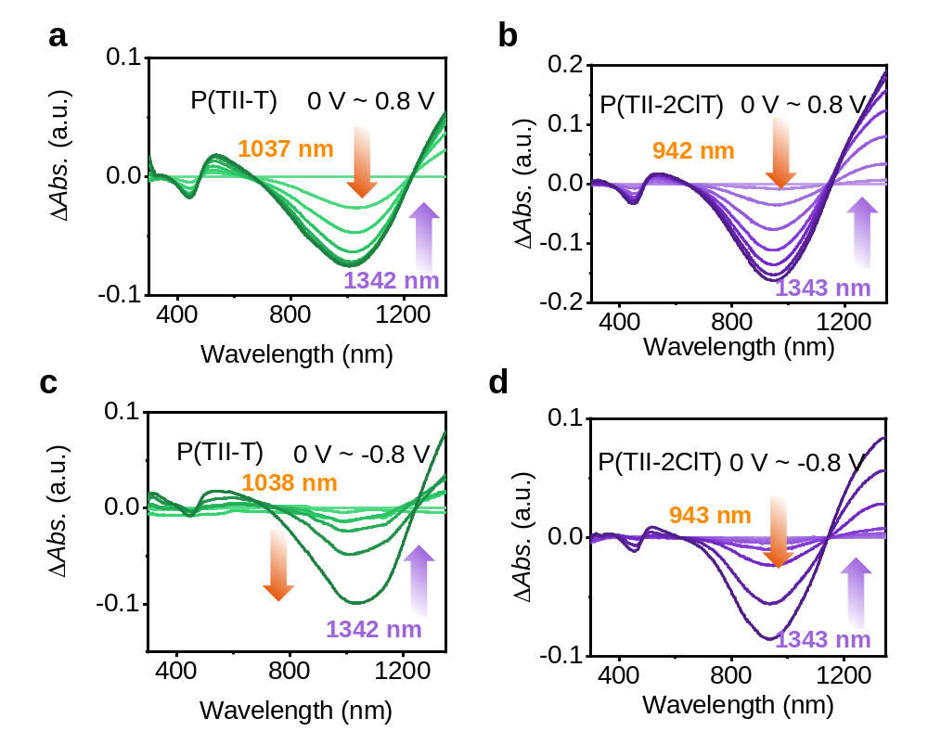
Fig. S12 Electrochemical absorption spectra of the polymers. a/c P(TII-T) and b/d P(TII-2ClT), with positive voltages (0 to +0.8 V)/negative voltages (0 to −0.8 V) on ITO glass in a 0.1 M NaCl aqueous solution. The ΔAbs. represents the difference in absorption intensity at various bias voltages.

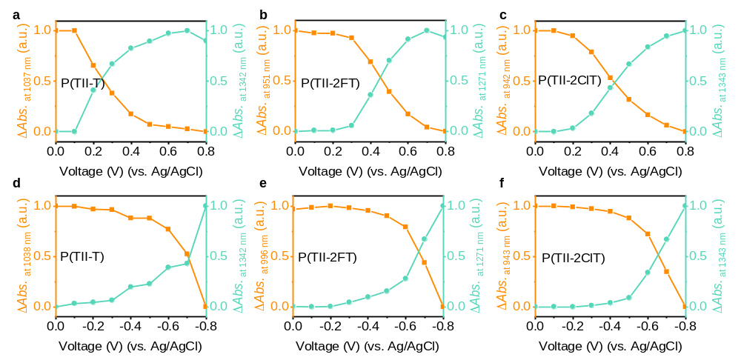
Fig. S13 Absorption intensity changes at the tagged wavelengths in the electrochemical absorption spectra. a/d P(TII-T), b/e P(TII-2FT), and c/f P(TII-2ClT), at the different bias voltages.

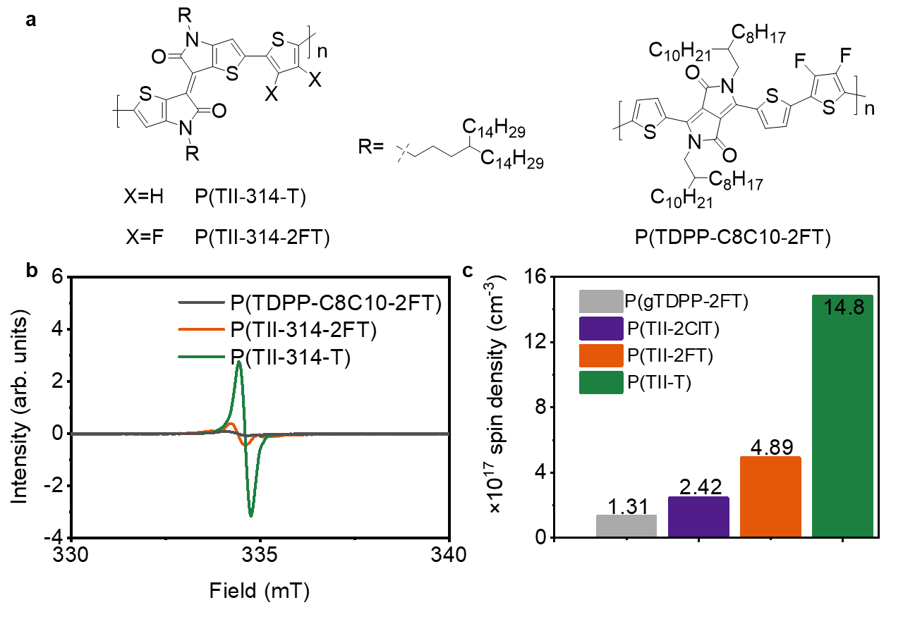
Fig. S14 Room temperature EPR signals. a Chemical structures of the alkyl side chain functionalized polymers, P(TII-314-T), P(TII-314-2FT), and P(TDPP-C8C10-2FT). b Room temperature EPR signals of P(TII-314-T), P(TII-314-2FT), and P(TDPP-C8C10-2FT) in the solid state. c Spin densities of the powders of P(gTDPP2FT), P(TII-T), P(TII-2FT), and P(TII-2ClT) at room temperature.

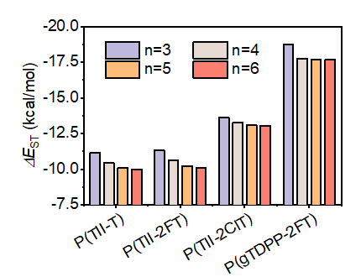
Fig. S15. Calculated ΔE_{ST} values. P(TII-T), P(TII-2FT), P(TII-2ClT), and P(gTDPP2FT), with different repeating units (n=3, 4, 5, 6).
As the number of repeating units increases, the calculated ΔE_{ST} values of these four polymers gradually become larger. This trend suggests that the actual polymers may exhibit larger ΔE_{ST} values and might even become positive values due to their longer conjugation length. Therefore, the actual polymer with a calculated negative ΔE_{ST} value may also display a high-spin character with the triplet state as the ground state.

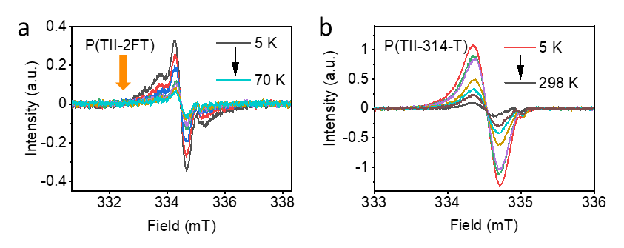
Fig. S16 Variable-temperature EPR signals. a P(TII-2FT) and b P(TII-314-T), in the solid state. The alkyl-substituted polymer P(TII-314-T) exhibits a decreasing trend in EPR signals as the temperature increases, similar to P(TII-2FT) and P(TII-T). This result further indicates that the unpaired electrons originate from their backbones rather than the EG side chains, suggesting the potential presence of a triplet ground state in the backbones of P(TII-2FT) and P(TII-T).

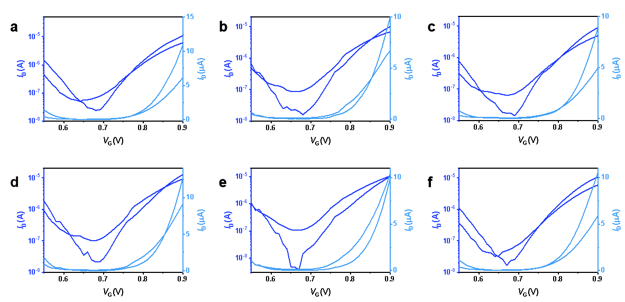
Fig. S17 Six typical n-type OECT transfer characteristics based on P(TII-T).

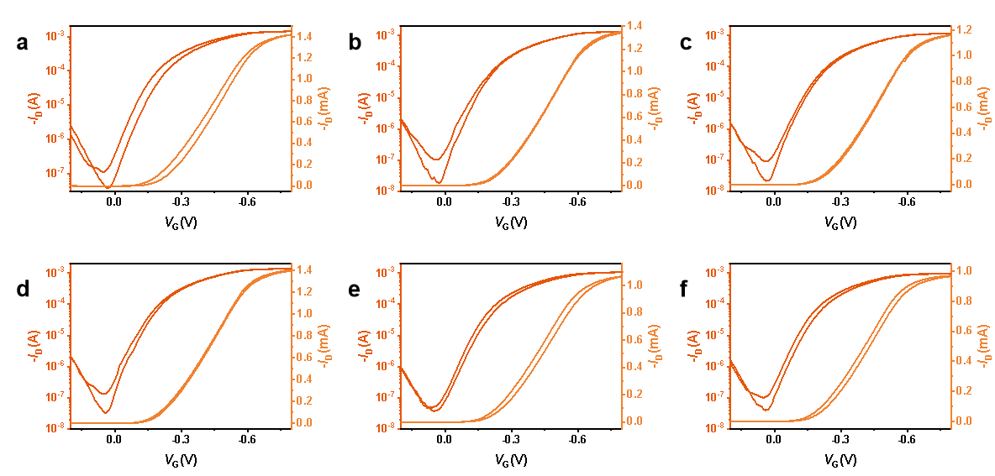
Fig. S18 Six typical p-type OECT transfer characteristics based on P(TII-T).

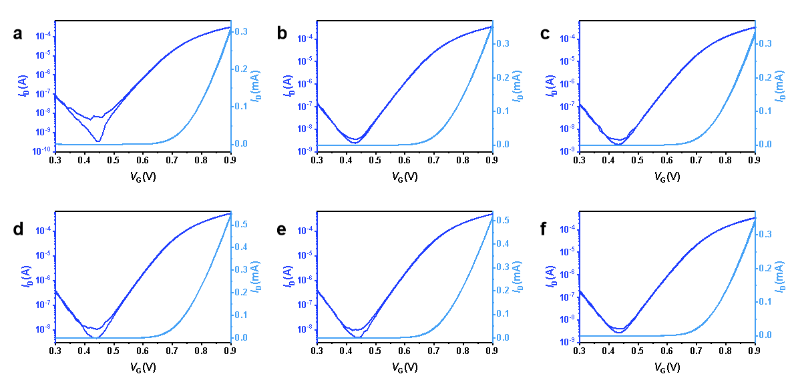
Fig. S19 Six typical n-type OECT transfer characteristics based on P(TII-2FT).

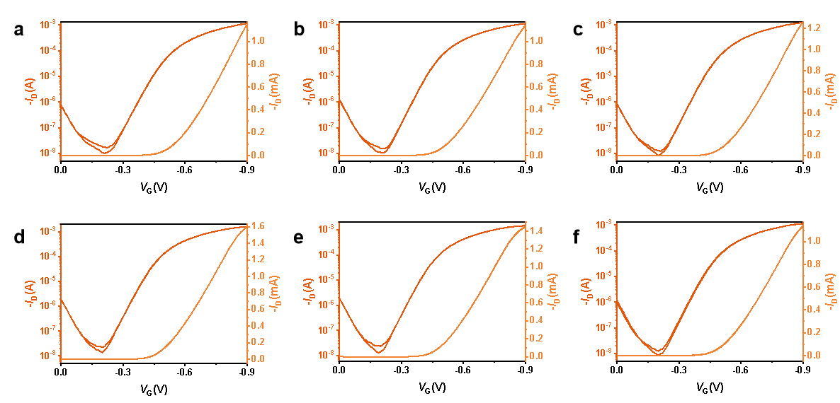
Fig. S20 Six typical p-type OECT transfer characteristics based on P(TII-2FT).

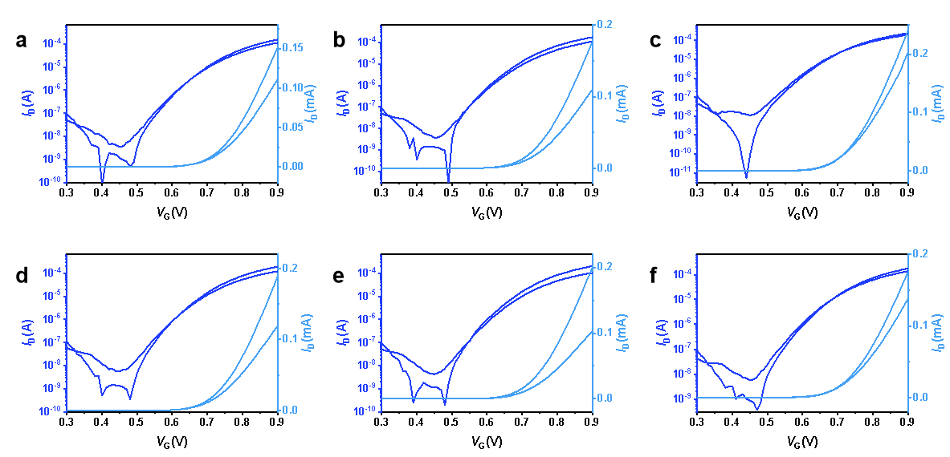
Fig. S21 Six typical n-type OECT transfer characteristics based on P(TII-2ClT).

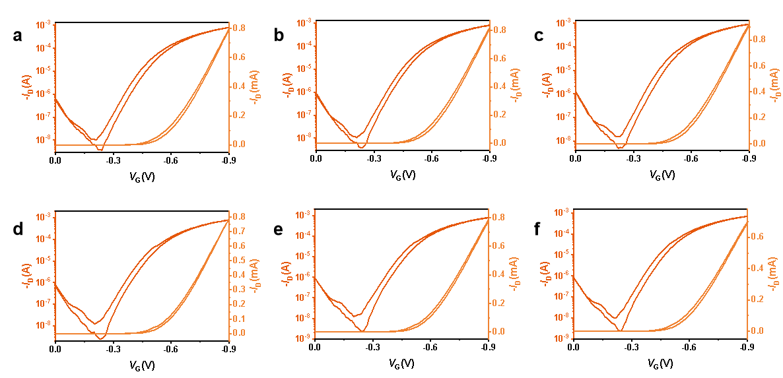
Fig. S22 Six typical p-type OECT transfer characteristics based on P(TII-2ClT).

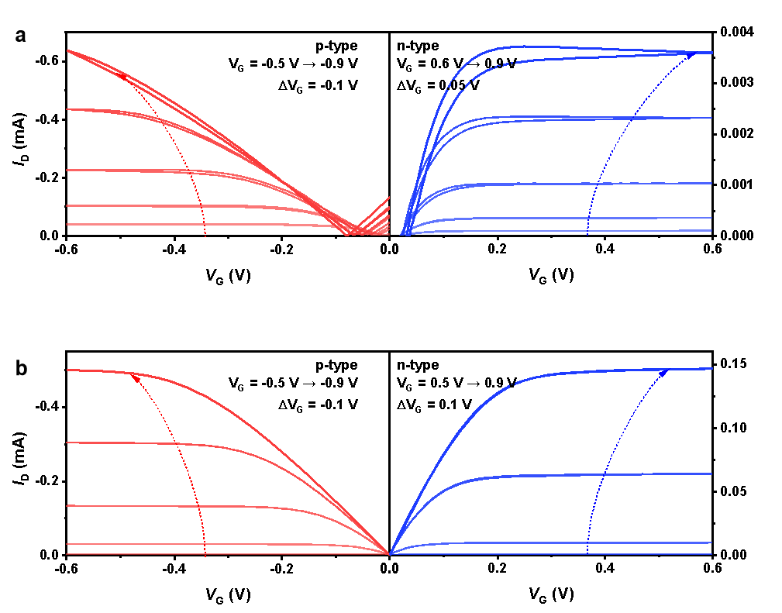
Fig. S23 Ambipolar OECT output characteristics. a P(TII-T) and b P(TII-2ClT).

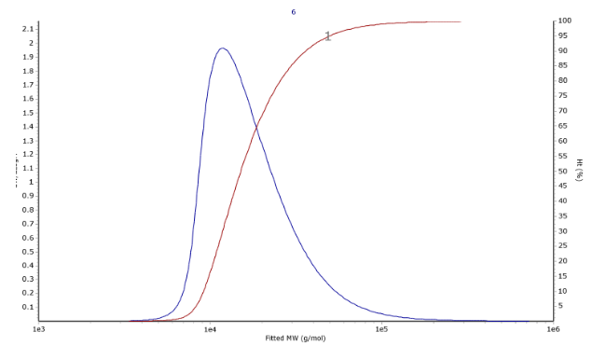
Fig. S24 Molecular weights and PDI of purified P(TII-2FT), measured by GPC with hexafluoroisopropanol as the eluent. Mn = 14.7 kDa; Mw = 20.9 kDa; PDI = 1.42.

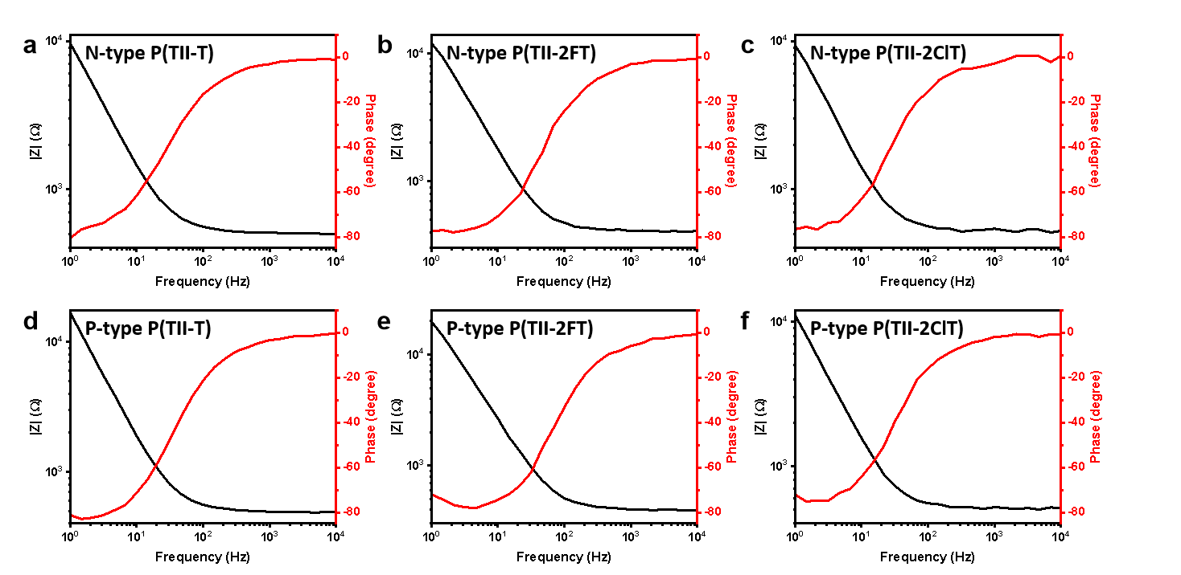
Fig. S25 Electrochemical impedance spectrum (EIS). a/d P(TII-T), b/e P(TII-2FT), and c/f P(TII-2ClT). |V_{DC}| = 0.8 V.

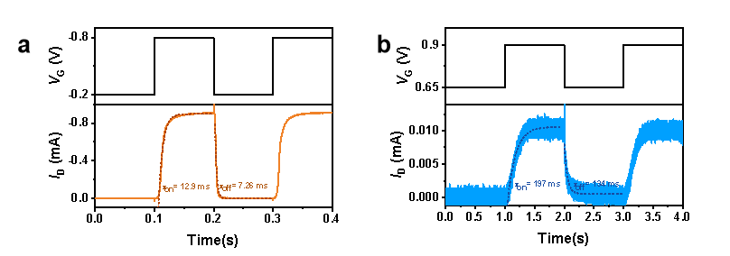
Fig. S26 Response time measurements for P(TII-T). a P-type and b n-type. |V_{DS}| = 0.6 V.

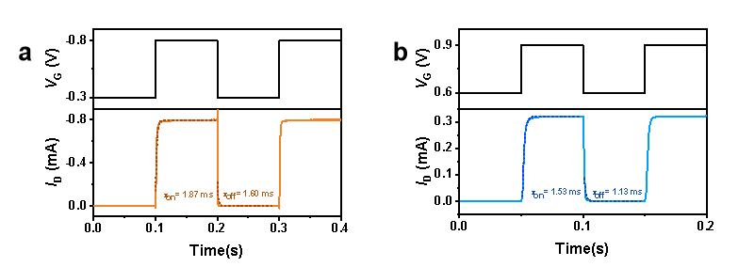
Fig. S27 Response time measurements for P(TII-2ClT). a P-type and b n-type. |V_{DS}| = 0.6 V.

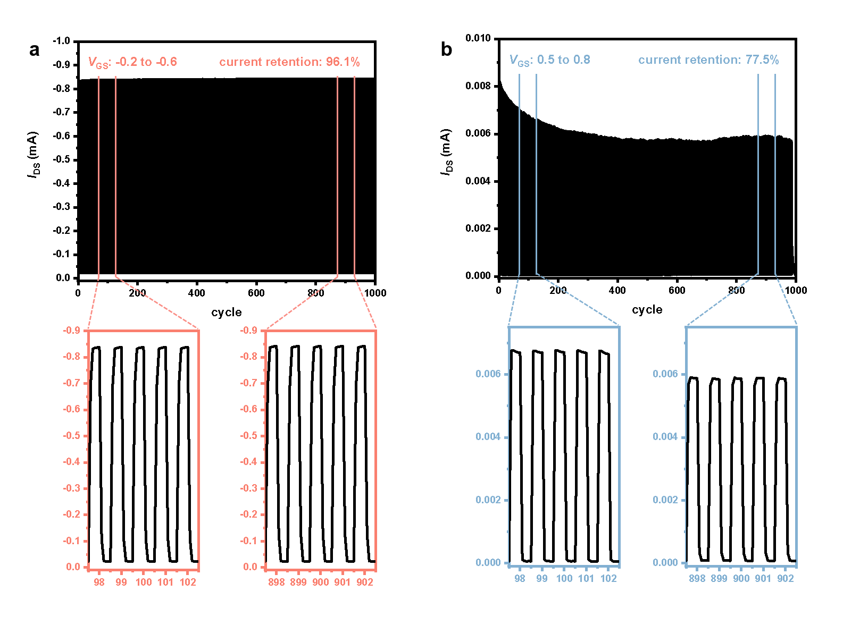
Fig. S28 Regime stability tests for P(TII-T). a P-type and b n-type. V_{DS} = -0.6 V.

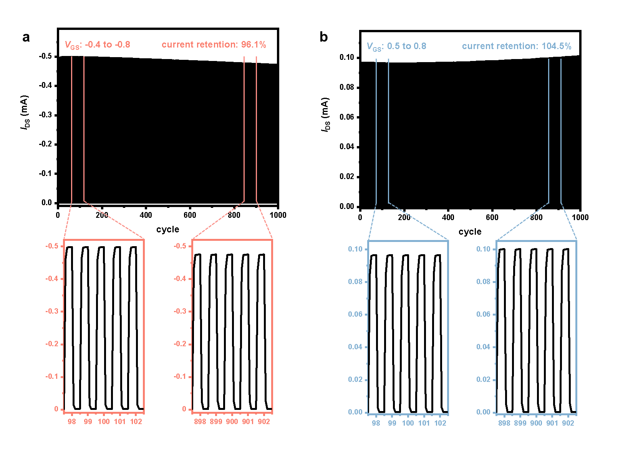
Fig. S29 Regime stability tests for P(TII-2FT). a P-type and b n-type. V_{DS} = -0.6 V.

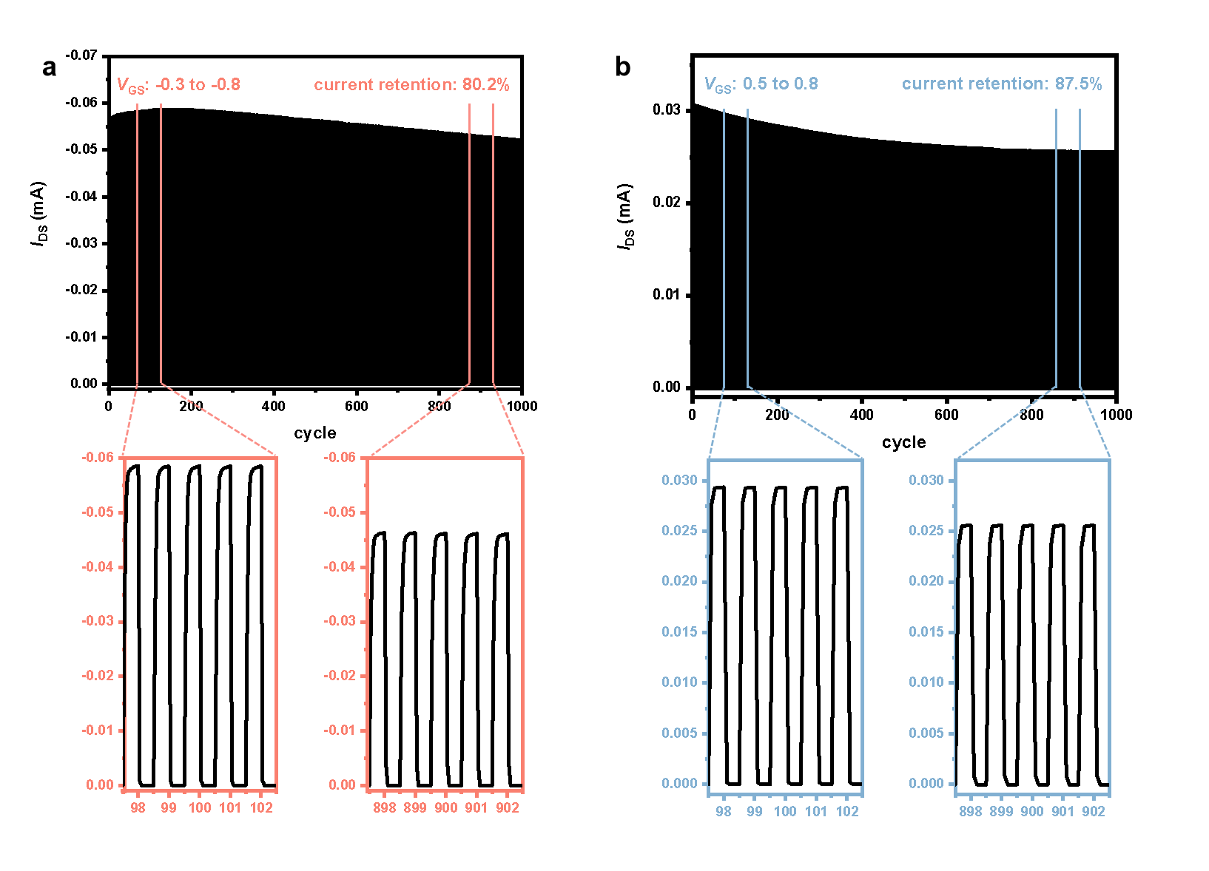
Fig. S30 Regime stability tests for P(TII-2ClT). a P-type and b n-type. V_{DS} = -0.6 V.

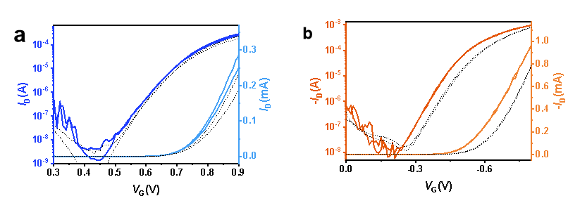
Fig. S31 Transfer characteristics based on TII-2FT. a N-type and b p-type. The black dotted lines represent the transfer characteristics of the device exposed to undried air for 81 days, while the colorful lines represent the original transfer characteristics for comparison.

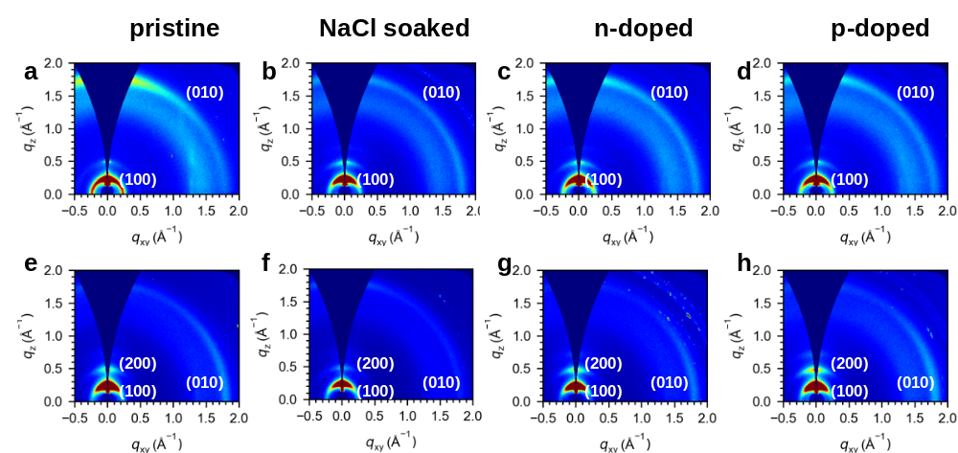
Fig. S32 2D-GIWAXS patterns of P(TII-T)/P(TII-2FT) films. a/e Pristine, b/f immersed in a 0.1 M NaCl solution, c/g n-doped, and d/h p-doped processes. The p-/n-doped processes stand for the films on the silicon substrate that are oxidized/reduced by the 0.8/−0.8 V voltage bias for 10 min.

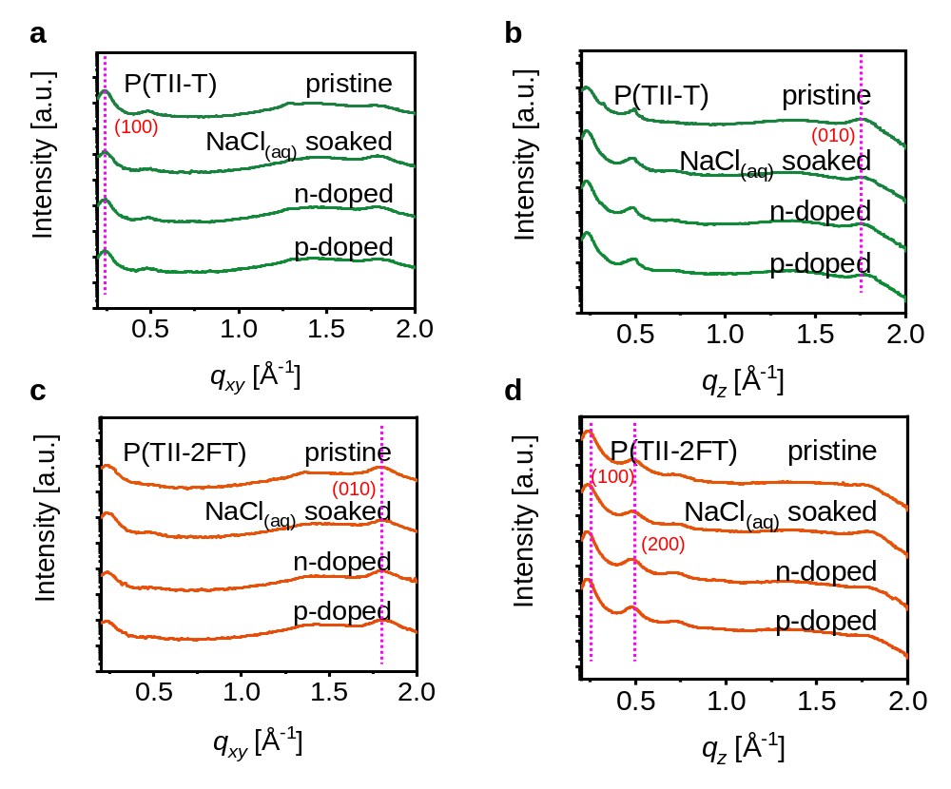
Fig. S33 The q_{xy} orientation (in plane) line-cuts and q_{z} orientation (out of plane) line-cuts. a & b P(TII-T) and c & d P(TII-2FT), with the different treated processes.

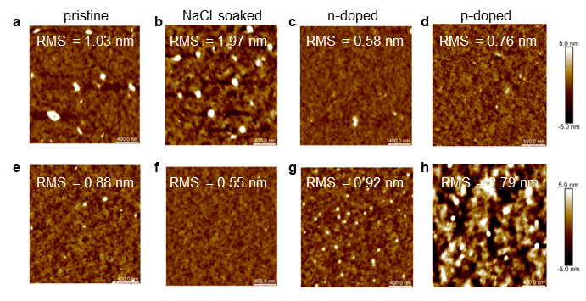
Fig. S34 AFM height images of P(TII-T)/P(TII-2FT) films. a/e Pristine, b/f immersed in a 0.1 M NaCl solution, c/g n-doped, and d/h p-doped. The p-/n-doped stand for the films on the silicon substrate that are oxidized/reduced by a 0.8/−0.8 V voltage bias for 10 min.

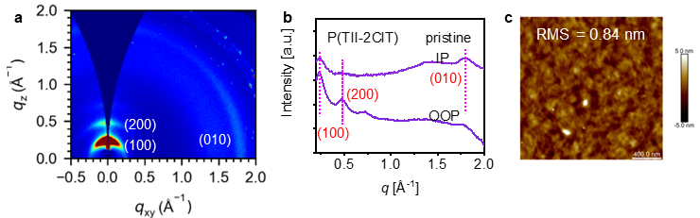
Fig. S35 The morphology of pristine P(TII-2ClT) film. a 2D-GIWAXS pattern, b 1D-GIWAXS line-cuts, and c AFM height image. In plane (IP) stands the q_{xy} orientation, and out of plane (OOP) stands the q_{z} orientation.

Pristine P(TII-2FT) and P(TII-2ClT) films exhibit strong (010) diffractions in the q_{xy} orientation and (100) diffractions in the q_{z} orientation, indicating a dominant edge-on packing in the film (Fig S32e and Fig. S35a). Conversely, the P(TII-T) film displays circular (100) and (010) diffraction signals ranging from q_{z} to q_{xy} orientation, indicating the coexistence of both edge-on and face-on packing (Fig. S32a). Upon immersion in a 0.1 M NaCl solution, both P(TII-2FT) and P(TII-T) films in (100) and (010) orientations display decreased crystallinity compared to their pristine films (Fig. S32b, f), corroborated by the reduction in their corresponding coherence lengths (CLs) (Fig. S33 and Table S5). When p-doped or n-doped, P(TII-T) films exhibit further diminished crystallinity, while those of P(TII-2FT) films display slightly enhanced crystallinity. These trends are also observed in AFM height images. Pristine P(TII-2FT) and P(TII-2ClT) films possess smooth surfaces with fiber-like textures (Fig. S34e and Fig. S35c), and the root-mean-square (RMS) roughness of P(TII-2FT) films subjected to p-/n-doping processes is slightly higher than that of the pristine films (Fig. S34g, h), suggesting a stronger crystallization feature after doping. However, the RMS roughness of the doped P(TII-T) films displays an opposite trend (Fig. S34a-d). Better crystallinity and minimal morphology change might explain the high charge carrier mobility and good stability of P(TII-2FT) after doping.

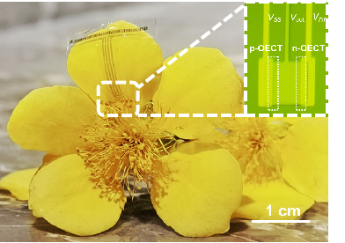
Fig. S36 Photograph and magnified microscope image of the thin and flexible inverters. Attached to a fragile petal.

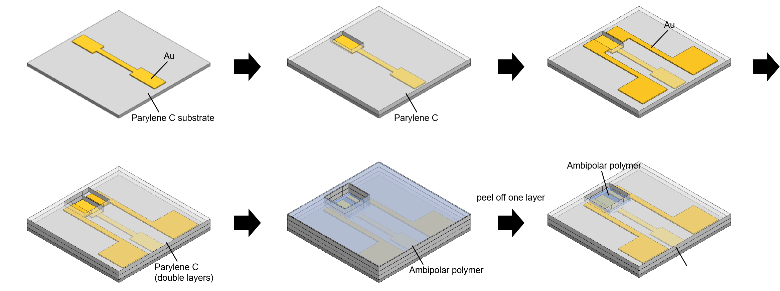
Fig. S37 Schematic illustration of the fabrication process of the flexible amplifiers. Used for EEG, ECG, and ECoG signal recording.

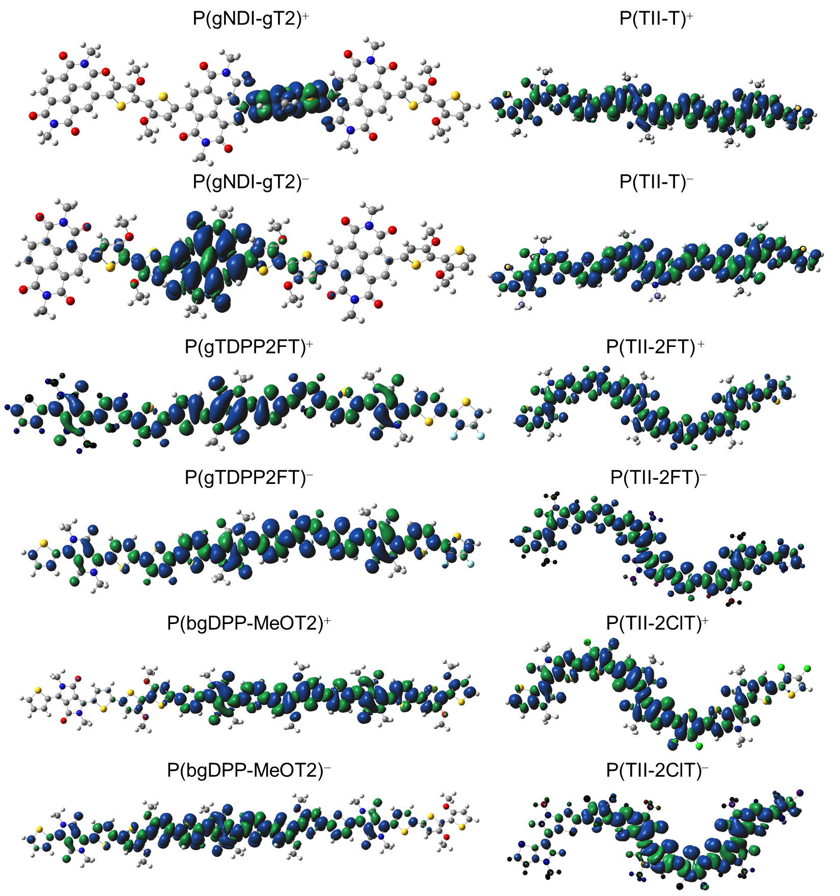
Fig. S38 Spin density distribution of positively (+) or negatively (−) charged trimers. P(gNDI-gT2), P(gTDPP2FT), P(bgDPP-MeOT2), P(TII-T), P(TII-2FT), and P(TII-2ClT).

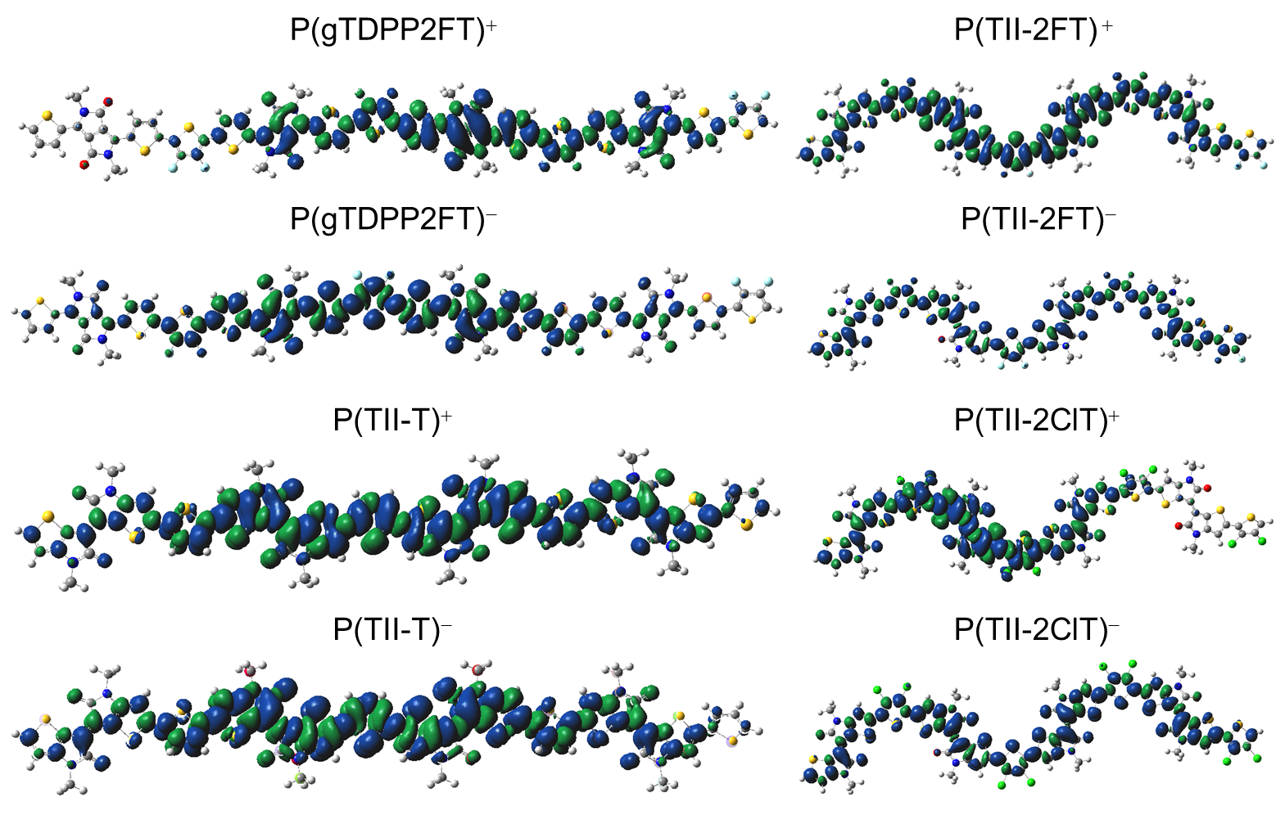
Fig. S39 Spin density distribution of positively (+) or negatively (−) charged tetramers. P(gTDPP2FT), P(TII-T), P(TII-2FT), and P(TII-2ClT).

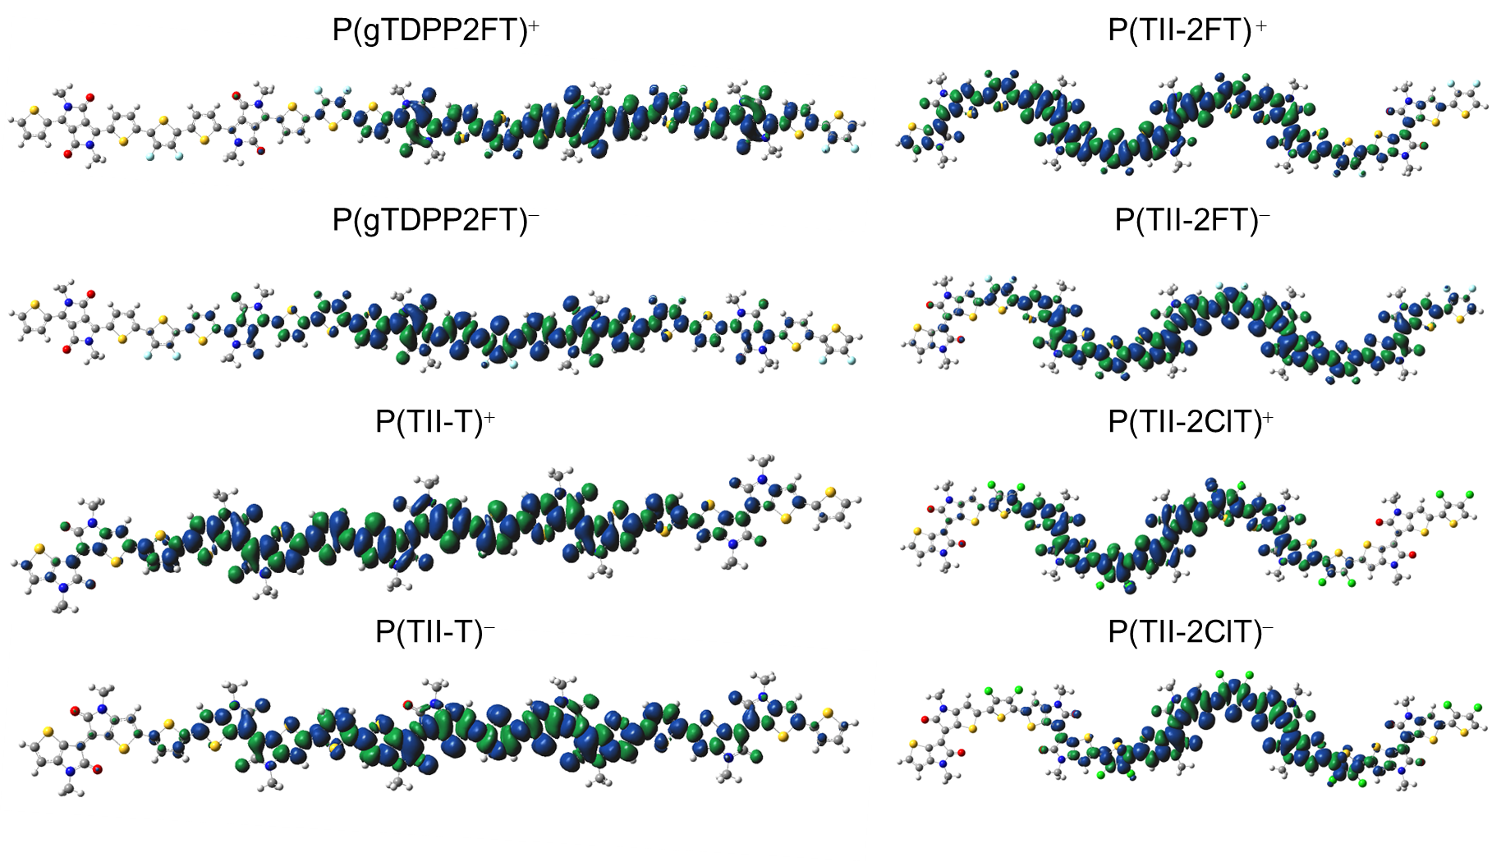
Fig. S40 Spin density distribution of positively (+) or negatively (−) charged pentamers. P(gTDPP2FT), P(TII-T), P(TII-2FT), and P(TII-2ClT).

In positively or negatively charged trimers, P(gTDPP2FT), P(TII-T), P(TII-2FT), and P(TII-2ClT) all demonstrate excellent delocalization characteristics. However, in P(bgDPP-MeOT2), the positive or negative charge cannot fully delocalize throughout the entire backbone, while P(gNDI-gT2) exhibits a strong localization effect in its spin density distribution (Fig. S38). In positively or negatively charged tetramers, the spin density in P(gTDPP2FT) concentrates in the core region of the backbone, whereas due to their quinoidal structures, P(TII-T), P(TII-2FT), and P(TII-2ClT) display completely delocalized spin density distributions (Fig. S39). We also observed that in the case of P(TII-2ClT), there is a lower positive charge distribution at the end of the tetramer (Fig. S39), possibly influenced by the pronounced twist in the configuration of P(TII-2ClT). These observations are consistent with those in pentamers (Fig. S40). Overall, when compared to closed-shell polymers, open-shell high-spin polymers with quinoidal structures exhibit a more delocalized distribution of spin density.

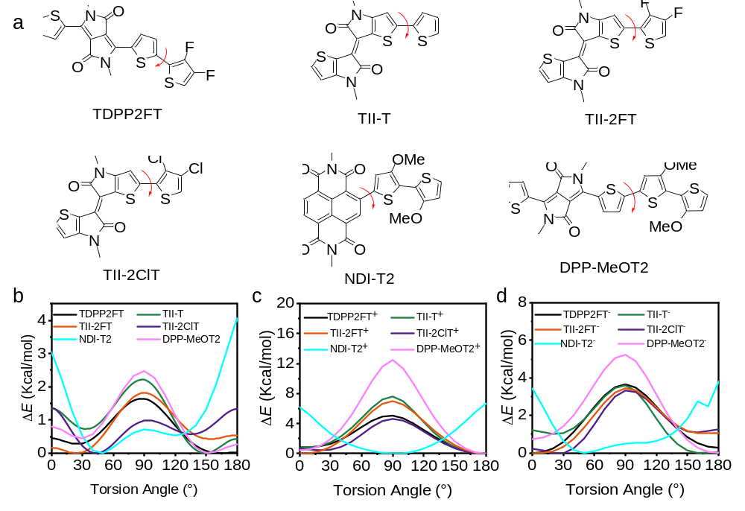
Fig. S41. Relaxed PES scans. a Chemical structures of the six monomers: TDPP2FT, TII-T, TII-2FT, TII-2ClT, NDI-T2, and DPP-MeOT2. Comparison of the relaxed PES scans of the torsion angles for the monomers under b neutral, c positively, and d negatively charged states. The torsion angles are the dihedral angles marked in Fig. S41a. The EG side chains were replaced with methyl groups to simplify the calculation.
The dominant conformation of the monomers TDPP2FT, TII-T, TII-2FT, TII-2ClT, and DPP-MeOT2 in the positively and negatively charged states shows good planarity, while that of NDI-T2 displays a twisted backbone, particularly in the positively charged state.

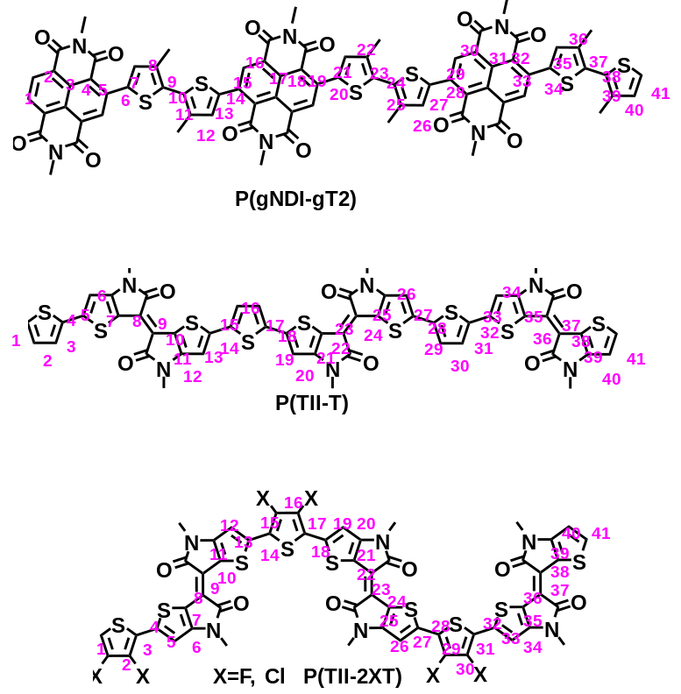
Fig. S42 Schematic diagram of single bond and double bond from index 1 to index 41. Along the polymer skeletons for P(gNDI-gT2), P(TII-T), P(TII-2FT), and P(TII-2ClT).

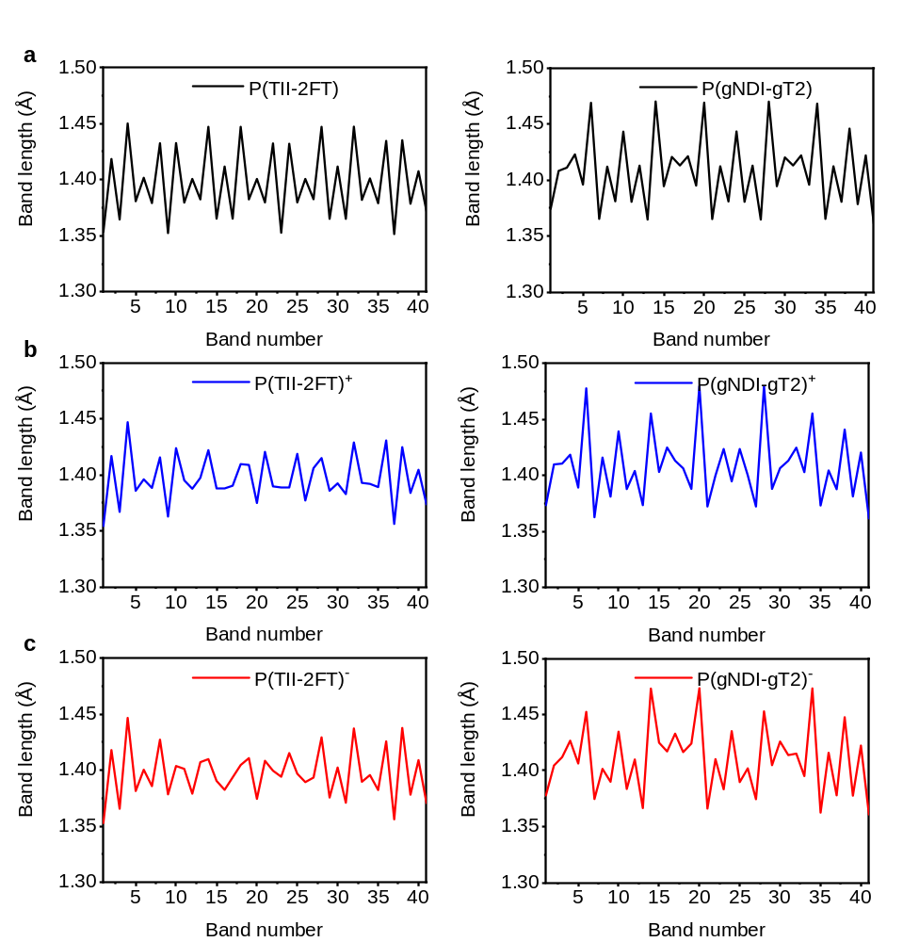
Fig S43. Comparison of the bond length alternation (BLA). P(TII-2FT) and P(gNDI-gT2), from the number 1 to the number 41 under the a neutral, b positively, and c negatively charged states.

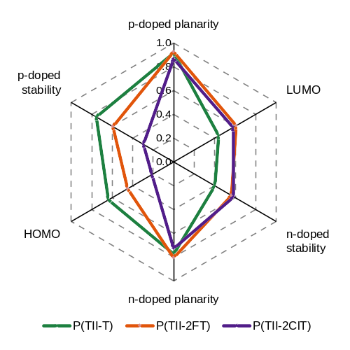
Fig S44. Comparison of the six important parameters of the three ambipolar open-shell polymers. P(TII-T), P(TII-2FT), and P(TII-2ClT).

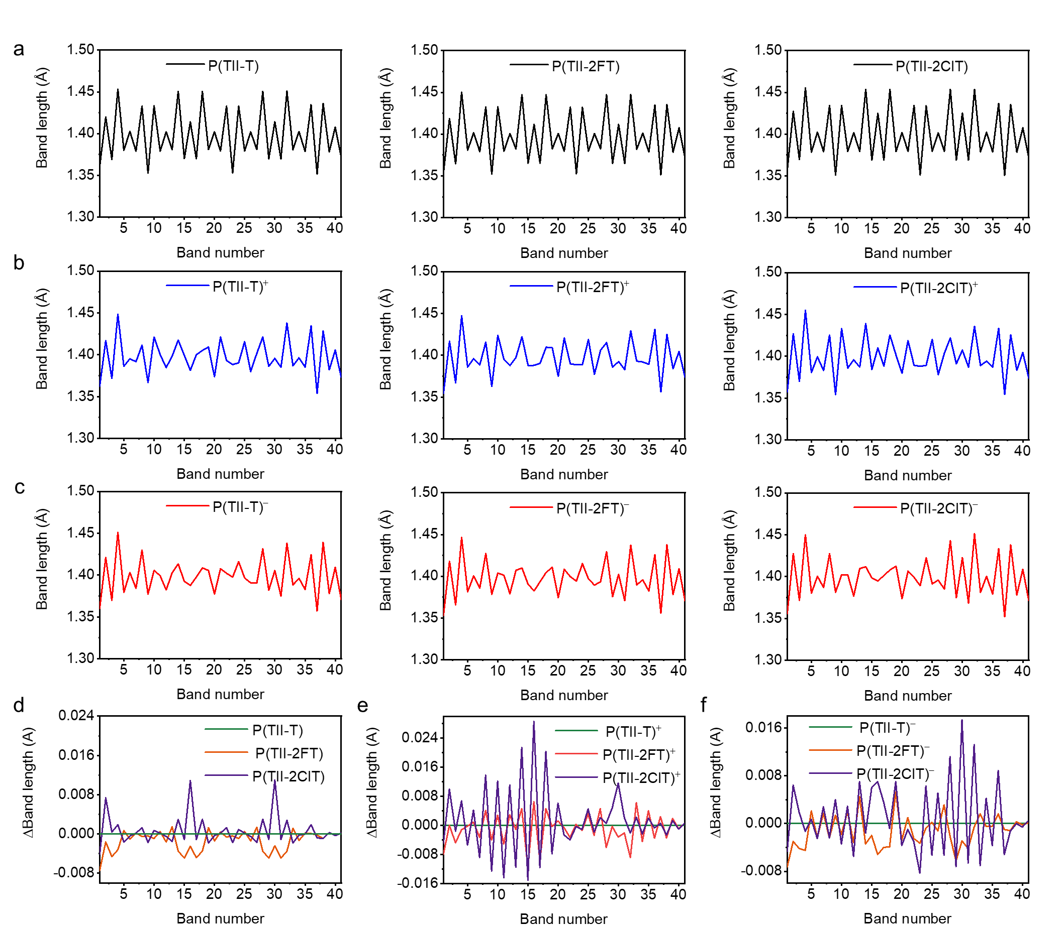
Fig S45. Comparison of the bond length alternation (BLA). P(TII-T), P(TII-2FT), and P(TII-2ClT) from number 1 to number 41, in a neutral, b positively, and c negatively charged states. Due to the similar conjugated backbone of these polymers, the differences among them are hard to observe. Therefore, we use P(TII-T) as a benchmark, and the difference in BLA (Δbond length) is observed in d neutral, e positively, and f negatively charged states. ΔBond length represents the difference in bond length between P(TII-2FT) or P(TII-2ClT) and P(TII-T). A lower Δbond length suggests a more uniform distribution in BLA and a stronger tendency to form a quinoid open-shell resonant structure. The order of this tendency is P(TII-T)>P(TII-2FT)>P(TII-2ClT).

- Synthesis and Characterization of New Compounds
Synthesis of compound 2Cl-T-2Sn
A solution of 2ClT (177 mg, 1.16 mmol) in dry THF (20 mL) under argon was cooled to −78 ℃, and 2.89 mL (2.89 mmol) of LDA (1 M in THF) was slowly added (over 10 min). The mixture was then stirred for 30 min at −78 ℃, and 2.54 mL (2.54 mmol) of trimethyltin chloride (1 M in THF) was added in 3 min. The mixture was stirred for 1 h at −78 ℃. The reaction was then quenched by adding 40 mL of anhydrous methanol. The mixture was extracted with DCM. The combined organic layers were dried over MgSO₄ and concentrated. The product was purified by chromatography on silica gel to yield a colorless oil, 2Cl-T-2Sn (389 mg, 70.0%). ¹H NMR (CDCl₃, 400 MHz, TMS), δ (ppm): 0.44 (s, 18H, CH₃). ¹³C NMR (100 MHz, CDCl₃), δ (ppm): 138.74, 132.02. FTMS (m/z): calcd. for C₁₀H₁₈Cl₂SSn₂: 479.8550 (100%), Found: 499.0826 (M + H₃O⁺, 100%).
Synthesis of compound TII-PEG-7
Under a nitrogen atmosphere, TII-H (448 mg, 1.63mmol) and potassium carbonate (1.33 g, 4.09 mmol) were added to 25 mL of N, N-dimethylformamide. After heating the mixture to 80 ºC, R-Br (1.45 g, 3.60 mmol) in DMF (5 mL) was added dropwise into the mixture and stirred for 12 h. After cooling to room temperature (RT), the mixture was washed with water and extracted with DCM. The residue was purified by silica gel column chromatography using EA/MeOH (v:v, 30/1) as the eluent to get a red oil, TII-PEG-7 (950 mg, 63.3%). ¹H NMR (CDCl₃, 400 MHz, TMS), δ (ppm): 7.51-7.50 (d, J = 4.2 Hz, 2H, Th-H), 6.97-6.95 (d, J = 4.2 Hz, 2H, Th-H), 4.01-3.99 (t, J = 5.9 Hz, 4H, CH₂), 3.76-3.73 (m, 4H, CH₂), 3.63-3.54 (m, 48H, CH₂), 3.37 (s, 6H, CH₃). ¹³C NMR (100 MHz, CDCl₃), δ (ppm): 171.09, 151.71, 134.00, 120.83, 114.11, 112.64, 71.87, 70.58, 70.54, 70.50, 70.45, 70.21, 69.64, 61.62, 58.98, 41.85, 29.63. FTMS (m/z): calcd. for C₄₂H₆₆N₂O₁₆S₂: 918.3854 (100%), Found: 941.3752 (M + Na⁺, 100%).
Synthesis of compound TII-PEG-7-2Br
TII-PEG-7 (143 mg, 0.155 mmol) was added to 20 mL of anhydrous chloroform in a nitrogen atmosphere. After liquid bromine (16.3 μL, 0.318 mmol) was added slowly at 0 ºC, the mixture was stirred at dark environment for 2 h. After the reaction was quenched by a NaHSO₄ aqueous solution, the mixture was washed with water and extracted with DCM. The residue was purified by silica gel column chromatography using EA/MeOH (v:v, 40/1) as the eluent to get a red oil, TII-PEG-7-2Br (150 mg, 90.1%). ¹H NMR (CDCl₃, 400 MHz, TMS), δ (ppm): 7.04 (s, 2H, Th-H), 3.96-3.93 (t, J = 5.2 Hz, 4H, CH₂), 3.72-3.70 (m, 4H, CH₂), 3.64-3.53 (m, 48H, CH₂), 3.37 (s, 6H, CH₃). ¹³C NMR (100 MHz, CDCl₃), δ (ppm): 170.18, 150.51, 122.58, 119.49, 116.65, 114.59, 71.89, 70.65, 70.62, 70.56, 70.53, 70.47, 69.77, 58.99, 42.00. FTMS (m/z): calcd. for C₄₂H₆₄Br₂N₂O₁₆S₂: 1074.2064 (100%), Found: 1097.1952 (M + Na⁺, 100%).
Synthesis of polymer P(TII-T)
Tetratriphenylphosphine palladium (1.35 mg, 1.20 μmol), cuprous iodide (0.44 mg, 2.30 μmol), T-2Sn (25.25 mg, 61.3 μmol), and TII-PEG-7-2Br (62.7 mg, 58.0 μmol) were combined in a 25 mL Schlenk tube with toluene/N-methylpyrrolidone (5 mL/5 mL). The tube was purged with nitrogen through a freeze-pump-thaw cycle three times. The sealed tube was then heated to 115 ºC and stirred for 48 h. After cooling the reaction mixture to room temperature, diethylphenylazothioformamide (3 mg) was added to remove the catalyst and the resulting mixture was stirred at 80 ºC for 1 h. The reaction mixture was poured into 50 mL of hexane to precipitate and filter the polymer. The solid polymer was placed in a Soxhlet extractor and extracted with hexane, methanol, acetone, and chloroform. The chloroform solution was concentrated under reduced pressure and then poured into 20 mL of hexane to reprecipitate the polymer, P(TII-T). The suspension was filtered and dried under vacuum to obtain the polymer. ¹H NMR (CDCl₃, 400 MHz, TMS), δ (ppm): 7.07, 6.99, 6.87, 6.81, 3.90-3.35; M_{n}: 11.1 kDa; M_{w}: 29.3 kDa; PDI: 2.64.
Synthesis of polymer P(TII-2FT)
Tetratriphenylphosphine palladium (1.11 mg, 0.960 μmol), cuprous iodide (0.370 mg, 1.92 μmol), 2FT-2Sn (22.5 mg, 50.4 μmol), TII-PEG-7-2Br (51.6 mg, 48.0 μmol), and toluene/N-methylpyrrolidone (3 mL/3 mL) were added in a 25 mL Schlenk tube. The tube was purged with nitrogen through a freeze-pump-thaw cycle three times. The sealed tube was then heated to 115 ºC and stirred for 48 h. After cooling the reaction mixture to room temperature, diethylphenylazothioformamide (3 mg) was added to remove the catalyst and the resulting mixture was stirred at 80 ºC for 1 h. The reaction mixture was poured into 50 mL of hexane to precipitate and filter the polymer. The solid polymer was placed in a Soxhlet extractor and extracted with hexane, methanol, acetone, and chloroform. The chloroform solution was concentrated under reduced pressure and then poured into 20 mL of hexane to reprecipitate the polymer, P(TII-2FT). The suspension was filtered and dried under vacuum to obtain the polymer. ¹H NMR (CDCl₃, 400 MHz, TMS), δ (ppm): 6.84, 6.82, 6.67, 3.72-3.33; M_{n}: 8.48 kDa; M_{w}: 24.1 kDa; PDI: 2.84.
Synthesis of polymer P(TII-2ClT)
Tetratriphenylphosphine palladium (1.22 mg, 1.10 μmol), cuprous iodide (0.400 mg, 2.10 μmol), 2ClT-2Sn (26.7 mg, 55.5 μmol), TII-PEG-7-2Br (56.9 mg, 53.0 μmol), and toluene/N-methylpyrrolidone (4 mL/4 mL) was added in a 25 mL Schlenk tube. The tube was purged with nitrogen through a freeze-pump-thaw cycle three times. The sealed tube was then heated to 115 ºC and stirred for 48 h. After cooling the reaction mixture to room temperature, diethylphenylazothioformamide (3 mg) was added to remove the catalyst and the resulting mixture was stirred at 80 ºC for 1 h. The reaction mixture was poured into 50 mL of hexane to precipitate and filter the polymer. The solid polymer was placed in a Soxhlet extractor and extracted with hexane, methanol, acetone, and chloroform. The chloroform solution was concentrated under reduced pressure and then poured into 20 mL of hexane to reprecipitate the polymer, P(TII-2ClT). The suspension was filtered and dried under vacuum to obtain the polymer. ¹H NMR (CDCl₃, 400 MHz, TMS), δ (ppm): 6.54, 6.33, 3.71-3.32; M_{n}: 6.40 kDa; M_{w}: 17.7 kDa; PDI: 2.76.
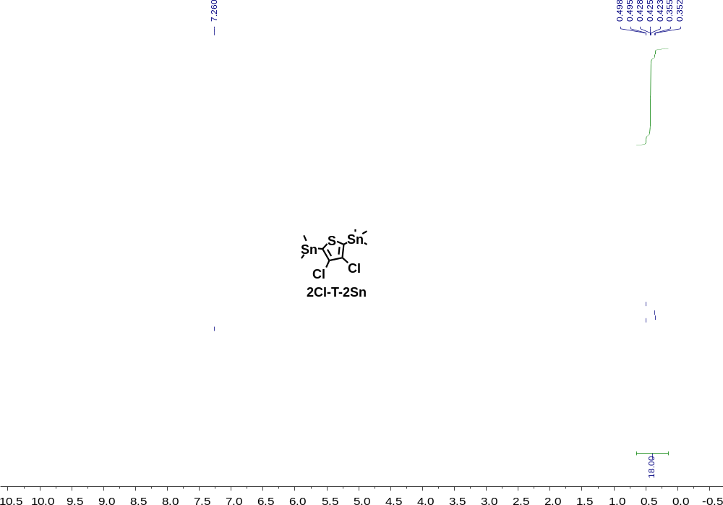
Fig. S46 ¹H NMR spectrum of 2Cl-T-2Sn. The spectrum is collected using CDCl₃ as the solvent at 298 K.
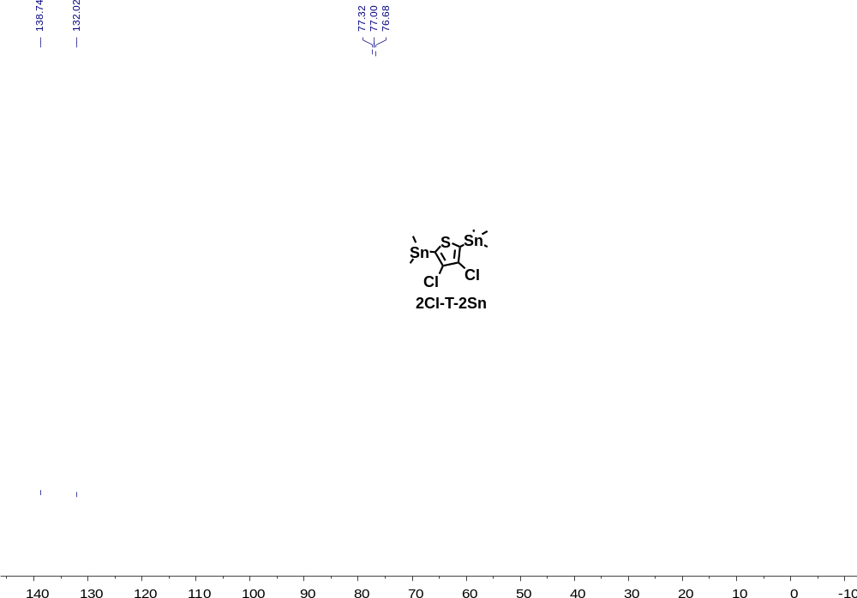
Fig. S47 ¹³C NMR spectrum of 2Cl-T-2Sn. The spectrum is collected using CDCl₃ as the solvent at 298 K.
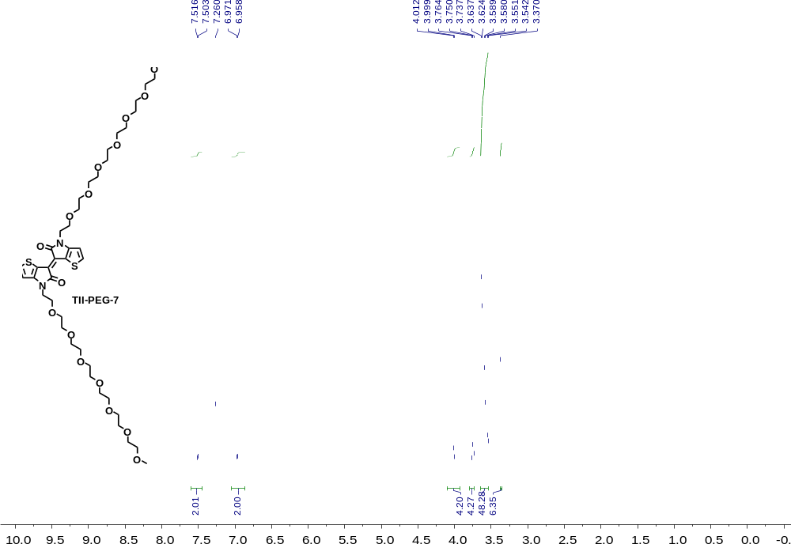
Fig. S48 ¹H NMR spectrum of TII-PEG-7. The spectrum is collected using CDCl₃ as the solvent at 298 K.
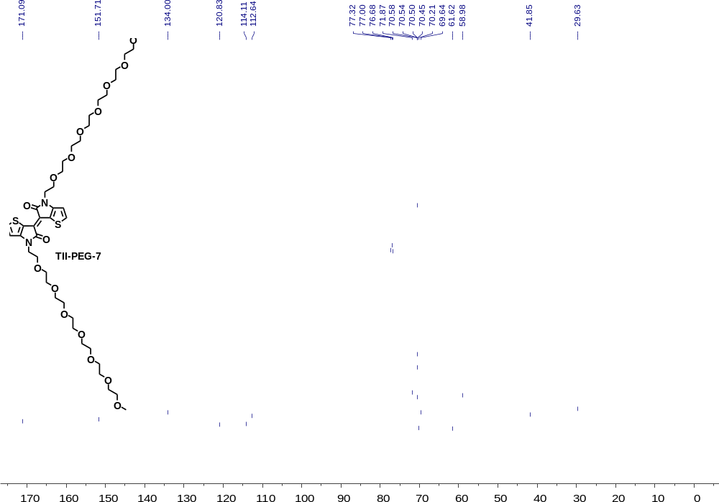
Fig. S49 ¹³C NMR spectrum of TII-PEG-7. The spectrum is collected using CDCl₃ as the solvent at 298 K.
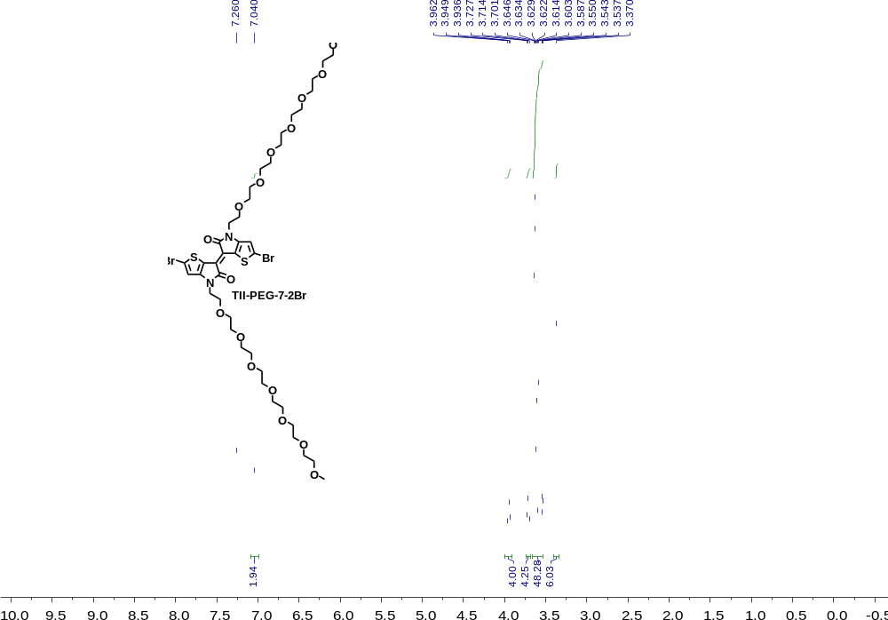
Fig. S50 ¹H NMR spectrum of TII-PEG-7-2Br. The spectrum is collected using CDCl₃ as the solvent at 298 K.
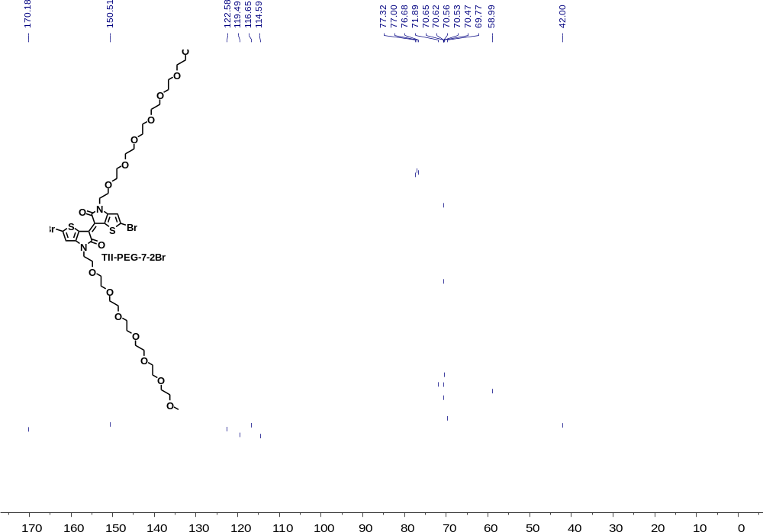
Fig. S51 ¹³C NMR spectrum of TII-PEG-7-2Br. The spectrum is collected using CDCl₃ as the solvent at 298 K.
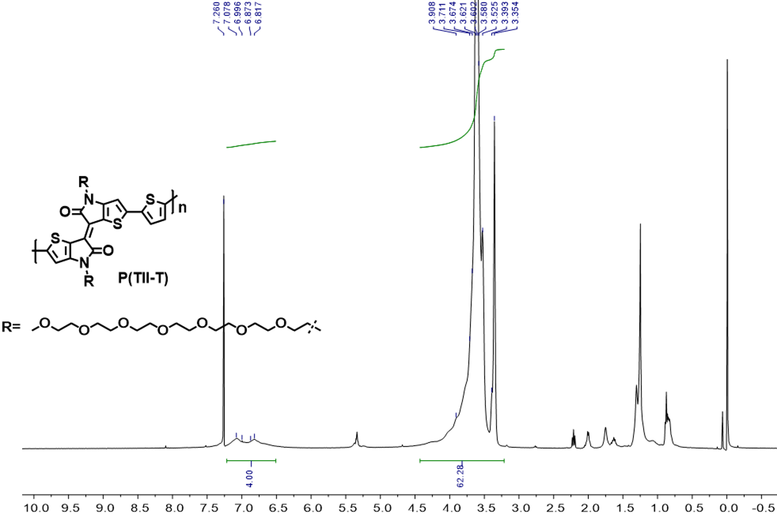
Fig. S52 ¹H NMR spectrum of polymer P(TII-T). The spectrum is collected using CDCl₃ as the solvent at 298 K.
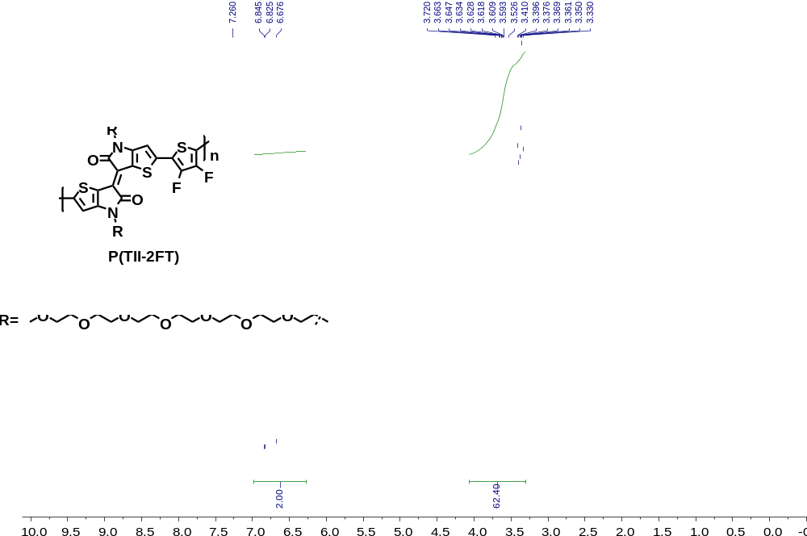
Fig. S53 ¹H NMR spectrum of polymer P(TII-2FT). The spectrum is collected using CDCl₃ as the solvent at 298 K.
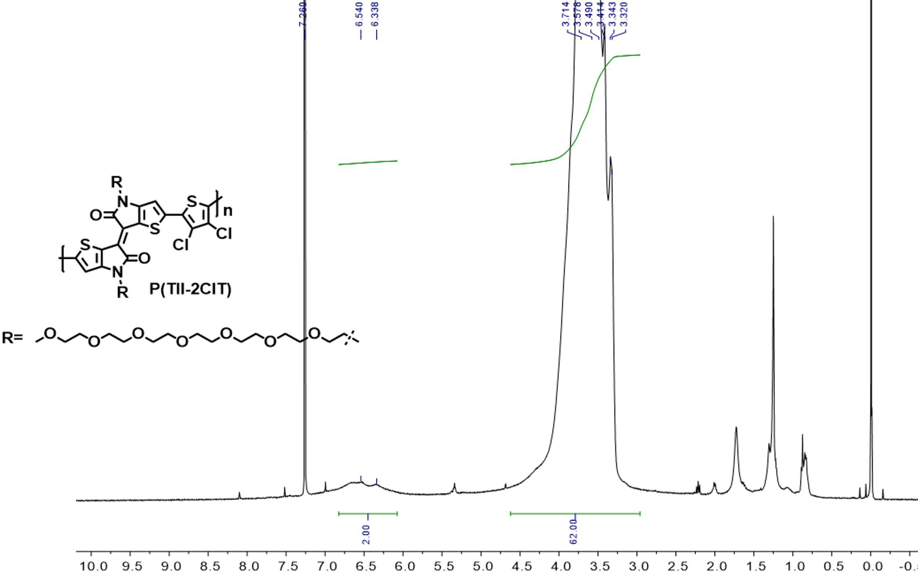
Fig. S54 ¹H NMR spectrum of polymer P(TII-2ClT). The spectrum is collected using CDCl₃ as the solvent at 298 K.
.
- Supplementary References
1 Frisch, M. et al. Gaussian 16 rev. C. 01, wallingford, ct. Wallingford, CT (2016).
2 Dennington, R., Keith, T. A. & Millam, J. M. Gaussview, version 6.0. 16. Semichem Inc Shawnee Mission KS (2016).
3 Lu, T. & Chen, F. Multiwfn: A multifunctional wavefunction analyzer. J. Comput. Chem. 33, 580-592 (2012).
4 Humphrey, W., Dalke, A. & Schulten, K. Vmd: Visual molecular dynamics. J Mol Graph 14, 33-38, 27-38 (1996).
5 Pan, Y. et al. An insight into the role of side chains in the microstructure and carrier mobility of high-performance conjugated polymers. Polym. Chem. 12, 2471-2480 (2021).
6 Wu, H.-Y. et al. Influence of molecular weight on the organic electrochemical transistor performance of ladder-type conjugated polymers. Adv. Mater. 34, 2106235 (2022).
7 Feng, K. et al. Fused bithiophene imide dimer‐based n‐type polymers for high‐performance organic electrochemical transistors. Angew. Chem. 133, 24400-24407 (2021).
8 Wang, Y. et al. Green synthesis of lactone-based conjugated polymers for n-type organic electrochemical transistors. Adv. Funct. Mater. 32, 2111439 (2022).
9 Li, P., Shi, J., Lei, Y., Huang, Z. & Lei, T. Switching p-type to high-performance n-type organic electrochemical transistors via doped state engineering. Nat. Commun. 13, 5970 (2022).
10 Feng, K. et al. Cyano-functionalized n-type polymer with high electron mobility for high-performance organic electrochemical transistors. Adv. Mater. 34, 2201340 (2022).
11 Wang, Y. et al. Acceptor functionalization via green chemistry enables high-performance n-type organic electrochemical transistors for biosensing, memory applications. Adv. Funct. Mater. https://doi.org/10.1002/adfm.202304103 (2023).
12 Yang, W. et al. High-performance n-type polymeric mixed ionic-electronic conductors: The impacts of halogen functionalization. Adv. Mater. https://doi.org/10.1002/adma.202305416 (2023).
13 Giovannitti, A. et al. N-type organic electrochemical transistors with stability in water. Nat. Commun. 7, 13066 (2016).
14 Samuel, J. J. et al. Single-component cmos-like logic using diketopyrrolopyrrole-based ambipolar organic electrochemical transistors. Adv. Funct. Mater. 31, 2102903 (2021).
15 Rashid, R. B. et al. Ambipolar inverters based on cofacial vertical organic electrochemical transistor pairs for biosignal amplification. Sci. Adv. 7, eabh1055 (2021).
16 Ohayon, D. et al. Influence of side chains on the n-type organic electrochemical transistor performance. ACS Appl. Mater. Interfaces 13, 4253-4266 (2021).
17 Stein, E. et al. Ambipolar blend-based organic electrochemical transistors and inverters. Nat. Commun. 13, 5548 (2022).
18 Wu, X. et al. All-polymer bulk-heterojunction organic electrochemical transistors with balanced ionic and electronic transport. Adv. Mater. 34, 2206118 (2022).
19 Jeong, S. Y. et al. Ion gel-gated quasi-solid-state vertical organic electrochemical transistor and inverter. Adv. Electron. Mater. 9, 2300053 (2023).
20 Hou, K. et al. High performance, flexible, and thermally stable all-solid-state organic electrochemical transistor based on thermoplastic polyurethane ion gel. ACS Appl. Electron. Mater. 5, 2215-2226 (2023).
21 Sun, H. et al. Complementary logic circuits based on high-performance n-type organic electrochemical transistors. Adv. Mater. 30, 1704916 (2018).
22 Zhang, Y. et al. High-performance organic electrochemical transistors and neuromorphic devices comprising naphthalenediimide-dialkoxybithiazole copolymers bearing glycol ether pendant groups. Adv. Funct. Mater. 32, 2201593 (2022).
23 Ma, S. et al. Sequential cyanation of polythiophenes: Tuning charge carrier polarity in organic electrochemical transistors. Adv. Electron. Mater. n/a, 2300207
24 Cho, K. G., Seol, K. H., Kim, M. S., Hong, K. & Lee, K. H. Tuning threshold voltage of electrolyte-gated transistors by binary ion doping. ACS Appl. Mater. Interfaces 14, 50004-50012 (2022).
25 Zabihipour, M. et al. Organic electrochemical transistors manufactured by laser ablation and screen printing. Flex. Print. Electron. 7, 035018 (2022).
26 Granelli, R. et al. High-performance bioelectronic circuits integrated on biodegradable and compostable substrates with fully printed mask-less organic electrochemical transistors. Small 18, 2108077 (2022).
27 Romele, P., Ghittorelli, M., Kovács-Vajna, Z. M. & Torricelli, F. Ion buffering and interface charge enable high performance electronics with organic electrochemical transistors. Nat. Commun. 10, 3044 (2019).

