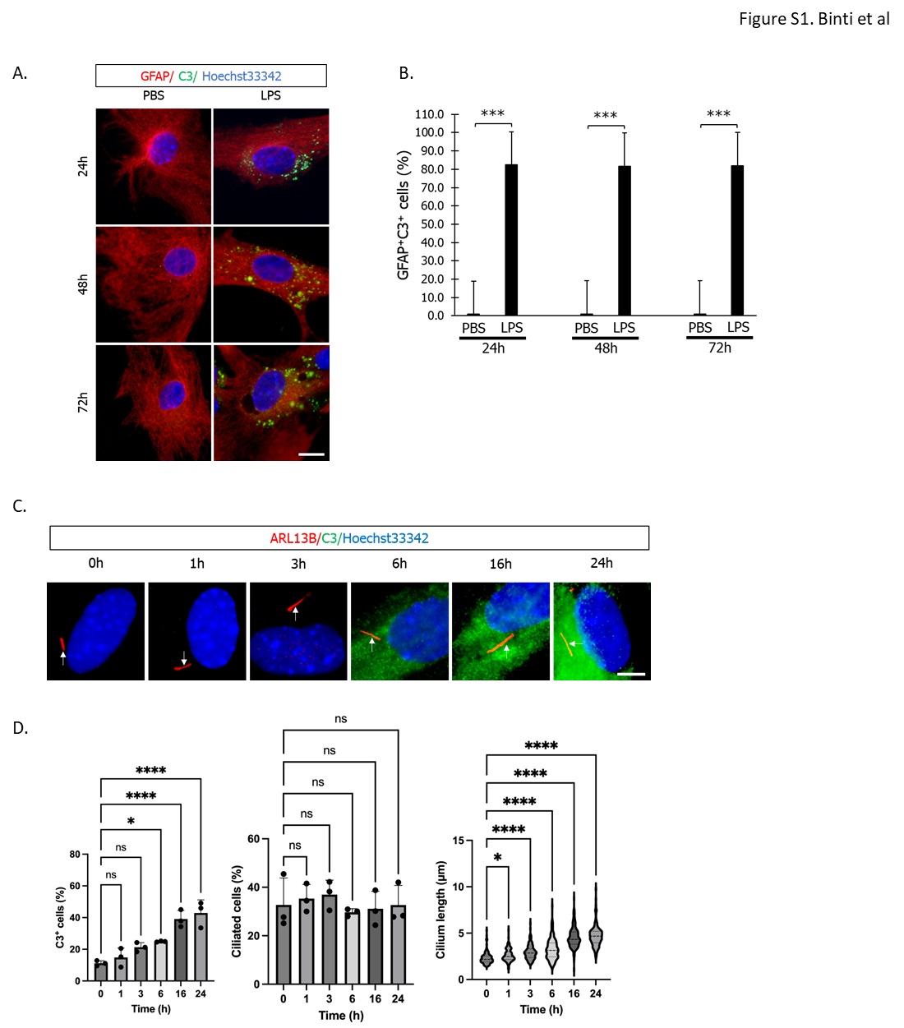

Figure S1. C3-positive reactive astrocyte differentiation elongates primary cilium length.
(A) Representative immunostaining image of C3 (green) and GFAP (astrocyte marker, red). Mixed cortical glial cells were treated with 100 ng/ml LPS for 24 h, 48 h, and 72 h. Scale bar; 20 μm. (B) Astrocytic primary cilium length shown in Figure S1A. Three independent experiments were performed. ***, P <0.001 (Mann‒Whitney U test). (C) Temporally-dependent C3 expression levels and cilium length were increased astrocyte cultures treated with 3 ng/mL IL-1⍺, 30 ng/ml TNF-⍺, and 400 ng/ml C1q. Representative images of Arl13B (red), C3 (green) and nuclei (Hoechst 33342, blue) are shown. Three independent experiments were performed. Scale bar; 5 μm. (D) The percentage of C3-positive cells (left) and ciliated cells (middle) and cilium length (right) shown in Figure S1C. Three independent experiments were performed. *, P <0.05, ****, P <0.0001, ns, nonsignificant. (Tukey’s multiple comparison).

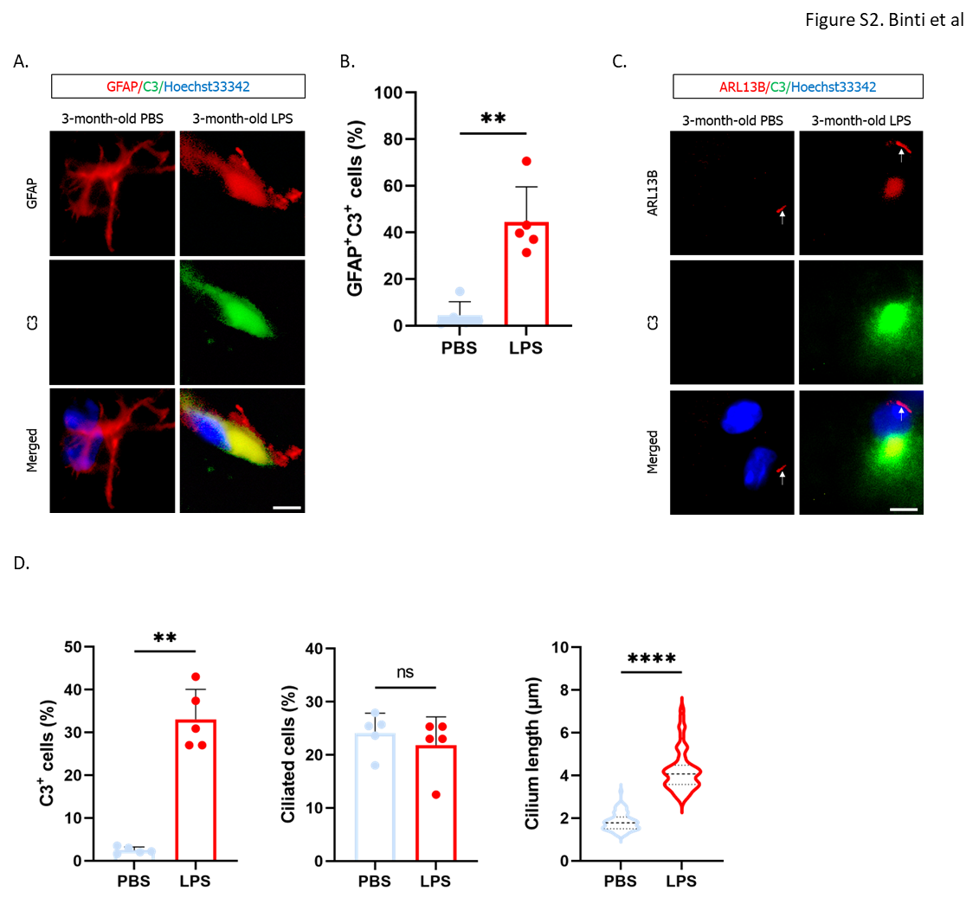

Figure S2. LPS injection into mice elongates the astrocytic primary cilium and induces cognitive decline.
(A) Representative images of GFAP (red), C3 (green), and nuclei (blue) in the mouse brain. Mice were i.p. injected with 1 mg/kg LPS twice a week for 6 weeks. PBS-treated mice; n=5. LPS-treated mice; n=5. Scale bar: 5 µm. (B) Percentage of GFAP-positive, C3-positive cells shown in Figure S2A. **, P <0.01 (Mann‒Whitney U test). (C) Representative images of Arl13B (red), C3 (green), and nuclei (blue) in the mouse brain. PBS-treated mice; n=5. LPS-treated mice; n=5. Scale bar: 5 µm. (D) Percentage of C3-positive cells (left), percentage of ciliated cells (middle), and cilium length (right) shown in Figure S2C. **, P <0.01, ****, P <0.0001, ns, nonsignificant. (Mann‒Whitney U test).

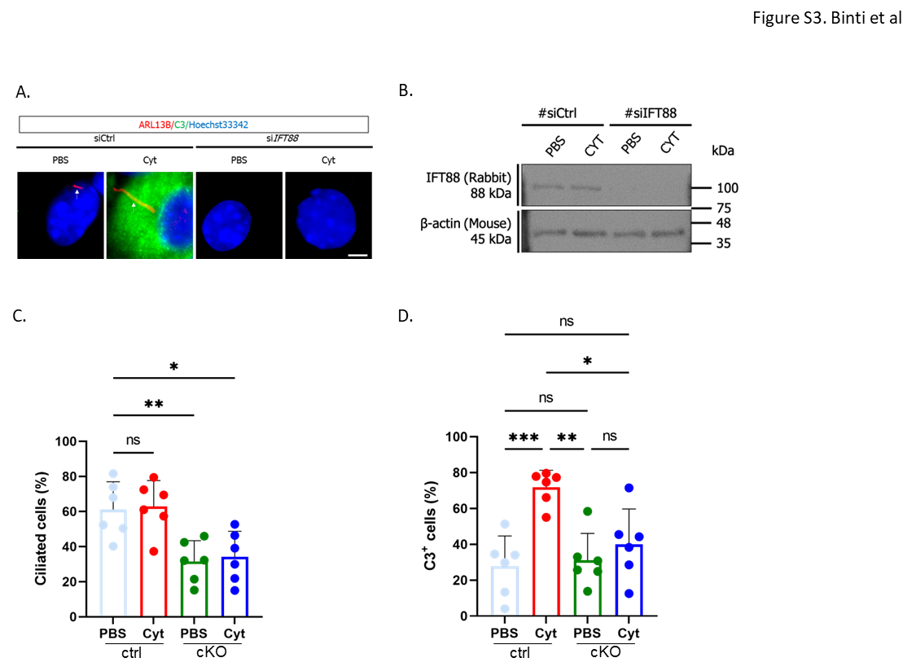

Figure S3. The transient downregulation of IFT88 expression in astrocytes reduces the expression levels of C3.
(A) Representative image of Arl13B (red) and C3 (green) in primary enriched astrocytes transfected with siRNA targeting IFT88 (siIFT88). Nontarget siRNA was used as a control (siCtrl). Two days after transfection, cells were stimulated with 3 ng/mL IL-1α, 30 ng/ml TNFα, and 400 ng/ml C1q (Cyt) for 24 h. PBS was used as a negative control. Scale bar; 2 µm. n=6 independent experiments. (B) Representative image of IFT88 expression detected by western blotting. n=6 independent experiments. (C) Percentage of Arl13-positive primary ciliated cells shown in Figure S3A. *, P <0.05, **, P <0.01, ns, nonsignificant. (Tukey’s multiple comparison). (D) Percentage of C3-positive cells shown in Figure S3A. *, P <0.05, **, P <0.01, ***, P <0.001, ns, nonsignificant. (Tukey’s multiple comparison).

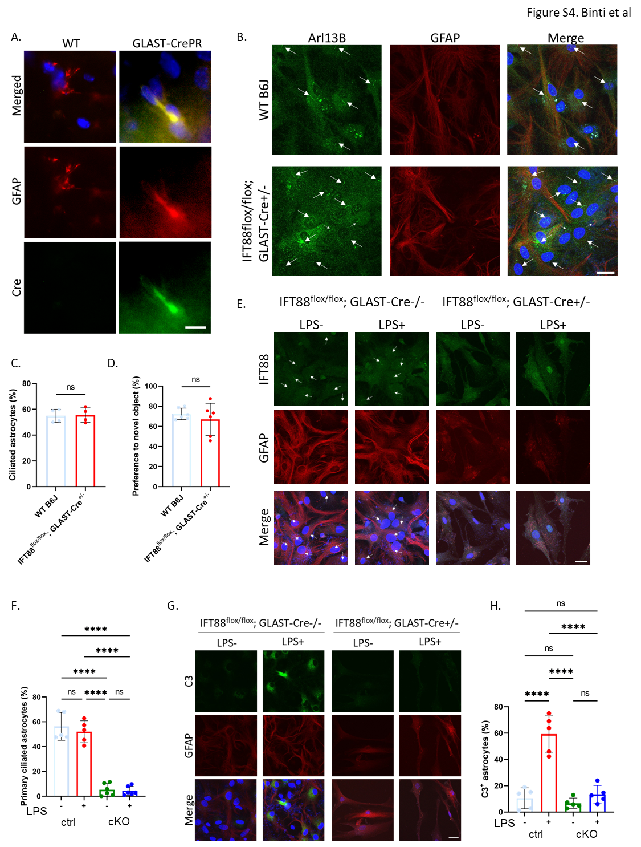

Figure S4. Astrocyte-specific IFT88 gene knockout downregulates C3 expression induced by LPS stimulation.
(A) Representative image of Cre recombinase expression in the mouse brain. Mouse brains were immunostained with GFAP (red), Cre (green), and Hoechst 33342 (blue). WT; C57BL/6J mice, n=3. GLAST-CrePR; GLAST-CrePR^{+/-} mice, n=3. Scale bar: 10 µm. (B) Representative image of Arl13B (green), GFAP (red), and Hoechst 33342 (blue) in primary astrocytes. Glial mixture cultures were prepared from C57BL/6J (WT B6J) or IFT88^{flox/flox}; GLAST-CrePR^{+/-} P7 pups. The arrow indicates the primary cilium. Scale bar; 20 µm. (C) The percentage of ciliated GFAP-positive astrocytes shown Figure S4B shows in the graph. ns, nonsignificant. (Mann‒Whitney U test). n=4 independent experiments. (D) Results of behavioural (object recognition) studies in 3-month-old C57BL/6J (WT, n=6) and IFT88^{flox/flox}; GLAST-CrePR^{+/-} mice (n=6). ns, nonsignificant. (Mann‒Whitney U test). (E) Representative image of IFT88 (green), GFAP (red) and Hoechst 33342 (blue) in glial mixture culture. Glial mixture cultures were prepared from P7 pups and stimulated with 10 nM RU486 for 48 h. After stimulation with RU486, cells were stimulated with 100 ng/ml LPS for 24 h. The arrow indicates the primary cilium. Scale bar; 20 µm. IFT88^{flox/flox}; GLAST-CrePR^{-/-} (ctrl) pups (n=5), IFT88^{flox/flox}; GLAST-CrePR^{+/-} (cKO) pups (n=6). (F) The percentage of ciliated GFAP-positive astrocytes shown Figure S4E shows in the graph. ****, P <0.0001, ns, nonsignificant (Tukey’s multiple comparison). (G) Representative image of C3 (green), GFAP (red) and Hoechst 33342 (blue) in glial mixture culture. Glial mixture cultures were prepared from P7 pups and stimulated with 10 nM RU486 for 48 h. After stimulation with RU486, cells were stimulated with 100 ng/ml LPS for 24 h. Scale bar; 20 µm. IFT88^{flox/flox}; GLAST-CrePR^{-/-} (ctrl) pups (n=5), IFT88^{flox/flox}; GLAST-CrePR^{+/-} (cKO) pups (n=5). (H) The percentage of C3-positive astrocytes shown Figure S4G shows in the graph. ****, P <0.0001, ns, nonsignificant (Tukey’s multiple comparison).

