Appendix
Table A1: Countries in Sample
Argentina | Korea
Australia | Morocco
Brazil | Mexico
Canada | Malaysia
Chile | New Zealand
China | Pakistan
Colombia | Peru
Costa Rica | Philippines
Dominican Republic | Portugal
Ecuador | Russia
Egypt | Thailand
European Union | Trinidad and Tobago
Indonesia | Turkey
India | Ukraine
Israel | Uruguay
Jamaica | United States
Japan | Venezuela
Kazakhstan | Vietnam
 | South Africa

Table A2: Retaliatory Motives in Antidumping and SPS (Excluding TBT)
 | (1) | (2)
VARIABLES | SPS | AD
Ongoing SPS | 0.0345*** | 0.00214***
 | (0.00382) | (0.000789)
Ongoing SPS, Other Sector | 0.00435*** | -5.20e-05
 | (0.000746) | (0.000154)
AD | -0.00402 | 0.00611***
 | (0.00326) | (0.000673)
AD, Other Sector | -0.000427 | -0.000116
 | (0.000557) | (0.000115)
ln(GDP, retaliator) | 0.000707 | 0.00119***
 | (0.000614) | (0.000127)
ln(GDP, initiator) | -0.000107 | 0.000414***
 | (0.000609) | (0.000126)
ln(Retaliator's Sectoral Imports from Initiator) | 0.000363*** | 6.28e-06
 | (4.17e-05) | (8.60e-06)
ln(Initiator's Sectoral Imports from Retaliator) | 0.000183*** | 5.80e-05***
 | (3.93e-05) | (8.12e-06)
Constant | 0.0363 | -0.0411***
 | (0.0232) | (0.00479)
Observations | 2,322,970 | 2,322,970
R-squared | 0.390 | 0.169
Table Notes: Parameter estimates from a linear probability model. Clustered standard errors in parentheses. ***, **, * indicate p<0.01, p<0.05, p<0.1 respectively.

Table A3: Likelihood Ratio Tests for Post-2016 Change Models
Model |  | Observations | LL (null) | LL (model) | DF | AIC | BIC
SPS
 | Constrained | 2,322,970 | 671503.2 | 671627.7 | 10 | -1343235 | -1343109
 | Unconstrained | 2,322,970 | 671503.2 | 671688.8 | 16 | -1343346 | -1343143
 |  |  |  |  |  | LR Chi2(6) | 122.14
 |  |  |  |  |  | p-value | (0.00)
TBT
 | Constrained | 2,322,970 | 629777.2 | 630528.3 | 10 | -1261037 | -1260910
 | Unconstrained | 2,322,970 | 629777.2 | 630621.9 | 16 | -1261212 | -1261009
 |  |  |  |  |  | LR Chi2(6) | 187.18
 |  |  |  |  |  | p-value | (0.00)
AD
 | Constrained | 2,322,970 | 4336760 | 4336903 | 10 | -8673787 | -8673660
 | Unconstrained | 2,322,970 | 4336760 | 4336966 | 16 | -8673901 | -8673698
 |  |  |  |  |  | LR Chi2(6) | 187.18
 |  |  |  |  |  | p-value | (0.00)

Figure A1: Pre- and Post-2016 Retaliatory Motives
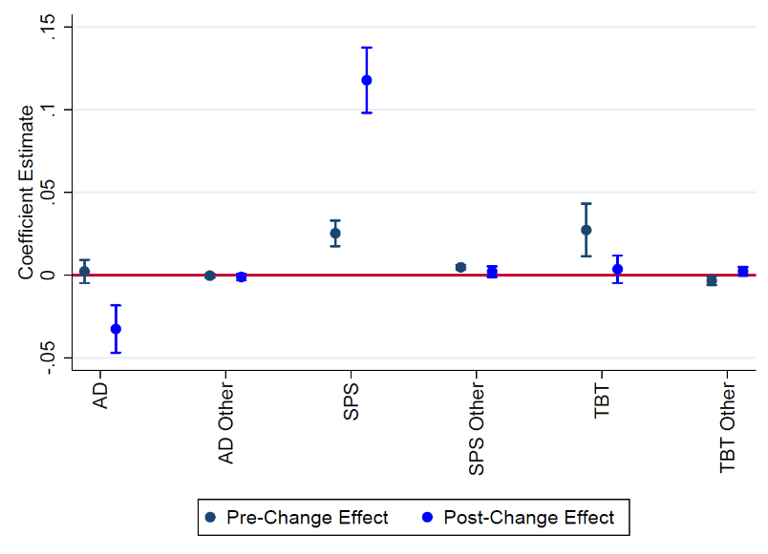
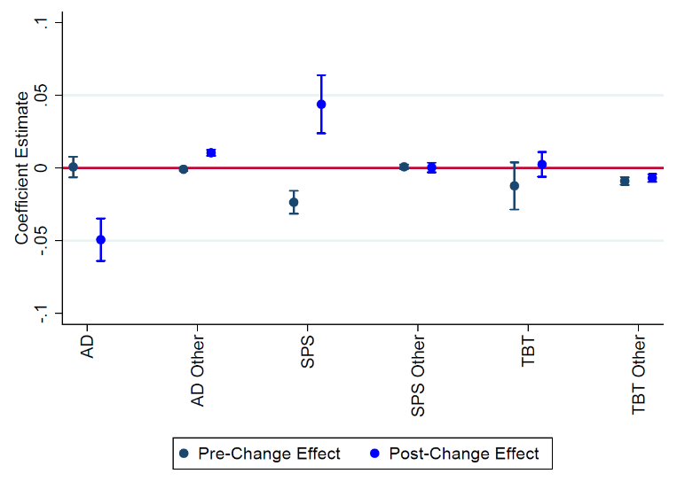

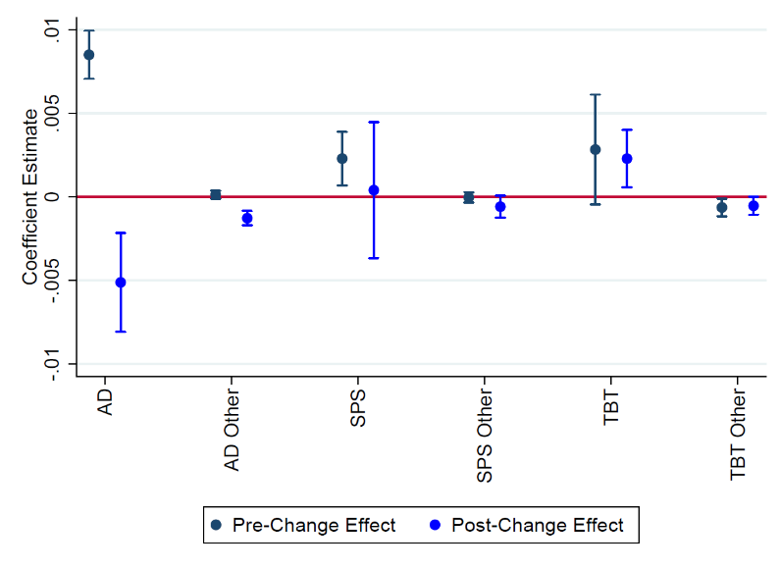
- SPS Model (b) TBT Model

(c) AD Model

