Supplementary materials: Sexual hormone-binding globulin may explain sex differences for glucose homeostasis and incidence of type 2 diabetes: The KORA study

Methods- Supplementary information 1
We excluded participants who withdrew consent (n=3), non-fasting participants and participants with missing information on fasting status (n=21), participants with 2 diabetes (n=217) and type 1 (n=7), participants with unclear diabetes diagnosis (n=75), participants newly diagnosed with diabetes by oral glucose tolerance test (OGTT) (n= 115), participants diagnosed with medication induced diabetes (n=1), participants with missing information on diabetic medications (n=2), participants taking external hormone therapy (including estrogen and/or progestin, anti-estrogens) (n= 240), participants with surgeries (including hysterectomy, oophorectomy) (n= 232), participants with missing information on surgeries (n=1), and participants with missing information on SHBG, sex hormones and glucose- and insulin-related traits (fasting glucose levels, insulin levels, 2-h glucose levels, homeostatic model assessment for insulin resistance HOMA-IR) (n= 229).

Methods- Supplementary information 2

Sexual hormone binding globulin, glucose homeostasis and T2D assessments
SHBG was measured in serum that was stored at -80 °C, until being assayed. Measurements of SHBG in serum were performed using the ARCHITECT SHBG assay, a chemiluminescent microparticle immunoassay (CMIA) for absolute quantification of SHBG (Abbott Diagnostics) (measuring range SHBG: 0-250 nmol/L, with intra-assay coefficient of variation: 4.29 % and inter-assay coefficient of variation range: 6.39-10.3%). Known T2D was self-reported, validated by a physician or medical record review, or self-reported current use of glucose-lowering medication. Participants without known T2D were given a standard 75g OGTT. Among those receiving an OGTT, newly diagnosed diabetes was defined according to the 1999 World Health Organization diagnostic criteria (i.e. fasting glucose > 6.9 mmol/L and/or 2h glucose > 11.0 mmol/L) (1). Incident diabetes at follow-up was a combination of diabetes clinically diagnosed during the follow-up period plus those who had newly diagnosed diabetes based on OGTT data at FF4 among those who did not have diabetes at baseline. Fasting glucose was measured in fresh serum using hexokinase-G6PD (GLUFlex; Dade Behring, USA). Fasting insulin was measured in thawed serum by an elctrochemiluminescence immunoassay (Cobas e602 Immunoassay Analyser; Roche Diagnostics GmbH, Germany).
Assessment of covariates
Information on age, sex, medication use (antihypertensive mediations and lipid-lowering medications (yes/ no)), hypertension (yes/no), smoking status (regular smoker, irregular smoker, ex-smoker, never-smoker), alcohol consumption (g/day), physical activity (inactive/ active) was collected by trained medical staff using a standardized interview (2). Body mass index (BMI) was calculated as weight (kg) divided by height squared (m²). Waist circumference (cm) was measured at the level midway between the lower rib margin and the iliac crest while the participants breathed out gently. High C reactive protein (CRP) was quantified in plasma using a high-sensitivity latex-enhanced nephelometric assay (BN II Analyzer, Dade Behring). Thyroid-stimulating Hormone (TSH) was measured using electrochemiluminescent methods (Dimension Vista Systems; Siemens, Germany). Total cholesterol (TC) was measured in fresh serum by enzymatic methods (CHOL Flex).
Methods- Statistical analyses- Supplementary information 3
We performed several sensitivity analyses to investigate the robustness of our results. 1) We defined a third model with additional adjustments for waist circumference, systolic blood pressure (SBP), TC, CRP, TSH, antihypertensive mediations and lipid lowering mediations. We did not consider model 3 as one of our main models since the covariates in this model are more likely to play an intermediate role in the pathways of investigated associations rather than being confounders. 2) To investigate the effect of age, we divided the participants into two groups based on the median age of 53 and repeated the analyses. 3) To account for the effect of weight, we repeated the mediation analysis for subset of individuals with normal weight (BMI < 25) and with overweight and obesity (BMI ≥ 25). 4) To investigate the independent role of SHBG from testosterone, we added testosterone to the main models and repeated the mediation analysis. This sensitivity analysis was run only for fasting glucose levels as an outcome, and we were not able to rerun the analyses for incidence of T2D as the incidence of T2D in the subsamples was limited.
Results-sensitivity analysis- Supplementary information 4

We additionally adjusted the association between sex (women vs men) and SHBG and between sex and glucose- and insulin-related traits for other cardiovascular risk factors as model 3. Similar to previous models, women had lower fasting glucose levels and higher SHBG levels than men (Supplementary Table 4). We also found an inverse association between SHBG and fasting glucose levels in this model (Supplementary Table 5). No association was observed between sex (women vs men) and SHBG with incidence of T2D in the third model (Supplementary Table 6). Also, we observed the mediatory role of SHBG on glucose levels while adjusting for further cardiovascular risk factors as well (PM 30%, CI: 22-39%, Supplementary Table 7).
We also performed another sensitivity analysis by adding testosterone to model 1 and 2 (Supplementary Table 8). PM of SHBG for fasting glucose levels was estimated up to 52% in model 1 and 53% in model 2. Also, PM of SHBG for T2D was up to 36% in model 1 and 31% in model 2.
Moreover, we observed the potential mediatory role of SHBG on the sex differences in fasting glucose levels in both age categories based on median of age (Supplementary Table 9). For individuals younger than 53 years old, the PM was 29% (CI:17-40%) in model 1 and the PM 30% (CI:19-43%) in model 2, whereas for those aged 53 and older, the PM was lower (PM 22%, CI:12-36% in model 1 and PM 19%, CI:10-34% in model 2).
Additionally, findings of mediation analysis of SHBG on the association between sex (women vs men) and fasting glucose levels in different categories of BMI showed a PM of 28% (CI:12-49%) in model 1 and PM 29% (CI:12-55%) in model 2 in normal weight individuals while the PM by SHBG for fasting glucose levels were 17% (CI:09-28%) in model 1 and 18% (CI:10-31%) in model 2 in overweight and obese individuals (Supplementary Table 10).

Supplementary Table 1. Association of sex (women vs men [Reference]) with SHBG and glucose- and insulin-related traits among participants of KORA F4.
Variable | ß (95 % CI) Model 1 |  | ß (95 % CI) Model 2
SHBG (nmol/l) | 0.47 (0.43, 0.52) |  | 0.47 (0.42, 0.51)
Glucose- and insulin-related traits
Fasting glucose levels (mg/dl) | -5.24 (-6.01, -4.47) |  | -4.94 (-5.77, -4.11)
Fasting insulin levels (µU/ml) | -0.10 (-0.15, -0.06) |  | -0.13 (-0.18, -0.08)
2h-glucose levels (mg/dl) | -2.13 (-4.66, 0.39) |  | -2.50 (-5.21, 0.19)
HOMA-IR | -0.16 (-0.21, -0.11) |  | -0.18 (-0.23, -0.13)
Model 1: Age.
Model 2: Model 1 + smoking + alcohol consumption + physical activity.
Fasting insulin levels, SHBG and HOMA-IR are log-transformed.
Abbreviations: SHBG, sex hormone-binding globulin; HOMA-IR, homeostatic model assessment for insulin resistance.

Supplementary Table 2. Association of SHBG with glucose- and insulin-related traits among participants of KORA F4.
Variable | ß (95 % CI) model 1 | ß (95 % CI) model 2
Fasting glucose levels (mg/dl) | -3.25 (-4.08, -2.42) | -3.22 (-4.05, -2.38)
Fasting insulin levels (µU/ml) | -0.36 (-0.40, -0.31) | -0.35 (-0.40, -0.31)
2h-glucose levels (mg/dl) | -11.39 (-14.09, -8.69) | -11.04 (-13.75, -8.33)
HOMA-IR | -0.39 (-0.44, -0.34) | -0.39 (-0.44, -0.34)
Model 1: Age.
Model 2: Model 1+ smoking+ alcohol consumption+ physical activity.
Fasting insulin levels, and HOMA-IR are log-transformed.
Abbreviations: SHBG, sex hormone-binding globulin; HOMA-IR, homeostatic model assessment for insulin resistance.

Supplementary Table 3. Association of sex (women vs men [Reference]) and SHBG with
incidence of T2D between KORA F4 and FF4.
Variable | OR (95% CI) model 1 | OR (95% CI) model 2
Sex (women vs men [Reference]) | 0.67 (0.42, 1.05) | 0.56 (0.34, 0.92)
SHBG (nmol/l) | 0.38 (0.23, 0.62) | 0.37 (0.22, 0.60)
Model 1: Age.
Model 2: Model 1+ smoking+ alcohol consumption+ physical activity.
Abbreviations: OR, odds ratio; T2D; type 2 diabetes; SHBG, sex hormone-binding globulin.

Supplementary Table 4. Association of sex (women vs men [Reference])
with SHBG and glucose- and insulin-related traits among participants of KORA F4 (model 3).
Variable | ß (95 % CI) model 3
SHBG (nmol/l) | 0.31 (0.27, 0.36)
Glucose- and insulin-related traits
Fasting glucose levels (mg/dl) | -1.68 (-2.62, -0.73)
Fasting insulin levels (µU/ml) | 0.14 (0.10, 0.19)
2h-glucose levels (mg/dl) | 7.05 (3.94, 10.15)
HOMA-IR | 0.12 (0.07, 0.17)

Model 3: Model 2 + waist circumference + SBP + antihypertensive
medications + lipid lowering medications + total cholesterol + CRP + TSH.
Fasting insulin and HOMA-IR are log-transformed.
Abbreviations: SHBG, sex hormone-binding globulin; HOMA-IR,
homeostatic model assessment for insulin resistance.

Supplementary Table 5. Association of SHBG with
glucose- and insulin-related traits among participants of KORA F4 (model 3).

Variable | ß (95 % CI) model 3
Fasting glucose levels (mg/dl) | -1.46 (-2.34, -0.59)
Fasting insulin levels (µU/ml) | -0.14 (-1.91, -0.10)
2h-glucose levels (mg/dl) | -5.98 (-8.85, -3.12)
HOMA-IR | -0.16 (-0.21, -0.11)

Model 3: Model 2+ waist circumference + SBP + antihypertensive
Medications + lipid lowering medications + total cholesterol + CRP + TSH.
SHBG, fasting insulin levels, and HOMA-IR are log-transformed.
Abbreviations: SHBG, sex hormone-binding globulin; HOMA-IR,
homeostatic model assessment for insulin resistance.

Supplementary Table 6. Association of sex (women vs men [Reference])
and SHBG with incidence of T2D between KORA F4 and FF4. (model 3).

Variable | OR (95% CI) model 3
Sex (women vs men [Reference]) | 0.92 (0.51, 1.63)
SHBG (nmol/l) | 0.61 (0.35, 1.04)
Model 3: Model 2+waist circumference+ SBP+ antihypertensive
medications+ lipid lowering medications+ total cholesterol + CRP+ TSH.
Abbreviations: OR, odds ratio; T2D; type 2 diabetes; SHBG, sex hormone-binding globulin;
SBP, systolic blood pressure; TSH, thyroid stimulating hormone.

Supplementary Table 7. Mediation analysis of SHBG on
the association between (women vs men [Reference]) and
glucose- and insulin-related traits (model 3).
Effects | ß (95% CI) model 3 | p-value
Fasting glucose levels
DE | -3.68 (-4.53, -2.86) | <0.001
IE | -1.56 (-1.99, -1.18) | <0.001
TE | -5.24 (-6.02, -4.52) | <0.001
PM | 0.30 (0.22-0.39) | <0.001
Fasting insulin levels
DE | 0.06 (0.01, 0.12) | 0.01
IE | -0.17 (-0.20, -0.14) | <0.001
TE | -0.10 (-0.15, -0.06) | <0.001
PM | 1.6 (1.12, 2.98) | <0.001
2h-glucose levels
DE | 3.33 (0.50, 6.34) | 0.05
IE | -5.47 (-6.71, -4.18) | <0.001
TE | -2.13 (-4.36, 0.59) | 0.08
PM | 2.56 (-4.66, 29.69) | 0.08
HOMA-IR
DE | 0.02 (-0.02, 0.07) | 0.35
IE | -0.18 (-0.22, -0.16) | <0.001
TE | -0.16 (-0.21, -0.11) | <0.001
PM | 1.16 (0.86-1.59) | <0.001

Model 3: Model 2+ waist circumference + SBP + antihypertensive
medications + lipid lowering medications + total cholesterol + CRP + TSH.
Abbreviations:DE, direct effect; IE, indirect effect; TE, total effect; PM, proportion mediated.

Supplementary Table 8. Mediation analysis of SHBG on the association between (women vs men [Reference]) and fasting glucose levels and T2D with adding testosterone in the main models.

Mediation analysis of SHBG and fasting glucose levels
Effects | ß (95% CI) model 1 | p-value | ß (95% CI) model 2 | p-value
DE | -2.85 ( -5.42, -0.48) | 0.02 | -2.60 (-4.88, -0.45) | 0.03
IE | -3.1 (-4.26, -2.15) | <0.001 | -3.00 (-4.20, -2.12) | <0.001
TE | -5.96 (-8.47, -3.79) | <0.001 | -5.6 (-7.9, -3.78) | <0.001
PM | 0.52 (0.32, 0.88) | <0.001 | 0.53 (0.32, 0.89) | <0.001
Mediation analysis of SHBG and T2D
Effects | OR (95% CI) model 1 | p-value | OR (95% CI) model 2 | p-value
DE | 0.49 (0.18, 1.2) | 0.15 | 0.43 (0.16, 0.99) | 0.04
IE | 0.45 (0.28, 0.65) | <0.001 | 0.43 (0.27, 0.68) | <0.001
TE | 0.22 (0.08, 0.51) | 0.01 | 0.19 (0.08, 0.48) | 0.01
PM | 0.36 (0.10, 1.17) | 0.01 | 0.31 (0.08, 0.84) | 0.01
Model 1: Age + testosterone.
Model 2: Model 1+ smoking + alcohol consumption + physical activity + testosterone.
Abbreviations: OR, odds ratio; SHBG, sex hormone-binding globulin; T2D, type 2 diabetes; DE, direct effect; IE, indirect effect; TE, total effect; PM, proportion mediated.

Supplementary Table 9. Mediation analysis of SHBG on the association between (women vs men [Reference]) and fasting glucose levels stratified by median age (53 years).
Mediation analysis for individuals < 53 years
Effects | ß (95% CI) model 1 | p-value | ß (95% CI) model 2 | p-value
DE | -4.44 (-5.46, -3.30) | <0.001 | -4.18 (-5.33, -2.99) | <0.001
IE | -1.82 (2.40, -1.13) | <0.001 | -1.79 (-2.52, -1.10) | <0.001
TE | -6.27 (-7.06, -5.25) | <0.001 | -5.97 (-6.90, -5.01) | <0.001
PM | 0.29 (0.17-0.40) | <0.001 | 0.30 (0.19-0.43) | <0.001
Mediation analysis for individuals >= 53 years
Effects | ß (95% CI) model 1 | p-value | ß (95% CI) model 2 | p-value
DE | -3.28 (-4.45, -1.99) | <0.001 | -3.33 (-4.71, -2.21) | <0.001
IE | -0.93 (-1.31, -0.51) | <0.001 | -0.82 (-1.28, -0.43) | <0.001
TE | -4.22 (-5.40, -3.03) | <0.001 | -4.16 (-5.47, -3.07) | <0.001
PM | 0.22 (0.12-0.36) | <0.001 | 0.19 (0.10-0.34) | <0.001
Model 1: Age.
Model 2: Model 1+ smoking + alcohol consumption + physical activity.
Abbreviations: SHBG, sex hormone-binding globulin; DE, direct effect; IE, indirect effect; TE, total effect; PM, proportion mediated.

Supplementary Table 10. Mediation analysis of SHBG on the association between (women vs men [Reference]) and fasting glucose levels stratified by BMI.
Mediation analysis for individuals with normal body weight (BMI < 25 kg/m²)
Effects | ß (95% CI) model 1 | p-value | ß (95% CI) model 2 | p-value
DE | -3.28 (-4.72, -1.94) | <0.001 | -3.13 (-4.61, -1.55) | <0.001
IE | -1.33 (-2.06, -0.62) | <0.001 | -1.30 (-2.14, -0.50) | <0.001
TE | -4.61 (-5.73, -3.54) | <0.001 | -4.43 (-5.75, -3.28) | <0.001
PM | 0.28 (0.12, 0.49) | <0.001 | 0.29 (0.12, 0.55) | <0.001
Mediation analysis for overweight and obese individuals (BMI >= 25 kg/m²)
Effects | ß (95% CI) model 1 | p-value | ß (95% CI) model 2 | p-value
DE | -3.85 (-4.65, -2.81) | <0.001 | -3.48 (-4.51, -2.40) | <0.001
IE | -0.82 (-1.30, -0.43) | <0.001 | -0.81 (-1.17, -0.44) | <0.001
TE | -4.68 (-5.51, -3.60) | <0.001 | -4.29 (-5.27, -3.22) | <0.001
PM | 0.17 (0.09, 0.28) | <0.001 | 0.18 (0.10, 0.31) | <0.001
Model 1: adjusted for age.
Model 2: Model 1+ smoking + alcohol consumption + physical activity.
Abbreviations: SHBG, sex hormone-binding globulin; DE, direct effect; IE, indirect effect; TE, total effect; PM, proportion mediated.

Supplementary Table 11. Mediation analysis of SHBG on the association between (women vs men [Reference]) and incidence of T2D (model 3).
Effects | OR (95% CI) model 3 | P value
NDE | 1.02 (0.59, 1.60) | 0.91
NIE | 0.87 (0.73, 1.05) | 0.15
TE | 0.89 (0.51, 1.50) | 0.69
PM | 1.27 (-8.4, 10.9) | 0.73

Model 3: Model 2 + waist circumference + SBP + antihypertensive
medications + lipid lowering medications + total cholesterol + CRP + TSH.
Abbreviations: OR, odds ratio; T2D, type 2 diabetes; SHBG, sex hormone-binding globulin;
DE, direct effect; IE, indirect effect; TE, total effect; PM, proportion mediated.

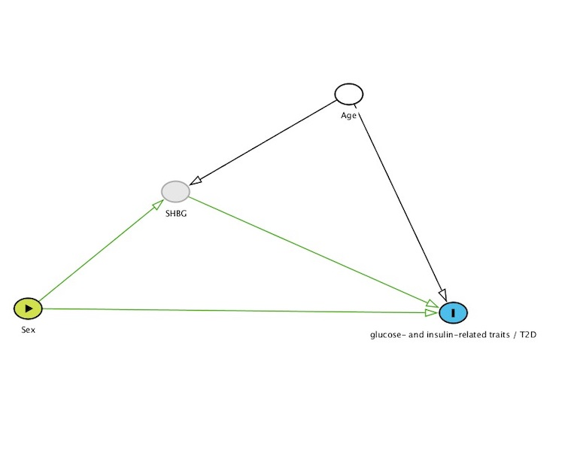

Supplementary Figure 1. Directed acyclic graph (DAG) for the association of sex through, sex hormone binding globulin (SHBG), on glucose- and insulin-related traits / type 2 diabetes (T2D). Study DAG for model 1, exposure = Sex, mediator = SHBG, outcome = glucose- and insulin-related traits / T2D. for model 1, adjustment = age.

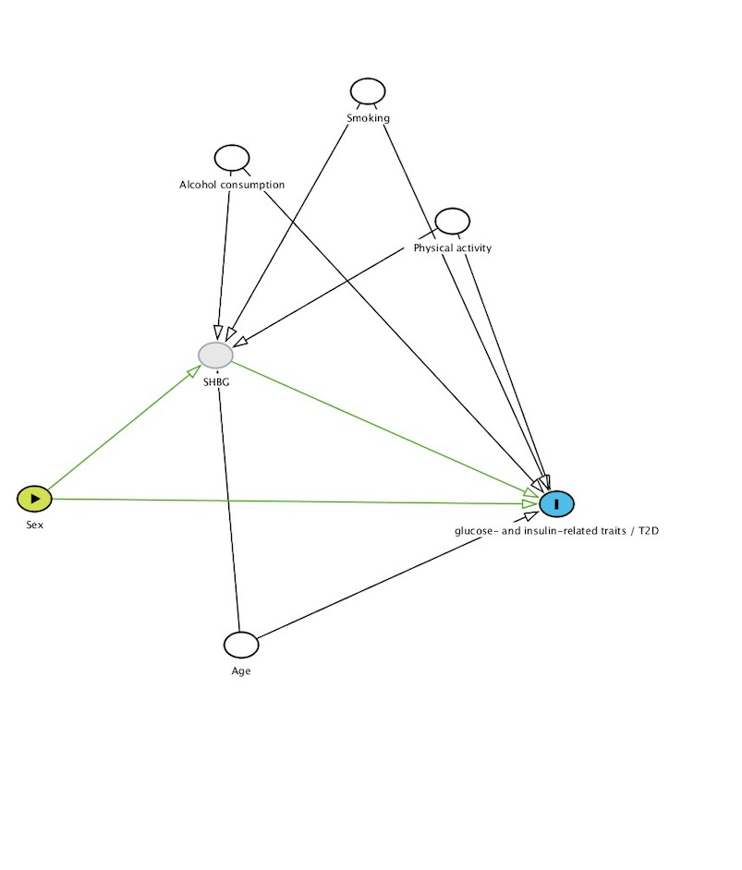
Supplementary Figure 2. Directed acyclic graph (DAG) for the association of sex, through sex hormone binding globulin (SHBG), on glucose- and insulin-related traits / type 2 diabetes (T2D). Study DAG for model 2, exposure = sex, mediator = SHBG, outcome= glucose- and insulin-related traits / T2D, adjustment variables = age + alcohol consumption + smoking + physical activity.

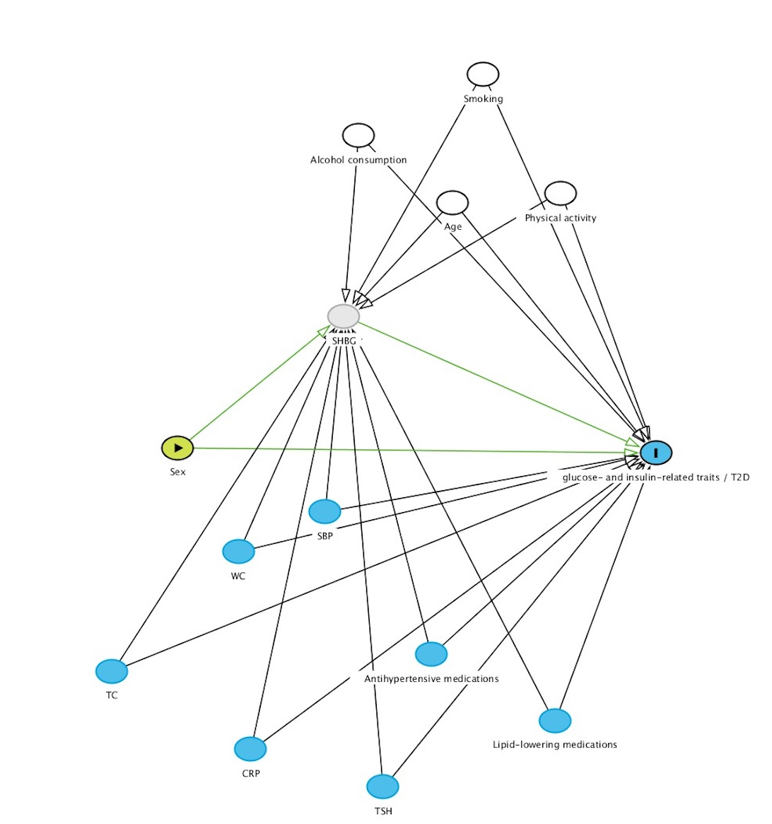

Supplementary Figure 3. Directed acyclic graph (DAG) for the association of sex, through sex hormone binding globulin (SHBG), on glucose- and insulin-related traits / type 2 diabetes (T2D). Study DAG for model 3, further adjustments for possible mediators (variables in blue). Exposure = Sex, mediator = SHBG, outcome = glucose- and insulin-related traits / T2D, adjustment variables = age + alcohol consumption + smoking, physical activity + waist circumference + SBP + antihypertensive medications+ lipid lowering medications + total cholesterol + CRP+ TSH.

References:
1. Organization WH. Definition, diagnosis and classification of diabetes mellitus and its complications: report of a WHO consultation. Part 1, Diagnosis and classification of diabetes mellitus: World health organization1999.
2. Lau LHY, Nano J, Cecil A, et al. Cross-sectional and prospective relationships of endogenous progestogens and estrogens with glucose metabolism in men and women: a KORA F4/FF4 Study. BMJ Open Diabetes Research and Care. 2021;9(1):e001951.

