Supplemental File S1

Acute kidney injury requiring dialysis in children: a multicentric, emerging country perspective.
Thais Lira Cleto-Yamane, MD, MS¹; Conrado Lysandro R. Gomes, MD, MS^{1,2}; Paulo Cesar Koch-Nogueira, MD, MS, PhD³; José Hermógenes Rocco Suassuna, MD, MS, PhD^{1,2}
¹ Clinical and Academic Unit of Nephrology, Pedro Ernesto University Hospital, Faculty of Medical Sciences, Rio de Janeiro State University, Rio de Janeiro, Brazil
² Kidney Assistance LLC. Rio de Janeiro, Brazil
³ Department of Pediatrics, Universidade Federal de São Paulo, Sao Paulo, Brazil
Corresponding author:
Thais Lira Cleto-Yamane

INDEX
- About the NefroWeb database, data acquisition, categorizations, and dialysis modalities.
- Figure S1. Flow chart showing the construction of the cohort.
- Figure S2 and Table S1: Prevalence of the precipitant factors of AKI-D across the study years
- Figure S3 and Table S2: Trends in dialysis modalities
- Figure S4: Kaplan–Meier survival curves according to pediatric age groups.
- Figure S5: Trends in mortality
- Figure S6: Kaplan–Meier survival curves according to primary diagnosis.

APPENDEX

- STROBE Statement

- About the NefroWeb database, data acquisition, categorizations, and dialysis modalities.

The NefroWeb® platform, a web-integrated relational database, was established using the Microsoft SQL Server management system to meet the administrative needs of an outsourced mobile inpatient dialysis initiative across public and private hospitals in Rio de Janeiro. As it evolved, a clinical and epidemiological component was incorporated. Nephrologists accessing the system were provided with unique user credentials.

Dialysis modalities included continuous automated peritoneal dialysis and hemodialysis with standard machinery using the following methods: conventional intermittent dialysis, prolonged intermittent kidney replacement therapy (PIKRT), or PIKRT in continuous mode (C-PIKRT, indicating continuous hemodialysis provided with standard dialysis equipment and PIKRT set-up parameters). In our region of the world, continuous kidney replacement therapy costs 3 to 6 times more than PIKRT or C-PIKRT, and many healthcare providers do not cover it. Consequently, volume-overloaded or hemodynamically unstable patients requiring renal replacement therapy were treated with PIRRT or C-PIRRT.

Diagnoses and related clinical information, such as the causes of acute kidney injury (AKI), were based on clinical evaluation, disease course, patient history, and laboratory and imaging results. Dialysis indications and modality recommendations were under the discretion of the attending nephrologist based on conventional criteria. Data compilation involved a review of medical records, physical assessments, and laboratory results. To simplify data acquisition and processing, most inputs were dichotomized at imputation. Patient data, critical to the study, underwent rigorous validation for consistency and categorization before undergoing statistical analysis.

- Figure S1: Flow chart showing the construction of the cohort.

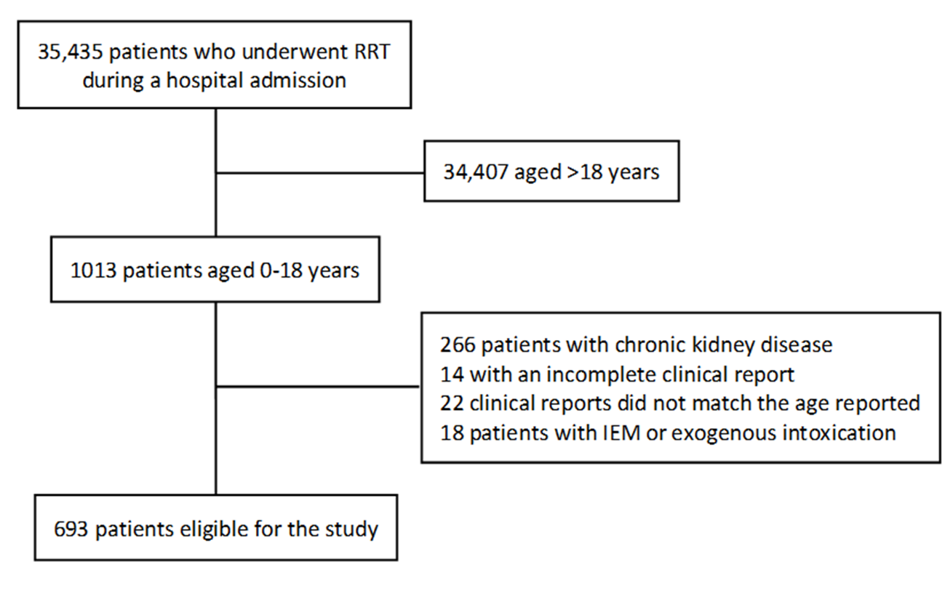
Figure S1: Flow chart showing the construction of the cohort. KRT: renal replacement therapy. IEM: inborn errors of metabolism.

- Figure S2 and Table S1: Prevalence of the precipitant factors of AKI-D across the study years
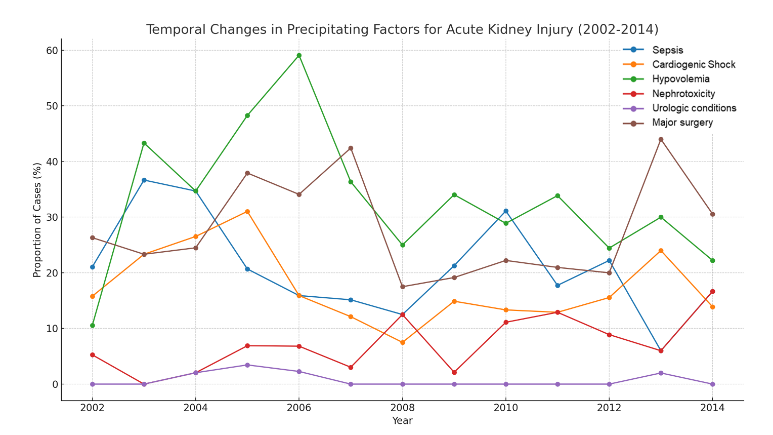

Figure S2. Temporal trends in the prevalence of precipitant factors for AKI-D.

Table S1. Mann-Kendall statistics for trends in the incidence of AKI-D across the study period.
 | tau | p_value
Sepsis | -0.222264953 | 0.296952653
Cardiogenic Shock | -0.247155766 | 0.261209066
Hypovolemia/Hypotension | -0.29678037 | 0.159776646
Nephrotoxicity | -0.147814218 | 0.495394415
Urological Causes | -0.344487919 | 0.148586223
Major Surgery | -0.013074409 | 0.95107857

- Figure S3 and Table S2: Trends in dialysis modalities
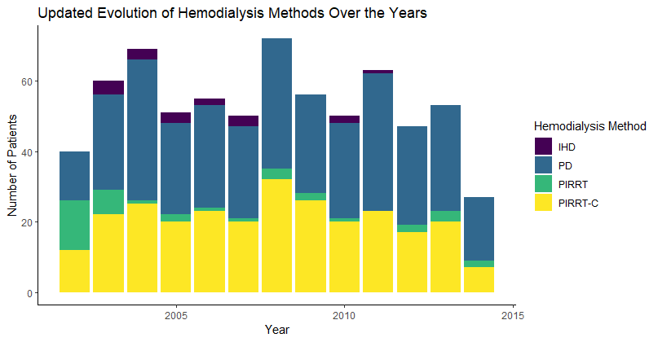

Figure S3. Evolution of dialysis modalities over the years

Table S2. Mann-Kendall statistics for trends in dialysis modalities
Dialysis Method | Kendall's Tau | Statistic (S) | P-value
PD | 0.115384615 | 9 | 0.625
PIRRT | -0.106060606 | -7 | 0.68
PIRRT-C | -0.166666667 | -13 | 0.464
IHD | -0.714285714 | -15 | 0.035

- Figure S4: Kaplan–Meier survival curves according to pediatric age groups.

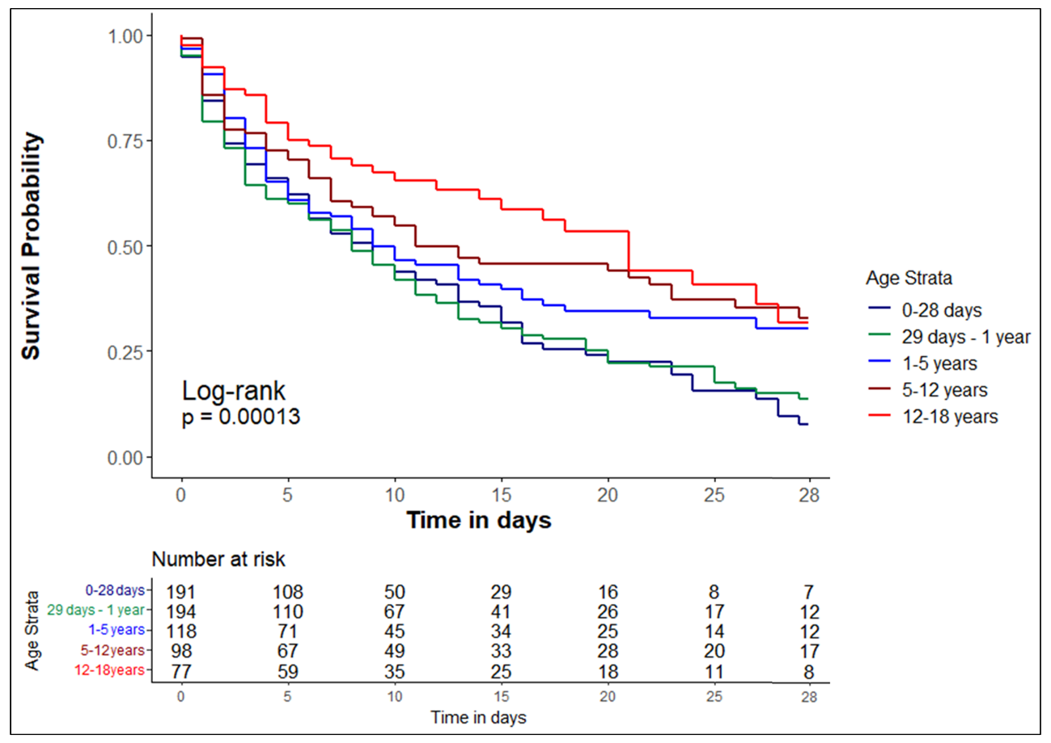
Figure S4: Kaplan–Meier survival curves according to pediatric age groups.

- Figure S5. Trends in Mortality

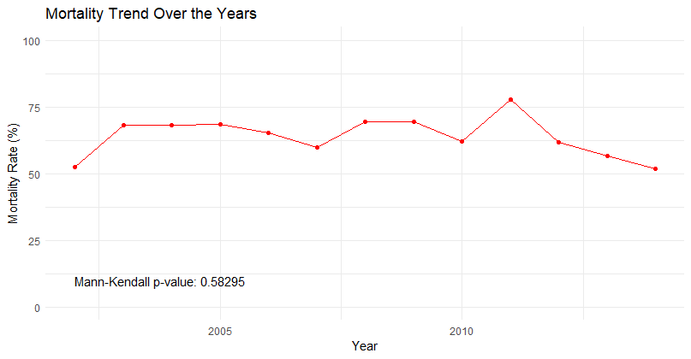

- Figure S6: Kaplan–Meier survival curves according to primary diagnosis.
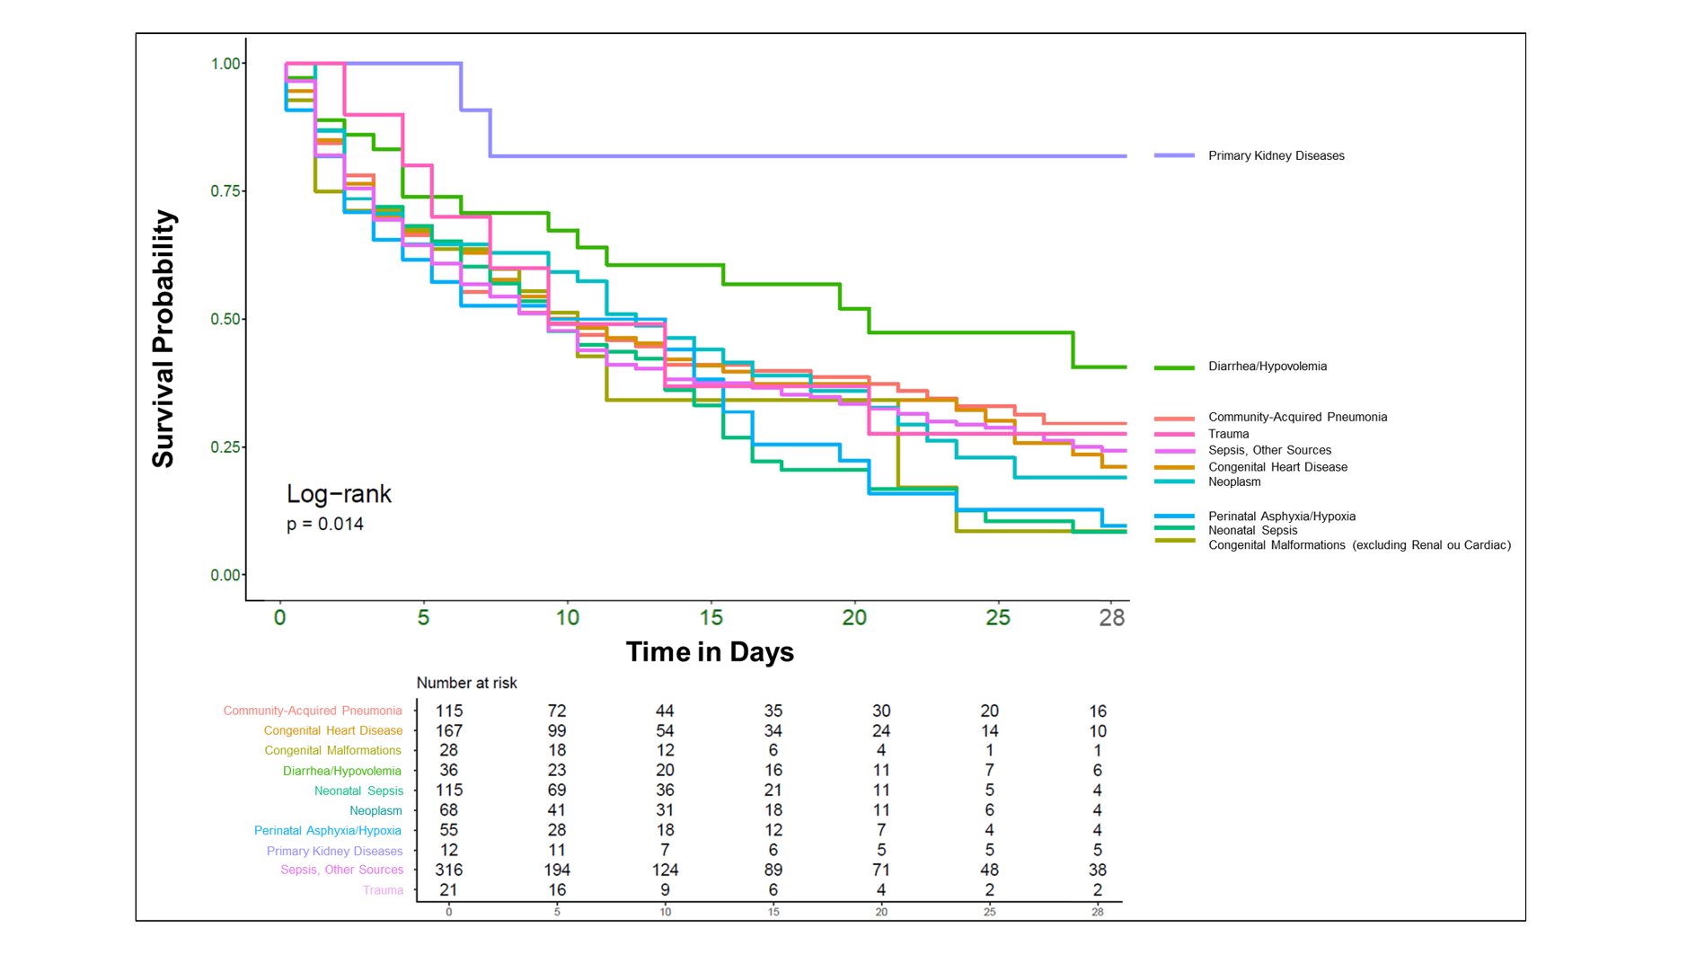

APPENDEX
STROBE Statement—checklist of items that should be included in reports of observational studies.

 |  | Item No | Recommendation | Page  No
Title and abstract |  | 1 | (a) Indicate the study’s design with a commonly used term in the title or the abstract | 1
 |  | 1 | (b) Provide in the abstract an informative and balanced summary of what was done and what was found | 2
Introduction
Background/rationale |  | 2 | Explain the scientific background and rationale for the investigation being reported | 3
Objectives |  | 3 | State specific objectives, including any prespecified hypotheses | 3
Methods
Study design |  | 4 | Present key elements of study design early in the paper | 4
Setting |  | 5 | Describe the setting, locations, and relevant dates, including periods of recruitment, exposure, follow-up, and data collection | 4
Participants |  | 6 | (a) Cohort study—Give the eligibility criteria, and the sources and methods of selection of participants. Describe methods of follow-up  Case-control study—Give the eligibility criteria, and the sources and methods of case ascertainment and control selection. Give the rationale for the choice of cases and controls  Cross-sectional study—Give the eligibility criteria, and the sources and methods of selection of participants | 4
 |  | 6 | (b) Cohort study—For matched studies, give matching criteria and number of exposed and unexposed  Case-control study—For matched studies, give matching criteria and the number of controls per case | 4
Variables |  | 7 | Clearly define all outcomes, exposures, predictors, potential confounders, and effect modifiers. Give diagnostic criteria, if applicable | 4,5
Data sources/ measurement |  | 8* | For each variable of interest, give sources of data and details of methods of assessment (measurement). Describe comparability of assessment methods if there is more than one group | 4,5
Bias |  | 9 | Describe any efforts to address potential sources of bias | 16
Study size |  | 10 | Explain how the study size was arrived at | 4
Quantitative variables |  | 11 | Explain how quantitative variables were handled in the analyses. If applicable, describe which groupings were chosen and why | 4,5
Statistical methods |  | 12 | (a) Describe all statistical methods, including those used to control for confounding | 5
 |  | 12 | (b) Describe any methods used to examine subgroups and interactions | 5
 |  | 12 | (c) Explain how missing data were addressed | 5
 |  | 12 | (d) Cohort study—If applicable, explain how loss to follow-up was addressed  Case-control study—If applicable, explain how matching of cases and controls was addressed  Cross-sectional study—If applicable, describe analytical methods taking account of sampling strategy | 5
 |  | 12 | (e) Describe any sensitivity analyses | -
Results
Participants | 13* | (a) Report numbers of individuals at each stage of study—eg numbers potentially eligible, examined for eligibility, confirmed eligible, included in the study, completing follow-up, and analysed |  | 4, 7
Participants | 13* | (b) Give reasons for non-participation at each stage |  | N/A
Participants | 13* | (c) Consider use of a flow diagram |  | 6
Descriptive data | 14* | (a) Give characteristics of study participants (eg demographic, clinical, social) and information on exposures and potential confounders |  | 5,6
Descriptive data | 14* | (b) Indicate number of participants with missing data for each variable of interest |  | 4
Descriptive data | 14* | (c) Cohort study—Summarise follow-up time (eg, average and total amount) |  | 4
Outcome data | 15* | Cohort study—Report numbers of outcome events or summary measures over time |  | 9,10-12
Outcome data | 15* | Case-control study—Report numbers in each exposure category, or summary measures of exposure
Outcome data | 15* | Cross-sectional study—Report numbers of outcome events or summary measures
Main results | 16 | (a) Give unadjusted estimates and, if applicable, confounder-adjusted estimates and their precision (eg, 95% confidence interval). Make clear which confounders were adjusted for and why they were included |  | 9-12
Main results | 16 | (b) Report category boundaries when continuous variables were categorized |  | -
Main results | 16 | (c) If relevant, consider translating estimates of relative risk into absolute risk for a meaningful time period |  | N/A
Other analyses | 17 | Report other analyses done—eg analyses of subgroups and interactions, and sensitivity analyses |  | 4
Discussion
Key results | 18 | Summarise key results with reference to study objectives |  | 13-14
Limitations | 19 | Discuss limitations of the study, taking into account sources of potential bias or imprecision. Discuss both direction and magnitude of any potential bias |  | 16
Interpretation | 20 | Give a cautious overall interpretation of results considering objectives, limitations, multiplicity of analyses, results from similar studies, and other relevant evidence |  | 16
Generalisability | 21 | Discuss the generalisability (external validity) of the study results |  | 16
Other information
Funding | 22 | Give the source of funding and the role of the funders for the present study and, if applicable, for the original study on which the present article is based |  | 17

