Manuscript Supplement Template
Electronic supplementary material (ESM)
Title page
GWAS identifies genetic clusters of cardiometabolic risk factors in continental Africans
Word count
All text: 4060 (From start to end of document).
Figures (15), Tables (14), and References (9).

Methods
Trait measurement(s)
The six traits measured in the Cardiometabolic PC analysis were Waist circumference (WC), triglycerides (TGs), high-density lipoprotein (HDL), systolic blood pressure (SBP), diastolic blood pressure (DBP), and Glycated hemoglobin in hemoglobin A_{1c} (HbA_{1c}).

Waist circumference (WC)
WC was measured to the nearest 0.1 cm over one layer of loose clothing using a non-stretch Seca 201 Ergonomic Circumference Measuring Tape. The midpoint between the lower costal margin and the level of the anterior superior iliac crests was used to calculate WC. WCs were measured twice, and a third measurement was made if the first and second measures differed by 3 cm or more. WC values were calculated as mean values of measurements taken; details on this have been previously published¹.

Triglycerides (TGs) and high-density lipoprotein (HDL)
Non-fasting lipids were assessed. The Cobas Integra 400 Plus Chemistry analyzer (Roche Diagnostics), a sophisticated integrated system for research and diagnostic clinical chemistry testing, was used to digitally record biochemistry data on lipid levels. The device automatically executes all test orders and utilizes four distinct technologies, including absorption photometry, fluorescence polarization immunoassay, immune-turbidimetry, and potentiometry. Triglyceride tests were enzymatic colorimetric with photometric detection. Sugiuchi et al. described homogenous enzymatic colorimetric techniques for measuring HDL-cholesterol and LDL-cholesterol¹⁻³. The manufacturer additionally assessed the precision of tests using both study samples and controls; more information on this has already been published¹.

Blood pressure
The Omron M6-I fully automated blood pressure machine was used to gather both SBP and DBP. The Omron M6-I has been verified for medical usage, including obese, pediatrics, and the elderly⁴⁻⁶. Participants were instructed to rest for at least 15 minutes before the test and to refrain from eating or drinking for 30 minutes before the measurement. Prior to the blood pressure measurements, the arm circumference was determined, and the appropriate Omron cut size used Blood pressure was taken three times in the sitting posture, with rest intervals of 3-5 minutes in between, and the blood pressure was computed as the mean of the second and third readings; further details on this have been previously published¹.

Glycated hemoglobin in hemoglobin A_{1c} (HbA_{1c})/fasting glucose
The Roche Cobas Integra 400 Plus Chemistry analyzer was used to digitally record HbA_{1c} data (Roche Diagnostics). After hemolysis of the anticoagulated whole blood samples, total hemoglobin and HbA_{1c} concentrations were measured. Total hemoglobin was measured using a colorimetric method. For hemolyzed whole blood, HbA_{1c} was measured using a turbidimetric inhibition immunoassay-quant Hemoglobin Alc Gen2. The Cobas output was represented as a percentage of the International Federation of Clinical Chemistry (IFCC). HbA1c and was calculated from the IFCC protocol HbA_{1c}/hemoglobin ratio as HbA_{1c} (%) = (HbA_{1c}/hemoglobin) x 100. These results were converted to the DCCT (Diabetes Control and Complications Trial)/NGSP (National Glycohemoglobin Standardization Program) percentage units using the following equation: HbA_{1c} % DCCT/NGSP = 0.915 x (HbA_{1c} % IFCC) + 2.15¹.

The accuracy of this Roche second generation HbA_{1c} test in the presence of haemoglobinopathies has been verified. The Cobas Integra 400 Plus test has also been validated against the high-performance liquid chromatography technique, which has previously been published¹. Finally, before being included in the PCs, the HbAc1 values were converted.

Results
- UGR b) DDS
UGR DDS

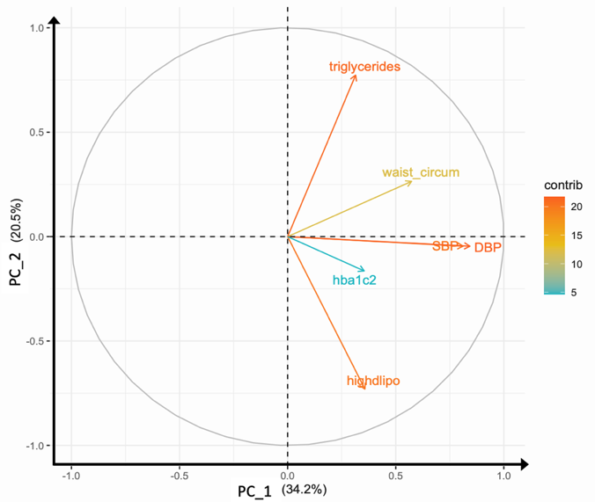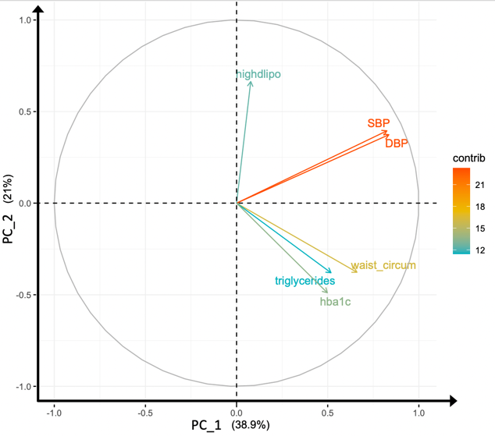
Electronic supplementary material (ESM) Figure 1: Variable plots from the PCA by study, by contribution per trait in PC1 vs. PC2.
Footnotes: (1) Abbreviations: waist_circum, waist circumference; SBP, systolic blood pressure; DBP, diastolic blood pressure; hba1c, hemoglobin A_{1c}; highdlipo, high density lipoprotein; PC, principal component. ;(2) The total variance measure by each PC is indicated on the x and y axis.; (3) Each box indicates the magnitude of the trait from point 0.0, on the x and y axis. For example, SBP and DBP are largely driving PC_1 in both UGR and DDS.

UGR DDS

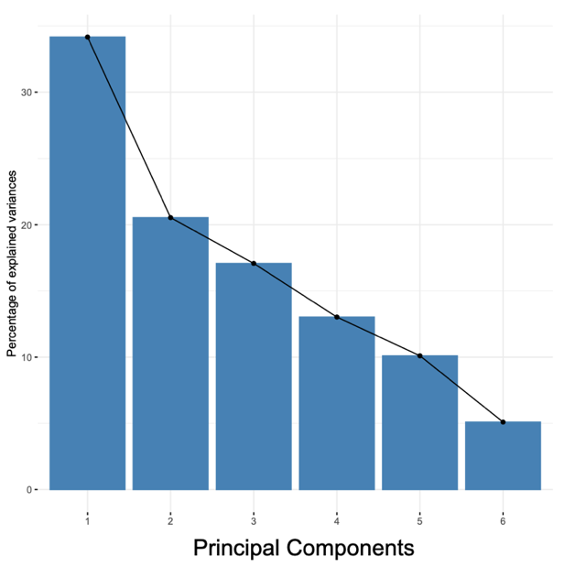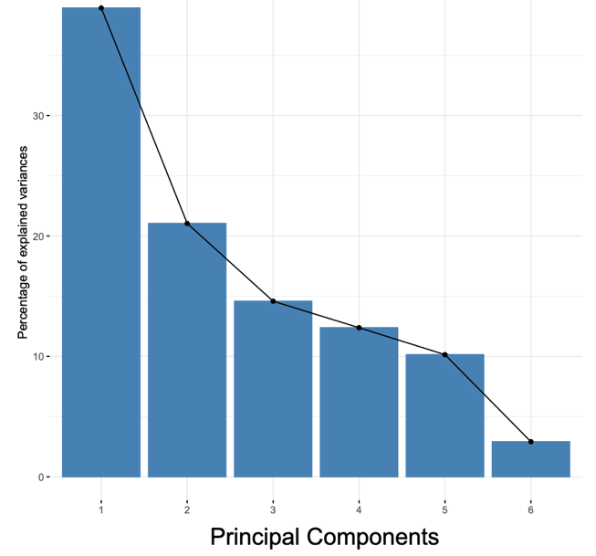
ESM Figure 2: An illustration of the percentage of explained variances each principal component contributes to each study.

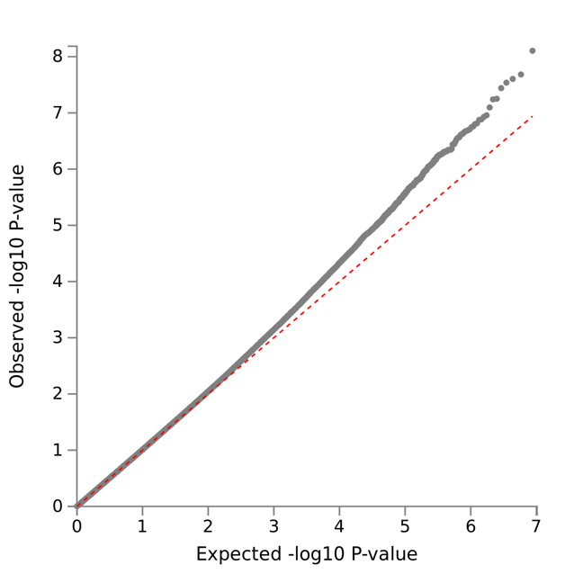
ESM Figure 3: A quantile-quantile (QQ) plot matching Figure 1. C’s Manhattan plot of the meta-analysis of PC1 in UGR and DDS.

ESM Tables 1-5: Bayesian fine-mapping of the genome wide significant loci for cardiometabolic risk factors

ESM Table 1: The 99% credible set for Chr 4, rs1560973606
Chr | Position | A1 | A0 | P | BETA | SE | Z | BF | PP | Cumulative PP
4 | 153032707 | A | T | 7.86E-09 | 0.49 | 0.085 | 5.771 | 12096404.22 | 0.997 | 0.997

ESM Table 2: The 99% credible set for Chr 1, rs1411180101
Chr | Position | A1 | A0 | P | BETA | SE | Z | BF | PP | Cumulative PP
1 | 2587850 | C | C | 2.07E-08 | 0.65 | 0.12 | 5.606 | 4711660.577 | 0.994 | 0.994

ESM Table 3: The 99% credible set for Chr 3, rs781852707
Chr | Position | A1 | A0 | P | BETA | SE | Z | BF | PP | Cumulative PP
3 | 53217607 | A | C | 2.49E-08 | -0.93 | 0.17 | -5.574 | 3945554.147 | 0.994 | 0.994

ESM Table 4: The 99% credible set for Chr 4, rs1248858263
Chr | Position | A1 | A0 | P | BETA | SE | Z | BF | PP | Cumulative PP
4 | 69605536 | A | T | 2.90E-08 | 0.53 | 0.096 | 5.547 | 3401497.369 | 0.987 | 0.987
4 | 69539880 | C | T | 1.31E-04 | -0.46 | 0.120 | -3.825 | 1061.664 | 3.08E-04 | 0.987
4 | 69661830 | G | G | 1.87E-04 | -0.29 | 0.079 | -3.735 | 757.275 | 2.20E-04 | 0.987
4 | 69547420 | G | A | 2.15E-04 | -0.42 | 0.114 | -3.700 | 664.804 | 1.93E-04 | 0.987
4 | 69542106 | C | T | 2.23E-04 | -0.43 | 0.116 | -3.691 | 642.447 | 1.86E-04 | 0.988
4 | 69585176 | C | G | 2.27E-04 | -0.41 | 0.112 | -3.687 | 633.075 | 1.84E-04 | 0.988
4 | 69561466 | G | C | 2.32E-04 | -0.41 | 0.113 | -3.681 | 619.983 | 1.80E-04 | 0.988
4 | 69549820 | T | T | 2.35E-04 | -0.42 | 0.114 | -3.678 | 611.526 | 1.77E-04 | 0.988
4 | 69568495 | G | A | 2.37E-04 | -0.41 | 0.112 | -3.676 | 607.295 | 1.76E-04 | 0.988
4 | 69577749 | C | T | 2.40E-04 | -0.41 | 0.112 | -3.673 | 600.340 | 1.74E-04 | 0.989
4 | 69576791 | C | T | 2.47E-04 | -0.41 | 0.112 | -3.665 | 583.771 | 1.69E-04 | 0.989
4 | 69542759 | T | C | 2.51E-04 | -0.42 | 0.115 | -3.662 | 576.768 | 1.67E-04 | 0.989
4 | 69587048 | G | T | 2.57E-04 | -0.41 | 0.112 | -3.655 | 562.468 | 1.63E-04 | 0.989
4 | 69573051 | A | G | 2.61E-04 | -0.41 | 0.113 | -3.651 | 554.362 | 1.61E-04 | 0.989
4 | 69537593 | C | T | 2.62E-04 | -0.42 | 0.116 | -3.650 | 553.297 | 1.61E-04 | 0.989
4 | 69533145 | C | G | 2.68E-04 | -0.43 | 0.117 | -3.644 | 540.855 | 1.57E-04 | 0.990
4 | 69971866 | T | G | 2.84E-04 | -0.28 | 0.076 | -3.630 | 513.265 | 1.49E-04 | 0.990
4 | 69572156 | G | C | 2.88E-04 | -0.41 | 0.113 | -3.625 | 505.431 | 1.47E-04 | 0.990
4 | 70335004 | A | G | 2.96E-04 | 0.24 | 0.067 | 3.619 | 494.096 | 1.43E-04 | 0.990
4 | 69661786 | G | A | 2.96E-04 | -0.26 | 0.073 | -3.619 | 493.891 | 1.43E-04 | 0.990

ESM Table 5: The 99% credible set for Chr 17, rs112128922
Chr | Position | A1 | A0 | P | BETA | SE | Z | BF | PP | Cumulative PP
17 | 12254446 | A | G | 3.63E-08 | 0.58 | 0.105 | 5.508 | 2737240.154 | 0.735 | 0.735
17 | 11615467 | A | T | 1.10E-07 | 0.43 | 0.082 | 5.309 | 933857.207 | 0.251 | 0.986
17 | 12345656 | T | A | 1.40E-05 | 0.44 | 0.101 | 4.344 | 8842.834 | 2.37E-03 | 0.988
17 | 12345655 | A | A | 1.62E-05 | 0.38 | 0.087 | 4.312 | 7720.530 | 2.07E-03 | 0.990

Footnotes: (1) All SNP positions are based on GRCh37 from Ensembl, dbSNP, or HaploReg. (2) Abbreviations: Chromosome (Chr), Effect allele (A1), Non-effect allele (A0), P-value(P), Standard error (SE), Z score of the summary statistics BETA/SE (Z), Bayes Factors (BF), The posterior probability of a SNP (PP calculated: PP = BFi /∑▒BFk), and the cumulative posterior probability (Cumulative PP)
ESM Tables 6-7: Variant effect predictions (VEPs) of 99% credible set variants
ESM Table 6: The Chromosome 4, rs1248858263, 99% credible set
Location | Allele | Consequence | SYMBOL | Gene | Feature | BIOTYPE | Existing variation | AF
4:69533145-69533145 | G | Intron variant | UGT2B15 | ENSG00000196620 | ENST00000338206.5 | Protein coding | rs143814331 | 0.01
4:69537593-69537593 | T | Upstream gene variant | UGT2B15 | ENSG00000196620 | ENST00000338206.5 | Protein coding | rs79309827 | 0.0098
4:69539880-69539880 | T | Upstream gene variant | UGT2B15 | ENSG00000196620 | ENST00000338206.5 | Protein coding | rs140778253 | 0.0098
4:69542106-69542106 | T | Intergenic variant | - | - | - | - | rs149669565 | 0.0098
4:69542759-69542759 | C | Intergenic variant | - | - | - | - | rs145171157 | 0.0098
4:69547420-69547420 | A | Intergenic variant | - | - | - | - | rs4547862 | 0.0098
4:69549820-69549820 | - | - | - | - | - | - | - | -
4:69561466-69561466 | C | Intergenic variant | - | - | - | - | rs149336649 | 0.0098
4:69568495-69568495 | A | Downstream gene variant | RP11-1267H10.4 | ENSG00000248635 | ENST00000509261.1 | Unprocessed pseudogene | rs147046533 | 0.0098
4:69572156-69572156 | C | Intron variant, non-coding transcript variant | RP11-1267H10.4 | ENSG00000248635 | ENST00000509261.1 | Unprocessed pseudogene | rs184941516 | 0.0098
4:69573051-69573051 | G | Intron variant, non-coding transcript variant | RP11-1267H10.4 | ENSG00000248635 | ENST00000509261.1 | Unprocessed pseudogene | rs149176242 | 0.0098
4:69576791-69576791 | T | Intron variant, non-coding transcript variant | RP11-1267H10.4 | ENSG00000248635 | ENST00000509261.1 | Unprocessed pseudogene | rs149544637 | 0.0098
4:69577749-69577749 | T | Intron variant, non-coding transcript variant | RP11-1267H10.4 | ENSG00000248635 | ENST00000509261.1 | Unprocessed pseudogene | rs17146669 | 0.0098
4:69585176-69585176 | G | Intergenic variant | - | - | - | - | rs149602378 | 0.0098
4:69587048-69587048 | T | Intergenic variant | - | - | - | - | rs147622971 | 0.0096
4:69605536-69605536 | T | Intergenic variant | - | - | - | - | - | -
4:69661830-69661830 | - | - | - | - | - | - | - | -
4:69971866-69971866 | G | Intron variant | UGT2B7 | ENSG00000171234 | ENST00000305231.7 | Protein coding | rs113764820 | 0.007
4:69971866-69971866 | G | Intron variant | UGT2B7 | ENSG00000171234 | ENST00000502942.1 | Protein coding | rs113764820 | 0.007
4:69971866-69971866 | G | Intron variant | UGT2B7 | ENSG00000171234 | ENST00000508661.1 | Protein coding | rs113764820 | 0.007
4:69971866-69971866 | G | Intron variant, non-coding transcript variant | UGT2B7 | ENSG00000171234 | ENST00000509763.1 | Processed transcript | rs113764820 | 0.007
4:70335004-70335004 | G | Intergenic variant | - | - | - | - | rs147063744 | 0.0038

ESM Table 7: The 99% credible set for Chr 17, rs112128922
Location | Allele | Consequence | SYMBOL | Gene | Feature | BIOTYPE | Existing variation | AF
17:11482197-11482197 | C | Intergenic variant | - | - | - | - | rs1370298843 | -
17:11601400-11601400 | A | Intron variant | DNAH9 | ENSG00000007174 | ENST00000262442.4 | Protein coding | rs147662990 | 0.0875
17:11601400-11601400 | A | Intron variant | DNAH9 | ENSG00000007174 | ENST00000454412.2 | Protein coding | rs147662990 | 0.0875
17:11615467-11615467 | T | Intron variant | DNAH9 | ENSG00000007174 | ENST00000262442.4 | Protein coding | - | -
17:11615467-11615467 | T | Intron variant | DNAH9 | ENSG00000007174 | ENST00000454412.2 | Protein coding | - | -
17:11856699-11856699 | - | - | - | - | - | - | - | -
17:11977564-11977564 | C | Intron variant | MAP2K4 | ENSG00000065559 | ENST00000353533.5 | Protein coding | rs566684939 | 0.0004
17:11977564-11977564 | C | Intron variant | MAP2K4 | ENSG00000065559 | ENST00000415385.3 | Protein coding | rs566684939 | 0.0004
17:11977564-11977564 | C | Intron variant, NMD transcript variant | MAP2K4 | ENSG00000065559 | ENST00000538465.3 | Nonsense mediated decay | rs566684939 | 0.0004
17:11977564-11977564 | C | Intron variant, non-coding transcript variant | MAP2K4 | ENSG00000065559 | ENST00000579089.1 | Processed transcript | rs566684939 | 0.0004
17:11977564-11977564 | C | Intron variant, non-coding transcript variant | MAP2K4 | ENSG00000065559 | ENST00000581941.1 | Processed transcript | rs566684939 | 0.0004
17:11977564-11977564 | C | Intron variant, NMD transcript variant | MAP2K4 | ENSG00000065559 | ENST00000582183.1 | Nonsense mediated decay | rs566684939 | 0.0004
17:11977564-11977564 | C | Intron variant, non-coding transcript variant | MAP2K4 | ENSG00000065559 | ENST00000582897.1 | Processed transcript | rs566684939 | 0.0004
17:11977564-11977564 | C | Intron variant, NMD transcript variant | MAP2K4 | ENSG00000065559 | ENST00000602305.1 | Nonsense mediated decay | rs566684939 | 0.0004
17:11977564-11977564 | C | Intron variant, NMD transcript variant | MAP2K4 | ENSG00000065559 | ENST00000602375.1 | Nonsense mediated decay | rs566684939 | 0.0004
17:11977564-11977564 | C | Intron variant, NMD transcript variant | MAP2K4 | ENSG00000065559 | ENST00000602537.1 | Nonsense mediated decay | rs566684939 | 0.0004
17:11977564-11977564 | C | Intron variant, NMD transcript variant | MAP2K4 | ENSG00000065559 | ENST00000602686.1 | Nonsense mediated decay | rs566684939 | 0.0004
17:11977564-11977564 | C | Intron variant, NMD transcript variant | MAP2K4 | ENSG00000065559 | ENST00000602811.1 | Nonsense mediated decay | rs566684939 | 0.0004
17:12254446-12254446 | G | Intergenic variant | - | - | - | - | rs112128922 | -
17:12345655-12345655 | - | - | - | - | - | - | - | -
17:12345656-12345656 | A | Intergenic variant | - | - | - | - | rs1270701092 | -
17:12346165-12346165 | A | Intergenic variant | - | - | - | - | rs530344396 | 0.0002
Footnotes: (1) All SNP positions are based on GRCh37 from Ensembl, dbSNP, or HaploReg. (2) Abbreviations: Allele Frequency (AF), Uridine Diphosphate Glycosyltransferase 2 Family Member B15 (UGT2B15), UDP-Glucuronosyltransferase-2B7 (UGT2B7), UDP glucuronosyltransferase 2 family pseudogene (RP11-1267H10.4), Dynein Axonemal Heavy Chain 9 (DNAH9), and Mitogen-Activated Protein Kinase Kinase 4 (MAP2K4).

ESM Tables 8-12: PheWAS tables of association from GWAS Atlas.

ESM Table 8: A PheWAS Table of significant associations for TTC34
Atlas ID | PMID | Year | Domain | Trait | P-value | N
3819 | 21833088 | 2011 | Neurological | Multiple Sclerosis | 4.05E-10 | 27148
3824 | 22057235 | 2011 | Gastrointestinal | Celiac disease | 5.15E-10 | 24269
4044 | 30124842 | 2018 | Metabolic | Body Mass Index | 5.58E-09 | 681275
2030 | 28067908 | 2017 | Gastrointestinal | Ulcerative colitis | 7.09E-08 | 45975
3435 | 31427789 | 2019 | Metabolic | Body Mass Index | 2.69E-07 | 385336
4074 | 30239722 | 2018 | Metabolic | Body Mass Index | 3.98E-07 | 806834
3445 | 31427789 | 2019 | Metabolic | Impedance measures - Body Mass Index (BMI) | 4.12E-07 | 379831
3436 | 31427789 | 2019 | Metabolic | Weight | 8.38E-07 | 385473
3821 | 20190752 | 2010 | Gastrointestinal | Celiac disease | 1.13E-06 | 15283
3440 | 31427789 | 2019 | Metabolic | Impedance measures - Weight | 1.68E-06 | 379840
4075 | 30239722 | 2018 | Metabolic | Body Mass Index (male) | 3.09E-06 | 374756
69 | 26192919 | 2015 | Gastrointestinal | Ulcerative Colitis | 3.92E-06 | 27432
3458 | 31427789 | 2019 | Metabolic | Impedance measures - Leg fat-free mass (left) | 7.46E-06 | 379766
3450 | 31427789 | 2019 | Metabolic | Impedance measures - Impedance of arm (right) | 7.64E-06 | 379786
1194 | 21297633 | 2011 | Gastrointestinal | Ulcerative colitis | 9.48E-06 | 27994
3457 | 31427789 | 2019 | Metabolic | Impedance measures - Leg fat mass (left) | 9.96E-06 | 379783
Footnotes: (1) Number of GWASs considered: 4756 (including GWASs in which the searched SNP or gene was not tested, Bonferroni corrected P-value: 1.05x10⁻⁵).
(2) Number of data points in the plot: 306 (Bonferroni corrected P-value: 1.63x10⁻⁴). (3) Abbreviations: PubMed Identifier (PMID) and sample size (N).

ESM Table 9: A PheWAS Table of significant associations for PRKCD
Atlas ID | PMID | Year | Domain | Trait | P-value | N
4080 | 30239722 | 2018 | Metabolic | Waist-hip ratio (adjusted for BMI) | 1.30E-13 | 694649
4082 | 30239722 | 2018 | Metabolic | Waist-hip ratio (adjusted for BMI, female) | 4.26E-10 | 379501
4077 | 30239722 | 2018 | Metabolic | Waist-hip ratio | 1.29E-08 | 697734
3448 | 31427789 | 2019 | Metabolic | Impedance measures - Impedance of leg (right) | 1.82E-07 | 379813
3447 | 31427789 | 2019 | Metabolic | Impedance measures - Impedance of whole body | 3.05E-07 | 379792
3449 | 31427789 | 2019 | Metabolic | Impedance measures - Impedance of leg (left) | 5.92E-07 | 379807
4079 | 30239722 | 2018 | Metabolic | Waist-hip ratio (female) | 9.30E-07 | 381152
4081 | 30239722 | 2018 | Metabolic | Waist-hip ratio (adjusted for BMI, male) | 2.01E-06 | 315284
3187 | 31427789 | 2019 | Skeletal | Standing height | 3.46E-06 | 385748
4383 | 30898391 | 2019 | Neoplasms | Epithelial ovarian cancer (high-grade serous) | 3.59E-06 | 5698
4280 | 30804560 | 2019 | Respiratory | FEV1/FVC ratio | 5.20E-06 | 400102
4043 | 30124842 | 2018 | Skeletal | Height | 6.55E-06 | 693529
4382 | 30898391 | 2019 | Neoplasms | Epithelial ovarian cancer (high -grade and low-grade serous) | 7.51E-06 | 5734
Footnotes: (1) Number of GWASs considered: 4756 (including GWASs in which the searched SNP or gene was not tested, Bonferroni corrected P-value: 1.05x10⁻⁵).
(2) Number of data points in the plot: 352 (Bonferroni corrected P-value: 1.42x10⁻⁴). (3) Abbreviations: PubMed Identifier (PMID) and sample size (N).

ESM Table 10: A PheWAS Table of significant associations for UGT2B7
Atlas ID | PMID | Year | Domain | Trait | P-value | N
3380 | 31427789 | 2019 | Cardiovascular | Systolic Blood Pressure (automated reading) | 3.49E-07 | 361402
4136 | 29403010 | 2018 | Hematological | Hemoglobin | 4.38E-07 | 108769
4122 | 29403010 | 2018 | Metabolic | Gamma-glutamyl transferase | 7.59E-07 | 118309
4137 | 29403010 | 2018 | Immunological | Hematocrit | 1.07E-06 | 108757
4373 | 30367059 | 2018 | Endocrine | Free thyroxine (FT4, male) | 1.97E-06 | 22455
3888 | 27863252 | 2016 | Immunological | Mean corpuscular volume (three-way meta) | 3.97E-06 | 172433
4176 | 30718926 | 2019 | Endocrine | Type 2 Diabetes | 5.16E-06 | 191764
4135 | 29403010 | 2018 | Immunological | Red blood cell count | 5.83E-06 | 108794
3551 | 31427789 | 2019 | Cardiovascular | Vascular/heart problems diagnosed by doctor: High blood pressure | 7.65E-06 | 385699
Footnotes: (1) Number of GWASs considered: 4756 (including GWASs in which the searched SNP or gene was not tested, Bonferroni corrected P-value: 1.05x10⁻⁵).
(2) Number of data points in the plot: 269 (Bonferroni corrected P-value: 1.86x10⁻⁴). (3) Abbreviations: PubMed Identifier (PMID) and sample size (N).

ESM Table 11: A PheWAS Table of significant associations for UGT2B15
Atlas ID | PMID | Year | Domain | Trait | P-value | N
930 | 27005778 | 2016 | Metabolic | Phosphatidylcholine and other cholines | 1.75E-06 | 13542
949 | 27005778 | 2016 | Metabolic | Total phosphoglycerides | 6.66E-06 | 13519
3888 | 27863252 | 2016 | Immunological | Mean corpuscular volume (three-way meta) | 6.94E-06 | 172433
3901 | 27863252 | 2016 | Immunological | Red cell distribution width (three-way meta) | 8.68E-06 | 171529
3608 | 31427789 | 2019 | Metabolic | Non-cancer illness code, self-reported: high cholesterol | 9.18E-06 | 289307
Footnotes: (1) Number of GWASs considered: 4756 (including GWASs in which the searched SNP or gene was not tested, Bonferroni corrected P-value: 1.05x10⁻⁵).
(2) Number of data points in the plot: 182 (Bonferroni corrected P-value: 2.75x10⁻⁴). (3) Abbreviations: PubMed Identifier (PMID) and sample size (N).

ESM Table 12: A PheWAS Table of significant associations for MYOCD
Atlas ID | PMID | Year | Domain | Trait | P-value | N
4192 | 31217584 | 2019 | Cardiovascular | QRS interval | 3.02E-08 | 17046
4361 | 30061737 | 2018 | Cardiovascular | Atrial fibrillation | 5.80E-07 | 1030836
4352 | 30573740 | 2018 | Dermatological | Male pattern baldness (BOLT LMM non-infinitesimal mixed model) | 1.4E-06 | 205327
4193 | 31217584 | 2019 | Cardiovascular | PR interval | 2.88E-06 | 17422
4351 | 30573740 | 2018 | Dermatological | Male pattern baldness (BOLT LMM infinitesimal mixed model) | 6.14E-06 | 205327
Footnotes: (1) Number of GWASs considered: 4756 (including GWASs in which the searched SNP or gene was not tested, Bonferroni corrected P-value: 1.05x10⁻⁵).
(2) Number of data points in the plot: 374 (Bonferroni corrected P-value: 1.34x10⁻⁴). (3) Abbreviations: PubMed Identifier (PMID) and sample size (N).

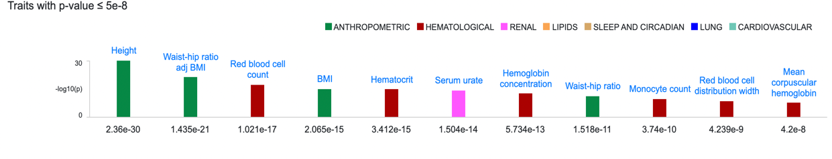
ESM Figure 4: Significant variant associations for PRKCD from T2DKP

ESM Table 13: Replication of genome-wide significant loci previously published in studies of African ancestry for metabolic syndrome and blood pressure

Phenotype/ Trait | PMID | Lead SNP (AFR) | Chr:Pos | Nearest Gene | GWS _{Original study} | OR _{Original study} | OR _{Cardiometabolic_PC1} | P value _{Cardiometabolic_PC1} | Lowest regional P value _{Cardiometabolic_PC1} | Chr:Pos Lowest regional P value Cardiometabolic_PC1
Metabolic Syndrome | 26507551 | rs77244975 | 10:69207975 | CTNNA3 | Yes | 0.15 | 1.04 | 0.69 | 0.000688 | 10:69299099
Metabolic Syndrome | 26507551 | rs76822696 | 8:84929136 | RALYL | Yes | 1.59 | 1.04 | 0.54 | 0.000798 | 8:84895360
Metabolic Syndrome | 26507551 | rs7964157 | 12:117982220 | KSR2 | Yes | 0.53 | 0.96 | 0.23 | 0.000172 | 12:118057286
Metabolic Syndrome | 26507551 | rs294 | 8:19816125 | LPL | Yes | N/A | 0.94 | 0.10 | 0.00573 | 8:19794197
Metabolic Syndrome | 26507551 | rs35237252 | 16:56994894 | CETP | Yes | N/A | 0.99 | 0.81 | 2.30E-05 | 16:57012995
SBP | 28498854 | rs76987554 | 6:134080855 | TARID/ TCF21 | Yes | 1.85 | 1.00 | 0.99 | 0.0114 | 6:134094590
CPASSOC (Het) | 28498854 | rs7651190 | 3:41765955 | ULK4 | Yes | 0.45 | 0.98 | 0.48 | 0.00233 | 3:41749801
SBP, DBP, CPASSOC (Hom) | 28498854 | rs11563582 | 7:27351650 | EVX1/  HOXA cluster | Yes | 1.61 | 0.96 | 0.25 | 4.83E-05 | 7:27295508
CPASSOC (Het) | 28498854 | rs11977526 | 7:46008110 | IGFBP3 | Yes | N/A | 1.03 | 0.34 | 0.000579 | 7:4598461
PP,CPASSOC (Het) | 28498854 | rs7006531 | 8:95110744 | CDH17 | Yes | 1.16 | 1.00 | 0.63 | 0.00671 | 8:95040761
DBP | 28498854 | rs78192203 | 8:142375073 | GPR20 | Yes | 0.77 | 1.06 | 0.05 | 0.000502 | 8:142397580
Footnotes: (1) The lowest regional P value represented a variant +/-100kb from the lead SNP was tested for replication and had the most significant results. (2) LPL and CETP were GWS in the original EUR ancestry studies (PMID: 22399527 & 21386085) and replicated in study PMID: 26507551⁷. (3) Abbreviations: CPASSOC (cross-phenotype association software: http://hal.case.edu/zhu-web/ )^{8,9}, PubMed Identifier (PMID), and genome-wide significant (GWS).

SCOPA and META-SCOPA were also employed to elucidate the discovery and dissection of multiple phenotype association signals through implementation of a powerful reverse regression approach (ESM Table 14).

ESM Table 14: Results of the significant loci from the META-SCOPA meta-analysis of UGR and DDS

Chr | Base Position | Other  Allele | EA | rsID | MAF | P-value | Nearest Gene | Function | Novel or Not
16 | 60725335 | T | A | rs11076406 | 0.0174 | 1.22E-15 | GNPATP/ RP11-105C20.2 | Intergenic | Novel
11 | 126187928 | G | A | rs116314603 | 0.00530 | 1.67E-15 | DCPS/ST3GAL4 | Intronic | Novel
1 | 68760363 | T | C | rs143539093 | 0.0242 | 1.06E-12 | COX6B1P7/WLS | Intergenic | Novel
15 | 61425601 | C | T | rs561365169 | 0.000756 | 1.65E-12 | RORA | Intronic | Novel
2 | 231735037 | C | T | rs548591187 | 0.00530 | 2.51E-08 | ITM2C | Intronic | Novel
Footnotes: (1) All SNP positions are based on GRCh37 from Ensembl, dbSNP, or HaploReg. (2) Some SNP readings/mappings may be on indel sites on different platforms. (3) Abbreviation(s): Effect Allele (EA).

ESM Figures 5-9: Significant loci from the META-SCOPA meta-analysis

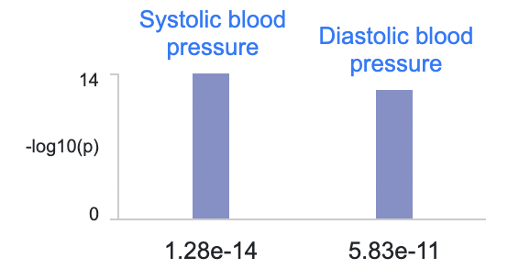
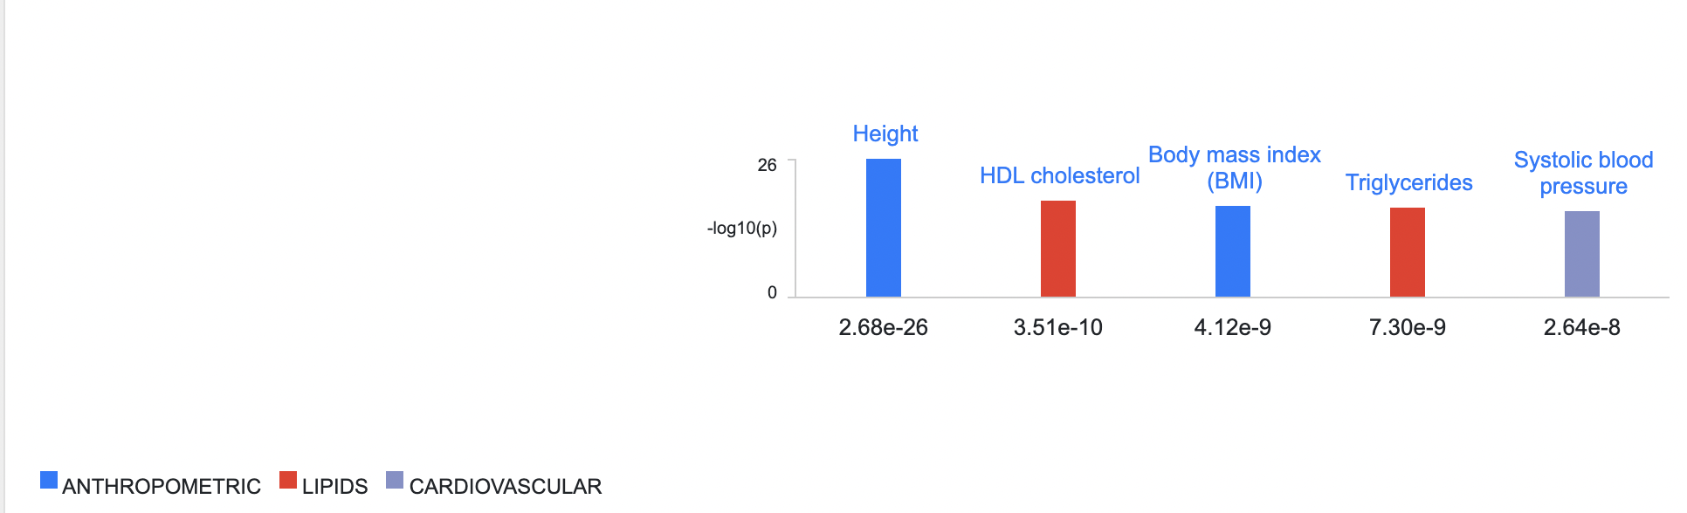
ESM Figure 5: Most significant variant associations in the region for Chromosome 16 locus, rs11076406 (Source: Cardiovascular Disease Knowledge Portal, CVDKP: https://cvd.hugeamp.org/). NB: Associations are clumped by linkage disequilibrium.

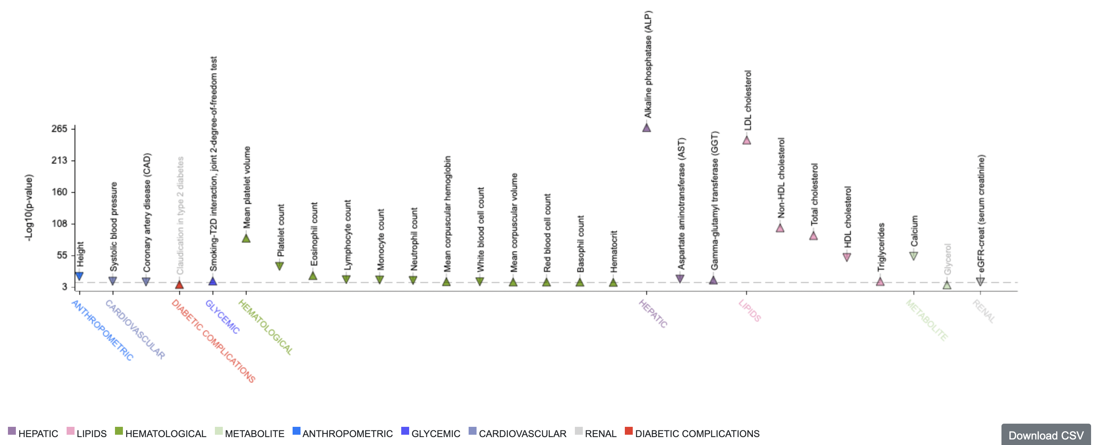
ESM Figure 6: Most significant variant associations in the region for Chromosome 11 locus, rs116314603 (Source: Cardiovascular Disease Knowledge Portal, CVDKP: https://cvd.hugeamp.org/). NB: Associations are clumped by linkage disequilibrium.

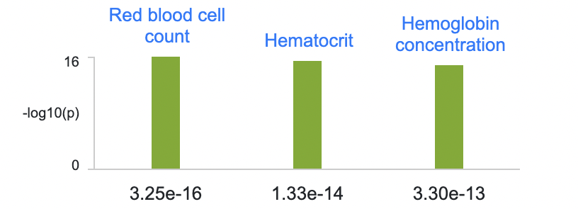
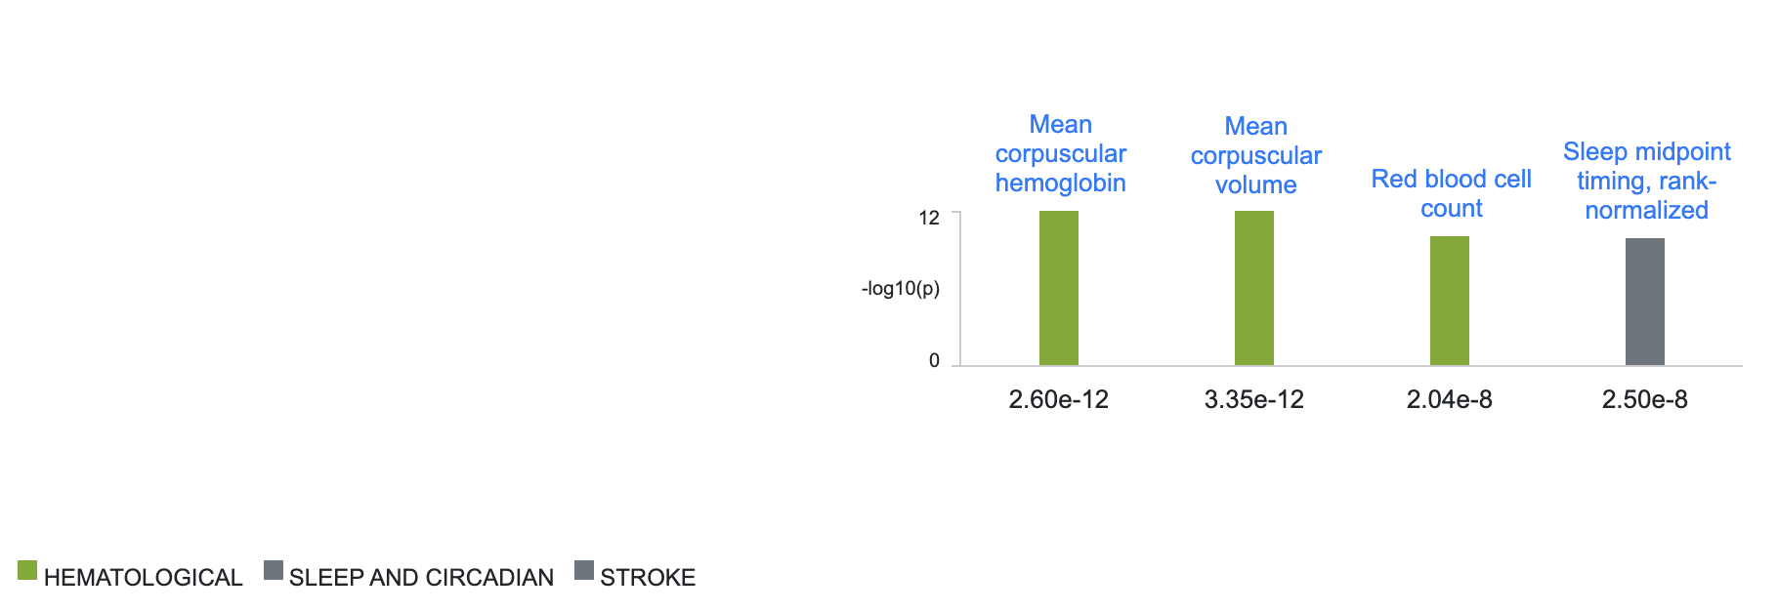
ESM Figure 7: Most significant variant associations in the region for Chromosome 1 locus, rs143539093 (Source: Cardiovascular Disease Knowledge Portal, CVDKP: https://cvd.hugeamp.org/). NB: Associations are clumped by linkage disequilibrium.

ESM Figure 8: Most significant variant associations in the region for Chromosome 15 locus, rs561365169 (Source: Cardiovascular Disease Knowledge Portal, CVDKP: https://cvd.hugeamp.org/). NB: Associations are clumped by linkage disequilibrium.

ESM Figure 9: Most significant variant associations in the region for Chromosome 15 locus, rs561365169 (Source: Cardiovascular Disease Knowledge Portal, CVDKP: https://cvd.hugeamp.org/). NB: Associations are clumped by linkage disequilibrium.

ESM Figures 10-15: Significant loci from the META-SCOPA meta-analysis database search findings

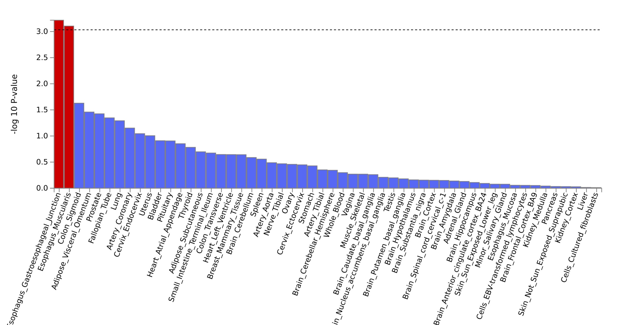

ESM Figure 10: MAGMA tissue expression analysis from the META-SCOPA meta-analysis findings

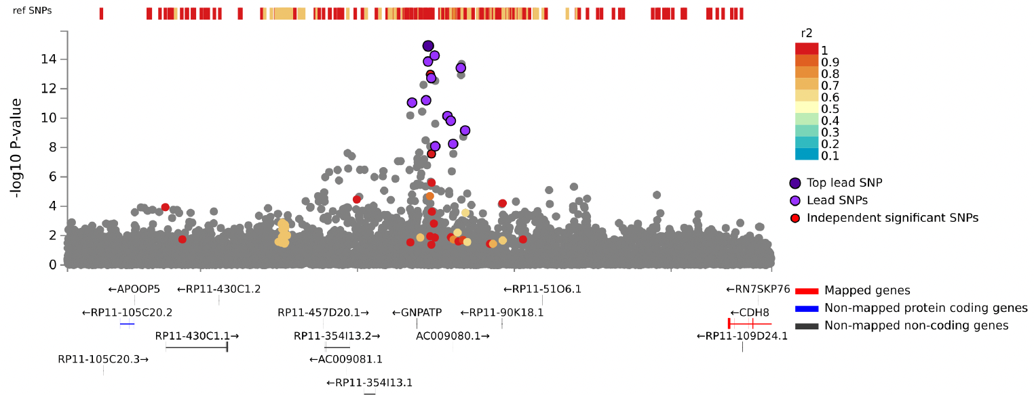
ESM Figure 11: Chromosome 16 locus, rs11076406

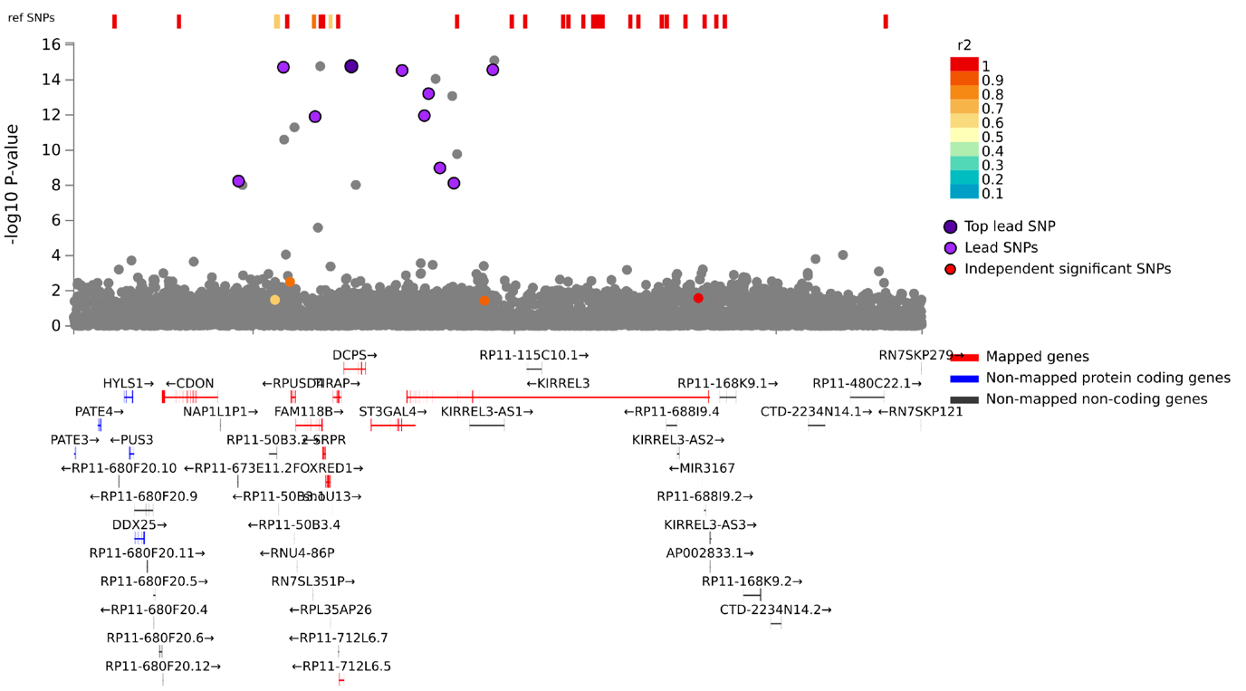
ESM Figure 12: Chromosome 11 locus, rs116314603

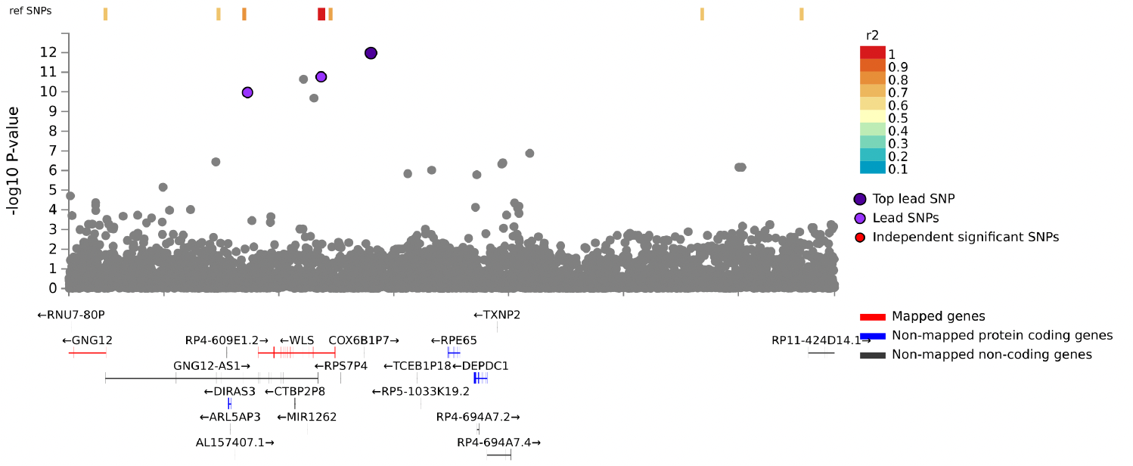

ESM Figure 13: Chromosome 1 locus, rs143539093
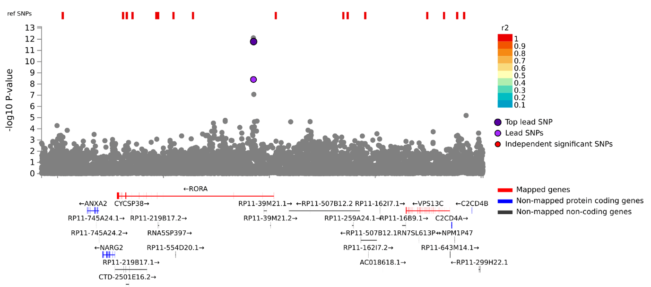

ESM Figure 14: Chromosome 15 locus, rs561365169
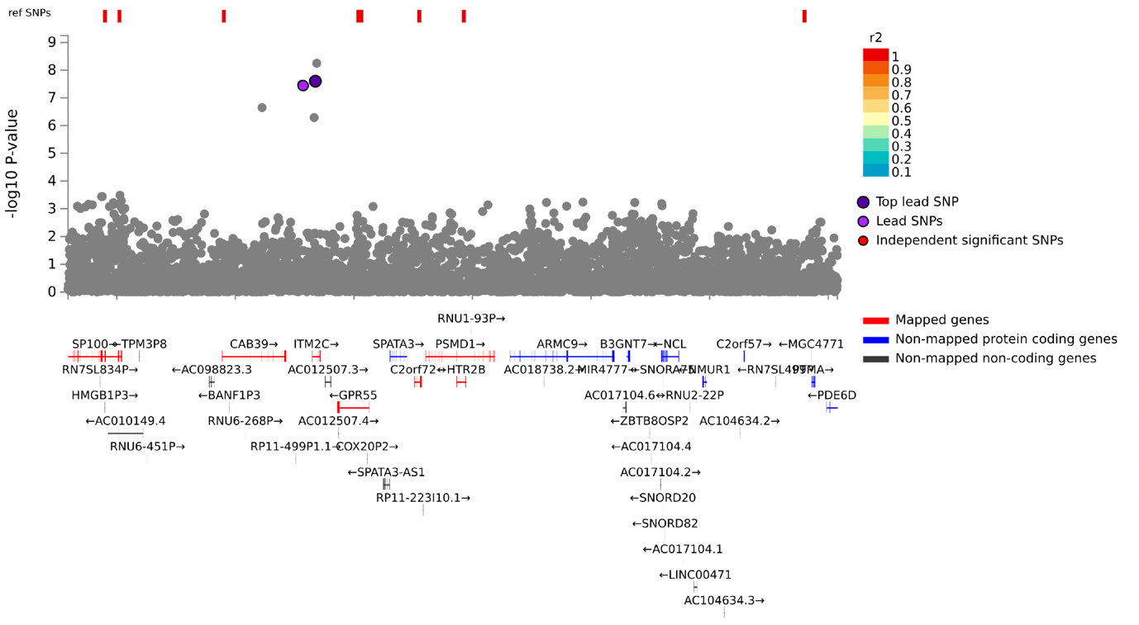

ESM Figure 15: Chromosome 2 locus, rs548591187

We dissected multiple phenotype association signals for the lead SNPs at the five loci attaining genome-wide significance after meta-analysis. We determined the best subset of phenotypes according to the Bayesian information criterion (BIC) across studies, which represents a trade off in overall model fit with the number of parameters required. At chromosome 16 locus, rs11076406, the phenotype subset with minimum BIC for the lead SNPs included waist circumference DBP, HDL and HbA_{1c} in UGR. Additionally, the rs11076406 locus appears to be a true signal in ESM Figure 11 since it displays a well-clustered regional plot. At chromosome 11 locus, rs116314603, included HDL and TG. At chromosome 1 locus, rs143539093, included HDL, TG and HbA_{1c} in UGR. At Chromosome 15 locus, rs561365169, included HDL and TG. At Chromosome 2 locus, rs548591187, included only DBP.

Subsequently, our models above are consistent with previous literature that the primary associations at these loci are with several of our six cardiometabolic risk factors, and that GWAS signals for cardiometabolic risk factors at several of these lead SNPs are likely driven through mediated pleiotropy. Our analyses suggest that the multiple phenotype associations are not entirely driven by correlation between cardiometabolic risk factors and mediation through cardiometabolic risk factors but highlight biological pleiotropy as a possible driving mechanism. However, further dissection of our lead loci in larger samples is required to confirm this assertion, and causal relationships between these phenotypes cannot be established without more detailed Mendelian randomization studies, for example.

References
1. Gurdasani, D., Carstensen, T., Fatumo, S., Chen, G., Franklin, C.S., Prado-Martinez, J., Bouman, H., Abascal, F., Haber, M., Tachmazidou, I., et al. (2019). Uganda Genome Resource Enables Insights into Population History and Genomic Discovery in Africa. Cell 179, 984-1002.e1036. https://doi.org/10.1016/j.cell.2019.10.004.
2. Sugiuchi, H., Uji, Y., Okabe, H., Irie, T., Uekama, K., Kayahara, N., and Miyauchi, K. (1995). Direct measurement of high-density lipoprotein cholesterol in serum with polyethylene glycol-modified enzymes and sulfated alpha-cyclodextrin. Clinical chemistry 41, 717-723.
3. Sugiuchi, H., Irie, T., Uji, Y., Ueno, T., Chaen, T., Uekama, K., and Okabe, H. (1998). Homogeneous assay for measuring low-density lipoprotein cholesterol in serum with triblock copolymer and α-cyclodextrin sulfate. Clinical chemistry 44, 522-531.
4. Topouchian, J.A., El Assaad, M.A., Orobinskaia, L.V., El Feghali, R.N., and Asmar, R.G. (2006). Validation of two automatic devices for self-measurement of blood pressure according to the International Protocol of the European Society of Hypertension: the Omron M6 (HEM-7001-E) and the Omron R7 (HEM 637-IT). Blood pressure monitoring 11, 165-171.
5. Altunkan, S., Iliman, N., Kayaturk, N., and Altunkan, E. (2006). Validation of the omron M6 upper arm blood pressure measuring device according to the international protocol in adults. (LIPPINCOTT WILLIAMS & WILKINS 530 WALNUT ST, PHILADELPHIA, PA 19106-3621 USA), pp. 213-213.
6. Altunkan, Ş., Ilman, N., and Altunkan, E. (2008). Validation of the Omron M6 (HEM-7001-E) upper arm blood pressure measuring device according to the International Protocol in elderly patients. Blood Pressure Monitoring 13, 117-122. 10.1097/MBP.0b013e3282f3fb50.
7. Tekola-Ayele, F., Doumatey, A.P., Shriner, D., Bentley, A.R., Chen, G., Zhou, J., Fasanmade, O., Johnson, T., Oli, J., Okafor, G., et al. (2015). Genome-wide association study identifies African-ancestry specific variants for metabolic syndrome. Molecular Genetics and Metabolism 116, 305-313. https://doi.org/10.1016/j.ymgme.2015.10.008.
8. Liang, J., Le, T.H., Edwards, D.R.V., Tayo, B.O., Gaulton, K.J., Smith, J.A., Lu, Y., Jensen, R.A., Chen, G., Yanek, L.R., et al. (2017). Single-trait and multi-trait genome-wide association analyses identify novel loci for blood pressure in African-ancestry populations. PLOS Genetics 13, e1006728. 10.1371/journal.pgen.1006728.
9. Zhu, X., Feng, T., Tayo, B.O., Liang, J., Young, J.H., Franceschini, N., Smith, J.A., Yanek, L.R., Sun, Y.V., and Edwards, T.L. (2015). Meta-analysis of correlated traits via summary statistics from GWASs with an application in hypertension. The American Journal of Human Genetics 96, 21-36.

