Supplementary Material

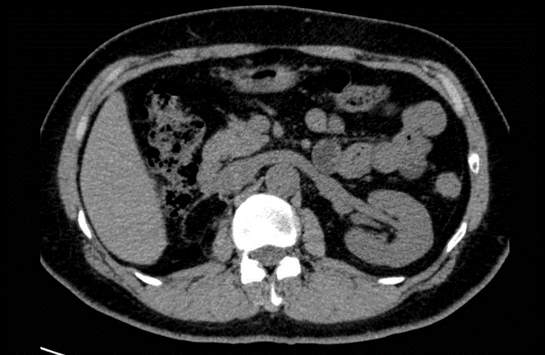
Supplementary Figure 1. Follow-up CT at 5 months after operation.
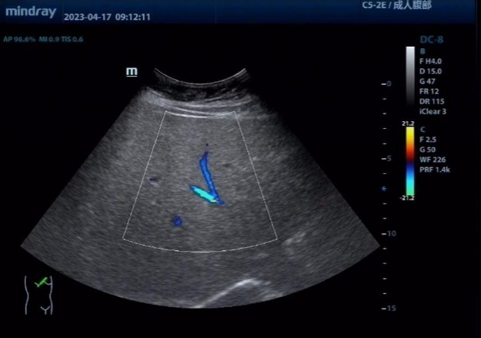
Supplementary Figure 2. Ultrasound, 10 months after operation.

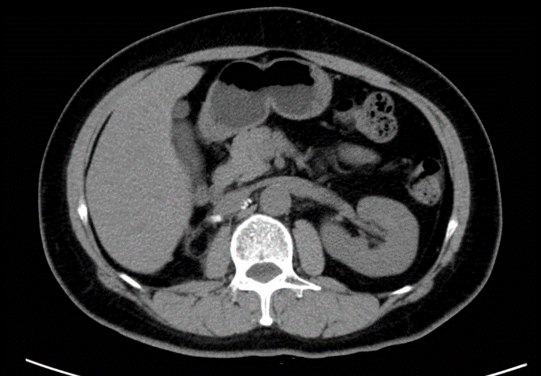
Supplementary Figure 3. Follow-up CT at 14 months after operation.

